3GPP TSG-SA WG6 Meeting #36-BIS-e S6-200510
E-meeting, 31st March – 8th April 2020 (revision of S6-20xxxx)

Source: Huawei, Hisilicon
Title: Basic application context relocation procedure
Spec: 3GPP TS 23.558 v0.1.2
Agenda item: 7.4
Document for: Approval
Contact: Cuili Ge – geuili@huawei.com

1. Introduction
This pCR is proposed to a application context relocation procedure.
2. Reason for Change
Based the email discussion, it is proposed a general procedure which focuses on the interaction from source EES to target EAS and leaves all the possible options to start this whole procedure as the triggers at source EES.
3. Conclusions
4. Proposal
It is proposed to agree the following changes to 3GPP TS 23.558 v0.1.2.

* * * First Change * * * *

8.x Capabilities to support service continuity

8.x.1 General

8.x.2 Procedures

8.x.2.aa Basic application context relocation procedure
In this procedure, the application context relocation is performed from a source EAS to a target EAS. Further, the on-going application traffic related to an Application Client at the UE is routed or switched from a source EAS to a target EAS. The Application Client behaviour at the UE is unaffected by this procedure.
The high level signalling flows for application context relocation is illustrated in the figure 8.x.2.aa-1.
Pre-conditions:
1. The Application Client at the UE already has on-going application traffic with the source Edge Application Server.
2. The source Edge Application Server has subscribed to the source Edge Enabler Server for application context relocation event notifications.
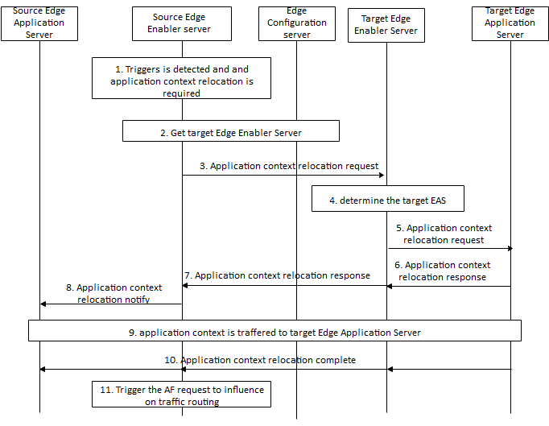
Figure 8.x.2.aa-1: Basic Application context relocation procedure
1. The source Edge Enabler Server determines the application context relocation related to a UE application traffic based on triggers/events (e.g. Application context relocation request from source Edge Application Server, UE is moving to another EDN, source EAS overload) at the source Edge Enabler Server.
2. The source Edge Enabler Server communicates with Edge Configuration Server, which provides application context relocation assistance based on the request from the source Edge Enabler Server and the information about other Edge Enabler Server(s), to retrieve information of the target Edge Enabler Server which has the registered Edge Application Server that can serve the Application Client at the UE. This procedure is specified in clause 8.x.2.bb.
3. The source Edge Enabler Server sends the application context relocation request (source Edge Application Server information, UE information, CN information) to the target Edge Enabler Server retrieved in step 2. The source Edge Application Server information includes the EAS ID and the IP address of the source Edge Application Server. The CN information (such as the subscription to NEF, PCF) may be included to assist the target Edge Enabler Server to interact with the 5GC.
Editor's note: The specification of reference point between Edge Enabler Server(s) is FFS.
4. The target Edge Enabler Server determines the target Edge Application Server as per the EAS ID received in step 3.
5. The target Edge Enabler Server sends the application context relocation request (source Edge Application Server information, UE information) to the target Edge Application Server for application context relocation.
6. When the target Edge Application Server accepts the request and is well prepared for the application context relocation, the target Edge Application Server sends the application context relocation response to the target Edge Enabler Server. The IP address of target Edge Application Server is included. Also other information such as the IP address and port number and protocol used for receiving the application context are also included, if required.
NOTE 1: If target Edge Enabler Server has enough information about the target EAS regarding application context transfer, then steps 5 and 6 can be skipped.
7. The target Edge Enabler Server sends the application context relocation response to the source Edge Enabler Server.
8. The source Edge Enabler Server sends the application context relocation notification with the IP address of the target Edge Application Server to the source Edge Application Server.
9. When the source Edge Application Server determines the point that the application context can be transferred, the source Edge Application Server delivers the application context to the target Edge Application Server via the source EES and target EES.
NOTE 2: This step can use methods to transfer the application context directly from the source Edge Application Server to the target Edge Application Server. Such methods are implementation specific and out of scope of this specification.
10. When the application context transfer is completed, the application context transfer complete message is sent from target Edge Application Server to the source Edge Application Server via the target EES and the source EES.
11. The source Edge Enabler Server (acting as AF) triggers the AF traffic influence procedure as described in 3GPP TS 23.502 [3]. The application traffic from the UE is now routed to the target EAS.
NOTE 3: Step 11 is applicable for 5GC.

8.x.2.bb Retrieve Target Edge Enabler Server procedure
Figure 8.x.2.bb-1 illustrates the procedure for the source Edge Enabler Server to retrieve the target Edge Enabler Server information from the Edge Configuration Server.
Pre-condition:
1. The source Edge Enabler Server has been pre-configured with the address of the Edge Configuration Server.
2. 1. The Application Client at the UE already has on-going application traffic with the source Edge Application Server.
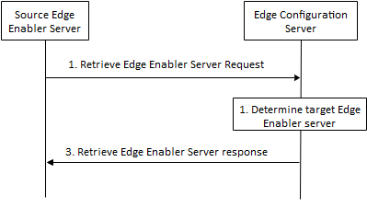
Figure 8.x.2.bb-1: Retrieve target Edge Enabler Server procedure
1. The source Edge Enabler Server sends the Retrieve Edge Enabler Server request (UE location information or UE identity, EAS ID of the source Edge Application Server) to the Edge Configuration Server in order identify the target Edge Enabler Server which has the same Edge Application Server registered and available to serve the given Application Client in the UE.
2. The Edge Configuration Server identifies the target Edge Enabler Server meeting the parameters in the request. If the request contained the UE identity but the UE location is not known to the Edge Configuration Server, then the Edge Configuration Server interacts with 3GPP core network to retrieve the UE location.
3. The Edge Configuration Server sends the Retrieve Edge Enabler Server response (EAS ID of the source Edge Application Server, target Edge Enabler Server information) to the source Edge Enabler Server. The target Edge Enabler Server information includes the endpoint of the target Edge Enabler Server, e.g. IP address.

