**3GPP TSG-SA WG6 Meeting #48-e S6-220xxxx**

**e-meeting, 5th – 14th April 2022 (revision of S6-22xxxx)**

**Source: CATT**

**Title: Discussion on fused location service architecture**

**Agenda Item: 9.8**

**Contact: Chunshan Xiong, chunshan.xiong@cictmobile.com**

**1. Discussion**

This discussion aims at two major issues:

* To further refine the architecture for fused location service.
* To resolve the remaining issue regarding relation with SEAL LM.
* To define the interaction between FLS and SEAL LM.

1. Extended fused location service architecture

In the current standalone architecture discussed in solution#1 (as illustrated in Figure 1), the Fused location function is within the positioning and location fusion realm, basically this function provides capabilities regarding positioning. The Fused location function exposes location information towards the application server (which can be of Verticals, LBS or Ecosystem partner) and the interface to UE - only to the target UE for location and positioning functions.

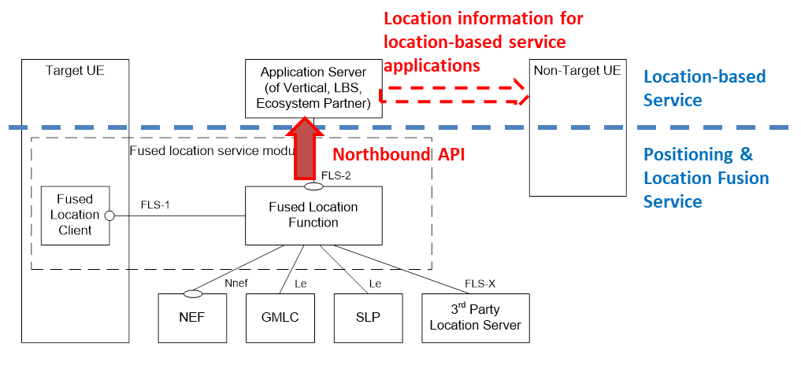

Figure 1. Illustative diagram for fused location service architecture

It should be addressed that the Fused location function does not interface with non-target UE directly for providing location for location-based service purpose, i.e. does not process the external user’s request of location-based service, since the Fused location function (positioning layer) does not have user information. The potential location retrieval by other users (of non-target UEs) will depend on the location-based service level mechanisms and authorizations.

Besides the Fused location function which provides fused location data from multiple sources and may further utilize other data source and fused location data, to provide the common services (i.e. common services to be reused frequently like geofencing, location analytics, heatmap etc.). The FLF may be able to retrieve data (e.g. location contextual information) from the database and/or the target UE. In the Use Case of Accurate positioning to support AR in 3GPP TR 22.872, the contextual information relating to the user’s position and motion is needed, and this contextual information can be acquired from the UE e.g. by sensors. In the Use Case of Flow management in large transportation hubs, the contextual information (e.g. local map, radio finger-print) is needed and can be acquired from the relevant database.

The figure below from Gartner’s report "Architecting for Location" (published on 15 December 2020, ID G00733883) shows a high-level (logicalized) view of a location architecture. The fused location service architecture, which is based upon 5G mobile network connectivity, can be regarded aligned with this logicalized location architecture. Besides Fused location function which exposes normalized location data, the common location capabilities can be further exposed to Verticals to address their location service needs.



As illustrated in the diagram below, fused location service architecture should include Fused Location Function and Common Service Functions as well. The common service functions are modeled capabilities that can provide dedicated APIs (through FLS-2 interface) towards the verticals, and are independent with each other. The common services including the mapping, geofencing and location analytics etc. It is possible that the FLF can access to the database for location contextual information( e.g. local map,radio finger-print information) used for indoor location services.

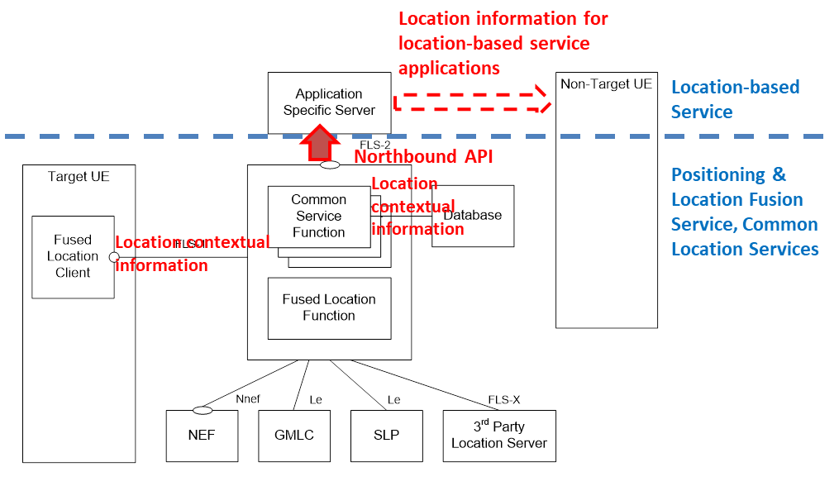

Figure 2. Illustative diagram for extended fused location service architecture

1. Relationship with SEAL Location Management

The SEAL Location Management architecture is originally part of the Mission Critical Service architecture which was defined from the perspective of vertical user layer:

- SEAL LM is responsible for transfer the location but not judge locations;

- SEAL LM is aware of the vertical user level information and process the user request (e.g. the SEAL LM can directly process the user’s request to obtain another user’s location, which is totally vertical layer service);

- SEAL-LM has two location exposure interfaces (for VAL server and for LMC respectively);

- SEAL LM is not visible to the underlying positioning network.

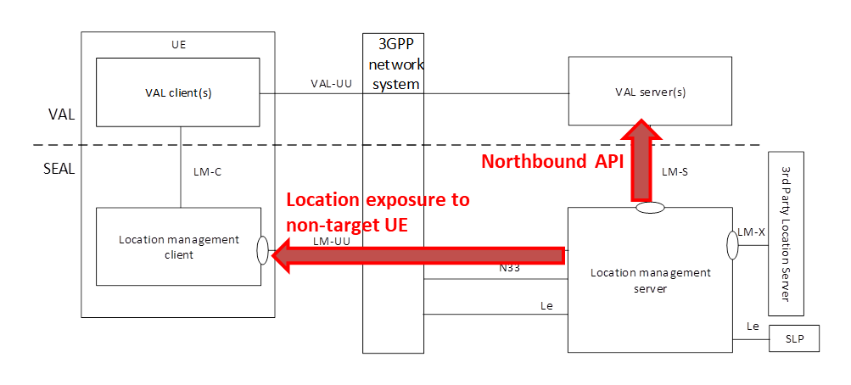

Figure 3. Illustrative diagram for SEAL location management architecture

The standalone Fused location service architecture is differnt in:

- FLS needs to determine and fuse location results from multiple sources;

- FLS does not process the VAL service level user’s request and is not aware of the user information;

- Single location exposures towards VAL applications (server);

- FLS needs to configure and dynamically manage the positioning source (network).

1. Two interaction modes between FLS and SEAL LM

FLS fuses different location information from multiple resources and provide a better location service/information to the Application Server via its northbound API. And the SEAL LM can be one of its location source as described in figure 4. Depending on the location requirements, if the application server needs better location information , the application server use the FLS (maybe with more charging rate) , otherwise, the application server can use the SEAL location service as described in figure 3.



Figure 4. SEAL LM as location source for Fused Location Server

If the SEAL receives a location request from the application server with special location requirements that the SEAL cannot provide, the SEAL re-directs or forwards such request to the FLS, after receiving the responses from the FLS, the SEAL responses to the application server as described in figure 5.



Figure 5. SEAL LM relays location request to Fused Location Server

**2. Conclusion**

Based on discussions above, two potential directions are considered:

1. To unify standalone Fused Location Service architecture with SEAL LM.

The issues are:

- SEAL LM architecture and service need to be decoupled to VAL user service layer and location service layer.

- Location Privacy has risks on current SEAL LM. Since SEAL LM can process the user’s request to obtain another user’s location, it’s unclear if user service level privacy handling is required at SEAL level, and how to avoid the risks of SEAL to share user location across different VAL services.

2. To keep standalone FLS and SEAL LM architectures as two options and develp location service in paralell.

3. To define the two interaction modes between SEAL LM and FLS.

**3. Proposal**

It is proposed to keep standalone FLS and SEAL LM architectures as two options and develp location service in paralell, and support the interaction between FLS and SEAL LM.