3GPP TSG-SA5 (Telecom Management)  S5-111136
Meeting SA5#76, 28 Feb -04 Mar 2011, San Diego, CA, USA revised to S5-110104
CR-Form-v9.6
CHANGE REQUEST
 | 32.762 | CR | 0046 |  rev | 1 |  Current version: | 10.2.0 | 
For HELP on using this form look at the pop-up text over the  symbols. Comprehensive instructions on how to use this form can be found at http://www.3gpp.org/specs/CR.htm.

Proposed change affects:  | UICC apps |  | ME |  | Radio Access Network | X | Core Network

Title:  | Add qciDscpMapping IOC
Source to WG:  | Motorola Solutions, Nokia Siemens Networks, China Mobile, Vodafone
Source to TSG:  | S5
Work item code:  | OAM10 |  |  |  |  |  |  | Date:  |  | 04/03/2011
Category:  | B |  |  |  |  |  |  | Release:  |  | Rel-10
 | Use one of the following categories:  F (correction)  A (corresponds to a correction in an earlier release)  B (addition of feature),  C (functional modification of feature)  D (editorial modification)  Detailed explanations of the above categories can  be found in 3GPP TR 21.900. |  |  |  |  |  |  |  | Use one of the following releases:  R97 (Release 1997)  R98 (Release 1998)  R99 (Release 1999)  Rel-4 (Release 4)  Rel-5 (Release 5)  Rel-6 (Release 6)  Rel-7 (Release 7)  Rel-8 (Release 8)  Rel-9 (Release 9)  Rel-10 (Release 10)
Reason for change:  |  | For Relay Node, the Uu bearers are mapped to Un bearers in UL, multiple Uu bearers of different QCIs may be mapped to a single DSCP based Un bearer. Operators shall be able to control the mapping of QCI to DSCP in UL.  The model supporting the control of the mapping is missing.
Summary of change:  |  | Add the QciDscpMapping IOC
Consequences if   not approved: |  | The control of mapping of Uu bearer to Un bearer in UL cannot be supported on Itf-N.
Clauses affected:  |  | 2, 6.2, 6.3.x (new), 6.5.1
 |  | Y | N
Other specs  |  |  | x | Other core specifications 
affected: |  |  | x | Test specifications
 |  | x |  | O&M Specifications |  |  | 32.766
Other comments: 

1st Modified Section

2 References
The following documents contain provisions which, through reference in this text, constitute provisions of the present document.
- References are either specific (identified by date of publication, edition number, version number, etc.) or non-specific.
- For a specific reference, subsequent revisions do not apply.
- For a non-specific reference, the latest version applies. In the case of a reference to a 3GPP document (including a GSM document), a non-specific reference implicitly refers to the latest version of that document in the same Release as the present document.
[1] 3GPP TS 32.101: "Telecommunication management; Principles and high level requirements".
[2] 3GPP TS 32.102: "Telecommunication management; Architecture".
[3] 3GPP TS 23.003: "Numbering, addressing and identification".
[4] 3GPP TS 32.300: "Telecommunication management; Configuration Management (CM); Name convention for Managed Objects".
[5] 3GPP TS 32.600: "Telecommunication management; Configuration Management (CM); Concept and high-level requirements".
[6] 3GPP TS 32.622: "Telecommunication management; Configuration Management (CM); Generic network resources Integration Reference Point (IRP): Network Resource Model (NRM)".
[7] 3GPP TS 32.602: "Telecommunication management; Configuration Management (CM); Basic CM Integration Reference Point (IRP) Information Service (IS)".
[8] 3GPP TS 32.612: "Telecommunication management; Configuration Management (CM); Bulk CM Integration Reference Point (IRP): Information Service (IS)".
[9] 3GPP TS 23.401: "Technical Specification Group Services and System Aspects; General Packet Radio Service (GPRS) enhancements for Evolved Universal Terrestrial Radio Access Network (E-UTRAN) access".
[10] 3GPP TS 36.331: "Evolved Universal Terrestrial Radio Access (E-UTRA) Radio Resource Control (RRC); Protocol specification".
[11] 3GPP TS 36.300: " Evolved Universal Terrestrial Radio Access (E-UTRA) and Evolved Universal Terrestrial Radio Access Network (E-UTRAN); Overall description; Stage 2 ".
[12] 3GPP TS 36.211: "Evolved Universal Terrestrial Radio Access (E-UTRA); Physical Channels and Modulation"
[13] 3GPP TS 36.101: "Evolved Universal Terrestrial Radio Access (E-UTRA); User Equipment (UE) radio transmission and reception"
[14] 3GPP TS 36.104: "Evolved Universal Terrestrial Radio Access (E_UTRA); Base Station (BS) radio transmission and reception"
[15] 3GPP TS 32.500: " Technical Specification Group Services and System Aspects; Telecommunication Management; Self-Organizing Networks (SON); Concepts and requirements"
[16] 3GPP TS 32.150: " Technical Specification Group Services and System Aspects; Telecommunication management; Integration Reference Point (IRP) Concept and definitions"
[17] 3GPP TS 21.905: " Technical Specification Group Services and System Aspects; Vocabulary for 3GPP Specifications"
[18] 3GPP TS 32.111-2: "Telecommunication management; Fault Management; Part 2: Alarm Integration Reference Point (IRP): Information Service (IS)"
[19] 3GPP TS 23.002: "Network Architecture"
[20] 3GPP TS 32.652: "Telecommunication management; Configuration Management (CM); GERAN network resources Integration Reference Point (IRP); Network Resource Model (NRM)"
[21] 3GPP TS 32.642: "Telecommunication management; Configuration Management (CM); UTRAN network resources Integration Reference Point (IRP); Network Resource Model (NRM)"
[22] 3GPP2 S.S0028-D "OAM&P for cdma2000 (Overview, 3GPP R7 Delta Specification, 3GPP2 Network Resource Model IRP)"
[23] 3GPP TS 32.752: "Telecommunication management; Evolved Packet Core (EPC) Network Resource Model (NRM) Integration Reference Point (IRP): Information Service (IS)"
[24] 3GPP TS 36.423: "Evolved Universal Terrestrial Radio Access Network (E-UTRAN); X2 application protocol (X2AP)".
[25] 3GPP TS 36.213: "Evolved Universal Terrestrial Radio Access (E-UTRA); Physical layer procedures".
[26] 3GPP TS 32.672: "Telecommunication management; Configuration Management (CM); State Management Integration Reference Point (IRP); Information Service (IS)".
[27] 3GPP TS 36.413: "Evolved Universal Terrestrial Access Network (E-UTRAN); S1 Application Protocol (S1AP)".
[28] 3GPP TS 32.443: "Evolved Universal Terrestrial Access Network (E-UTRAN);M2 Application Protocol (M2AP)".
[29] 3GPP TS 22.011: "Service accessibility".
[w] 3GPP TS 32.662: "Telecommunication management; Configuration Management (CM); Kernel CM; Information service (IS)".
[x] 3GPP TS 23.203: "Policy and charging control architecture”.
[y] 3GPP TS 23.207: "End-to-end Quality of Service (QoS) concept and architecture”.
[z] RFC 2474: "Definition of the Differentiated Services Field (DS Field) in the IPv4 and IPv6 Headers".

Next Modified Section

6.2 Class diagram

6.2.1 Attributes and relationships

Figure 6.2.1.1: Cell view of E-UTRAN NRM

Figure 6.2.1.2a: E-UTRAN relaying view of E-UTRAN NRM
1
QciDscpMapping

<<InformationObjectClass>>
0..1
<<InformationObjectClass>>
RNFunction

Figure 6.2.1.2b: E-UTRAN relaying view of E-UTRAN NRM_2
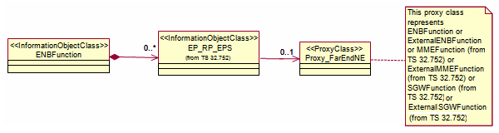

Figure 6.2.1.3: Transport view of E-UTRAN NRM

Figure 6.2.1.4: Radio equipment view of E-UTRAN NRM
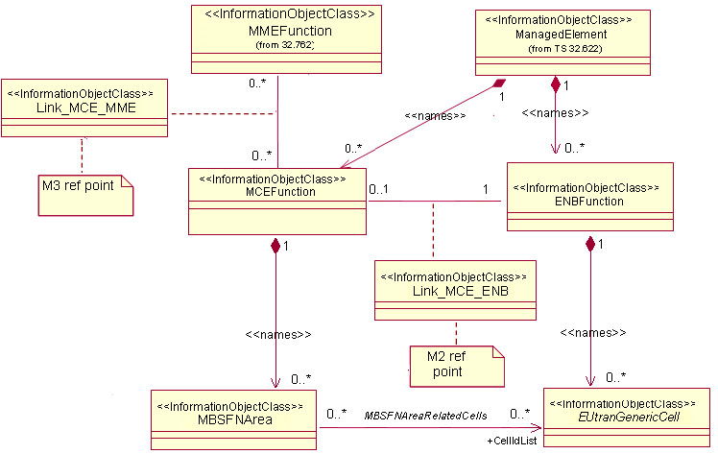

Figure 6.2.1.5: MBMS view of E-UTRAN NRM 1
NOTE 1: This is E-UTRAN NRM containment/relationship Figure form view of MBMS when MCE and ENB belong to one Network Element.
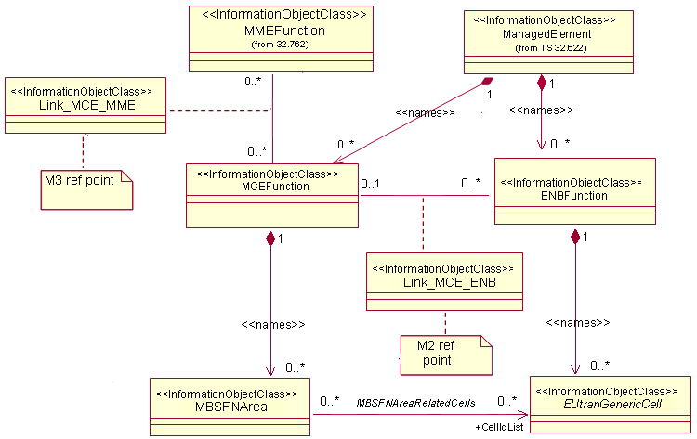

Figure 6.2.1.6: MBMS view of E-UTRAN NRM 2
NOTE 2: This is E-UTRAN NRM containment/relationship Figure form view of MBMS when MCE and ENB belong to different Network Elements.

Figure 6.2.1.7: Energy Saving view of E-UTRAN NRM

6.2.2 Inheritance
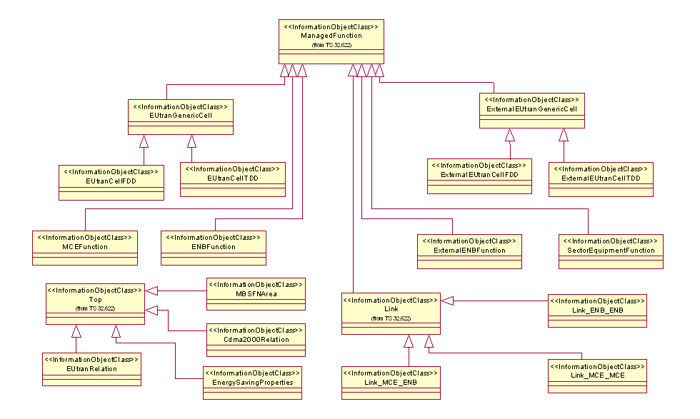

Figure 6.2.2.1: E-UTRAN NRM Inheritance Hierarchy

Figure 6.2.2.2: EPC NRM Inheritance Hierarchy_2
ManagedFunction
(from 32.622)
<<InformationObjectClass>>
QciDscpMapping
<<InformationObjectClass>>
Next Modified Section

6.3.x IOC QciDscpMapping

6.3.x.1 Definition
This IOC represents a set of mapping between QCI and DSCP.

6.3.x.2 Attributes
Attribute Name | Support Qualifier | Read Qualifier | Write Qualifier
id | M | M | -
qciDscpMappingList | M | M | M

6.3.x.3 Attribute constraints
Null.

6.3.x.4 Notifications
Name | Qualifier | Notes
notifyAttributeValueChange | See Kernel CM IRP (3GPP TS 32.662 [w])
notifyObjectCreation | See Kernel CM IRP (3GPP TS 32.662 [w])
notifyObjectDeletion | See Kernel CM IRP (3GPP TS 32.662 [w])

Next Modified Section

6.5.1 Definition and legal values
Table 6.5.1.1 defines the attributes that are present in several Information Object Classes (IOCs) of the present document.

Table 6.5.1.1: Attributes definitions and legal values
Attribute Name | Definition | Legal Values
adjacentCell | This attribute contains the DN of a EUtranGenericCell or ExternalEUtranGenericCell.
adjacentSector | This attribute contains the DN of an ExternalSector.
relatedAntennaList | This attribute contains the DNs of one or more AntennaFunction
relatedTmaList | This attribute contains the DNs of one or more TmaFunction
relatedEUtranCellList | This attribute contains the DNs of one or more EUtranGenericCell
cellLocalId | Unambiguously identify a cell within an eNodeB | 0 - 255.
cellIdList | This holds a list of DN of EUtranGenericCell. These  cells all belong to one MBSFN Area.
cellSize | See cell-Size in TS 36.423 [24]. | See cell-Size in TS 36.423 [24].
cellResvInfo | This attribute represents whether the cell is MBSFN Area Reserved Cell or not.  See TS 36.300[11] for MBSFN Area Reserved Cell. | See 3GPP TS 36.443 [28] for Cell Reservation Info.
confOutputPower | It defines the allowed total power to use for all cells together in this sector. It may be set by the operator and/or limited by HW limitation or licensed power, e.g.: 20, 40, 60, 80,120 watts
relatedSector | This attribute contains the DN of an SectorEquipmentFunction
referenceSignalPower | This defines the cell specific downlink reference signal transmit power, which is described in 3GPP TS 36.213[25] | See 3GPP TS 36.331[10]
earfcn | It is the frequency number for the central frequency. See 3GPP TS 36.104[14]. | See 3GPP TS 36.104[14].
earfcnul | Specifies the channel number for the central UL frequency. The mapping from channel number to physical frequency is described in 3GPP specification TS 36.101 [13] subclause 5.7.3. | See EARFCN in TS 36.101 [13] subclause 5.7.3.
earfcnDl | Specifies the channel number for the central DL frequency. The mapping from channel number to physical frequency is described in 3GPP specification TS 36.101 [13] subclause 5.7.3. | See EARFCN in TS 36.101 [13] subclause 5.7.3
energySavingControl | This attribute allows to IRPManager to initiate energy saving activation or deactivation. Its value can not be changed by the IRPAgent. | Enumerated  {energySaving, notEnergySaving}.
energySavingState | Specifies the status regarding the energy saving in the cell.  If the value of energySavingControl is energySaving, then it shall be tried to achieve the value isEnergySaving for the energySavingState.  If the value of energySavingControl is notEnergySaving, then it shall be tried to achieve the value isNotEnergySaving for the energySavingState. | Enumerated  {isNotEnergySaving,  isEnergySaving}.
eNBId | Unambiguously identifies an eNodeB within a PLMN | See 3GPP TS 36.413[27], 36.300[4]
fqBand | This is the frequency band supported by the hardware associated with the SectorEquipmentFunction. The earfcnDl and earfcnUl of cells associated with the SectorEquipmentFunction must be assigned with value within this fqBand value. | See section 5 Table 5.2-1 "E-UTRA frequency band" of TS 36.104 [14].  Other legal values would be applicable for other technologies such as for UTRA.
id | An attribute whose "name+value" can be used as an RDN when naming an instance of the object class. This RDN uniquely identifies the object instance within the scope of its containing (parent) object instance.
isESCoveredBy | The value of the attribute is configured by the IRPmanager and is not changed by the IRPAgent. It indicates whether the adjacentCell according to this planning provides no, partial or full coverage for the cell which name-contains the EUtranRelation instance.  Adjacent cells with this attribute equal to “yes” are recommended to be considered as candidate cells to take over the coverage when the original cell is about to be transferred to energySaving state.  The entirety of adjacent cells with this property equal to “partial” are recommended to be considered as entirety of candidate cells to take over the coverage when the original cell is about to be transferred to energySaving state.  The value “partial” is not allowed in an eNB overlaid scenario. | No, partial, yes
isRemoveAllowed (see note 1) | This indicates if the subject EUtranRelation can be removed (deleted) or not.  If ‘yes’, the subject EUtranRelation instance can be removed (deleted).  If ‘no’, the subject EUtranRelation instance shall not be removed (deleted) by any entity but an IRPManager. | yes, no
isHOAllowed (see note 1) | This indicates if HO is allowed or prohibited.  If ‘yes’, handover is allowed from source cell to target cell. The source cell is identified by the name-containing EUtranGenericCell of the EUtranRelation that has the isHOAllowed. The target cell is referenced by the EUtranRelation that has this isHOAllowed.  If ‘no’, handover shall not be allowed. | yes, no
isICICInformationSendAllowed | This indicates if ICIC (Inter Cell Interference Coordination) load information message (see TS 36.423 [24] Section 9.1.2.1 LOAD INFORMATION) sending is allowed or prohibited.  If ‘yes’, ICIC load information message sending is allowed from source cell to target cell. The source cell is identified by the name-containing EUtranGenericCell of the EUtranRelation that has the isICICInformationSendAllowed. The target cell is referenced by the EUtranRelation that has this isICICInformationSendAllowed.  If ‘no’, ICIC load information message sending shall not be allowed. | yes, no
isLBAllowed | This indicates if load balancing is allowed or prohibited from source cell to target cell.  If ‘yes’, load balancing is allowed from source cell to target cell. The source cell is identified by the name-containing EUtranGenericCell of the EUtranRelation that has the isLBAllowed. The target cell is referenced by the EUtranRelation that has this isLBAllowed.  If ‘no’, load balancing shall be prohibited from source cell to target cell. | yes, no
maximumTransmissionPower | This is the maximum possible for all downlink channels, used simultaneously in a cell, added together.
mbsfnAreaId | This is the identifier of MBSFN Area.  See TS 36.300[11] for MBSFN Area. | See 3GPP TS 36.443 [28] for mbsfnAreaId
partOfSectorPower | This is the requested part (i.e. %) of the total radio power available to the SectorEquipmentFunction. The requested % power should be allocated to the cell. | 0 : 100
pb | $P_{B}$, which is described in Section 5.2 of TS 36.213 [25] | See 3GPP TS 36.213[25]
pci | This holds the Physical Cell Identity (PCI) of the cell (for NM-Centralized, EM-Centralized and Distributed PCI assignment cases).  In the case of NM-Centralized PCI assignment, see TS 36.300, [11] subclause 22.3.5, IRPManager signals a specific value by writing this attribute. | See TS 36.211 [12] subclause 6.11 for legal values of pci.
pciList | This holds a list of physical cell identities that can be assigned to the pci attribute by eNB. The assignment algorithm is not specified.  This attribute shall be supported if and only if the EM-Centralized or Distributed PCI Assignment is supported. See TS 32.500, ref [15] subclause 6.1.6. | See TS 36.211 [12] subclause 6.11 for legal values of pci. The number of pci in the list is 1 to 504.
plmnIdList | List of unique identities for PLMN.  Note: A cell can broadcast up to 6 PLMN-id's. This is to support the case that one cell can be used by up to 6 operators’ core networks.  One member of plmnIdList is the primary PLMN Id.  See TS 36.331 [10] section 6.2.2: SystemInformationBlockType1/cellAccessRelatedInformation/plmn-IdentityList is a SEQUENCE (SIZE (1..6)) | A list of at most six entries of PLMN Identifiers. The PLMN Identifier is composed of a Mobile Country Code (MCC) and a Mobile Network Code (MNC).  See TS 23.003 [3] subclause 2.2 and 12.1.
qciDscpMappingList | It is a list of mapping between QCI and DSCP, each mapping is a structure including the element QCI and DSCP;  Wherein  - QCI represents the number of the QCI (Ref. 3GPP TS 23.203[x]);  - DSCP represents the DiffServ codepoint (Ref. 3GPP TS 23.207[y] and RFC 2474[z]). | For QCI, Ref. 3GPP TS 23.203[x];  For DSCP, Ref. RFC 2474[z]
sfAssignment | This is the uplink-downlink subframe configuration number of a TDD E-UTRAN cell. | See 3GPP TS 36.211[12].
specialSfPatterns | This is the special subframe configuration number of a TDD E-UTRAN cell. | See 3GPP TS 36.211[12].
tac | Common Tracking Area Code for the PLMNs. The identity used to identify tracking areas. | - It is the Tracking Area Code (TAC).  - A cell can only broadcast one TAC. See TS 36.300 [11], section 10.1.7 (PLMNID and TAC relation).  - TAC is defined in TS 23.003 [3], section 19.4.2.3.
tCI | This is the Target Cell Identifier. It consists of E-UTRAN Cell Global Identifier (ECGI) and Physical Cell Identifier (PCI) of the target cell.  The EUtranRelation.tCI identifies the target cell from the perspective of the EUtranGenericCell, the name-containing instance of the subject EUtranRelation instance. | The Target Cell Identifier is defined in TS 36.300 [11]. See TS 36.211 [12] subclause 6.11 for legal values of the PCI.
x2BlackList | This is a list of DNs of ENBFunction and ExternalENBFunction. If the target node DN is a member of the source node’s ENBFunction.x2BlackList, the source node is:  - Prohibited from sending X2 connection request to target node;  - Forced to tear down established X2 connection to target node  - Not allowed to accept incoming X2 connection request from target node.  The same DN may appear here and in ENBFunction.x2WhiteList. In such case, the DN in x2WhiteList shall be treated as if it is absent.
x2IpAddressList | Represents one or more IP addresses used by ENBFunction for this ENBFunction’s X2 Interface | One or more IPv4 or IPv6 addresses
x2WhiteList | This is a list of DNs of ENBFunction and ExternalENBFunction. If the target node DN is a member of the source node’s ENBFunction.x2WhiteList, the source node :  - Is allowed to request the establishment of X2 connection with the target node;  - Is not allowed to initiate the tear down of established X2 connection to target node  The same DN may appear here and in ENBFunction.x2BlackList. In such case, the DN here shall be treated as if it is absent.
x2HOBlackList | This is a list of DNs of ENBFunction. The ENBFunction.x2HOBlackList identifies a list of neighbour ENBFunction with whom the subject ENBFunction is prohibited to use X2 interface for HOs even if the X2 interface exists between them.
rnId | This is defined as RN Indicator. Based on that, the deNB selects an MME supporting relay functionality | See 3GPP TS 36.300 [11] for RN Indicator.
deNBId | This is defined as deNB Indicator. It indicates that specific cells is allowed to access by RNs.
allowedAccessClasses | This holds information for access classes (10-15) – [3GPP TS 22.011] that are allowed for the eUTRANCell .  The access classes are:  Class 10 – emergency call  Class 11 - For PLMN Use.  Class 12 - Security Services;  Class 13 - Public Utilities (e.g. water/gas suppliers);  Class 14 - Emergency Services;  Class 15 - PLMN Staff; | The default value is all access classes are allowed  See TS 22.011 [29] and 36.331 [10] for more details on the definition and SIB2 broadcast message definition

NOTE: Attributes isRemoveAllowed and isHOAllowed each has 2 legal values, allow (A) and prohibited (P). The two attributes are semantically equivalent to one attribute with 4 legal values such as:
hOAllow; hOProhibited; hOWhiteListed; hOBlackListed;
where
- hOAllow == isRemoveAllowed is A and isHOAllowed is A;
- hOProhibited == isRemoveAllowed is A and isHOAllowed is P;
- hOWhiteListed == isRemoveAllowed is P and isHOAllowed is A;
- hOBlackListed == isRemoveAllowed is P and isHOAllowed is P.
Therefore, the choice of an option is FFS.

End of modifications

