|  |  |
| --- | --- |
| 3GPP TR 28.873 V19.1.0 (2024-12) | |
| Technical Report | |
| 3rd Generation Partnership Project;  Technical Specification Group Services and System Aspects;  Study on data management, subscriptions and reporting  (Release 19) | |
|  | |
|  |  |
|  | |
| The present document has been developed within the 3rd Generation Partnership Project (3GPP TM) and may be further elaborated for the purposes of 3GPP. The present document has not been subject to any approval process by the 3GPPOrganizational Partners and shall not be implemented. This Specification is provided for future development work within 3GPPonly. The Organizational Partners accept no liability for any use of this Specification. Specifications and Reports for implementation of the 3GPP TM system should be obtained via the 3GPP Organizational Partners' Publications Offices. | |

|  |
| --- |
|  |
| ***3GPP***  Postal address  3GPP support office address  650 Route des Lucioles - Sophia Antipolis  Valbonne - FRANCE  Tel.: +33 4 92 94 42 00 Fax: +33 4 93 65 47 16  Internet  http://www.3gpp.org |
| ***Copyright Notification***  No part may be reproduced except as authorized by written permission. The copyright and the foregoing restriction extend to reproduction in all media.  © 2024, 3GPP Organizational Partners (ARIB, ATIS, CCSA, ETSI, TSDSI, TTA, TTC).  All rights reserved.  UMTS™ is a Trade Mark of ETSI registered for the benefit of its members  3GPP™ is a Trade Mark of ETSI registered for the benefit of its Members and of the 3GPP Organizational Partners LTE™ is a Trade Mark of ETSI registered for the benefit of its Members and of the 3GPP Organizational Partners  GSM® and the GSM logo are registered and owned by the GSM Association |

Contents

Foreword 4

Introduction 5

1 Scope 6

2 References 6

3 Definitions of terms, symbols and abbreviations 7

3.1 Terms 7

3.2 Symbols 7

3.3 Abbreviations 7

4 Concept and background 7

5 Use cases and potential requirements 7

5.1 Use case#1: Trace/MDT/QoE Identity uniqueness 7

5.1.1 Description 7

5.1.2 Potential requirements 8

5.2 Use case#2: Redundant Subscriptions 8

5.1.1 Description 8

5.2.2 Potential requirements 9

6 Potential solutions 9

6.1 Potential solution #1: a globally unique Collection Id 9

*6.1.1 Description* 9

6.2 Potential solution #2: Job identity generator 9

*6.2.1 Description* 9

6.3 Potential solution #3: Reduce redundantSubscriptions by subscription aggregation function 11

*6.3.1 Description* 11

6.4 Potential solution #4: Reduce redundantSubscriptions with a measurement scope indicator 12

*6.4.1 Description* 12

6.5 Potential solution #5: Enhancement on trace failure notification and administrative messages 12

*6.5.1 Description* 12

7 Conclusions and recommendations 13

7.1 Conclusions 13

7.2 Recommendations 13

Annex <A> (informative): Change history 14

# Foreword

This Technical Report has been produced by the 3rd Generation Partnership Project (3GPP).

The contents of the present document are subject to continuing work within the TSG and may change following formal TSG approval. Should the TSG modify the contents of the present document, it will be re-released by the TSG with an identifying change of release date and an increase in version number as follows:

Version x.y.z

where:

x the first digit:

1 presented to TSG for information;

2 presented to TSG for approval;

3 or greater indicates TSG approved document under change control.

y the second digit is incremented for all changes of substance, i.e. technical enhancements, corrections, updates, etc.

z the third digit is incremented when editorial only changes have been incorporated in the document.

In the present document, modal verbs have the following meanings:

**shall** indicates a mandatory requirement to do something

**shall not** indicates an interdiction (prohibition) to do something

The constructions "shall" and "shall not" are confined to the context of normative provisions, and do not appear in Technical Reports.

The constructions "must" and "must not" are not used as substitutes for "shall" and "shall not". Their use is avoided insofar as possible, and they are not used in a normative context except in a direct citation from an external, referenced, non-3GPP document, or so as to maintain continuity of style when extending or modifying the provisions of such a referenced document.

**should** indicates a recommendation to do something

**should not** indicates a recommendation not to do something

**may** indicates permission to do something

**need not** indicates permission not to do something

The construction "may not" is ambiguous and is not used in normative elements. The unambiguous constructions "might not" or "shall not" are used instead, depending upon the meaning intended.

**can** indicates that something is possible

**cannot** indicates that something is impossible

The constructions "can" and "cannot" are not substitutes for "may" and "need not".

**will** indicates that something is certain or expected to happen as a result of action taken by an agency the behaviour of which is outside the scope of the present document

**will not** indicates that something is certain or expected not to happen as a result of action taken by an agency the behaviour of which is outside the scope of the present document

**might** indicates a likelihood that something will happen as a result of action taken by some agency the behaviour of which is outside the scope of the present document

**might not** indicates a likelihood that something will not happen as a result of action taken by some agency the behaviour of which is outside the scope of the present document

In addition:

**is** (or any other verb in the indicative mood) indicates a statement of fact

**is not** (or any other negative verb in the indicative mood) indicates a statement of fact

The constructions "is" and "is not" do not indicate requirements.

# Introduction

In the existing system it is a need that the "job reference" (e.g. Trace Reference for TraceJob, jobId for PerfMetricJob and qoEReference for QMCJob) is unique within a PLMN so that the producer can send the requested data to the right consumer.

In the existing system it is the consumers that sets the "job reference". With a number of consumers that are separated from each other, it is not possible to fulfil the requirement of uniqueness, as the consumers can be different Network Functions (NFs) as well as different MnFs (Management Function).

With an increasing number of consumers, it is likely that the same data is requested by different consumers. It is investigated whether the NF needs to capture those data several times or if the reporting to different consumers can be moved out from the NF without any significant drawback.

# 1 Scope

The present document investigates how unique "job reference id" (e.g. Trace Reference, QoE Reference, Job Id) can be unique within a 3GPP system and whether it is possible to decrease the load in the NFs when there are several consumers asking for the same data within a PLMN.

The study is done for SBMA.

# 2 References

The following documents contain provisions which, through reference in this text, constitute provisions of the present document.

- References are either specific (identified by date of publication, edition number, version number, etc.) or non‑specific.

- For a specific reference, subsequent revisions do not apply.

- For a non-specific reference, the latest version applies. In the case of a reference to a 3GPP document (including a GSM document), a non-specific reference implicitly refers to the latest version of that document *in the same Release as the present document*.

[1] 3GPP TR 21.905: "Vocabulary for 3GPP Specifications".

[2] 3GPP TS 28.622: "Generic Network Resource Model (NRM) Integration Reference Point (IRP); Information Service (IS)".

[3] 3GPP TS 32.422: "Telecommunication management; Subscriber and equipment trace: Trace control and configuration management".

[4] 3GPP TS 28.623: "Telecommunication management; Generic Network Resource Model (NRM) Integration Reference Point (IRP); Solution Set (SS) definitions".

[5] 3GPP TS 28.532: "Management and orchestration; Generic management services".

[6] 3GPP TS 32.421: "Telecommunication management; Subscriber and equipment trace; Trace concepts and requirements".

[7] 3GPP TS 32.422: "Telecommunication management; Subscriber and equipment trace: Trace control and configuration management".

[8] 3GPP TS 32.423: "Telecommunication management; Subscriber and equipment trace; Trace data definition and management".

[9] 3GPP TS 28.404: "Telecommunication management; Quality of Experience (QoE) measurement collection; Concepts, use cases and requirements".

[10] 3GPP TS 28.405: "Telecommunication management; Quality of Experience (QoE) measurement collection; Control and configuration".

[11] 3GPP TS 28.550: "Management and orchestration; Performance assurance".

[12] 3GPP TS 28.537: "Management and orchestration; Management capabilities".

# 3 Definitions of terms, symbols and abbreviations

## 3.1 Terms

For the purposes of the present document, the terms given in 3GPP TR 21.905 [1] and the following apply. A term defined in the present document takes precedence over the definition of the same term, if any, in 3GPP TR 21.905 [1].

Collection Id**:** A globally unique identification which is used as reference identify in PM/Trace/QoE/MDT procedure.

Examples of the Collection Ids are Trace Reference for TraceJob, jobId for PerfMetricJob and qoEReference for QMCJob.

## 3.2 Symbols

For the purposes of the present document, the following symbols apply:

<symbol> <Explanation>

## 3.3 Abbreviations

For the purposes of the present document, the abbreviations given in 3GPP TR 21.905 [1] and the following apply. An abbreviation defined in the present document takes precedence over the definition of the same abbreviation, if any, in 3GPP TR 21.905 [1].

MnF Management Function

NF Network Function

SBMA Service Based Management Architecture

# 4 Concept and background

The existing solutions for retrieving management data (performance measurements, trace, MDT and QoE) build on that there are few consumers that request these data. It is the consumer that has the responsibility to ensure that the collectionId (e.g. Trace Reference for TraceJob, jobId for PerfMetricJob and qoEReference for QMCJob) is unique within a PLMN.  
But the number of consumers of these data is getting many, and they do not have interface to coordinate the collectionId. The consequence is that the collectionId might not be unique, which can lead to e.g. that a consumer does not receive the data that it has requested.

As the number of consumers are increasing much, it also leads to that the true data producer may get many requests for the same data (e.g. measurement). Therefore, the producer needs to be able to handle many requests from many consumers, of which several can be for the same data (e.g. measurement). At the producer this leads to an increased amount of memory and processor power is needed for administrating all those requests.

# 5 Use cases and potential requirements

## 5.1 Use case#1: Trace/MDT/QoE Identity uniqueness

### 5.1.1 Description

In the current 3GPP system, the number of automation functions are increasing. There are domain specific entities and interdomain entities. Both entities are performing automated functionality. All of these require collecting measurement data from the NFs and/or 3GPP management system. A unique identity is required to identify the measurement collection requests to avoid collisions. The example of this unique measurement job identity, which is used for all management and orchestration jobs, are:

* traceReference in TraceJob, refer to 3GPP TS28.622 [2]
* qoEReference in QMCJob, refer to 3GPP TS28.622 [2]
* jobId in PerfMetricJob, TraceJob, and QMCJob, refer to 3GPP TS28.622 [2]

With the large number of different consumers, the uniqueness of the measurement job identities cannot be guaranteed. One example is:

*Consumer A (e.g. NWDAF) request MDT data "1", "2", "5", and "22" in Cell "a" and want the collected data to be sent to itself.*

*Consumer B (e.g. a customer care central) request MDT data "1", "5" and "22" in Cell "a" and want the collected data to be sent to second line support.*

*These two requests are received within a short time difference.*

*As the two consumers are different and do not have any possibility to correlate the value for the Trace Reference, both use the value "123", which will lead to that the base station supporting Cell "a" cannot differ on which collected data is sent where.*

The examples of consumer are: SLS assurance function, Centralized coverage and capacity optimization function, Distributed load balancing function, Operator technician and Customer care center.

The examples of producer are: Base station, AMF-node, UDR-node and Element manager.

### 5.1.2 Potential requirements

REQ-PM-Y1: The identity used in a measurement job shall be globally unique between consumers and producers.

Editor's note: The requirement may be clarified on the entity performing this activity after discussing the solutions.

## 5.2 Use case#2: Redundant Subscriptions

### 5.2.1 Description

In the current 3GPP system, the number of automation functions are increasing. There are domain specific entities and interdomain entities. Both entities are performing automated functionality. All of these require collecting measurement data from the NFs and/or 3GPP management system. There are large possibility that the measurement collection requests are redundant. The followings are some examples on how the redundant PM/Trace/MDT/QoE subscriptions are created:

* Multiple Trace/MDT/QoE activation requests from different consumers with different measurements on the same target, e.g. same UE or same area scope.
* Multiple Trace/MDT/QoE activation requests from different consumers with overlapped measurements on the same target, e.g. same UE or same area scope.
* Multiple Trace/MDT/QoE activation requests from different consumers with different measurements and overlapped target, e.g. overlapped area scope.
* Multiple Trace/MDT/QoE activation requests from different consumers with overlapped measurements and overlapped target, e.g. overlapped area scope.

When the number of redundant subscriptions increased, there are many potential issues:

* RRC interface may be overloaded due to too many MDT/QoE activations and reporting.
* Inefficient due to duplicated measurements and reports which may require too many resources on the same task.
* Exhausted network signaling in order to support multiple Trace/MDT at mobility.

### 5.2.2 Potential requirements

REQ-PM-Y1: The traffic node shall support a limitation of a maximum number of a specific PM/Trace/MDT/QoE measurement.

# 6 Potential solutions

## 6.1 Potential solution #1: a globally unique Collection Id

### 6.1.1 Description

As discussed in subclause 5.1 that the identity used in a measurement job needs to be globally unique between consumer and producer.

This solution introduces globally uniqueness mechanism on the Collection Id, for use case 1 defined in clause 5.1.

The globally unique Collection Id is:

* Trace Reference for TraceJob which needs to be unique per Trace Job.
* qoEReference for QMCJob which needs to be unique per QMC Job. or
* JobId in PerfMetricJob can be the same in more than one PerfMetricJob. But it needs to be unique number between consumers.

The Collection Id format is MCC + MNC + consumerId + taskId. The consumerId is unique within PLMN, which is assigned to the consumer by the operator. The uniqueness is per PLMN. The taskId is generated by MnS consumer. The uniqueness is per MnS consumer.

consumerId + taskId provides the uniqueness per PLMN. With MCC and MNC, it makes the Collection Id globally unique.

The detail of the solution is discussed during the normative phase.

|  |  |  |  |  |  |
| --- | --- | --- | --- | --- | --- |
| **Attribute name** | **S** | **isReadable** | **isWritable** | **isInvariant** | **isNotifyable** |
| mcc | M | T | T | T | N/A |
| mnc | M | T | T | T | N/A |
| taskId | M | T | T | T | N/A |
| consumerId | M | T | T | T | N/A |

## 6.2 Potential solution #2: Job identity generator

### 6.2.1 Description

As discussed in subclause 5.1 that the identity used in a measurement job needs to be globally unique between consumers and producers.

This solution introduces a new function, named ID generator, in the network which has the responsibility to generate a global unique identity for use case 1 defined in clause 5.1.

One option is that at PM/Trace/MDT/QoE activation, all requests are going to be sent to the ID generator without a global unique identity. Upon receiving this request, the ID generator

* generates a globally unique identity,
* inserts it into the PM/Trace/MDT/QoE activation request, and sends to the producer, and
* responses to the consumer with the generated globally unique identity

In any subsequent PM/Trace/MDT/QoE message, the globally unique identity is going to be used as Job ID, Trace Reference, or QoE Reference.

Alternative is that before sending a PM/Trace/MDT/QoE activation request, the consumer sends an ID request to this ID generator. Upon receiving this request, the ID generator generates a globally unique identity, and responses to the consumer. The consumer inserts the received globally unique identity into the PM/Trace/MDT/QoE activation request and use it in any subsequent PM/Trace/MDT/QoE message, as Job ID, Trace Reference, or QoE Reference.

Editor's Note: The feasibility of this potential solution needs further consideration, especially for the concern of complexity

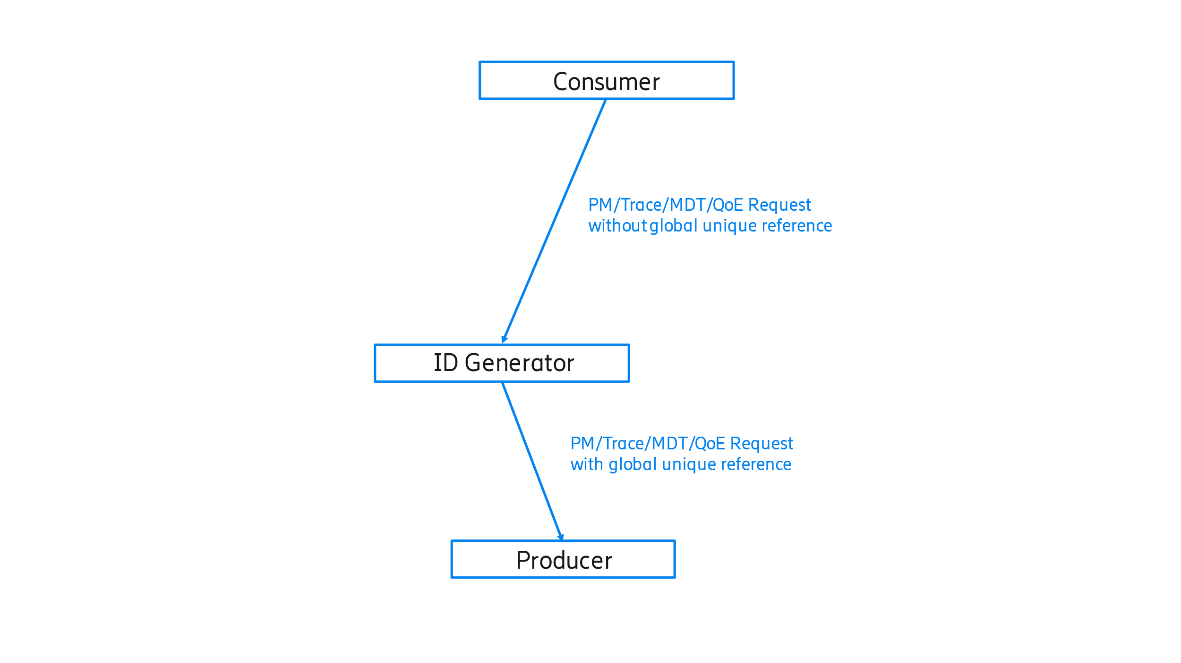Figure 6.2.1-1 example one of PM/Trace/MDT/QoE with ID generator

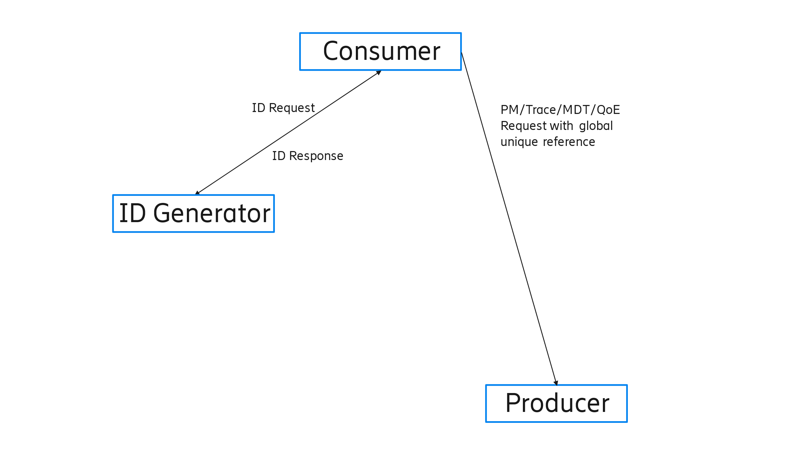 Figure 6.2.1-2 example two of PM/Trace/MDT/QoE with generator

## 6.3 Potential solution #3: Reduce redundantSubscriptions by subscription aggregation function

### 6.3.1 Description

As discussed in clause 5.2, the traffic node needs to support a limitation of a maximum number of a specific PM/Trace/MDT/QoE measurement.

One solution, for use case 2 defined in clause 5.2, which could reduce the number of subscription requests is to introduce a new aggregation function by enhancement of the existing subscription service.

At PM/Trace/MDT/QoE activation, all requests are going to be sent to this subscription aggregation function. Upon receiving the activation request, it checks if this new subscription request can be aggregated into existing subscription(s), or a new activation is needed. If aggregation is possible, a subscription updating request will be created and sent to the data producer. Otherwise, a new subscription activation request is created.

In both above use cases, the reporting address may be changed if report data privacy is a concern. When report is received, the subscription aggregation function needs to split the report information based on the original request and distribute the split PM/Trace/MDT/QoE report to multiple consumers. The details of reporting needs FFS.

## 6.4 Potential solution #4: Reduce redundantSubscriptions with a measurement scope indicator

### 6.4.1 Description

As discussed in clause 5.2, the traffic node needs to support a limitation of a maximum number of a specific PM/Trace/MDT/QoE measurement.

One solution, for use case 2 defined in clause 5.2, is to reduce the number of subscriptions at measurement activations is that the consumer could provide a measurement scope indicator which specifies how the measurements are expected to be done.

When more than one measurement is configured in one activation request, the consumer may inform the producer of the expectation of the requested measurements, with following measurement scope indicator in the Activation Request message:

* Best effort: the producer should provide the requested measurements as much as it can.
* AllNeeded: the producer should provide all requested measurements configured in the activation request.

This indication provides more clear requirements in the subscription that the producer could make a choice to activate a minimum set of the requested measurements based on the resource conditions. If the producer is not able to produce the mandatory measurements, the job can be rejected.

This indication avoids the situation that a producer only can provide part of the requested measurements due to a reason, but the consumer is expecting the full set of measurements for data analytic.

Examples:

Example A: a consumer needs to perform a data analytic which is based on 5 measurements result. If only part of the measurements result is provided, the data analytic cannot be completed. Meaning providing part of the requested measurements result will only waste the producer resource. In this case, the consumer can provide a measurement scope indicator with value 'AllNeeded' in the activation request message. Upon receiving the activation request, if the producer cannot provide all 5 measurements due to a reason, e.g. resource limitation, it may reject the activation request.

## 6.5 Potential solution #5: Enhancement on trace failure notification and administrative messages

### 6.5.1 Description

As discussed in clause 5.2, the traffic node needs to support a limitation of a maximum number of a specific PM/Trace/MDT/QoE measurement.

One solution, for use case 2 defined in clause 5.2, is to allow the producer to report a measurement failure and notify the management system or consumer with a reason. In TS 32.422 [3], a Trace failure notification and administrative messages are specified for that purpose. Both the message and procedure are limited to Trace. It can be specified for MDT/QoE as well. It needs to be enhanced and enabled for Trace/MDT/QoE.

# 7 Conclusions and recommendations

## 7.1 Conclusions

The following issues are identified in the present document so far:

- The identity used in a measurement job needs to be globally unique between consumers and producers. The following potential solutions are studied.

- Defining a globally unique Collection Id, refer to subclause 6.1

- Defining a Job identity generator, refer to subclause 6.2

- The traffic node needs to support a limitation of a maximum number of a specific PM/Trace/MDT/QoE measurement.

- Defining a subscription aggregation function, refer to subclause 6.3

- Defining a measurement scope indicator, refer to subclause 6.4

- Enhancement on trace failure notification and administrative messages, refer to subclause 6.5

## 7.2 Recommendations

The following potential solutions are not recommended for normative work in this release:

* Job identity generator for generating a globally unique reference identity, referring to subclause 6.2;
* Defining a subscription aggregation function to avoid duplicated or overlapped subscription, referring to subclause 6.3.

Normative work could be started in this release for the following potential solutions:

- Defining a globally unique Collection Id, referring to subclause 6.1

- Defining a measurement scope indicator, referring to subclause 6.4

- Enhancement on trace failure notification and administrative messages, referring to subclause 6.5

The above normative work may require Network Resource Model enhancement in TS 28.622[2]/TS 28.623[4]/TS 28.532 [5], and enhancements in Trace specifications TS 32.421[6]/TS 32.422[7]/TS 32.423[8], and the QoE specifications TS 28.404 [9]/TS 28.405 [10], and review stage 1 requirements in Performance Management TS 28.550 [11], review stage 1 requirements in Management capabilities TS28.537[12]:

- Update TraceJob IOC with globally unique Trace Reference.

- Update PerfMetricJob IOC with globally unique Job ID.

- Update QMCJob IOC with globally unique QoE Reference.

- Update TraceJob IOC with measurement scope indicator.

- Update PerfMetricJob IOC with measurement scope indicator.

- Update QMCJob IOC with measurement scope indicator.

- Add measurement scope indicator procedure for Trace/PM/MDT/QoE

- Enhance the Trace failure notification message and administrative messages for Trace/PM/MDT/QoE.

The detail of the solution is discussed during the normative phase.

Annex A (informative):  
Change history

|  |  |  |  |  |  |  |  |  |
| --- | --- | --- | --- | --- | --- | --- | --- | --- |
| **Change history** | | | | | | | | |
| **Date** | **Meeting** | **TDoc** | **CR** | **Rev** | **Cat** | **Subject/Comment** | **New version** |
| 2024-04 |  |  |  |  |  | Initial skeleton | 0.0.0 |
| 2024-04 | SA5#154 | S5-241794 |  |  |  | pCR TR 28.873 Add structure for data management regarding subscriptions and reporting | 0.1.0 |
| 2024-04 | SA5#154 | S5-242093 |  |  |  | pCR TR 28.873 Add introduction for data management regarding subscriptions and reporting | 0.1.0 |
| 2024-04 | SA5#154 | S5-242094 |  |  |  | pCR TR 28.873 Add scope for data management regarding subscriptions and reporting | 0.1.0 |
| 2024-04 | SA5#154 | S5-242095 |  |  |  | pCR TR 28.873 Redundant Trace/MDT Subscriptions Use Case | 0.1.0 |
| 2024-04 | SA5#154 | S5-242096 |  |  |  | pCR TR 28.873 Unique Trace/MDT/QoE Identity | 0.1.0 |
| 2024-05 | SA5#155 | S5-243229 |  |  |  | pCR TR 28.873 globally unique collectionId | 0.2.0 |
| 2024-05 | SA5#155 | S5-243230 |  |  |  | pCR TR 28.873 Job identity generator between producer and consumer | 0.2.0 |
| 2024-05 | SA5#155 | S5-243231 |  |  |  | pCR TR 28.873 Reduce redundant Subscriptions by adding a subscription aggregation MnS | 0.2.0 |
| 2024-05 | SA5#155 | S5-243232 |  |  |  | pCR TR 28.873 Reduce redundant Subscriptions with a measurement scope indicator | 0.2.0 |
| 2024-05 | SA5#155 | S5-243233 |  |  |  | pCR 28.873-010 Add concepts and background | 0.2.0 |
| 2024-08 | SA5#156 | S5-244744 |  |  |  | pCR TR 28.873 trace failure notification and administrative messages | 0.3.0 |
| 2024-08 | SA5#156 | S5-244745 |  |  |  | pCR TR 28.873 conclusions and recommendations | 0.3.0 |
| 2024-09 | SA#105 | SP-241133 |  |  |  | After editHelp cleanup and presented at SA#105 for Information and Approval | 1.0.0 |
| 2024-09 | SA#105 | - | - | - | - | MCC editorial update for publication after TSG SA#105 approval | 19.0.0 |
| 2024-12 | SA#106 | SP-241666 | 0001 | 1 | F | Rel-19 CR 28.873_1900 Remove normative text from the TR | 19.1.0 |