3GPP TSG-SA5 Meeting #148e S5-233528
Electronic meeting, Online, 17 -25 April 2023

Source: Nokia, Nokia Shanghai Bell, Microsoft

Title: Add key issue on enhancing the description of management data

Document for: Approval
Agenda Item: 6.8.8.1

1 Decision/action requested
In this box give a very clear / short /concise statement of what is wanted.

2 References
(Reference - in list form - should be made to previous related SA5/3GPP/etc. documents.)
(For changes against a draft TS/TR, a pseudo CR - a.k.a. pCR - will be provided using this Tdoc template. In this case, the number, name and version of the draft TS/TR used as base must be provided and the version must be the latest available version of the draft TS/TR.)
[1] 3GPP TR 28.842: "Study of data management phase 2"

3 Rationale
This pCR proposes a new key issue to [1] to describe management data, especially PM data, in more detail (e.g. available granularity periods, available time in history, aggregation across elements or areas) in order to allow management producers to register the details of the data they are able to produce.

4 Detailed proposal
First modification

2 References
The following documents contain provisions which, through reference in this text, constitute provisions of the present document.
- References are either specific (identified by date of publication, edition number, version number, etc.) or non-specific.
- For a specific reference, subsequent revisions do not apply.
- For a non-specific reference, the latest version applies. In the case of a reference to a 3GPP document (including a GSM document), a non-specific reference implicitly refers to the latest version of that document in the same Release as the present document.
[1] 3GPP TR 21.905: "Vocabulary for 3GPP Specifications".
[2] 3GPP TS 28.622 Generic Network Resource Model
[3] 3GPP TS 28.533 Architecture framework
[4] 3GPP TS 28.550 Performance assurance
Next modification

4.x Key issue#x: Describe management data in more detail

4.x.1 Description
Currently the management system offers a MnS consumer to control the collection of PM by the following means:
- The MnsRegistry [2] offers the MnS consumer means to find the address of MnS producers. This discovery is based on the MnSInfo by the criteria: mnsLabel, mnsType, mnsVersion, and mnsScope.
- Subnetwork, ManagedFunction, ManagedElement, and EP_RP are offering the attribute supportedPerfmetricGroups to inform the MnS consumer about the PM data the MnS producer is able to provide, including the possible granularity periods and reporting methods [2].
- MnS producer offers to create instances of IOC PerfMetricJob [2].
  - The MnS producer offers to use the administrave state to stop and resume an existing PerfMetricJob.
  - The MnS producer will indicate the creation or modification of a PerfMetricJob as failed in case the consumer requests attribute values that the producer is not able to handle.
- MnS producer offers to create instances of IOC ManagementDataCollection [2] and create/stop/listMeasurementJob [5].

Any realistic management system of a mobile network is composed of many management functions (including the management functions implemented at the NF), representing the mobile network with different level of abstraction and working at different scope in time, e.g. as depicted in clause 4.5 and A.6 of [3]. These management functions are able to exchange PM data between each other: Each management function is able to:
- Receive management data from MnS producers
- Perform internally e.g. aggregation, filtering, KPI calculation, storing.
- Providing management data to other MnS consumers.

Editors note: For easier reference a copy of Figure A.6.1 from [3]:
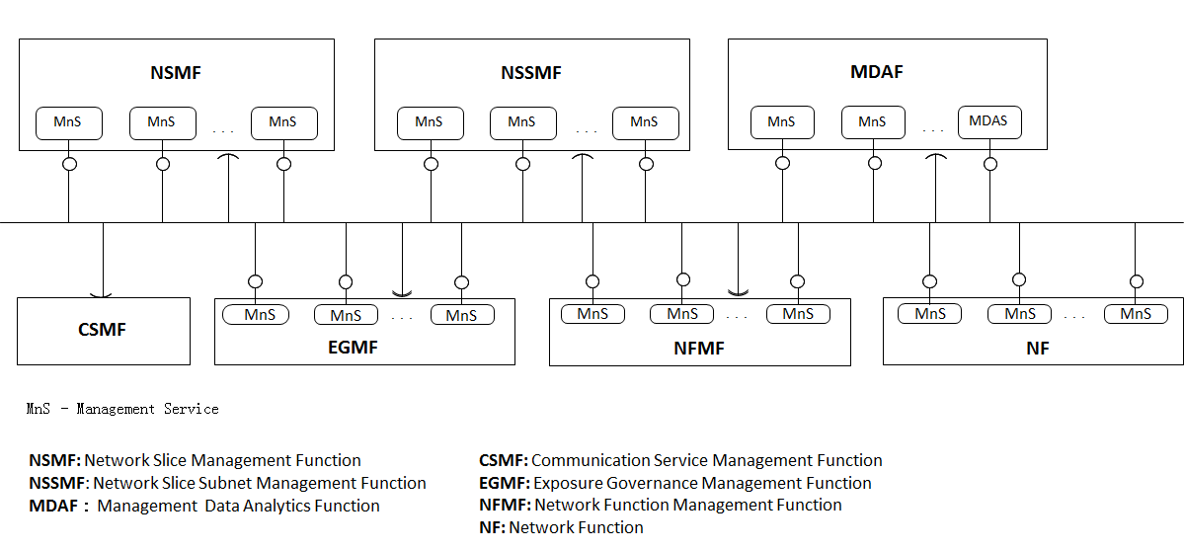
Figure A.6.1: Example of functional management architecture
End of editors note.

As a consequence, management data representing the same counter (or KPI) related to the same network function and same point of time might be available at different management functions (otherwise we would not need interfaces at all). In turn, all these management functions might offer these management data to other MnS consumers again.
In an exemplified, yet realistic overall management system we might face the following situation:
- The MnS producers implemented at the network elements are able to provide actual counters with granularity period 15 min in real-time, i.e. as soon as a granularity period is over, the MnS producer at the network element sends a specific management data to its MnS consumer(s).
- The corresponding element/domain management systems might be able to provide the same management data for the same objects in real time with a granulatity period of 15min.
- Further, the element/domain management systems might be able to store a two week history of the same counter.
- A central PM data warehouse might be able to provide a history of the same counters
  - with a granularity period of 15 min for the last year and with a re-calculated granularity period of 1h, 6h, and 12h for the last 2 years.
  - aggregated across all cells of a base station or aggregated across all cells of a set of base stations, with granularity periods 15 min 1h, 6h, and 12h for the last 2 years.
- A central MDA function might offer predictions of the same counter for one week in the future, every 15min.

4.x.2 Observations
The mechanism offered by MnS Registry [1] does not offer to find MnS that provide specific management data.
To find MnS producers that offer the production of specific management data the potential MnS consumer needs to visit all MnS offered by the MnS Registry and that cover the scope in order to query all relevant objects for their supportedPerfmetricGroups [1]. This cumbersome pull mechanism only works to control the collection of management data, i.e. to control how network elements are collecting and reporting data close to real time and to transfer these data through the 3GPP management system.
The current mechanisms are not able to handle situations where data for e.g. the same counter is available at multiple MnS producers, while the different MnS producers offer different scopes of times like real-time values (i.e. as soon as measured in the network), historic values, or predicted values for some future point of time.
Neither is a MnS producer able to register its capabilities to produce a specific management data for a specific scope of time, nor is a MnS consumer able to discover a MnS producer according to the different scopes in time.
The current mechanisms of controlling MnS producers do not allow a MnS consumer to request historical management data according to specific aspects like point of time, granularity period, aggregation across elements or areas.

4.x.3 Problem statement
Currently the 3GPP specifications do not offer a formal, machine readable description of management data to allow producers of management data to inform consumers about the availability of such capabilities, to enable potential consumers of management data to find producers of corresponding management data, nor to enable consumer to request specific management data, especially historical management data.
The target therefore is to define a formal description of management data to cover the different aspects of management data in order to describe PM data in more detail (e.g. available granularity periods, available time in history, aggregation in time or across elements or areas) in order to allow MnS producers to register the details of the data they are able to produce, MnS consumers to find the MnS producer that offers the specific management data, and to allow the MnS consumer to request and get the management data from the MnS producer.
End of modifications

