3GPP TSG-SA5 Meeting #148e S5-233517rev2
Electronic meeting, Online, 17 -25 April 2023

Source: CATT,Huawei

Title: pCR 28.841 Editorial clean-up

Document for: Approval

Agenda Item: 6.8.7.1

1 Decision/action requested
The group is asked to discuss and approval.

2 References
[1] TR 28.841 " Study on Management Aspects of IoT NTN Enhancements v0.4.0".

3 Rationale
The current version of the draft TR 28.841[1] contains several editorial errors.

4 Detailed proposal
It is proposed to introduce the following content in the draft TR 28.841[1].

1st Change

2 References
The following documents contain provisions which, through reference in this text, constitute provisions of the present document.
- References are either specific (identified by date of publication, edition number, version number, etc.) or non-specific.
- For a specific reference, subsequent revisions do not apply.
- For a non-specific reference, the latest version applies. In the case of a reference to a 3GPP document (including a GSM document), a non-specific reference implicitly refers to the latest version of that document in the same Release as the present document.
[1] 3GPP TR 21.905: "Vocabulary for 3GPP Specifications".
[2] 3GPP TS 36.300: " Evolved Universal Terrestrial Radio Access (E-UTRA) and Evolved Universal Terrestrial Radio Access Network (E-UTRAN); Overall description; Stage 2".
[3] 3GPP TS 38.300: " NR; NR and NG-RAN Overall description; Stage-2 ".
[4] 3GPP TR 28.808: "Study on management and orchestration aspects of integrated satellite components in a 5G network".
[5] 3GPP TS 23.401: "General Packet Radio Service (GPRS) enhancements for Evolved Universal Terrestrial Radio Access Network (E-UTRAN) access".
[6] 3GPP TS 36.331: "Evolved Universal Terrestrial Radio Access (E-UTRA); Radio Resource Control (RRC); Protocol specification".
[7] 3GPP TS 36.304: "Evolved Universal Terrestrial Radio Access (E-UTRA); User Equipment (UE) procedures in idle mode"
[8] 3GPP TR 38.821: " Solutions for NR to support non-terrestrial networks (NTN) ".
[9] 3GPP TS 28.313: "Self-Organizing Networks (SON) for 5G networks".
[10] 3GPP TS 28.552: "Management and orchestration; 5G performance measurements".

2nd Change

3 Definitions of terms, symbols and abbreviations

3.1 Terms
For the purposes of the present document, the terms given in 3GPP TR 21.905 [1] and the following apply. A term defined in the present document takes precedence over the definition of the same term, if any, in 3GPP TR 21.905 [1].
example: text used to clarify abstract rules by applying them literally.

3.2 Symbols
For the purposes of the present document, the following symbols apply:
<symbol> <Explanation>

3.3 Abbreviations
For the purposes of the present document, the abbreviations given in 3GPP TR 21.905 [1] and the following apply. An abbreviation defined in the present document takes precedence over the definition of the same abbreviation, if any, in 3GPP TR 21.905 [1].
AN Access Network
BL Bandwidth reduced Low complexity
5GC 5G Core Network
CN Core Network
eMTC enhanced Machine-Type Communication
GEO Geostationary satellites
gNB generic Node B
gNB-CU gNB-Central Unit
gNB-DU gNB-Distributed Unit
HARQ Hybrid Automatic Repeat Request
HEO Highly-Eccentric Orbiting satellites
LEO Low-Earth Orbiting satellites
IoT Internet of Things
MEO Medium-Earth Orbiting satellites

NGSO Non-geostationary Orbiting satellites
NOP Network Operator
NS Network Slice
NSI Network Slice Instance
NSSI Network Slice Subnet Instance
SON Self-organized network
QoS Quality of Service
RAN Radio Access Network
RAT Radio Access Technology
RU Radio Unit

Next Change

4 Concepts and background

4.1 Reference management architecture for integrated satellite components

4.1.1 Management architecture #1 for integrated satellite NBIoT/LTE-M RAT
The reference architecture (according to TS 36.300[2] and TS 38.300[3]) depicted in figure 4.1.1 below considers the case of a 3GPP RAN integrating a satellite NBIoT/LTE-M RAT, possibly together with a Terrestrial RAT. The NOP operates the 5G network interfacing through API's with Communication Service Customers or Verticals on the one hand and delivers services to UEs on the other hand. The 3GPP Management system manages the 3GPP RAN aspect.
Figure 4.1.1: Reference architecture #1 for the management of a satellite NBIoT/LTE-M RAT

4.1.2 Management architecture #2 for integrated satellite NBIoT/LTE-M RAT and satellite NR-RAT
The reference architecture (according to TS 36.300[2] and TS 38.300[3]) depicted in figure 4.1.2 considers another case of a 3GPP RAN integrating a satellite NBIoT/LTE-M RAT, possibly together with a Terrestrial RAT and a satellite NR-RAT. The NOP operates the 5G network interfacing through API's with Communication Service Customers or Verticals on the one hand and delivers services to UEs on the other hand. The 3GPP Management system manages the 3GPP RAN aspect.
Figure 4.1.2: Reference architecture #2 for the management of a satellite NBIoT/LTE-M RAT and satellite NR-RAT

4.1.3 Management architecture #3 for integrated non-3GPP satellite RAN
The reference architecture depicted in figure 4.1.3 considers the case of a non-3GPP satellite RAN integrated in an EPS/5GS. The NOP operates the 5G network interfacing through API's with Communication Service Customers or Verticals on the one hand and delivers services to UEs on the other hand. The 3GPP management system manages the 3GPP RAN and the non-3GPP RAN.
Figure 4.1.3: Reference architecture for the management of a non-3GPP satellite RAN

4.2 Architecture Scenarios for integrated satellite components

4.2.1 scenario #1: A 3GPP network with access networks and terrestrial access networks
In this scenario, a 3GPP network is composed of a 3GPP core network, a satellite IoT 3GPP access network, a satellite NR 3GPP access network and a terrestrial 3GPP access network, where the satellite component is also integrated as a 3GPP access network. The satellite IoT network, satellite NR network and the terrestrial network share the same PLMN and access networks are managed by the same 3GPP management system. This architecture scenario follows the Satellite access class scenario in clause 4.2.2 from 3GPP TR 28.808[4] .
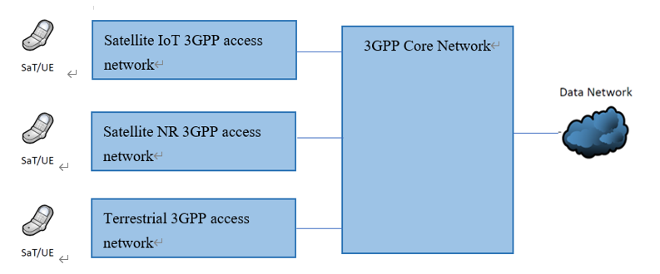
Figure 4.2.1: Architecture of 3GPP network with a satellite IoT 3GPP access network, a satellite NR 3GPP access network and a satellite NR 3GPP access network
Note: All access networks are in the same management domain.

4.2.2 scenario #2: Satellite enabled 3GPP network as a roaming network for terrestrial network operators
In this scenario, consider two separate 3GPP networks, one 3GPP network with a satellite IoT access network and satellite NR access network, another 3GPP network with a terrestrial access network. Both networks have their own PLMN ID and have a roaming agreement in place with each other. Roaming is used by the terrestrial operator to use the 3GPP network with a satellite access. Both the satellite and terrestrial networks have their own separate 3GPP management domain. This architecture scenario follows the Satellite access class scenario in clause 4.2.1 from 3GPP TR 28.808[4].

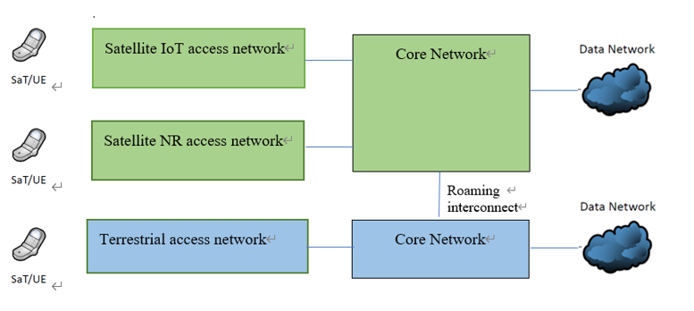
Figure 4.2.2: Architecture of satellite 3GPP network (green)
as roaming network to a terrestrial 3GPP network (blue)
NOTE: The green and blue networks are separate management domains.

Next Change

5.3.1.1 Solution #1: Prevent PCI conflicts, PCI confusion and continuous NCR-reconfigurations by using SON functions
Satellite RAN can be comprised out of either LEO, MEO, GEO satellites or a combination of these three. LEO and MEO satellites do not have a fixed position relative to the earth and travel at high speed in trajectories around the earth. The possible satellite beam coverage area may therefore change in a continuous fashion, as can also be seen in Figure 5.3.1.1. This is also described in more detail in clause A.2.
A LEO, MEO or GEO satellite can either be working in transparent mode or in regenerative mode. When a satellite is configured in transparent mode, no data processing will be done locally in the satellite. The incoming signal will be received, amplified, and transmitted back to earth. A regenerative satellite may actually demodulate/decode and process the incoming signal before sending data back to earth. A regenerative satellite may therefore embark a eNB/gNB/gNB-DU/gNB-CU and use inter satellite links to communicate with other satellite eNB/gNBs. A transparent satellite may be coupled to a eNB/gNB which is located on earth, this eNB/gNB will use a satellite gateway to transmit to the satellite which reflects the signal back to earth.
In case of MEO and LEO satellites with moving beams the cell coverage may not be fixed to a specific location on earth, and since the possible coverage area of a satellite may even span multiple countries, it would be possible that the neighbouring (terrestrial) cells of the satellite eNB/gNB will change continuously. This may result in continuous NCR reconfigurations and PCI conflicts and/or PCI confusion since the NTN cell coverage may overlap with terrestrial RAN. This effect is also described in clause 8.5.3 from TR 38.821 [8].

Figure 5.3.1.1: Example of a MEO or LEO satellite flying over multiple geographical areas. Here it is assumed that the TAC will be fixed on earth.
To prevent these issues, it would be possible to use/extent the SON ANR and SON PCI re-configuration functions from TS 28.313 [9] and adapt these to support continuously moving cells. This way, the PCI re-configuration procedure may deconflict PCI's when an PCI conflict happens between an NTN cell and a terrestrial cell. The ANR could be used to automatically configure new neighbouring cells when the NTN cell coverage moves over the earth atmosphere. The SON ANR and SON PCI functions should be fast enough to keep up with the moving satellites which may have new neighbouring cells every 5 - 30 seconds.
In case of GEO satellites or MEO and LEO satellites with earth fixed beams, there is no need to adapt the SON ANR and SON PCI re-configuration functions since the coverage area of the satellite RAN will be fixed to a geographical area on earth's surface.

End of changes

