**3GPP TSG-SA5 Meeting #148e *S5-233479rev1***

Electronic meeting, Online, 17 -25 April 2023

**Source: Huawei**

**Title: pCR TR 28.925 update the example for management function deployment scenarios**

**Document for: Approval**

**Agenda Item: 6.8.1.5**

# 1 Decision/action requested

***Discuss and approve on the proposal.***

# 2 References

[1] 3GPP TR 28.925 enhancement of service-based management architecture v0.a.0

# 3 Rationale

The existing IOCs listed in Table 4.8.1-2 is used to represent MnFs to be managed. Fault management and performance management are traditional management features which should also be included as example. This contribution proposes to add fault management and performance management related MnF to be managed.

# 4 Detailed proposal

This document proposes the following changes in TR 28.925 [1].

|  |
| --- |
| **1st Change** |

## 4.8 Issue #8: Use of Models in SBMA

### 4.8.1 Description

**The following existing concepts are related to SBMA:**

* TS 28.533 Management Function: A Management Function (MnF) is a logical entity playing the roles of MnS consumer and/or MnS producer. Management Function can be deployed as a separate entity or embedded in Network Function to provide MnS(s).

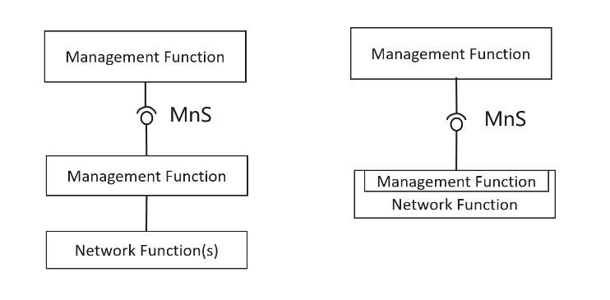

Figure 4.8-1: Examples of MnS deployment scenario

* TR 21.905 Network Element: A discrete telecommunications entity which can be managed over a specific interface e.g. the RNC.
* TS 28.533 / TS 23.501 Network Function: A 3GPP adopted or 3GPP defined processing function in a network, which has defined functional behaviour and 3GPP defined interfaces.

**The following IOCs are specified to represent Network Element and Network Function:**

* TS 28.622 ManagedElement IOC: This IOC represents telecommunications equipment or TMN entities within the telecommunications network providing support and/or service to the subscriber. A ManagedElement IOC is used to represent a Network Element defined in TS 32.101[1] including virtualization or non-virtualization scenario.
* TS 28.622 ManagedFunction IOC: This IOC is provided for sub-classing only. It provides attribute(s) that are common to functional IOCs. Note that a ManagedElement may contain several managed functions, a managed function may contain other managed functions as specified for the specific subclass. This IOC can represent a telecommunication function either realized by software running on dedicated hardware or realized by software running on NFVI.

**The following IOCs as specified in TS 28.622 are used to represent Management Function provided by MnS Producer:**

* TS 28.622 MnsAgent IOC: The MnsAgent represents the MnS producers, incl. the supporting hardware and software, available for a certain management scope that is related to the object name-containing the MnS Agent.
* TS 28.622 ManagementNode IOC: This IOC represents a telecommunications management system (EM) within the TMN that contains functionality for managing a number of ManagedElements (MEs). (Note: This description is to be updated to replace use of EM)

### 4.8.2 Potential solutions

This clause provides the description of using NRM to represent management of management function, network function, and network element.

Management Function could be deployed in following different deployment scenarios:

* The Management Function can be deployed in management system, including
  + The Management Function deployed in domain management system.
  + The Management Function deployed in cross domain management system.
* The Management Function deployed in Network Element.

From the three deployment scenarios of Management Functions above. Management Functions deployed in domain management system and Management Function deployed in Network Element need to be managed as managing network node in 3GPP management system. The way of managing the Management Function are modelled in corresponding management function IOC.

ManagementNode IOC represents a telecommunications management system within the TMN provided by vendor that contains management functionalities for managing a number of ManagedElements (MEs).

The Management Functions are managed by corresponding management function IOC as defined in TS 28.541, TS 28.104, TS 28.105 and TS 28.536 and TS 28.622:

* IOC for Management of D-SON function:
* D-SON of ANR in TS 28.541 DANRManagementFunction IOC
* D-SON Energy Saving (ES) functions in TS 28.541 DESManagementFunction IOC
* D-SON RACH functions in TS 28.541 DRACHOptimizationFunction,
* D-SON MRO functions in TS 28.541 DMROFunction,
* D-SON PCI Configuration functions in TS 28.541 DPCIConfigurationFunction,
* D-SON LBO functions in TS 28.541 DLBOFunction,
* IOC for Management of management functions:
* EM centralized SON Energy Saving (ES) functions in TS 28.541 CESManagementFunction IOC
* EM centralized-SON PCI Configuration functions in TS 28.541 CPCIConfigurationFunction,
* EM centralized-SON CCO functions in TS 28.541 CCOFunction
* MDAFunction in TS 28.104
* MLTrainingFunction in TS 28.105
* AssuranceClosedControlLoop in TS 28.536
* ThresholdMonitor representing a threshold monitor for threshold monitoring control in TS 28.622
* PerfMetricJob representing a performance metric production job for PM control in TS 28.622
* AlarmList representing the capability to store and manage alarm records for FM control in TS 28.622

If NRM IOCs which represent ManagementFunction(MnF) have been modelled, the corresponding MnF should be managed.

The following table captures the relation between the concepts and related models**:**

Table 4.8.1-1 Relation between the concepts and related models

|  |  |
| --- | --- |
| **Concepts** | **Illustration of Related Management Models** |
| TS 28.622 ManagementNode | A telecommunications management system within the TMN provided by vendor that contains management functionalities for managing a number of ManagedElements (MEs) are represented by ManagementNode IOC defined in TS 28.622, and a number of management functions. |
| TS 28.533 Management Function | The corresponding XXXManagementFunction IOC is used to support the managing of XXXMnF. |
| TR 21.905 Network Element | A network element is represented by ManagedElement IOC defined in TS 28.622. |
| TS 28.533 / TS 23.501 Network Function | A Network function is represented by ManagedFunction IOC defined in TS 28.622. |

It’s recommended the followingIOCs which could be used to represent MnFs to be managed. The modelling is not changed for existing functions to keep the backward compatibility.

Table 4.8.1-2 IOCs which could be used to represent MnFs to be managed

|  |  |  |  |
| --- | --- | --- | --- |
| **TS** | **IOC** | **Inheritant from** | **Contained by** |
| TS 28.541 | 1. CPCIConfigurationFunction 2. CESManagementFunction 3. CCOFunction | Top | 1. ManagedEntity(SubNetwork/ManagedElement/NRCellDU/ManagementNode) 2. ManagedEntity(SubNetwork/ManagedElement/NRCellCU/ManagementNode) 3. SubNetwork/ManagementNode |
| TS 28.104 | MDAFunction | ManagedFunction | MDAEntity (SubNetwork/ManagedElement/ManagedFunction/ManagementNode) |
| TR 28.105 | MLTrainingFunction | ManagedFunction | ManagedEntity(Subnetwork/ManagedElement/ManagementFunction/ManagementNode) |
| TS 28.536 | AssuranceClosedControlLoop | Top | SubNetwork/ManagedElement/ManagementNode |

Editors’ Note: whether the MnFs to be managed IOCs are needed to be inherited from a same root IOC is FFS.

The ManagementFunction IOCs listed in Table 4.8-2 can be used to support different deployment scenarios based on which managed entity contain such Management Function IOCs. For example, following Figure 4.8.2-1 is one example for management function model, in which all ManagementFunction IOCs (i.e. MDAFunction, AIMLtrainingFunction, AssuranceClosedControlLoop, CESManagementFunctuion, CCOFunctuion, CPCIConfigurationFunction, ThresholdMonitor, PerfMetricJob and AlarmList) are contained by SubNetwork. The ManagedElement IOC is included in the Figure 4.8.2-1to show the dependency between Management Function and Managed Element under a Subnetwork.

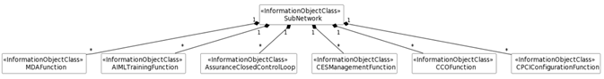



Figure 4.8.2-1 An example of management function model

Above example for management function model can be used to support following deployment scenario for management function, see Figure 4.8.2-2. In this deployment scenario example, RAN network management provides the following management capabilities (including MDA capabilities, ML Training capabilities, AssuranceClosedControlLoop capabilities, CESManagement capabilities, CCO capabilities, CPCIConfiguration capabilities, Threshold Monitoring control capabilities, PM control capabilities and FM control capabilities).

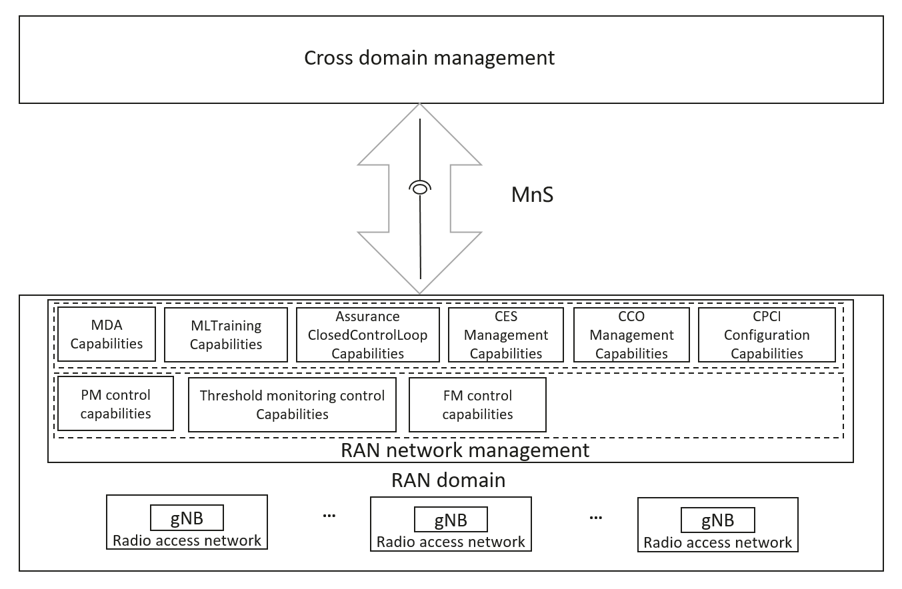

Figure 4.8.2-2 An example of deployment scenario for management function contained by SubNetwork

The ManagementFunctions in management function model in Figure 4.8.2-1 provides the capabilities to allow cross domain management to control these management capabilities via corresponding MnSs. See below:

* + MDAFunction is used to represent MDA capabilities in RAN network management.
  + AIMLtrainingFunction is used to represent AIMLTraining capabilities in RAN network management.
  + AssuranceClosedControlLoop is used to represent AssuranceClosedControlLoop capabilities in RAN network management.
  + CESManagementFunctuion is used to represent CESManagement capabilities in RAN network management.
  + CCOFunctuion is used to represent CCO capabilities in RAN network management.
  + CPCIConfigurationFunction is used to represent CPCIConfiguration capabilities in RAN network management.
  + Threshold monitoring control is used to represent Threshold monitoring control capabilities in RAN network management.
  + PM control is used to represent PM control capabilities in RAN network management.
  + FM control is used to represent FM control capabilities in RAN network management.

A management function is a logical entity playing the roles of MnS consumer and/or MnS producer (see TS 28.533). The management function may consume multiple management services from one or multiple MnS producers. A management function within a domain management can take the role of provisioning MnS producer, performance MnS producer to manage those managed object(s) defined NRM IOC as described in TS 28.622 and TS 28.541. The management function that provides assurance management capability can hold the AssuranceClosedControlLoop IOC and its parameters. The changes to assurance closed control loop should be provided to management functions that constitute the closed control loop (e.g. changing data sources, KPIs being calculated, models, policies, etc.) (see Figure 4.2.5.1 in TS 28.535).

The example for management function model can be used to support following deployment scenario for provisioning management, performance management, fault management, assurance management and other relevant management capabilities is shown in Figure 4.8.2-x.

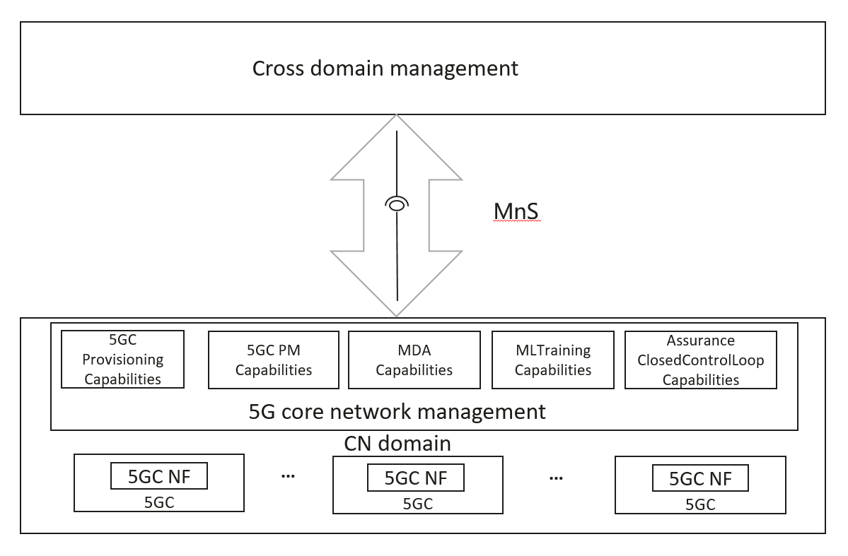

Figure 4.8.2-x An example of deployment scenario for management function for 5GC network

The ManagementFunctions in management function model in Figure 4.8.2-x provides the capabilities to allow 3GPP management system consume the MnSs provided by these management capabilities. See below:

* + Provisioning MnS and Performance MnS.
  + AssuranceClosedControlLoop is used to represent AssuranceClosedControlLoop capabilities in core network management.
  + MDAFunction is used to represent MDA capabilities in core network management.
  + MLtrainingFunction is used to represent MLTraining capabilities in core network management.

|  |
| --- |
| **End of change** |