3GPP TSG-SA5 Meeting #148e S5-233456
Electronic meeting, Online, 17 -25 April 2023

Source: ZTE Corporation

Title: Add description of network slice subnet instance in clause 4.2

Document for: Approval
Agenda Item: 6.7.4.1

1 Decision/action requested
In this box give a very clear / short /concise statement of what is wanted.

2 References
[1] 3GPP draft TR 28.836: "Telecommunication management; Study on intent-driven management for network slicing v0.4.0".
[2] 3GPP TS 28.312 "Management and orchestration; Intent driven management services for mobile networks v17.0.1"
[3] 3GPP TS 28.530 "Management and orchestration; Concepts, use cases and requirements v17.3.0"
[4] 3GPP TS 28.531 "Management and orchestration; Provisioning v17.6.0"

3 Rationale
In the existing content of TR28.836, the relevant study focus on not only network slice and network slice instance, but also network slice subnet and network slice subnet instance.
In classification of use cases in TS 28.531, a network slice instance and a network slice subnet instance are included, See Table 4.2-1. It is proposed to add the relevant description of “network slice subnet” and “network slice subnet instance” in clause 4.2.

4 Detailed proposal

1st Change

4 Concepts and Overview

4.1 General
Network slicing is one of the key 5G features. The lifecycle of a Network Slice instance can be described by the following: commissioning, operation and decommissioning. Before a NetworkSlice instance can be created there is a preparation phase. The different phases are described in more detail in TS 28.530 [2].
The attributes in ServiceProfile represent the network slice related requirements, and the attributes in SliceProfile represent network slice subnet related requirements. The uses of ServiceProfile and SliceProfile are described in TS 28.531 [3] and TS 28.541 [4].
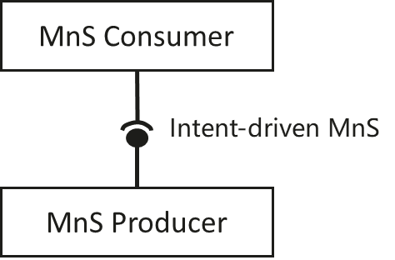
Figure 4.1-1: Intent-driven MnS
In Intent-driven management, the MnS consumer provides its intent to the MnS producer. The producer of an Intent-driven MnS shall allow the consumer to manage the service and / or network resources through the use of intents.

4.2 Classification of use cases in TS 28.531
The use cases for provisioning of a network slice instance and a network slice subnet instance described in TS 28.530 [2] and TS 28.531 [3] are as follows:
- Create a network slice instance;
- Activate a network slice instance;
- De-active a network slice instance;
- Modify a network slice instance;
- Terminate a network slice instance.
- Create a network slice subnet instance;
- Activate a network slice subnet instance;
- De-active a network slice subnet instance;
- Modify a network slice subnet instance;
- Terminate a network slice subnet instance.
The technical specification TS 28.531 [3] describes specification level use cases related to network slice management and network slice subnet management. Table 4.2-1 provides the classification of those use cases related to network slice instance and network slice subnet management capabilities. The detail information about use cases and management capability supporting the use cases are described in TS 28.531 [3].
Table 4.2-1: The classification of use cases in TS 28.531
Clause | Use case | Management capabilities required
5.1.1 | Network slice instance allocation | Provisioning of a network slice
5.1.2 | Network slice instance subnet allocation | Provisioning of a network slice subnet
5.1.3 | Network slice instance deallocation | Provisioning of a network slice
5.1.4 | Network slice subnet instance deallocation | Provisioning of a network slice subnet
5.1.5 | Obtaining network slice subnet instance information | Query information
5.1.6 | Network slice feasibility check | Provisioning of a network slice (subnet)
5.1.7 | Network slice instance activation | Provisioning of a network slice
5.1.8 | Network slice instance deactivation | Provisioning of a network slice
5.1.9 | Network slice instance modification | Modification of a network slice
5.1.10 | Network slice subnet instance activation | Provisioning of a network slice subnet
5.1.11 | Network slice subnet instance deactivation | Provisioning of a network slice subnet
5.1.12 | Network slice subnet instance modification | Modification of a network slice subnet
5.1.13 | Network slice subnet configuration | Modification of a network slice subnet
5.1.14 | Exposure of network slice management data | Query information
5.1.15 | Exposure of network slice management capability | Management capability exposure
5.1.16 | Network slice subnet instance management capability exposure | Management capability exposure

Editor’s Note: the Table 4.2-1 may be updated according to the outcome of release 17 work item eNETSLICE_PRO.

End of changes

