3GPP TSG-SA5 Meeting #148e S5-233388
Electronic meeting, Online, 17 -25 April 2023

Source: ZTE Corporation

Title: Add intent fulfilment feasibility information into intent report

Document for: Approval
Agenda Item: 6.7.3.2

1 Decision/action requested
In this box give a very clear / short /concise statement of what is wanted.

2 References
[1] 3GPP draft TR 28.912: "Management and orchestration; Study on enhanced intent driven management services for mobile networks v1.2.0".
[2] 3GPP TS 28.312 "Management and orchestration; Intent driven management services for mobile networks v17.0.1"

3 Rationale

4 Detailed proposal

1st Change

4.5 Issue#4.5: Intent Report

4.5.1 Description
In TS 28.312 [2], the Fulfilment information (including the intentFulfilmentinfo, expectationfulfilmentInfo and targetfulfilmentInfo) are defined for the MnS consumer to monitor the intent fulfilment information. The intent report also can contain the current and optional predicted value for performance indicated by corresponding expectation targets (e.g. WeakRSRPRatio for the weakRSRPRatioTarget, Average UL RAN UE Throughput for aveULRANUEThptTarget), which can be used by MnS consumer to validate whether the intent is really fulfilled and to evaluate whether the intent (especially for expectation targets) needs to be updated if needed (improve the target value when corresponding target is fulfilled or reduce the target value when corresponding target is not fulfilled or not fulfilled with the reason of target confliction). Besides, intent conflict information and intent fulfilment feasibility check information which send by MnS producer to MnS consumer is another type of intent report information. So, following are the three types of information needs to be monitored by MnS consumer:
- Intent Fulfilment information, which represents the properties of a specific fulfilment information for an aspect of the intent (i.e. either an expectation, a target or the whole intent). The detailed information see clause 6.2.1.3.6 in TS 28.312 [2].
- Achieved values for targets, which represent current performance values for corresponding expectation targets.
- Intent conflict information, which represents conflict type (i.e., intent conflict, expectation conflict and target conflict) and possible solution recommendation to address the conflicts.
- Intent fulfilment feasibility check information, which indicates that the intent is feasible or infeasible. Intent fulfilment feasibility check information is provided after MnS producer automatically performs feasibility check when receive the intent creation and modification request from MnS consumer.
Different MnS consumer may have different requirements for intent report (e.g. Some MnS consumer may want to have corresponding performance value information while others don't want, Different MnS consumer may want to calculate or monitor the performance value in different period).
While the report (with the current performance values for corresponding expectation targets) is provided at the end of each observation period, the consumer may also wish to know whether the fulfilment info was consistent for the entire observation period. For example, the intent expectation may be reported FULFILLED at the end of observation period. However, may be possible that within observation period the intent expectation was NOTFULFILLED. The consumer may wish to know this information. This information can be important for the MnS consumer to understand whether the observation period they specified need an update (e.g shortened) or not. Moreover, it helps the MnS consumer to understand whether their expectation is fulfilled during the entire observation period which also gives transparency to the MnS consumer to update their observation period and/or expectations targets specified in the intent.

REQ-Intent_Driven_MnS_Report-1: The intent driven MnS should have the capability to enable the MnS consumer to request intent report information.
REQ-Intent_Driven_MnS_Report-2: The intent driven MnS should have the capability to enable the MnS consumer to obtain intent report information with current performance value for corresponding expectation targets.
REQ-Intent_Driven_MnS_Report-3: The intent driven MnS should have the capability to enable the MnS consumer to obtain intent report information with intent fulfilment information.
REQ-Intent_Driven_MnS_Report-4: The intent driven MnS should have the capability to enable the MnS consumer to obtain intent report information with intent conflict information.
REQ-Intent_Driven_MnS_Report-5: The intent driven MnS should have the capability to enable the MnS consumer to obtain intent report information with intent fulfilment feasibility check information.
REQ-Intent_Driven_MnS_Report_6: The intent driven MnS should have capability enabling MnS consumer to specify the content of the report.
REQ-Intent_Driven_MnS_Report_7: The intent driven MnS should have capability enabling MnS consumer to configure the frequency of the intent reporting.
REQ-Intent_Driven_MnS_Report_8: The intent driven MnS should allow MnS consumers to receive reports, with different content and intervals.
REQ-Intent_Driven_MnS_Report_9: The intent driven MnS should allow MnS consumer to obtain reports with current values for specified expectation targets.
REQ-Intent_Driven_MnS_Report_10: The intent driven MnS should have capability enabling MnS consumer to obtain intent report information with current context information for corresponding expectation targets.
REQ-Intent_Driven_MnS_Report_11: The intent driven MnS should allow reports to contain information on whether the fulfilment info was consistent throughout the observation period.

2nd Change

4.5.2 Potential solutions

4.5.2.1 Potential solution#1
This solution extends the existing model in 28.312 [2] by adding new attributes to the Intent IOC to indicate what is to be observed, and a new IntentReport IOC to enable the MnS consumer to obtain the intent report information.
The following specific changes would be made:
- Extend the Intent <<IOC>> with the following attributes:
- "reportingPeriod", represents MnS consumer's requirements for the reporting period. The performance value for corresponding Expectation Targets will be reported at the end of each period.
- Introduce the IntentReport <<IOC>> to represent the intent fulfilment information, intent conflict information, intent fulfilment feasibility check information and current performance values for the Expectation Targets in the associated Intent. The MnS consumer can use the "getMOIAttributeValue" operation to query the IntentReport <<IOC>> to obtain the intent report information and/or subscribe the "notifyMOIAttributeValueChanges" notification to obtain the intent report information The IntentReport <<IOC>> includes the following attributes:
- "intentReference", to reference (DN) the associated Intent instance.
- “reportIndicator”, to enable/disable (Boolean) reporting for associated Intent instance
- "intentFulfimentInfo", to represent the fulfilment information for intent, intent expectation and expectation targets. For detailed information see clause 6.2.1.3.6 in TS 28.312[2].
- "intentConflictInfo", to represent the intent conflict information that should be informed to the MnS consumer. For detailed intent conflict information see clause 4.2.2.
- "intentFeasibilityCheckInfo", to represent the intent fulfilment feasibility check information that should be informed to the MnS consumer.
- "TargetAchieveValues", to represent the current performance value for the ExpectationTargets.
- “lastUpdated”, timestamp (DateTime) of latest update
This could result in NRM for Intent Reporting as follows:

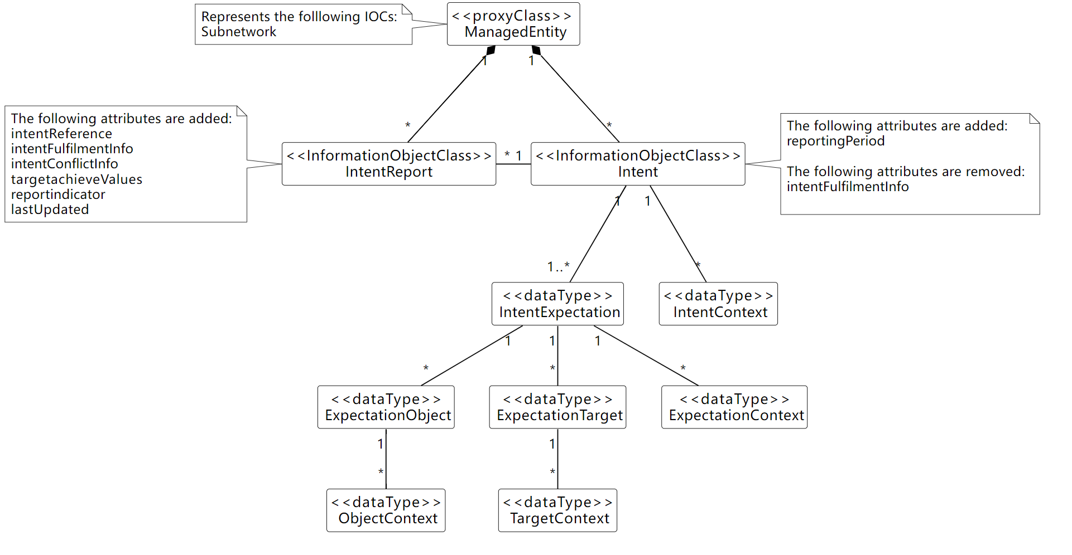
Figure 4.5.2.1-1
Observations on this approach
- Different MnS consumers can query different attributes of IntentReport to obtain corresponding Intent instance report information.
- Different MnS consumers can subscribe to attribute value change notifications for IntentReport <<IOC>> to obtain the notification for different intent report information.
Several benefits are listed below for the solution:
- Separates the intent expectation information (generated by MnS consumer) and intent monitor information (generated by MnS producer).
- MnS consumer can manage Intent instance and IntentReport instances separately.
- Intent <<IOC>> is aligned with intent definition (expectations including requirements, goals and constraints given to a 3GPP system)

4.5.2.2 Potential solution #2
This solution extends the existing model in 28.312 [2] by adding new attributes to the Intent IOC to indicate what is to be observed, and a new IntentReport IOC to report the achieved values.
The following specific changes could be made:
- Extend the IntentExpectation <<dataType>> with the following attribute:
- "observationTime", represents MnS consumer's requirements for the observation period of performance value for corresponding Expectation Targets. The performance value for corresponding Expectation Targets will be observed from the start of each observation period, then at the end of each observation period, the value will be derived and configured
- Introduce the "achieveValue" attribute in the ExpectationTarget to represent the performance value for the ExpectationTarget. Then the MnS consumer can use the "getMOIAttributeValue" operation to query the Intent <<IOC>> to obtain the achieveValue for a given ExpectationTarget.
This could result in NRM for Intent Reporting as follows:

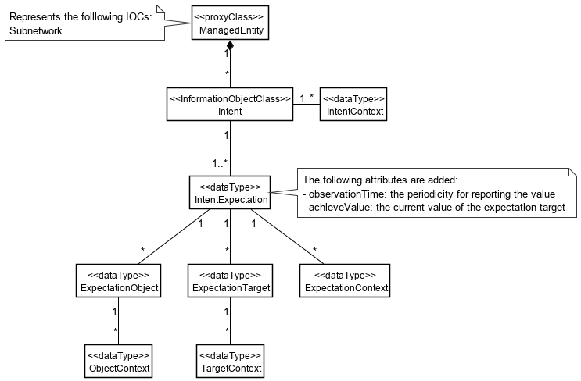
Figure 4.5.2.2-1

The above solution would require, per Intent, that:
  - MnS Consumer configures each IntentExpectation to be reported with ‘observationTime=N’
  - For each period N, MnS Producer reports the achieved value*
  - For every period N, MnS Producer update the achieveValue of each expectation target
  - MnS Consumer queries achieveValue of interested targets
Editor’s Note: would ‘achievedValue’ be current value (per Solution #1, as available in NRM at time of reporting), or some other computed value for the interval. If computed, the definition and format could vary based on which attribute(s) are included.
Observations on this approach:
  - Should avoid mix-and-match of observability
    - For attributes defined in NRM, existing subscription mechanism can be used to monitor updates. E.g. ‘achieveValue’ proposed in this solution
    - For content not defined in NRM, new notifications would need to be defined for the intent content to be reported. E.g. associated PM/KPI
  - The configuration of the report output is contained in the Intent itself.
  - MnS Consumer would need to query (i.e. polling). Notifications would be preferred.
  - Since the observationTime of each IntentExpectation is configured separately, MnS Consumer would need to be aware of how relatively up-to-date each value is.
  - Should use of the term “report” which can be misleading, as there is no ‘report’ object (e.g. NRM, file, stream). This solution is completely notification based.

4.5.2.3 Potential solution #3
This solution would not modify the existing model in 28.312 [2]. A separate IntentReportCtrl IOC is proposed. The IntentReport IOC is used to contain the output of the expectation targets, as well as other status information currently contained in Intent. The latter would be removed to further separate the configuration of the Intent, from the monitoring/reporting of it throughout its lifecycle.

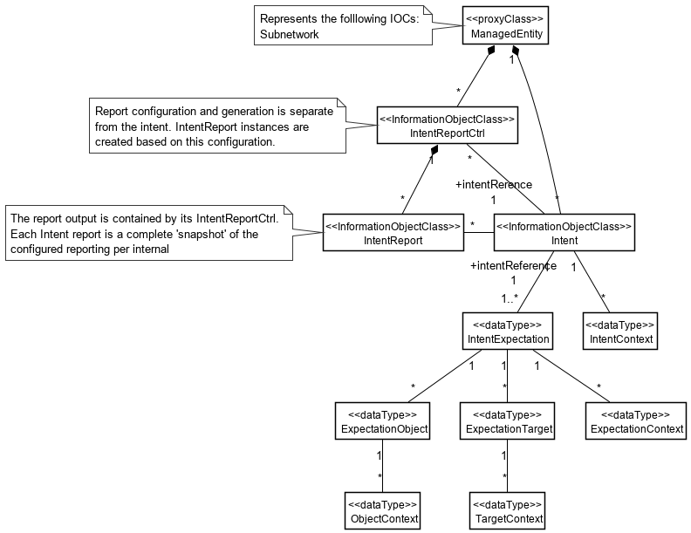
Figure 4.5.2.3-1
The above solution would require, per Intent, that:
  - MnS Consumer configures each IntentReportCtrl with ‘reportingPeriod=N’, and reference ‘intentReference’ to the Intent instance for which the report is to be producer
  - For each period N, MnS Producer generates an IntentReport instance
  - For every period N, MnS Producer ‘snapshots’ the Intent values
  - MnS Consumer receives notification of the new IntentReport instance
Observations on this approach:
  - The configuration of the report output is external to the Intent itself, and supports ability to configure different reports per Intent. The content (i.e. attributes) and reporting intervals can different for each report generated.
  - Each report is a complete ‘snapshot’ of the Intent at time of generation, available in NRM.
  - MnS Consumer does not need to handle different ‘observationIntervals’ per attribute within same Intent.

4.5.2.4 Potential solution #4
This solution does not modify the existing model in 28.312 [2]. A separate IntentReportJob IOC is proposed, along with a file/stream based Intent report similar to other performance reporting.

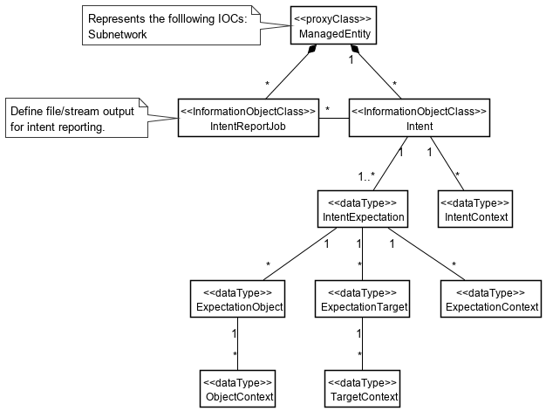
Figure 4.5.2.4-1

The above solution would require, per Intent, that:
  - MnS Consumer configures each IntentReportJob control for file or streaming output, and a reference ‘intentReference’ to the Intent instance for which the report is to be producer
  - For every period N, MnS Producer outputs the report content as configured in the job
    - for file based, MnS Consumer receives notification of the new Intent report file
    - for stream, MnS Consumer receives streaming content
Observations on this approach:
  - This approach is consistent with other performance related reporting
  - Each report should be complete and self-describing, and suitable for offline processing and/or archival
  - A schema will need to be agreed, perhaps based on the existing PM/KPI formats

4.5.2.5 Potential solution #5
This solution would modify the existing model in 28.312 [2] to add configuration of notifications of achieved values. The values to be notified are defined directly in the Intent.

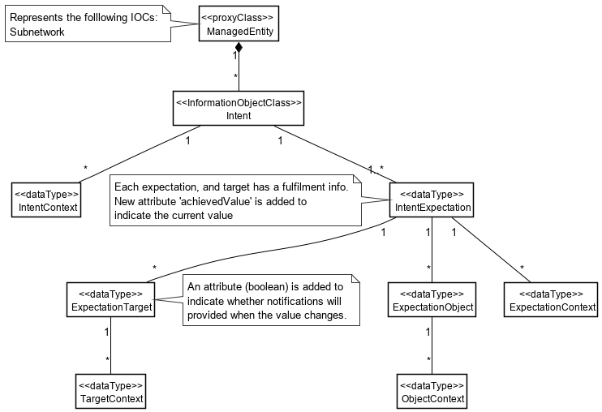
Figure 4.5.2.5-1

  - MnS Consumer configures each Intent with ‘reportIndicator=True’ for values to be monitored.
  - MnS Consumer subscribes to the ‘achievedValues’ in IntentExpection.
  - MnS Consumer receives notifications each time a new value is available.
Observations on this approach:
  - The configuration of the report output is contained in the Intent itself, and is a Boolean. This effectively limits the content of the report to a single report per Intent.
  - This approach is different than subscribing to attribute notifications.
  - The notifications required, and how they represent values in NRM and/or derived values not in the NRM, needs to be defined.
  - There would be no “report’ objects with this approach.

End of changes

