**3GPP TSG-SA5 Meeting #148e S5-233234rev2**

**Electronic meeting, Online, 17 -25 April 2023**

**Source: Samsung, EUTC, EDF, Deutsche Telekom, BMWK, NOVAMINT**

**Title: Rel-18 pCR 28.829 – Clean up**

**Document for: Approval**

**Agenda Item: 6.9.3.0**

# 1 Decision/action requested

***The group is asked to discuss and approve the proposals.***

# 2 References

[1] 3GPP TR 22.867: "Study on 5G smart energy and infrastructure

[2] 3GPP TR 28.829: "Study on Network and Service Operations for Energy Utilities"

[3] S5-216428 : New SID on Network and Service Operations for Energy Utilities

# 3 Rationale

changes in rev2

- 6.3.5 section break was not clear [Rapporteur]

- additional text in definitions [for a comment by Huawei]

- clean up the text around the new figure 6.9.2.2 [Nokia, Huawei]

- remove the introduction [Mirko]

- moved 6.1, 6.2, 6.3, 6.4, 6.6 and 6.7 into a new annex C, now C.2, C.3, C.4, C.5, C.6 and C.7 respectivelyl [Nokia]

- renumbered clauses 6.5 to 6.1, 6.8 to 6.2 and 6.8 to 6.3. Fixed references in the TR to align with these new clause numbers.

- added a table for information elements and

- removed capital letters in clause titles

This document cleans up TR 28.829. In addition to some editorial clean up, the following remaining editor's notes are resolved.

|  |  |  |  |
| --- | --- | --- | --- |
| **Clause** | **Editor's Note** | **Reason for removal** | **Changes** |
| 3.1 | **site operator:** In some network sharing scenarios, for some particularly base station(s) and/or cell site(s), there exist business entities who operate this infrastructure on behalf of MNOs.  Editor's Note: This term is to be clarified. | There was no clarification proposed to be added.  If some clarification is identified at SA5 148e, it will be added. | EN is removed. |
| 6.9.2 | **Use case service flow Preconditions**:  There is a feeder, whose operation requires smart energy services. The smart energy services are available through DSO equipment RTUs. These RTUs are connected with a router, a CPE in the DSO site, that supports a mobile telecommunications interface, a UE.  The DSO can obtain information from each UE in the DSO network. The DSO-MS is aware of the Base station ID of the serving base station for each UE.  Editor's Note: Additional clarification of the preceding two paragraphs will be added. | The two paragraphs lack of clarity is resolved. | The two paragraphs are reworded and a figure is added. The EN is removed. |
| 6.9.3 | PR 6.9.3-1. The 3GPP management system should expose management services, subject to operator policy and other conditions (see NOTE 4), to enable the DSO to provide the site operator with information concerning the expected restoration time of its distribution services for site operator for effected sites.  Editor's Note: Further detail may be needed for the preceding requirement. | No additional information is needed.  If some additional information is identified during SA5 148e, it will be added. | EN is removed. |
| 7.3 | 7.3 Key Issue #3: Energy utility and telecommunication coordinated recovery of energy service  Editor's Note: Key issue #3 corresponds to a solution provided in S5-23zzzz | The corresponding solution was not agreed at SA5 147, but is propopsed to be added in SA5 148e (please see S5-233zzz). | EN is removed. |
| 7.3.1.3 | The functions described here correspond to the requirements in the use case 6.9 "Business use case: Rapid Intervention for Outages without Redundant Topology".  Editor's Note: A new use case is proposed separately. This new use case includes the requirements referred to below. | The EN is not needed because the corresponding text is already in TR 28.829, 1.0.0, clause 6.9. | EN is removed. |

# 4 Detailed proposal

It is proposed to make the following changes in TR 28.829, 1.0.0.

|  |
| --- |
| **Start of Changes** |

|  |
| --- |
| **Next Change** |

# 1 Scope

The present document considers service requirements introduced in TR 28.829 [2] related to telecom management[3] The present document identifies use cases and requirements for exposing capabilities of the 3GPP management system to external energy utility service providers. The present document further considers how management capabilities or what information can be provided to mobile network operators by the external energy utility service providers. Both energy utility use cases and requirements are considered. TR 28.824 [4] can be considered for the technical investigation.

|  |
| --- |
| **Next Change** |

# 2 References

The following documents contain provisions which, through reference in this text, constitute provisions of the present document.

- References are either specific (identified by date of publication, edition number, version number, etc.) or non‑specific.

- For a specific reference, subsequent revisions do not apply.

- For a non-specific reference, the latest version applies. In the case of a reference to a 3GPP document (including a GSM document), a non-specific reference implicitly refers to the latest version of that document *in the same Release as the present document*.

[1] 3GPP TR 21.905: "Vocabulary for 3GPP Specifications".

[2] 3GPP TS 22.104: "Service requirements for cyber-physical control applications in vertical domains".

[3] 3GPP TS 22.261: "Service requirements for the 5G system".

[4] 3GPP TR 28.824: " Study on network slice management capability exposure"

[5] IT Process Wiki – The ITIL Wiki:. https://wiki.en.it-processmaps.com/index.php/ITIL_Service_Operation Content is available according to Creative Commons Attribution-NonCommercial-ShareAlike 3.0 Germany License. Access 08.12.21.

[6] 3GPP TR 22.867: "Study on 5G smart energy and infrastructure"

[7] Connected Nations 2020, UK Report, Ofcom. https://www.ofcom.org.uk/__data/assets/pdf_file/0024/209373/connected-nations-2020.pdf Access 20.4.22.

[8] Telecom Services Security Incidents 2019 Annual Analysis Report, ENISA European Agency for Cybersecurity, July 23, 2020. <https://www.enisa.europa.eu/publications/annual-report-telecom-security-incidents-2019> .

NOTE: This publication is intended for information purposes only and is accessible free of charge. Reproduction is authorised provided the source is acknowledged.

[9] DIRECTIVE (EU) 2019/ 944 OF THE EUROPEAN PARLIAMENT AND OF THE COUNCIL - of 5 June 2019 - on common rules for the internal market for electricity and amending Directive 2012/ 27/ EU (europa.eu)  
<https://eur-lex.europa.eu/legal-content/EN/TXT/PDF/?uri=CELEX:32019L0944&from=EN>

[10] IEC TC 57 <https://www.iec.ch/ords/f?p=103:7:511571509228708::::FSP_ORG_ID,FSP_LANG_ID:1273,25>

[11] 3GPP TR 22.867: "Study on 5G smart energy and infrastructure".

[12] 3GPP TS 28.554: "Management and orchestration; 5G end to end Key Performance Indicators (KPI)".

[13] 3GPP TS 28.552: "Management and orchestration; 5G performance measurements".

[14] 3GPP TS 22.104, " Service requirements for cyber-physical control applications in vertical domains ".

[15] 3GPP TS 32.404, " Performance Management (PM); Performance measurements; Definitions and template".

[18] CAMARA: Telco Global API Alliance https://www.gsma.com/futurenetworks/ip_services/understanding-5g/camara-telco-global-api-alliance, accessed 16.02.23.

[x] 3GPP TS 32.130: " Telecommunication management;Network sharing; Concepts and requirements".

|  |
| --- |
| **Next Change** |

3.1 Terms

For the purposes of the present document, the terms given in 3GPP TR 21.905 [1] and the following apply. A term defined in the present document takes precedence over the definition of the same term, if any, in 3GPP TR 21.905 [1].

**Distribution System Operator**: a natural or legal person who is responsible for operating, ensuring the maintenance of and, if necessary, developing the distribution system in a given area and, where applicable, its interconnections with other systems, and for ensuring the long-term ability of the system to meet reasonable demands for the distribution of electricity.

NOTE 1: See Article 2, definitions in DIRECTIVE (EU) 2019/ 944 [9].

**SCADA**: 'Supervisory Control and Data Acquisition'.

NOTE 2: This facility is for controlling the power grid. The management system of power grid is standardized by IEC TC 57, see Dashboard, scope [10].

**Distribution Automation**:Family of technologies, systems and processes (including sensors, actuators, processors, communication networks, switches, etc.) that enable the remote, real-time monitoring, operation, and optimization of utility distribution systems on the field.

**Remote Terminal Unit**: a host in a customer network operated entirely out of the scope of 3GPP standardization.

**Uninterruptable Power Supply**: an independent source of energy that, for a limited time duration, can sustain operations normally despite an interruption of energy distribution services.

**Customer Premises Equipment**: a component of communications infrastructure that is installed in the facility owned and operated by a customer.

**Energy Supply** **ID**: Point where the energy supply terminates in the operator site and has a unique ID that is known by both the MNO and DSO.

**site operator:** In some network sharing scenarios, for some particularly base station(s) and/or cell site(s), there exist business entities who operate this infrastructure on behalf of MNOs.

NOTE 3: This entity supports telecommunications operations and management, e.g. in network sharing scenarios. The site operator is a Master Operator (MOP) as defined in 32.130 [x]

4 Overview

4.1 General

The delivery of energy has to occur with extreme levels of availability. Reliability is crucial in this domain, for regulatory, business and public health and safety requirements. To achieve this reliability, a range of ‘smart energy services’ are employed by the energy system. These services, largely standardized by IEEE and IEC, require communication. As greater degrees of efficieny, resiliency, responsiveness and other capabilities are sought in the generation and delivery of energy, more and more communications services are required by the energy sector.

There are many options for delivery of communication services today – power line communications, fiber optics, fixed networks, microwave transmission, satellite communications and mobile telecommunications. The appropriate means, or rather mix of communications services, depends on several factors including the location, the possibility of leveraging existing assets (e.g. power lines,) and the ‘total cost of operations,’ and the properties of the communication service.

To the extent that the 3GPP system can provide services that meet the needs of the energy sector, telecommunications will be an increasingly important part of the technical ecosystem by which energy is delivered.

The stage 1 feature ‘Smart Energy Infrastructure’ includes service requirements that will be considered further, in detail, in the present document. In particular, TR 22.867 [6] identified requirements for specific standardized capabilities that allow a utility operator to obtain information from an operator’s network, and to share information with the operator. This information all serves to improve the realized availability of energy system services.

The energy utility service provider needs information regarding outages and performance degradation of the communication system, as it may be possible for the energy utility service provider to reactively or even proactively establish and use an alternative means of communication. Changes in the configuration of the network may also impact the energy utility service provider. Finally, the energy utility service provider can share information with the MNO in order to facilitate rapid diagnosis and recovery from performance problems and energy supply interruptions.

Another reason that energy utilities are an important sector for 3GPP is that telecommunications network operations themselves require energy. The relationship is bi-directional: MNOs require energy services, and energy utilities require communication services. This demands a particular risk management be undertaken by both systems, especially in the event of an energy outage. The present document considers how energy utility service providers and MNOs can exchange information in a standardized format related to an energy service interruption and how to resolve such energy service interruptions efficiently.

# 5 Concepts

## 5.1 Energy Service is Critical for Telecommunications Service Availability

It is important to note that energy outages are one of the principal factors that in telecommunication service availability failures.

Ofcom analyzed service outages between September 2019 and August 2020 in the UK and found that power cuts were the #2 most common causes of telecommunications failure incidents during that period. [7]

ENISA analyzed European data and found that in 2019, the second most common cause of telecommunications service failure were power cuts. " Power cuts are the second most common detailed cause: Overall, independent from the underlying root cause, power cuts are either a primary or a secondary cause in over a fifth of the major incidents." [8]

Governments in each country settle requirements for reporting of failure of power grid. In some cases, the the consumer can claim economic compensations due to caused damage.

As a common principle in all countries worldwide, a state autority is responsible to report failures on a yearly basis in the power grid but deviations do exist.

The telecom network can be impacted by external factors, specifically by the power grid. If there is a failure in the grid, then the faulty part needs to be disconnected to avoid risk for fire or human injuries due to short circuit. Further, the telecom network requires electricity and has a limited capacity to operate without energy from the power grid.

The telecom network can be impacted due to internal power system failure at the site. This can be a short circuit or damaged batteries. This is part of telecom operator’s incident management or fault management system and out of scope of this study.

The startup of electrical power grid can be cumbersome. As common a top-down approach is performed in centralized energy distribution system. However, in future a bottom-up approach may be the best alternative, since some of the micro grids may still work to the extent that they can operate autonomously. Detailed assessment of micro-grids is outside the scope of this study.

Each country sets their own requirements and regulations for the energy sector and telecom sector operating in that country. It is common for there to be the following regulation:

- Telecom act is controlling the telecom regulation. This is setting requirement for how the telecom service in the country is handling. This can include reliable operation.

- Energy act is controlling the energy regulation

Disaster act is giving guidance when major problem is impacting the countries.Network Operators do have backup system installed at site since they are operating a mobile network 24/7. There can be external power failure and then the backup system can have internal problem or limited capacity.

|  |
| --- |
| **Next Change**  **The change to 6.5 was added to S5-233234d2 to address comments** |

## 6.1 Business use case: MNO exposes network performance monitoring

### 6.1.1 Description

**Motivation**

In 6.1, it was explained that DSOs require extremely high availability for communication to provide distribution automation and SCADA services to prevent energy service outages. Unlike the use case 6.4 MNO exposes Network Service Alarm, this use case focusses on proactive measures. The motivation for this is described in 6.1.1.

The sooner and in sufficient detail that the DSO obtains information regarding communication service deterioration, the better. This deterioration may be considered a 'problem.' (The term 'problem' is used in the sense described in Annex A, a reduction in service metrics. This is distinguished from an 'incident' in which required service levels cannot be maintained.)

As described in 6.1, a DSO can determine levels of service over time by means of their own infrastructure. The DSO has many routers in their network. These provide networking within substation networks and have wireless access interfaces to connect the substation network over a wide area. These routers perform periodic monitoring operations, e.g. sending ICMP echo (ping) messages to ascertain latency and reachability. In addition, the UE has access to radio and cellular information - signal strength, serviced Cell ID, radio technology. These measurements are captured on the UE and obtained 'over the top' by the DSO using their own management system over time. The acquired data are assessed to discern trends that, historically considered, indicate that an incident is likely. This monitoring occurs at a coarse granularity (e.g. one measurement per minute.) There are two shortcomings to this approach that this use case seeks to overcome:

1. The information is based on measurements of single nodes only, not the overall network. The DSO knows (a) the location of each of their devices and the serving Cell ID. (b) The DSO has several devices (in the same cell) and can by means of correlation of data received by devices identify possible problems that affect the entire cell. (c) the nature of the deterioration of performance remains ambiguous - is it an issue in the DSO's own network (essentially a managed set of VLANs and substation networks), or is it a problem in the MNO's network?

2. The granularity of the measurement is coarse, the bandwidth requirements to control and collect the data significant compared to the service data traffic (when there is no need for more than routine monitoring and management of the energy system) and the measurements are distributed - requiring connectivity to all UEs. To the extent the performance deteriorates, so too does the access of the DSO to the UEs that provide measurements. So, as an incident approaches, just when more information granularity is needed, it becomes increasingly difficult to acquire data.

These two problems have one clear solution: centralized information obtained from the MNO instead of decentralized information acquisition. The exposed information from the MNO will correspond to the network performance absolutely, it need not be approximated. It will assist in determining the cause of performance problems - if the MNO does not report the problem but it is detected in the DSO network, this indicates that the problem is in the DSO network. If the MNO reports performance indicating a problem, then the DSO can focus on this rather than on investigating the root cause of the problem in their own network. The centralized measurements will be more efficient, can be of finer granularity, will be available even if the network performance seriously declines.

The acquired data is used, as described in 6.1, to determine when to initiate back up communication capabilities. These take some time (e.g. 2 minutes) to activate. Accurate, timely, sufficiently granular information can lead to better historical information, which correlates diverse behaviors of the network including service performance incidents. This can lead to improved understanding of service, such as periodic changes in service levels and on the other hand developments that have historically been associated with service level incidents.

In the latter, rare case, the DSO may elect to take proactive decisions. These proactive decisions will improve communication service availability. It is essential to maintain the best possible communication service availability to avoid even brief intervals of lack of availability of communication. If there is a specific need to monitor and manage the network during one of these intervals, it will not be possible to do so (i.e. by means of Distribution Automation or SCADA smart energy services), and this could lead to damage or an outage affecting energy service customers.

**Background**

See use case C.2.

### 6.1.2 Details

**Use Case Actors**

**DSO network operations center engineer**: The DSO network operations center engineer is responsible for deploying monitoring and control mechanisms in the network. The DSO network operations center engineer determines how to control and configure the network for resiliency, e.g. when and how to switch between different accesses to maximize availability.

**DSO electrical system operations center engineer**: This actor is responsible for maintaining availability, efficiency and safety of the energy system.

**Use case service flow**

1. The energy system is monitored and managed by the DSO electrical system operations center engineer who relies upon a functioning network to communicate with electrical utility equipment in substation networks.

2. There are a set of substation networks with routers that include a UE for wide area communications. The DSO network operations center engineer is responsible for this network. The DSO network operations center engineer employs monitoring mechanisms to observe the performance of the telecommunications network over time, to capture historic data and continually watch for performance degradation indicating risk of an incident, as described in C.2.1. These monitoring mechanisms are exposed by the MNO, so that authorized third parties (including the DSO) are able to receive performance monitoring information.

NOTE: The alarms are provided at the network level, based on the overall statistical performance of the network. The alarms described here do not correspond to the performance of individual UEs or sessions.

3. The DSO network operations center engineer, using the exposed monitoring mechanism interface, can request which metrics, under which conditions, will be provided. The interface provides a means by which the alarms can be configured, including frequency and parameters to report.

|  |  |  |  |
| --- | --- | --- | --- |
| Parameter | Configuration | Expected Behavior | Notes |
| latency | location (cell ID), frequency of reporting, granularity of reporting. | The report is provided by network exposure by the MNO. | The time of the measurement is crucial, so this information is included in the report delivered to the DSO. |
| throughput | location (cell ID), frequency of reporting, granularity of reporting. | The report is provided by network exposure by the MNO. | As above. |
| packet loss | location (cell ID), frequency of reporting, granularity of reporting. | The report is provided by network exposure by the MNO. | As above. |

The information that are needed by the DSO will change over time, thus it is important that the DSO can configure the monitoring process, especially in terms of granularity.

4. The reports are delivered according to the above configuration.

**Service flow result**

When a problem develops, the DSO network operations center engineer (or an automated management function) may trigger a fail-over to a backup network communications facility. This proactive and timely intervention can reduce or even eliminate the occurrence of incidents. Even if the activation of a back up communication facility occurs too late to entirely eliminate interval in which the DSO substation network components are unreachable or only reachable with inadequate quality of service, this interval will be significantly reduced.

### 6.1.3 Potential Requirements

PR 6.1.3-1. The 3GPP management system shall, according to mobile network operator policy, regulatory requirements and contractual obligations, expose standardized interfaces to authorized third parties that provide the ability to initiate and terminate requests for monitoring including the configuration of the monitoring (e.g. monitoring interval, measurement period granularity, location of interest, etc.)

Table 6.1.3-1: Information Elements and Management Functionality Mapping (see 7.1.2)

|  |  |  |
| --- | --- | --- |
| Purpose | Applied | Existing Management functionality or New Management Functionality |
| Determining monitoring configuration (monitoring interval, measurement period granularity) | Monitoring configuration is general and applied to any monitoring done to satisfy this requirement. | Existing: tbd |
| Determining location of interest | Monitoring area of interest will identify a base station ID | Existing: tbd |

PR 6.1.3-2. The 3GPP management system shall, according to mobile network operator policy, regulatory requirements and contractual obligations, expose standardized interfaces to authorized third parties that provide a mechanism for the mobile network operator to send reports containing required performance metrics measurements to the DSO. The measurements in these reports are provided in a form such that it will be possible to ascertain the number of measurements made as well as to calculate the standard deviation of those measurements, in order to aid in the interpretation of the reported measurement.

Table 6.1.3-2: Information Elements and Management Functionality Mapping (see 7.1.2)

|  |  |  |
| --- | --- | --- |
| Purpose | Applied | Existing Management functionality or New Management Functionality |
| Communicating Measurements | For any monitoring information provided by the MNO to the DSO. | Existing: Measurement [15] |

PR 6.1.3-3. The 3GPP management system shall support the following performance metrics to monitor information according to the associated configuration:

a) Latency between the UE and the base station, base station or network slice;

b) Throughput [an average for the base station's network traffic or network slice];

c) Packet loss [an average for the base station's network traffic or network slice];

d) Availability [an average for the network's availability at a specific base station].

Table 6.1.3-2: Information Elements and Management Functionality Mapping (see 7.1.3)

|  |  |  |
| --- | --- | --- |
| Purpose | Applied | Existing Management functionality or New Management Functionality |
| Latency | Over Uu, for traffic between the UE and the base station (averaged); either for all traffic or for the network slice traffic. | Existing: tbd |
| Throughput | As above | Existing: tbd |
| Packet Loss | As above | Existing: tbd |
| Availability | For all traffic of the Uu. | New: tbd |

|  |
| --- |
| **Next Change**  **The change to 6.8 was added to S5-233234d2 to address comment** |

## 6.2 Business use case: Energy utility and telecommunication coordinated recovery of energy service

### 6.2.1 Description

There is clearly a mutual interest in coordination between telecommunications and energy service operations to achieve rapid recovery of energy service. This is not only true for the MNO, who benefits from the availability of supplied power, but also of the DSO who needs mobile telecommunication service to restore and maintain the operation of its grid.

Energy service interruptions may occur in many parts of the energy system, ultimately effecting the end customer. This use case does not consider every service interruption scenario. It rather concentrates on one specific level of the system. The remainder of the task of efficient recovery is out of scope of this use case. Please consider the following model:

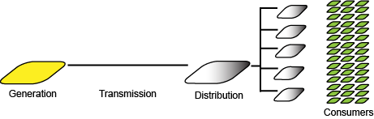

Figure 6.2.1-1: A simple model of the energy service delivery system

We concentrate on the distribution aspects, which is depicted above as a single level in a hierarchy, but in fact may have a series of sub-stations between high voltage transmission and the final distribution to energy consumers.

Interruptions occur in the distribution system, as at some level, the medium voltage network may rquire local reconfigurations or suffer unplanned loss of distribution service (e.g. due to distribution cable damage, etc.) The resulting energy service interruptions last a variable amount of time (from minutes to hours.)

The normal situation is that a utility may need to disconnect a certain Medium Voltage feeder. As the grid does not automatically re-connect this feeder to an active one, there will be a power outage in all points of supply connected to it while the power is being restored. The procedures and times to reconnect the affected feeder would be the same if for any reason this has been caused by a planned operation, an unexpected incident, or if it is a major grid problem.

In the recovery procedures, the DSO network operations center needs to restore power in a certain order often for regulatory compliance: the order includes prioritizing the more important energy consumers (e.g., Hospitals, government sites).

This prioritization may also include major MNOs’ sites, such as base stations and core network sites to restore communication services, which is in the interest of both MNO and DSO stakeholders. This prioritized recovery of MNO sites is enabled by this use case.

It is here where a standardized mechanism connecting DSOs and MNOs would be beneficial. This use case describes the information and operations that would be required on that interface.

Part of the information may have a more static nature.

This is the point of Energy Supply ID. The DSO is aware of each point of supply (to an energy consumer), by means of the Energy Supply ID. The MNO needs to let the DSO know the relevant Energy Supply IDs, so that the utility can know where they connect to its feeders. Another critical information element is the power back up installed by the MNO in each site (including 'back up' base stations), and its expected duration. In addition, for each Energy Supply ID, base station, e.g. eNB, IDs (serving the cell IDs) served by the base station as shown in figure 6.2.1-2 below.

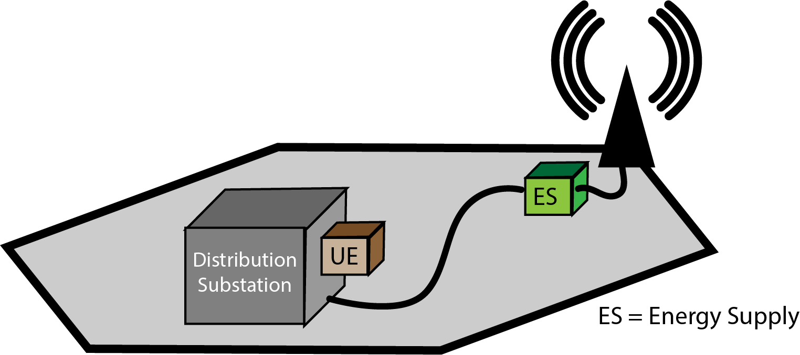

Figure 6.2.1-2: Local recovery scenario

NOTE: The representation of the ID above corresponds to the Energy Supply termination of the base station site.

The correspondence between the communication system serving the distribution substation by means of a UE (camped in the depicted cell), the Energy Supply ID of the base station and the ID of the base station enables the DSO to identify important operational aspects, such as:

(a) the impact of the distribution substation interrupting service: specifically the base station that the distribution substation relies on will have its power supply interrupted;

(b) upon recovery of the distribution substation, which substations may be high priority for resumption of service.

As implied in Figure 6.2.1-2, there is a dependency that the DSO has on the MNO in that the DSO relies upon data connectivity to smart energy equipment in the distribution system. Through the use of smart energy services, restoration of energy service is rapid and reliable. If the energy substation lacks data connectivity, it is sometimes necessary to send a technician to the site to restore service, which is time consuming.

Within the distribution substation is a router, a kind of customer premises equipment (CPE) that communicates as a router that supports a mobile interface, shown as the UE. Beyond the CPEs DSO Remote Terminal Units (RTUs) are connected. The DSO monitors and controls the RTUs as part of normal operations, especially in the event of a service outage.

Other information exposed by the new mechanism is dynamic.

The figure below depicts the situation at the time of a failure and what is needed in order to restore energy service.

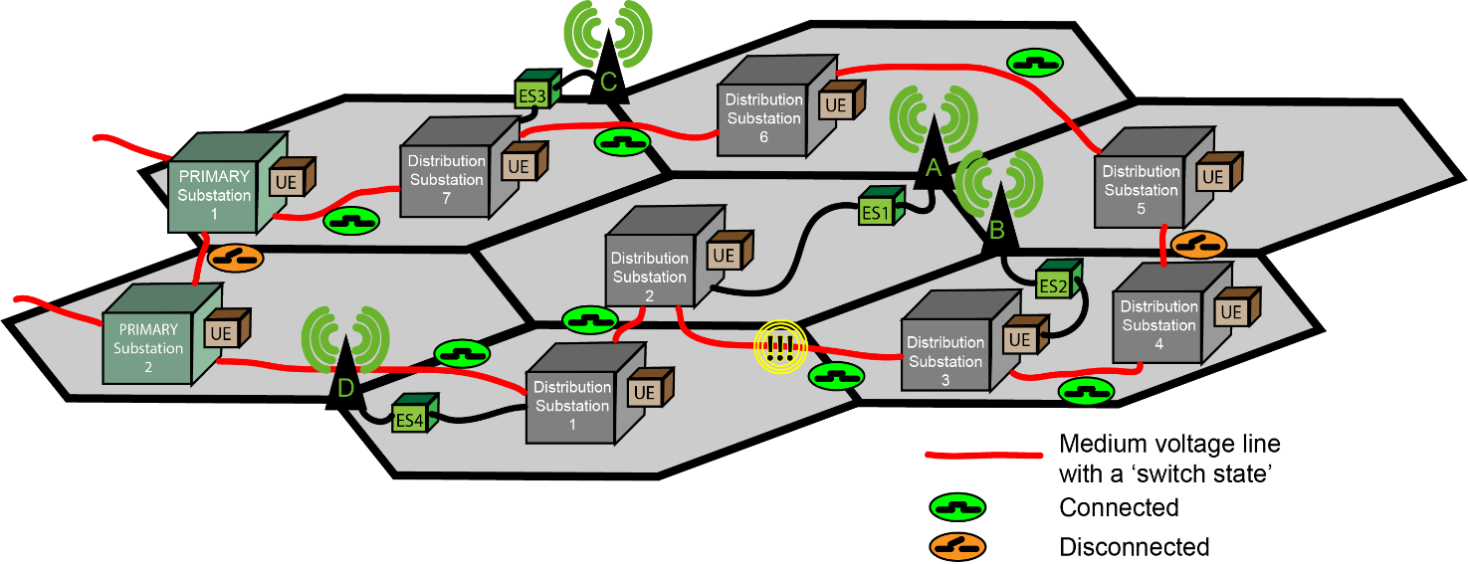

Figure 6.2.1-3: Local failure event

NOTE: In Figure 6.2.1-3 and 6.2.1-4 below, the green cubes labeled 'ES' represent energy supply points, associated with an Energy Supply ID.

The red lines above are medium voltage lines between energy distribution subtations (DS). Note that initially Primary Substation (PS) 1 feeds DS7, DS6 and DS5, and PS2 feeds DS1, DS2, DS3 and DS4.

Between DS2 and DS3 there is a distribution failure. This has the result of causing DS3 and DS4 to no longer be able to maintain the energy distribution service to customers.

Note that the topology of energy distribution lines is redundant. In order to achieve distribution successfully through this redundant topology, energy service has to be **switched** **on and off** at corresponding distribution substations. This for example could be done between DS4 and DS5 to feed restore service to all substations. The switching is disruptive of energy service. For some time, energy supplied by the distribution substation to the energy customers is off-line. This would result in the following topology:

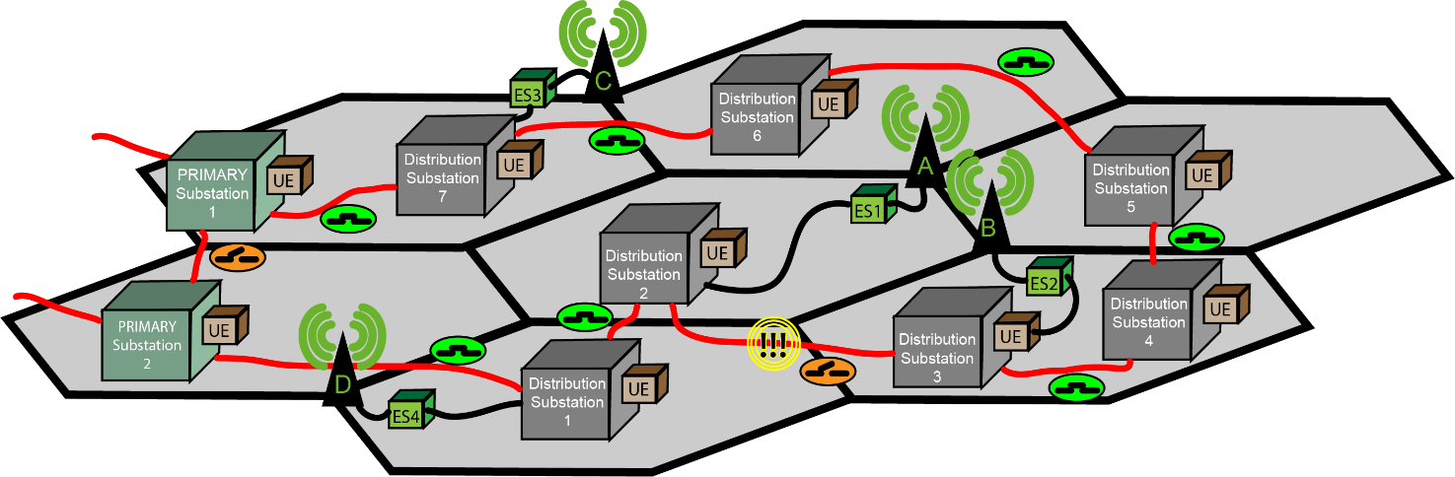

Figure 6.2.1-4: Local failure restored

The topology in Figure 6.2.1-4 is altered so that DS4 and DS5 are now connected, accepting the medium voltage line between DS2 and DS3 are disconnected. PS1 and PS2 remain disconnected; they represent another level of redundancy in the system.

If the process of switching on and off until a stable configuration is achieved has to be done **manually** the process can take considerable time (e.g. hours) as technicians has to be on-site to control the substation configuration. The technicians have to communicate, e.g. using mobile telecommunications. However, if the process takes a long time - the mobile telecommunication infrastructure, as shown by base station A and base station B, will likely have exhausted their Uninterruptable Power Supply (UPS), further complicating recovery procedures.

The alternative investigated in this use case involves taking into account the configuration (as described in Figure 6.2.1-2) and dynamic information obtained from the 3GPP network management system concerning the **current capacity (expected remaining duration of service) of the UPS in each of the MNO's critical infrastructure sites.**

Using smart energy services (principally Distribution Automation), it is possible to perform the 'switch on and off' procedures rapidly, within minutes, and reconfigure the network. There will still be transient electrical service outages to the customers that the distribution substations serves.

Taking into account (a) which mobile network infrastructure sites (i.e. base stations) are critical to service and which cells they serve, (b) the corresponding Energy Supply ID, (c) the distribution substation (UEs) that rely on these base stations, (d) the remaining UPS capacity available in the sites, it is possible for the DSO to plan the 'switch on / switch off process' to avoid any interruption of service. This is done by **selective ordering**of the switch on / switch off activity, to avoid exhausting any mobile network infrastructure UPS - especially where this base station (etc.) serves to enable communication services to a distribution substation.

Note that in figure 6.8.1-3, the cell in which each is located is served by a base station that can be affected by 'switching off.' It is also known to the DSO that e.g. DS2 is served by A and (secondarily) by base station B. Knowledge of this redundancy can also be of benefit to the planning of the DSO, to prevent in the worst case that both base stations UPS capacity is exhausted and there is no way to restore energy service to these sites.

In order to support the process described above, another example of dynamic real-time information is the ‘real’ back up power available at the base station, at any moment in time; the intention is to see how much time the DSO has to restore the power before service interruption compromises the MNO's operation.

### 6.2.2 Details

**Use case actors**

**DSO network operations center 'management system'**

The DSO network operations center management system (DSO-MS) maintains operational information to inform DSO network operations.

**MNO network operations center 'management system'**

The MNO network operations center management system (MNO-MS) has and can expose operational information to DSOs concerning the network's configuration and status.

The MNO-MS is a 3GPP management system and the DSO-MS is not a 3GPP management system, however it supports mechanisms that are defined by 3GPP standards (e.g. it uses 'northbound interfaces' exposed by the 5G network management system.)

**Use case service flow**

Preconditions:

There is a feeder, whose operation requires smart energy services. The smart energy services are available through DSO equipment RTUs. These RTUs are connected with a router, a CPE in the DSO site, that supports a mobile telecommunications interface, a UE.

The DSO can obtain information from each UE in the DSO network. The DSO-MS is aware of the Base station ID of the serving base station for each UE.

On a regular basis, e.g. daily, the DSO-MS obtains 'static information' from the MNO-MS. The DSO-MS is aware which base stations each of the DSO's UE camp on. The DSO-MS is also aware of which base stations rely on which Distribution Substation.

**Service Flow: MNO-DSO coordination to achieve rapid energy service outage recovery**

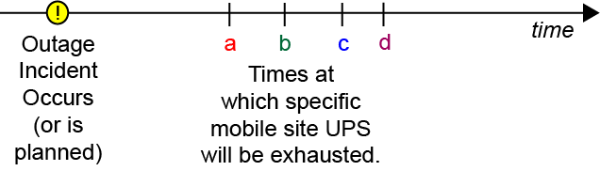

Figure 6.2.2-1: Timeline for Restoration of a Distribution Substation

1. The DSO-MS uses the standardized mechanism to identify an energy service outage at a particular Distribution Substation (or set of Distribution Substations.)

This is shown in Figure 6.2.2-1 as the time of the outage incident.

2. The DSO-MS uses the standardized mechanism to request information from the MNO-MS, to identify the UPS capacity of the base stations in the vicinity of the outage, where the distribution substations will need to be switched on and off. This is shown in figure 6.2.2-1 as a, b, c, d which correspond to base stations A, B, C and D.   
  
This request may be done repeatedly, over time, so that the DSO-MS can track the status of the MNO-MS.

3. The DSO-MS can use the standardized mechanism to inform the MNO-MS of which sites (using the Energy Supply ID known by both the MNO and the DSO). The DSO can inform the MNO in advance of a planned outage, e.g. when switching on and off will take place.

4. The DSO will actively switch on and off the medium voltage topology at the different distribution stations seeking to establish a stable and sufficient topology. The DSO will prioritize switching involving DS1 so that the UPS of base station A is not exhausted, because 'a' will expire first as shown in Figure 6.2.2-1.

5. A stable and sufficient medium voltage distribution topology is established without exhausting any of the UPS capacity of the base stations and other critical mobile infrastructure sites.

Post-conditions:

The DSO-MS has informed the MNO-MS before, during and after an energy service outage.

The DSO-MS has been able to obtain dynamic UPS information corresponding to mobile infrastructure sites throughout the recovery process.

Service Result:

Energy service is restored to the MNO sites and to the rest of the DSO's energy service customers efficiently, without requiring mobile manual intervention.

### 6.2.3 Potential Requirements

PR 6.2.3-1. The 3GPP management system should support, subject to operator policy, regulatory requirements and contractual obligations, the for the DSO to obtain the following information from the site operator.

For each 'site' for which energy service is critical to the site operator:

- Energy Supply ID

- UPS Capacity of the site (at the time at which this information is obtained);

- Base Station ID (if applicable. The site may not be a base station, e.g. it could be data centre or other facility.)

PR 6.2.3-2. The 3GPP management system should support, subject to operator policy, regulatory requirements and contractual obligations, the capability to enable the DSO to provide the site operator with information concerning the beginning of an energy service outage and the effected sites.

PR 6.2.3-3. The 3GPP management system should support, subject to operator policy, regulatory requirements and contractual obligations, the capability to enable the DSO to obtain information from the site operator concerning the UPS capacity corresponding to a specific site.

PR 6.2.3-4. The 3GPP management system should support, subject to operator policy, regulatory requirements and contractual obligations, the capability to enable the DSO to inform the site operator concerning the end of an energy service outage and the related sites.

|  |
| --- |
| **Next Change** |

## 6.3 Business use case: Rapid intervention for outages without redundant energy feeder topology

### 6.3.1 Description

This use case is a variation on 6.8 above.

In 6.8, a redundant topology offers the opportunity to adjust the switching of medium voltage lines for energy distribution. When there is a failure of one of these lines, it is possible to adjust the topology to reestablish energy supply to all distribution substations.

This possibility exists only if there is a redundant topology. There are scenarios in which there is no redundant topology, either because a substation is remotely located or because the redundant topology is sufficiently damaged that a sufficient network cannot be reestablished. This use case addresses these scenarios.

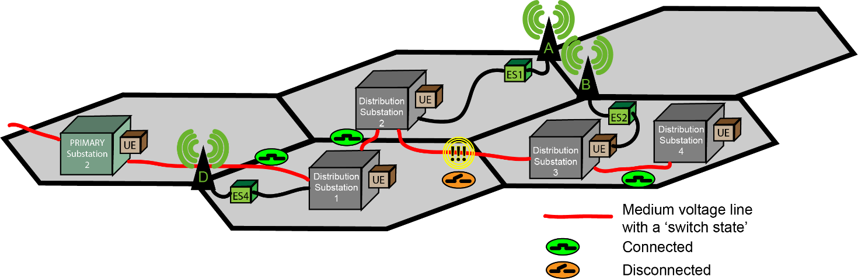

Figure 6.3.1-1: Local Failure Event of feeder of Distribution Substations without Redundant Toplogy

In figure 6.3.1-1, there is a failure in the distribution line between Distribution Substation 2 and Distribution substation 3. This will result in a failure to supply energy to ES2, and thereby base station 2.

In this use case, it is necessary to reestablish the energy supply between substation 2 and substation 3 prior to resuming service in substation 3 and 4.

Once this has been reestablished the topolology is restored as shown in Figure 6.3.1-2.

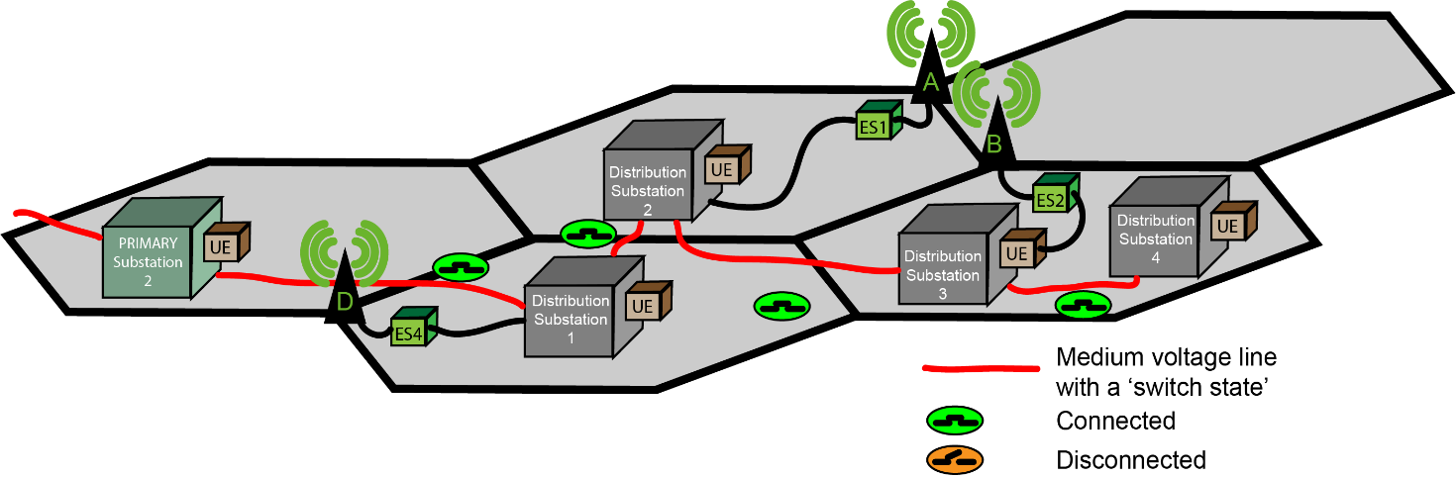

Figure 6.3.1-2: Restored Energy feeder to Distribution Substations

At the point when the distribution is again possible, it is necessary to resume service at distribution substation 3 and 4. However, as some time has elapsed, the UPS capacity of B will be exhausted. This will mean that any smart energy automated operations to distribution substation 3 and 4 will be impossible. Manual intervention to restart service will require substantially more time than automated response.

For this reason, this use case suggests a new operational capability to achieve rapid coordinated recovery. In this approach the DSO informs the site operators to *reserve UPS capacity* in certain sites, so that it will be possible to *resume telecom operations* subsequent to the resumption of energy distribution service. If energy distribution service does not resume, after the UPS capacity becomes exhausted, telecom operations will become impossible.

### 6.3.2 Details

**Use case actors**

**DSO network operations center 'management system'**

The DSO network operations center management system (DSO-MS) maintains operational information used for DSO network operations. The DSO-MS supports interfaces defined in this use case. All other aspects of the DSO-MS are out of scope of 3GPP specification. The DSO-MS is a consumer of the 3GPP management system.

**Site Operator network operations center 'management system'**

The site operator network operations center management system (SiteOp-MS) has and can expose operational information to DSOs concerning the network's configuration and status. The SiteOp-MS as discussed in this use case can be considered a producer of management interfaces consumed by the DSO-MS. The SiteOp-MS is effectively a standardized subset of interfaces and semantics of the 3GPP management system.The SiteOp-MS is a 3GPP management system for 5G and the DSO-MS is not a 3GPP management system, however it supports mechanisms that are defined by 3GPP standards (e.g. it uses 'northbound interfaces' exposed by the 5G network management system.)

**Use case service flow Preconditions**:

The purpose of the following description is to explain the scenario in which the energy utility operates a network by means of diverse accesses. It is important to mention that other access systems are used to access the energy utility site networks as well, but only access via the mobile telecommmunication system mis in of scope of this use case.

An energy utility maintains many energy distribution substations. Each is an energy utility infrastructure site that is responsible for distribution of energy to customer sites. This energy utiltity infrastructure site's operation requires smart energy services. The smart energy services are used to manage and control DSO equipment. This equipment is present on a local area network in the energy utility infrastructure site, which is accessed (e.g. as a VLAN) over any access. In this use case, the access that is used is 3GPP access. A UE is used effectively to carry DSO energy utility infrastructure site communication opaquely (that is, as encrypted traffic) to the Utility Service Provider Network. For background infomation on this scenario, see TR 22.867 [6], clause 5.7. [11]

The DSO can obtain information from each UE that is used to provide access to the DSO networks. The DSO is, by means of this informtion obtained from UEs in the DSO network, aware of the Base station ID of the serving base station for each UE.

On a regular basis, e.g. daily, the DSO-MS reads information from the SiteOp-MS exposed 3GPP management system MnS Producer's exposed interfaces. The DSO-MS is aware which base stations each of the DSO's UE camp on. The DSO-MS is also aware of which base stations rely on which Distribution Substation.

**Service Flow:**

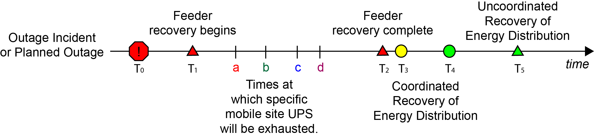

Figure 6.3.2-1: Timeline for Restoration of a Distribution Substation

1. At some time (T0) there is an outage incident either a planned or unplanned incident.

2. At some subsequent time (T1), the energy utility begins restoration of energy feeder lines or other affected infrastructure.

3. The period of time that will elapse before the restoration of energy service from some set of distribution substations will be *longer* than the UPS capacity of the mobile infrastructure sites. This use case assumes that the MNO knows or can estimate the remaining time of operation after T0 given the UPS capacity of different mobile infrastructure sites, shown as a, b, c, d in Figure 6.3.2-1. That is, T2 occurs after the UPS capacity in the sites affected by the energy outage. This use case assumes that the DSO knows or can estimate time at which energy distribution service can resume, shown as T2 in figure 6.3.2-1. This may not be the exact time at which resumption of energy service can resume, which is shown as T3. T2 is an estimate when the energy feeder of while crepresents the time at which energy feeder service resumes and restoration of distribution is possible.

4. The energy feeder for one or more energy distribution substations is now complete. At this point, it will be possible to restore energy distribution. However, operations are required at the distribution substation. This can be performed by smart energy services remotely if there is network coverage. The starting time, when the MNO provides service with remaining UPS capacity, is shown in Figure 6.3.2-1 as T3. The smart energy services to restore energy distribution services to all customers, including the MNO, is shown as T4.

There are two alternatives for how the restoration can occur. Manually, as described in 5a, or with remote intervention, as described in 5b.

5a. Without prior arrangement, there will be no UPS capacity remaining in the infrastructure that serves the distribution substations that have restored power. They will not be able to perform automated recovery, as explained in use case 6.3. In this case, manual intervention is required to restore energy distribution. This will be complete after a substantial period of time (T5).

5b. Alternatively, prior arrangement can be made so UPS capacity will remain in the infrastructure at the time it is needed to restore energy distribution service. This prior arrangement is described in the steps below, and consists of operations between the DSO-MS and MNO-MS.

This is to enable the situation that, at time (T3), the MNO is able to use remaining UPS capacity to offer telecommunication service at the time at which the DSO will perform remote operations by means of data communicadtions to restore service in the sites affected by the outage, and operates them until the outage concludes.

5.b.1. In this use case, the DSO-MS communicates to the MNO-MS:

- the affected sites (Energy Supply IDs) by the outage

- the time X after which recovery is possible

- the time Y (that is a certain interval of time after X) that the recovery is expected to complete (a small number of minutes)

The site operator, knowing this, has the opportunity to manage the use of the UPS in the affected sites so that they do not exhaust at time (a, b, c, d, etc.). Rather, capacity sufficient for operation between time X and Y are reserved. Figure 6.3.2-2 below shows a concrete example of this interaction.

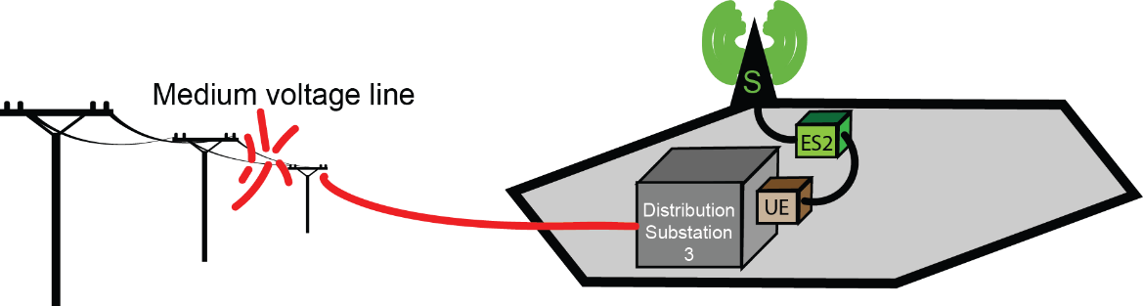

Figure 6.9.2-2: Example Restoration Scenario of a Distribution Substation

|  |  |
| --- | --- |
| Time | Event |
| **00:34** | A storm rages and causes power lines to collapse in the mountain province. Energy distribution service by Distribution Substation 3 is no longer possible! |
| **00:36** | The DSO informs the MNO that there has been an energy distribution incident that will affect site S. The DSO expects to repair the medium voltage line by 02:45, and if telecommunications service permits it, remote control (using Distribution Automation and SCADA controls) of all sites served by Distrution Substation 3 can be restored - by 02:50.  In terms of the procedure step 5a, X=0:2:45, Y = 5 minutes. |
| **00:40** | The MNO conserves energy as appopriate to conserve 5 minutes of operating capacity of their UPS reserve. |
| **02:38** | The DSO informs the MNO that the feeder line is restored. Remote control restoration of service can begin now. This is T2 in figure 6.9.1-2. |
| **02:43** | The MNO resumes operation at site S. The DSO is informed that the servicce has resumed. |
| **02:47** | The DSO completes distribution automation. Site S now has energy service. This is T4 in Figure 6.9.1-1. |

5.b.2. The DSO, after time (T3), employs smart energy services such as distribution automation or specific SCADA operations to restore service to customers rapidly, including the site operator.

5.b.3. The incident concludes (T4). Energy distribution service has been restored to the MNO site(s) as well as other energy service customers.

**Service flow result**

T4 occurs before manual uncoordinated recovery of service would be successful (T5 in Figure 6.9.2-1.) Thus, alternative 5.b is superior to 5.a for both the site operator and the DSO.

Service is restored to distribution substation 3 and 4 at T4, within minutes of the restoration of the medium voltage line between distribution substation 2 and 3 T3. This is substantially faster than service could be restored if a technician had to visit distribution substation 2 and 3 - represented on Figure 6.9.2-1 as T5. As a result, service is restored to the MNO sites affected more rapidly than in an uncoordinated incident.

|  |
| --- |
| **Next Change** |

6.9.3 Potential requirements

This use case also has potential requirements 6.8.3-1, 6.8.3-2, 6.8.3-3 and 6.8.3-4. These requirements, if supported,

For all the requirements below, supported interaction is described between the DSO and the site operator or site operator. The reason for this term 'site operator' is that in network sharing scenarios, the base station and/or cell site may be operated by a third party. In active network sharing scenarios the DSO can communicate with an site operator that operates the site, but can be distinct from the serving site operator. The interaction described is really between the DSO and the management services of the entity that operates the site essential for telecommunication service, identified by the energy supply ID.

PR 6.9.3-1. The 3GPP management system should expose management services, subject to operator policy and other conditions (see NOTE 4), to enable the DSO to provide the site operator with information concerning the expected restoration time of its distribution services for site operator for effected sites.

PR 6.9.3-2. The 3GPP management system should support, subject to operator policy, the capability to enable the DSO (or site operator) to provide the site operator with information concerning the time when DSO is ready to remote energy distribution services can resume, and the locations where distribution is possible. The time when communication services are needed corresponds to the time when DSO has restored its energy transmission service and is ready to remote energy distribution services can resume. The location information expressing where restoration will occur could be expressed in terms such as latitude-longitude pairs or Energy Supply ID.

PR 6.9.3-3. The 3GPP management system should support, subject to operator policy, the capability to enable the DSO to provide the site operator with information concerning the time duration for which DSO expects to require site operator's communication services to achieve coordinated recovery for being able to use smart energy services to restore its energy distribution services. ies

PR 6.9.3-4. The 3GPP management system should support, subject to operator policy, the capability to enable the DSO to provide the site operator with information concerning the locations where for example DSO substations need to restore distribution services on priority. Location information expressing where restoration will occur could be expressed in terms such as latitude-longitude pairs or Energy Supply Id.

PR 6.9.3-5. The 3GPP management system should support, subject to operator policy and other conditions (see NOTE 3), the capability to enable the DSO to provide the site operator with information concerning the time at which MNO (or site operator) should actually able to provide communication services to achieve coordinated recovery to DSO for a particular region.

PR 6.9.3-6. The 3GPP management system should support, subject to operator policy, the capability to enable the DSO to provide the site operator with information concerning the time duration for which site operator should actually able to provide communication services to achieve coordinated recovery to DSO for a particular region.

|  |
| --- |
| **Next Change** |

7.3 Key Issue #3: Energy utility and network operator coordinated recovery of energy service

|  |
| --- |
| **Next Change** |

7.3.1 Description

#### 7.3.1.1 General

This describes the issues to study in context of the use case of Energy utility and network operator coordinated recovery of energy service.

There is clearly a mutual interest in coordination between network operator operations and energy service operations to achieve rapid recovery of energy service. This is not only true for the MNO, who benefits from the availability of supplied power, but also of the DSO who needs mobile telecommunication service to restore and maintain the operation of its grid.

NOTE: Though DSOs use many forms of access (e.g. fixed access, dedicated fiber access, etc.), they increasingly rely on telecommunications services for communication access to many substations and other facilities. It therefore directly benefits the overall availability of communication service for the energy utility when the availability of the telecommunication service improves. The Energy utility provider (DSO) knows when and where outage has occured and when telecommunication services are critically important for recovery. The MNO knows their uninterruptable power supply resources and the possibility of utilizing telecommunication services to enable utility’s energy system rapid recovery via smart energy services.

Without a standardized mechanism to share all this information, the service recovery mechanism would be very inefficient and time consuming. Therefore, a standardized mechanism is needed to share all this information between DSO and MNO to enable efficient usage of smart energy services for service recovery.

#### 7.3.1.2 Coordinated recovery of energy service with redundant topology

The functions described here correspond to the requirements in the use case 6.8 "Business use case: Energy utility and telecommunication coordinated recovery of energy service".

a) How can the DSO obtain the information from the MNO that is listed in PR 6.2.3-1?

b) How can the DSO provide the MNO with information concerning the beginning of an energy service outage and the affected sites? [PR 6.2.3-2]

c) How can the DSO obtain the UPS capacity related info of a specific site from the MNO? [PR 6.2.3-3]

d) How can the DSO inform the MNO of energy service outages ending and the affected sites? [PR 6.2.3-4]

|  |
| --- |
| **Next Change** |

#### 7.3.1.3 Coordinated recovery of energy service without redundent topology

The functions described here correspond to the requirements in the use case 6.9 "Business use case: Rapid intervention for outages without redundant topology".

The key issue topics described in 7.3.1.2 have to be resolved for this key issue. In addition, the following key issues also have to be addressed.

a) How does the DSO provide the MNO with information concerning the expected time at which the DSO will be able to restore its energy services? [PR 6.3.3-1]

b) How does the DSO provide the MNO with the timeat which it has restoted its energy transmission service? [PR 6.3.3-2]

c) How does the DSO provide the MNO with the time duration that the DSO expects to require to restore energy services, facilitated by telecommunication services? [PR 6.3.3-3]

d) How does the DSO inform the MNO of the locations affected by an energy service outage (latitude-longitude pairs, energy supply IDs) where the DSO will like to restore service on priority than some other locations? [PR 6.3.3-4]

e) How does the MNO inform the DSO of the actual time and locations (e.g. base station IDs) where the MNO is *able* to provide telecommunication services to enable the DSO to restore energy service? [PR 6.3.3-5]

f) How does the MNO inform the DSO of the time durationfor which the MNO is able to provide telecommunication services to enable the DSO to restore energy service? [PR 6.3.3-6]

|  |
| --- |
| **Next Change** |

# 8 Conclusion and recommendation

## 8.1 Key Issue #1: MNO exposes network performance monitoring

The solution in 7.1.2.1 provides a mechanism by which the 3GPP management system, according to mobile network operator policy, can expose standarized interfaces to DSO entity that provides the ability to initiate and terminate requests for monitoring and to receive reports containing the required performance data. This corresponds to the key issue objectives listed in 7.1.1.

The solution in 7.1.2.1 addresses only performance management use case (6.5). The purpose of the table below is to show that key issue 1 is fully addressed by the solution 7.1.2.1.

Table 8.1-1: Key Issue to Solution Mapping

|  |  |  |
| --- | --- | --- |
| Key Issue | Solution | Remarks |
| 7.1.1.a. configuring network monitoring | 7.1.2.1.2, step 5-7 |  |
| 7.1.1.b. obtain reports | 7.1.2.1.2, step 8-12 |  |
| 7.1.1.c. does PM contain enough measurements and KPIs to support the requirements? | 7.1.2.1.2, step 5a | It is reccomended that the required measurement and KPIs be defined as part of 28.552 [13] and 28.554 [12] respectively. |

The solution will entail:

1. An update to ThresholdMonitor for an additional location based attributes to be used to scope the objectInstance.

2. New Performance Measurements and KPI related to availability, cell in-service and out-service.

3. The specification of the procedure and explanation of its relevance to and use by energy utilities.

The solution is feasible as it re-uses the existing mechanism and follows the model driven approach. Hence, the recommendation is to normatively define the solution. It is recommended to proceed with 1-3 listed above in normative specifications.

NOTE: The solution enhances 3GPP management system capabilities so that DSO can use it for MNO’s network monitoring purposes. However, the access to these capabilities, when it occurrs, will be subject to proper authorization and authentication. Further, all use of these mechanisms is subject to operator policy, contractual obligations and regulatory restrictions.

## 8.2 Key Issue #3: Energy utility and telecommunication coordinated recovery of energy service

The solution in 7.3.2. provides a solution to each of the elements in the key issues 7.3.1.2 and 7.3.1.3.

The data model containing all the above elements will be defined in the normative specification phase.

The solution provides a mechanism for the energy utility (DSO) and telecommunication coordinated recovery of energy service. This involves mutual sharing of information between DSO and site operator, according to mobile network operator policy, through standarized interfaces. The information shall be at least the following information elements:

- the time of the beginning of an energy service outage and the effected sites;

- the UPS capacity corresponding to a specific site, end of an energy service outage and the related sites

- DSO and site operator rapid intervention related information (transmission restore time, required intervention duration, feasible intervention duration).

For the solution, supported interaction is described between the DSO and the site operator. In some network sharing scenarios, the base station and/or cell site may be operated by this third party. In this case, the specified interaction described is really between the DSO and the site operator would be between the DSO and the site operator of the site essential for telecommunication service, identified by the energy supply ID.

The solution requires the NRM enhancements related to step 1, step 4 in clause 7.3.2.1.2.

NOTE: The solution enhances 3GPP management system capabilities so that DSO can use it for site operator’s network monitoring purpose. However the access to these capabilities, when occurred, will be subject to proper authorization and authentication.

The specification of the procedure and explanation of its relevance to and use by energy utilities will be defined as part of the normative work.

The solution is feasible as it re-uses the existing mechanism and follows the model driven approach. It satisfies the requirements given in 6.2 and 6.3. Hence, the recommendation is to normatively define the solution.

It is recommended to specify 7.3.2 in normative specifications.

# Annex A: Service model for energy utilities and communication service providers

The purpose of this annex is to discuss a model and terminology for IT service processes that will be useful when considering the use cases for this study.

IT processes concern the delivery of IT services within a given organization. The IT processes and operations of a third party are out of scope of 3GPP. The IT processes and operations of a MNO are also out of scope of the standard, and not exposed to a third party except in very specific cases, for specific reasons.

In the present document, the *interaction* between the energy utility and the communication service provider at the IT service level are considered. These interactions are essential to the successful service delivery of energy services. To the extent that these interactions can be standardized, they will become more efficient to operate and require less integration effort for both the energy utility service provider and the MNO.

There are three IT Service processes that will be considered briefly in this section to provide context for the use cases that follow. [5]

|  |  |  |
| --- | --- | --- |
| IT Process | ITIL Definition | Relevance to this study |
| Event Management | Process Objective: To make sure CIs [NOTE 1] and services are constantly monitored, and to filter and categorize Events in order to decide on appropriate actions.  An 'Event' is essentially an alert or alarm created by any IT service, CI or monitoring tool. It is further characterized, often as input to the Problem Management or Incident Management processes described below. | To address the objectives of the present document, alerts or alarms and related information will be considered, as communicated between the energy utility operator and the MNO. These may trigger further action by either the energy utility operator or MNO.  While the specifics of the use of categorization of events and the details of IT Processes is out of scope of this study (and 3GPP), the utility of creating and communicating standardized events to *enable* such processes is in scope. |
| Problem Management | Process Objective: To manage the lifecycle of all Problems [NOTE 2]. The primary objectives of Problem Management are to prevent Incidents from happening, and to minimize the impact of incidents that cannot be prevented. Proactive Problem Management analyzes Incident Records, and uses data collected by other IT Service Management processes to identify trends or significant Problems. | Many of the use cases in the present document concern different problems. Either the energy utility operator or the MNO ascertains that a problem exists and is able to take further action to address this.  The specifics of the IT processes of the energy utility operator and the MNO are out of scope of the present document. However, there are some 'Problems' that may have relevance to both operators. |
| Incident Management | Process Objective: To manage the lifecycle of all Incidents [NOTE 3]. The primary objective of Incident Management is to return the IT service to users as quickly as possible. | Some of the use cases in the present document concern Incidents, specifically – communication service outages and energy service outages. Both of these have relevance to both energy utility operators and MNOs. For these specific Incidents some operational requirements may be identified to enable all actors to eliminated the unplanned interruption in service or reduction in quality of service. |

Table A.1: ITIL Processes

# Annex B: Network services and operations for energy utilities applicability statement

The present annex discusses how NSCE and layered services can complement the functionality in the conclusions of the present document.

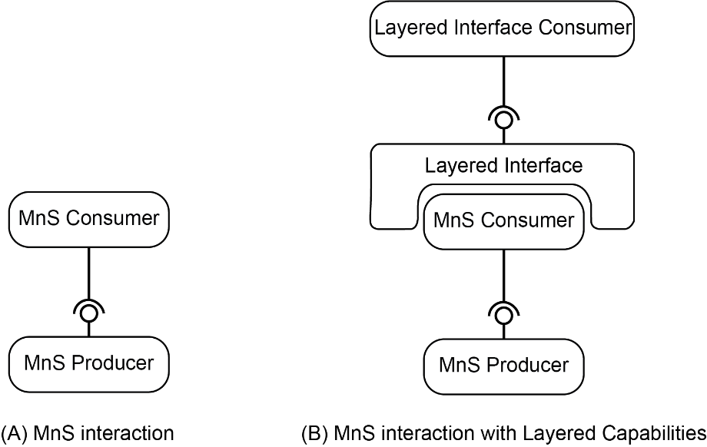

Figure B-1: Consumer Interaction with or without a Layered Interface

In Figure B-1, above, two distinct architectures are shown.

(A) includes a well-defined and understood management system relationship as defined in 3GPP.

NOTE: Given only model (A), an implementation and deployment of NSOEU will only be feasible given two assumptions:

- Energy utility backend  IT systems from are able to consume as-is SA5 defined MnSs (i.e., they are able to interpret MnS component Type A, B and C,) and thus are able to become MnS consumers.

- As MnS consumers, the energy utility is authorized to gain access  to MnS producer capabilities, according to a previous authentication and authorization procedure. Such procedures are not in scope of this technical report.

It is noted that there are already systems that are deployed today by which energy utilities exchange information, mostly request and receive information, in a 'custom' (that is to say not a standards specified) manner. Extensive and successful experience in the past with custom exposed information through vendor extensions to RADIUS was the motivation to pursue SEI in 3GPP. This approach has two drawbacks:

- The functionality of the interface needs to be implemented for each energy utility-operator relationship.

- The security and policy governing this interface needs to be implemented for each energy utility-operator relationship.

TR XX. XXX [x] addresses these shortcomings of a proprietary approach,. The conclusions of the present document address the first shortcoming but not the second.

To address a policy and security framework for exposure of management services, the mechanisms in the conclusions of the present document can rely upon a layered interface.. The layered service can do so in a general way, so that capabilities that are supported for all forms of management services, including those for energy utilities and far beyond.

Additional layered services are possible beyond those for authorization, security and access policy.

For example, the CAMARA initiative of GSMA [18] aims to define, develop, integrate and validate APIs that 3rd parties can invoke. Unlike standard telco-centric APIs (e.g. 3GPP APIs), which are mostly focused on ensuring interoperability within (multi-vendor) and between operators, CAMARA APIs will follow developer-friendly style, with semantics and consumption patterns that are tailored to the business and operational needs of 3rd parties (including especially third parties who are not in the telecommunications industry sector, specifically.) CAMARA can in future focus on defining which information will be exchanged between the network operator and third parties, including energy utilities. As stated in [c], CAMARA offers an " Abstraction from Network APIs to Service APIs is necessary: To hide telco complexity making APIs easy to consume for customers with no telco expertise (user-friendly APIs); To fulfil data privacy and regulatory requirements; To facilitate application to network integration."

In summary, without layered interface support, the solutions in the present documentconform to the model depicted in Figure B-1 (A) above. The solution requires proprietary (closed) solutions to achieve the three objectives (hiding complexity, data privacy and regulatory requirements, application to network integration.) As soon as there are standards supporting layered interfaces over the solutions defined in the present document, be they NSCE or CAMARA or both, these shortcomings are resolved.

|  |
| --- |
| **Next Change** |

# Annex C: Use cases not pursued

## C.1 General

The use cases and the associated potential requirements in this annex have no associated solutions (clause 7) nor conclusions (clause 8).. The potential requirements listed are not to be considered as conclusions of the present document.

## C.2

### C.2

has to

### C.2

has to

has to

### C.2

## C.3

### C.3

e present

### C.3

### C.3

.

## C.4oc

### C.4

### C.4

### C.4

e present document [x]

### C.4

has to

### C.4

## C.5na

### C.5

### C.5

Table C.5.2-1: Parameters for alarms

|  |  |  |  |
| --- | --- | --- | --- |
|  |  |  |  |
|  |  |  |  |
|  |  |  |  |
|  |  |  |  |
|  |  |  |  |

### C.5r

## C.6ppircn

### C

### C

### Cr

## C.7

### C.

C.3

C.3

### C.

### C.r

|  |
| --- |
| **Next Change** |

## 

### 

### 

### 

## 

### 

### 

### 

## 

### 

### 

### 

### 

### 

### 

|  |  |  |  |
| --- | --- | --- | --- |
|  |  |  |  |
|  |  |  |  |
|  |  |  |  |
|  |  |  |  |
|  |  |  |  |

### 

|  |
| --- |
| **Next Change** |

## 

### 

### 

### 

## 

### 

### 

### 

|  |
| --- |
| **End of Changes** |