**3GPP TSG-SA5 Meeting #148e S5-233234d1**

**Electronic meeting, Online, 17 -25 April 2023**

**Source: Samsung, EUTC, EDF, Deutsche Telekom, BMWK, NOVAMINT**

**Title: Rel-18 pCR 28.829 – Clean up**

**Document for: Approval**

**Agenda Item: 6.9.3.0**

# 1 Decision/action requested

***The group is asked to discuss and approve the proposals.***

# 2 References

[1] 3GPP TR 22.867: "Study on 5G smart energy and infrastructure

[2] 3GPP TR 28.829: "Study on Network and Service Operations for Energy Utilities"

[3] S5-216428 : New SID on Network and Service Operations for Energy Utilities

# 3 Rationale

Changes in d1

-

This document cleans up TR 28.829. In addition to some editorial clean up, the following remaining editor's notes are resolved.

|  |  |  |  |
| --- | --- | --- | --- |
| **Clause** | **Editor's Note** | **Reason for removal** | **Changes** |
| 3.1 | **site operator:** In some network sharing scenarios, for some particularly base station(s) and/or cell site(s), there exist business entities who operate this infrastructure on behalf of MNOs.  Editor's Note: This term is to be clarified. | There was no clarification proposed to be added.  If some clarification is identified at SA5 148e, it will be added. | EN is removed. |
| 6.9.2 | **Use case service flow Preconditions**:  There is a feeder, whose operation requires smart energy services. The smart energy services are available through DSO equipment RTUs. These RTUs are connected with a router, a CPE in the DSO site, that supports a mobile telecommunications interface, a UE.  The DSO can obtain information from each UE in the DSO network. The DSO-MS is aware of the Base station ID of the serving base station for each UE.  Editor's Note: Additional clarification of the preceding two paragraphs will be added. | The two paragraphs lack of clarity is resolved. | The two paragraphs are reworded and a figure is added. The EN is removed. |
| 6.9.3 | PR 6.9.3-1. The 3GPP management system should expose management services, subject to operator policy and other conditions (see NOTE 4), to enable the DSO to provide the site operator with information concerning the expected restoration time of its distribution services for site operator for effected sites.  Editor's Note: Further detail may be needed for the preceding requirement. | No additional information is needed.  If some additional information is identified during SA5 148e, it will be added. | EN is removed. |
| 7.3 | 7.3 Key Issue #3: Energy utility and telecommunication coordinated recovery of energy service  Editor's Note: Key issue #3 corresponds to a solution provided in S5-23zzzz | The corresponding solution was not agreed at SA5 147, but is propopsed to be added in SA5 148e (please see S5-233zzz). | EN is removed. |
| 7.3.1.3 | The functions described here correspond to the requirements in the use case 6.9 "Business use case: Rapid Intervention for Outages without Redundant Topology".  Editor's Note: A new use case is proposed separately. This new use case includes the requirements referred to below. | The EN is not needed because the corresponding text is already in TR 28.829, 1.0.0, clause 6.9. | EN is removed. |

# 4 Detailed proposal

It is proposed to make the following changes in TR 28.829, 1.0.0.

|  |
| --- |
| **Start of Changes** |

3.1 Terms

For the purposes of the present document, the terms given in 3GPP TR 21.905 [1] and the following apply. A term defined in the present document takes precedence over the definition of the same term, if any, in 3GPP TR 21.905 [1].

**Distribution System Operator**: a natural or legal person who is responsible for operating, ensuring the maintenance of and, if necessary, developing the distribution system in a given area and, where applicable, its interconnections with other systems, and for ensuring the long-term ability of the system to meet reasonable demands for the distribution of electricity, see Article 2, definitions in DIRECTIVE (EU) 2019/ 944 [9].

**SCADA**: Stands for 'Supervisory Control and Data Acquisition'. This facility is for controlling the power grid. The management system of power grid is standardized by IEC TC 57, see Dashboard, scope [10].

**Distribution Automation**: Distribution Automation (DA) is the family of technologies, systems and processes (including sensors, actuators, processors, communication networks, switches, etc.) that enable the remote, real-time monitoring, operation, and optimization of utility distribution systems on the field.

**Remote Terminal Unit**: a host in a customer network operated entirely out of the scope of 3GPP standardization.

**Uninterruptable Power Supply**: an independent source of energy that, for a limited time duration, can sustain operations normally despite an interruption of energy distribution services.

**Customer Premises Equipment**: a component of communications infrastructure that is installed in the facility owned and operated by a customer.

**Energy Supply** **ID**: This is the point where the energy supply terminates in the operator site and has a unique ID that is known by both the MNO and DSO.

**site operator:** In some network sharing scenarios, for some particularly base station(s) and/or cell site(s), there exist business entities who operate this infrastructure on behalf of MNOs. This entity supports telecommunications operations and management, e.g. in network sharing scenarios.

|  |
| --- |
| **Next Change** |

### 6.9.2 Details

**Use case actors**

**DSO network operations center 'management system'**

The DSO network operations center management system (DSO-MS) maintains operational information used for DSO network operations. The DSO-MS supports interfaces defined in this use case. All other aspects of the DSO-MS are out of scope of 3GPP specification. The DSO-MS is a consumer of the 3GPP management system.

**Site Operator network operations center 'management system'**

The site operator network operations center management system (SiteOp-MS) has and can expose operational information to DSOs concerning the network's configuration and status. The SiteOp-MS as discussed in this use case can be considered a producer of management interfaces consumed by the DSO-MS. The SiteOp-MS is effectively a standardized subset of interfaces and semantics of the 3GPP management system.The SiteOp-MS is a 3GPP management system for 5G and the DSO-MS is not a 3GPP management system, however it supports mechanisms that are defined by 3GPP standards (e.g. it uses 'northbound interfaces' exposed by the 5G network management system.)

**Use case service flow Preconditions**:

There is an energy utility infrastructure site that is responsible for distribution of energy to customer sites. This energy utiltity infrastructure site's operation requires smart energy services. The smart energy services are used to manage and control DSO equipment. This equipment is present on a local area network in the energy utility infrastructure site, here termed the "Utility Service Provider Site Network". This local area network is connected with a router (an IP router,) present in the DSO site. This router (operated by the energy utililty) makes use of wireless communications by means of a mobile telecommunications interface, a UE. The MT

The Utililty Service Provider Site Network, its topology and the router itself are out of scope of 3GPP. From a 3GPP perspective, only the UE is relevant. The figure 6.9.2-2 is provided to clarify the scenario underlying this use case, from the customer's perspective.

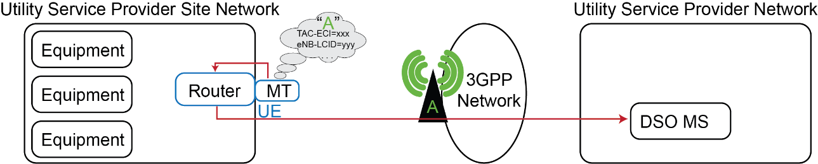

Figure 6.9.2-2: DSO Obtains Serving Network Information

The DSO can obtain information from each such IP router in the DSO network. These IP routers are able to obtain information that the mobile termination exposes to the upper layers of any UE. The DSO-MS is, by means of this informtion obtained from IP routers in the DSO network, aware of the Base station ID of the serving base station for each UE. Please see Figure 6.9.2-1 above representing this process.

On a regular basis, e.g. daily, the DSO-MS reads information from the SiteOp-MS exposed 3GPP management system MnS Producer's exposed interfaces. The DSO-MS is aware which base stations each of the DSO's UE camp on. The DSO-MS is also aware of which base stations rely on which Distribution Substation.

**Service Flow:**

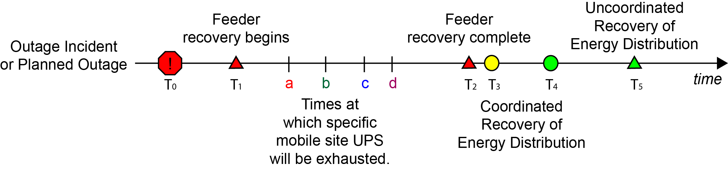

Figure 6.9.2-2: Timeline for Restoration of a Distribution Substation

1. At some time (T0) there is an outage incident either a planned or unplanned incident.

2. At some subsequent time (T1), the energy utility begins restoration of energy feeder lines or other affected infrastructure.

3. The period of time that will elapse before the restoration of energy service from some set of distribution substations will be *longer* than the UPS capacity of the mobile infrastructure sites. This use case assumes that the MNO knows or can estimate the remaining time of operation after T0 given the UPS capacity of different mobile infrastructure sites, shown as a, b, c, d in Figure 6.9.2-2. That is, T2 occurs *after* the UPS capacity in the sites affected by the energy outage. This use case assumes that the DSO knows or can estimate time at which energy distribution service can resume, shown as T2 in figure 6.9.2-2. This may not be the exact time at which resumption of energy service can resume, which is shown as T3. T2 is an estimate when the energy feeder of while crepresents the time at which energy feeder service resumes and restoration of distribution is possible. Please see the difference between figures 6.9.1-1 and 6.9.1-2 above: this depicts the event which occurs at T3.

4. The energy feeder for one or more energy distribution substations is now complete. At this point, it will be possible to restore energy distribution. However, operations are required at the distribution substation. This can be performed by smart energy services remotely if there is network coverage. The starting time, when the MNO provides service with remaining UPS capacity, is shown in Figure 6.9.2-1 as T3. The smart energy services to restore energy distribution services to all customers, including the MNO, is shown as T4.

There are two alternatives for how the restoration can occur. Manually, as described in 5a, or with remote intervention, as described in 5b.

5a. Without prior arrangement, there will be no UPS capacity remaining in the infrastructure that serves the distribution substations that have restored power. They will not be able to perform automated recovery, as explained in use case 6.3. In this case, manual intervention is required to restore energy distribution. This will be complete after a substantial period of time (T5).

5b. Alternatively, prior arrangement can be made so UPS capacity will remain in the infrastructure at the time it is needed to restore energy distribution service. This prior arrangement is described in the steps below, and consists of operations between the DSO-MS and MNO-MS.

This is to enable the situation that, at time (T3), the MNO is able to use remaining UPS capacity to offer telecommunication service at the time at which the DSO will perform remote operations by means of data communicadtions to restore service in the sites affected by the outage, and operates them until the outage concludes.

5.b.1. In this use case, the DSO-MS communicates to the MNO-MS:

- the affected sites (Energy Supply IDs) by the outage

- the time X after which recovery is possible

- the time Y (that is a certain interval of time after X) that the recovery is expected to complete (a small number of minutes)

The site operator, knowing this, has the opportunity to manage the use of the UPS in the affected sites so that they do not exhaust at time (a, b, c, d, etc.). Rather, capacity sufficient for operation between time X and Y are reserved. Figure 6.9.2-3 below shows a concrete example of this interaction.

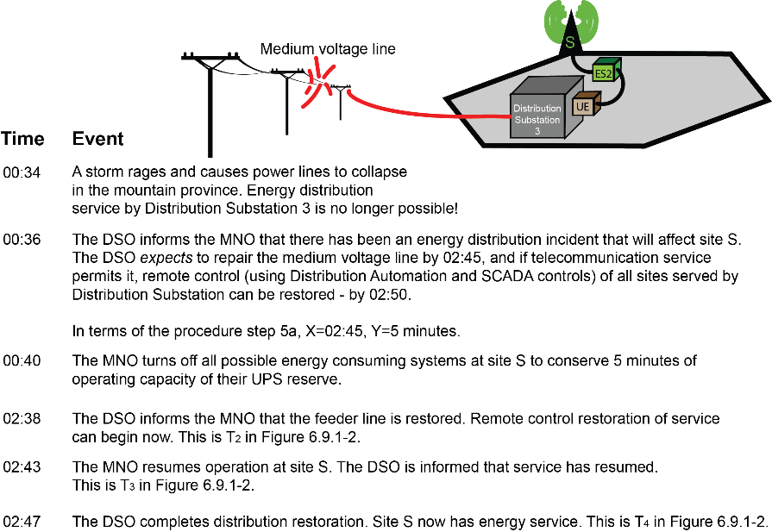

Figure 6.9.2-3: Example of Restoration of a Distribution Substation

5.b.2. The DSO, after time (T3), employs smart energy services such as distribution automation or specific SCADA operations to restore service to customers rapidly, including the site operator.

5.b.3. The incident concludes (T4). Energy distribution service has been restored to the MNO site(s) as well as other energy service customers.

**Service flow result**

T4 occurs before manual uncoordinated recovery of service would be successful (T5 in Figure 6.9.2-2.) Thus, alternative 5.b is superior to 5.a for both the site operator and the DSO.

Service is restored to distribution substation 3 and 4 at T4, within minutes of the restoration of the medium voltage line between distribution substation 2 and 3 T3. This is substantially faster than service could be restored if a technician had to visit distribution substation 2 and 3 - represented on Figure 6.9.2-2 as T5. As a result, service is restored to the MNO sites affected more rapidly than in an uncoordinated incident.

|  |
| --- |
| **Next Change** |

6.9.3 Potential Requirements

This use case also has potential requirements 6.8.3-1, 6.8.3-2, 6.8.3-3 and 6.8.3-4.

For all the requirements below, supported interaction is described between the DSO and the site operator or site operator. The reason for this term 'site operator' is that in network sharing scenarios, the base station and/or cell site may be operated by a third party. In active network sharing scenarios the DSO can communicate with an site operator that operates the site, but can be distinct from the serving site operator. The interaction described is really between the DSO and the management services of the entity that operates the site essential for telecommunication service, identified by the energy supply ID.

PR 6.9.3-1. The 3GPP management system should expose management services, subject to operator policy and other conditions (see NOTE 4), to enable the DSO to provide the site operator with information concerning the expected restoration time of its distribution services for site operator for effected sites.

PR 6.9.3-2. The 3GPP management system should support, subject to operator policy and other conditions (see NOTE 3), the capability to enable the DSO (or site operator) to provide the site operator with information concerning the time when DSO is ready to remote energy distribution services can resume.

NOTE 1: The time when communication services are needed corresponds to the time when DSO has restored its energy transmission service and is ready to remote energy distribution services can resume.

PR 6.9.3-3. The 3GPP management system should support, subject to operator policy and other conditions (see NOTE 3), the capability to enable the DSO to provide the site operator with information concerning the time duration for which DSO expects to require site operator's communication services to achieve coordinated recovery for being able to use smart energy services to restore its energy distribution services.

NOTE 2: The time that the DSO provides to the site operator can be adjusted as new information becomes available. The time estimate can specify which base stations are needed for the remote recovery operations.

PR 6.9.3-4. The 3GPP management system should support, subject to operator policy and other conditions (see NOTE 3), the capability to enable the DSO to provide the site operator with information concerning the locations where for example DSO substations need to restore distribution services on priority.

NOTE 3: Location information expressing where restoration will occur could be expressed in terms such as latitude-longitude pairs or Energy Supply Id.

PR 6.9.3-5. The 3GPP management system should support, subject to operator policy and other conditions (see NOTE 3), the capability to enable the DSO to provide the site operator with information concerning the time at which MNO (or site operator) should actually able to provide communication services to achieve coordinated recovery to DSO for a particular region.

PR 6.9.3-6. The 3GPP management system should support, subject to operator policy and other conditions (see NOTE 3), the capability to enable the DSO to provide the site operator with information concerning the time duration for which site operator should actually able to provide communication services to achieve coordinated recovery to DSO for a particular region.

NOTE 4: The above requirements enable the site operator to voluntarily discontinue service, retain UPS capacity, and wait until an opportune time to restore service. This is subject to operator policy, contractual obligations and regulatory restrictions.

|  |
| --- |
| **Next Change** |

7.3 Key Issue #3: Energy utility and network operator coordinated recovery of energy service

|  |
| --- |
| **Next Change** |

7.3.1 Description

#### 7.3.1.1 General

This describes the issues to study in context of the use case of Energy utility and network operator coordinated recovery of energy service.

There is clearly a mutual interest in coordination between network operator operations and energy service operations to achieve rapid recovery of energy service. This is not only true for the MNO, who benefits from the availability of supplied power, but also of the DSO who needs mobile telecommunication service to restore and maintain the operation of its grid.

NOTE: Though DSOs use many forms of access (e.g. fixed access, dedicated fiber access, etc.), they increasingly rely on telecommunications services for communication access to many substations and other facilities. It therefore directly benefits the overall availability of communication service for the energy utility when the availability of the telecommunication service improves. The Energy utility provider (DSO) knows when and where outage has occured and when telecommunication services are critically important for recovery. The MNO knows their uninterruptable power supply resources and the possibility of utilizing telecommunication services to enable utility’s energy system rapid recovery via smart energy services.

Without a standardized mechanism to share all this information, the service recovery mechanism would be very inefficient and time consuming. Therefore, a standardized mechanism is needed to share all this information between DSO and MNO to enable efficient usage of smart energy services for service recovery.

|  |
| --- |
| **Next Change** |

#### 7.3.1.3 Coordinated Recovery of energy service without redundent topology

The functions described here correspond to the requirements in the use case 6.9 "Business use case: Rapid Intervention for Outages without Redundant Topology".

The key issue topics described in 7.3.1.2 must be resolved for this key issue. In addition, the following key issues must also be addressed.

a) How does the DSO provide the MNO with information concerning the *expected time* at which the DSO will be able to restore its energy services? [PR 6.9.3-1]

b) How does the DSO provide the MNO with the  *time* at which it has restoted its energy transmission service? [PR 6.9.3-2]

c) How does the DSO provide the MNO with the *time duration* that the DSO expects to require to restore energy services, facilitated by telecommunication services? [PR 6.9.3-3]

d) How does the DSO inform the MNO of the locations affected by an energy service outage (latitude-longitude pairs, energy supply IDs) where the DSO will like to restore service on priority than some other locations? [PR 6.9.3-4]

e) How does the MNO inform the DSO of the *actual time* and *locations* (e.g. base station IDs) where the MNO is *able* to provide telecommunication services to enable the DSO to restore energy service? [PR 6.9.3-5]

f) How does the MNO inform the DSO of the *time duration* for which the MNO is *able* to provide telecommunication services to enable the DSO to restore energy service? [PR 6.9.3-6]

|  |
| --- |
| **End of Changes** |