3GPP TSG-SA5 Meeting #148e S5-233231

E-meeting, 17-21 April 2023

Source: Nokia, Nokia Shanghai Bell

Title: pCR 28.912 Potential Solution on Intent-driven Closed Loop control

Document for: Approval

Agenda Item: 6.7.3.3

1 Decision/action requested
The group is asked to discuss and approval.

2 References
[1] 3GPP draft TR28.912: “Study on enhanced intent driven management services for mobile networks”.

3 Rationale
Intents may be used to manage and control closed loops. This pCR proposes a potential solution for such manage and control closed loops.

4 Detailed proposal

1st Change

4.8 Key Issue#4.8: Enablers for Intent Fulfilment

4.6 Issue#4.6: Intent-driven Closed Loop control

4.6.1 Description
A Closed Loop (CL) is an entity that implements the capabilities to get data, analyse it, generate decision and execute those decision on the network. It may be implemented in one or more stages (in Figure 1 as 4 or 3 stages) and each may be implemented by a specific component (i.e. MnF). Each CL may implement a Closed-loop Control (CC) as the producer of CL management services that support control capabilities used to manage or control the closed loop and to support interaction with the external world.
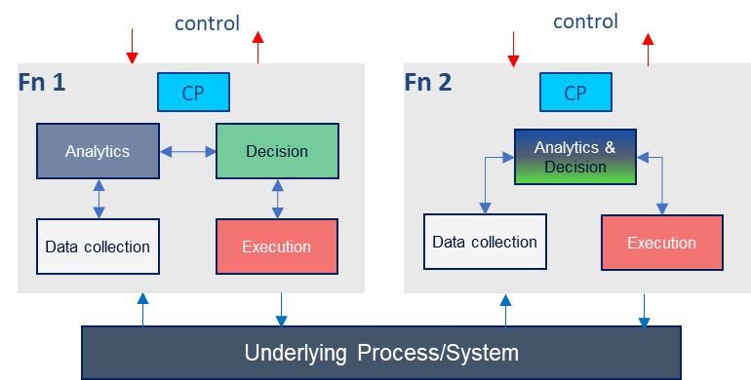
Figure 4.6.1-1: Example relations among closed loop components
Given a set of deployed network functions and/or management functions, the Closed-Loop Control may configure different network and management functions to achieve the desired closed loop goals based on intents with the input “context” (e.g. capabilities, control or use case) provided by the operator, as illustrated by Figure 4.N.1-3. Within the intent driven system, the MnS producer for intent driven MnS may play the role of closed loop control to implement the intent driven closed loop or interact with closed loop control to control the closed loop.
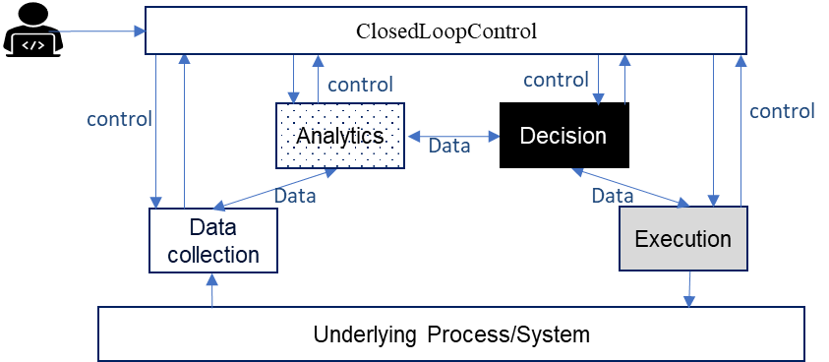
Figure 4.6.1-2: Using Intents towards Closed-Loop Control to automate closed loops management and control
Editor's Note: above closed loop description needs to be revised based on content in TS 28.535 and TS 28.312.
REQ-Intent_GEN_CON_01: The 3GPP management systems shall support a capability to allow a consumer (e.g. an operator) to express an intent to enable the provider of CL management to configure a CL based on an intent that expresses the intent expectations as closed loop goals, KPI, SLS, SLA targets, input-output pairs or capabilities
REQ-Intent_GEN_CON_02: The 3GPP management systems shall support a capability to allow a consumer (e.g. an operator) to express an intent to enable the provider of CL management to configure its constituent management functions and goals to achieve the objectives/expectations of the intent.
REQ-Intent_GEN_CON_03: The 3GPP management systems shall support a capability to inform an authorized consumer (e.g., an operator) about closed loops and management functions servicing the intent

4.6.2 Potential solutions
Introduce an expectation with targets which capture the objectives for an entity that undertakes optimization. The expectation may be termed as network optimization expectation. The network optimization expectation may be expressed for a network slice or a network slice subnet i.e., the expectation object may be a network slice or a network slice subnet, . This enables the MnS Producer to take steps, e.g., configure closed loops or the goals thereof intended to deliver on those targets.
The network optimization expectation targets may express the desired optimization outcomes. Depending on the stated targets, the MnS producer may as such configure one or more closed loops or optimization functions to achieve the desired targets. The network optimization expectation targets may for example be KPI targets that the optimization is required to achieve.
The network optimization expectation may include relative prioritizations of the different targets which indicate the relative interests of the intent MnS consumer on the different optimization targets.
Introduce the list of Closed loop Identifiers (e.g., DN of AssuranceClosedControlLoop) in IntentReport IOC to represent the closed loop instance(s) used to satisfy the intent.

2nd Change

7 Conclusion and recommendation

7.1 Conclusion and recommendation for new capabilities

7.1.1 Issue#4.1: intent driven approach for RAN energy saving
It is recommended to introduce the scenario and requirements for intent driven approach for RAN energy saving, and define corresponding scenario specific IntentExpectation definition (including introducing new expectation targets for RAN Energy Consumption and RAN Energy Efficiency). The detailed solution see clause 4.1.2.

7.1.2 Issue#4.2: Intent conflicts and intents containing contradictions
It is recommended to introduce three intent related conflict scenarios, including Target conflict, Expectation conflict and Intent conflict. Also recommend to introduce the notification information provided by MnS producer when such a conflict is detected with the specified intent, intent expectations or expectation targets which give rise to the conflict. Additionally, MnS consumer can give intent conflict handling guidelines to MnS producer as contexts to solve such intent conflict.

7.1.3 Issue#4.3: Enhancement of radio network intent expectation
It is recommended to enhance the existing radio network intent expectation to support following aspects:
- Support MnS consumer to express the radio network expectation targets for the coverage area represented by a list of Cells.
- Support MnS consumer to express the radio network expectation targets for the specific service type or UE groups instead of the whole radio network.
-Support MnS consumer to express the radio network capacity targets (including Maximum HighUL/DLPRB Load Ratio) for the specified areas.
-Support MnS consumer to express the radio network transport contexts (including NgInterfaceContext, OMInterfaceContext and NextHopContext) for delivering a radio network for a specified area.
-Support MnS consumer to express the radio network expectation targets for specific time periods.
The detailed solution see clause 4.3.2.

7.1.4 Issue#4.4: 5GC related intent expectations
It is recommended to introduce the IntentExpectation for core network by utilizing the construct of the generic IntentExpectation <<dataType>> with set of allowed values and concrete dataTypes, including the objectType, ObjectContext and ExpectationTargets for the 5GC to represent MnS consumer’s expectation for 5GC.
The detailed solution see clause 4.4.2.1

7.1.5 Issue#4.5: Intent Report
TBD

7.1.6 Issue#4.6: Intent-driven Closed Loop control
It is recommended to introduce a network optimization expectation which capture the desired optimization targets for a specific network scope and which then enable ethe MnS producer to configure one or more closed loops with goals to achieve the optimization targets.
The detailed solution see clause 4.6.2

7.1.7 Issue#4.7: Monitoring intent fulfilment information
TBD

7.1.8 Issue#4.8: Enablers for Intent Fulfilment

7.1.8.4.1 Testing Intent-driven MnS Capabilities

7.1.8.4.2 Mapping of Intents to ML Entities capabilities
It is recommended to introduce the AIML_capability_mapping_report <<datatype>> with which the intent driven MnS Producer can inform its potential intent driven MnS consumers about the AI/ML capabilities it relies on to accomplish intent fulfilment. Additionally, it is recommended to introduce an attribute on the intent object that used by an intent driven MnS consumer to request for specific capabilities to be applied for their intents.

7.1.8.4.3 Intent-driven SON orchestration
It is recommended to introduce

7.1.9 Issue#4.9: Intent fulfilment feasibility check
TBD

7.1.10 Issue#4.10: Intent handling capability obtaining
It is recommended to introduce the new IntentHandlingFunction <<IOC>>, which includes a list of supportedIntentHandlingCapability <<datatype>> which represent intent handling function's capabilities in support of intent handling. Change the Intent <<IOC>> to be contained by IntentHandlingFunction <<IOC>>.
The detailed solution see clause 4.10.2

7.1.11 Issue#4.11: Enhancement of generic Information model definition
It is recommended to enhance the existing generic intent information model support following aspects:
- Introduce attribute "intentAdminState" in Intent <<IOC>> to allow MnS consumer to suspend and resume an intent.
- Introduce attribute "observationTime" in Intent <<IOC> to allow MnS consumer to specify the observation period for the intent fulfilment evaluation
- The detailed solution see clause 4.11.2

End of changes

