**3GPP TSG-SA5 Meeting #145-e *S5-225526rev1***

**e-meeting, 15 August – 24 August 2022**

**Source: China Mobile**

**Title: pCR TR 28.833 Add Annex A of UML code of FS_5GLAN_Mgt**

**Document for: Approval**

**Agenda Item: 6.8.4.3**

# Decision/action requested

***The group is asked to discuss and endorse the proposal in section 4***

# 2 References

[1] SP-220324 " New Study on Management Aspects of 5GLAN "

[2] 3GPP TS 23.501: "System Architecture for the 5G System; Stage 2".

[3] 3GPP TS 22.261: "Service requirements for next generation new services and markets; Stage 1".

# 3 Rationale

This contribution proposes to add potential solutions for TR 28.833.

# 4 Detailed proposal

It proposes to make the following changes.

|  |
| --- |
| **1st Change** |

Annex A (informative):  
Plant UML source code

A.1 Procedure for Topic1: 5G VN group data management

@startuml

!theme plain

"Management service provider" -> "Management service customer": 1. Allocate 5G LAN-type service(s) request

"Management service customer" -> "Management service customer":2. 5G LAN-type service(s) configuration

"Management service customer" -> "Management service provider":3.Allocate 5G LAN-type service(s) response

@enduml

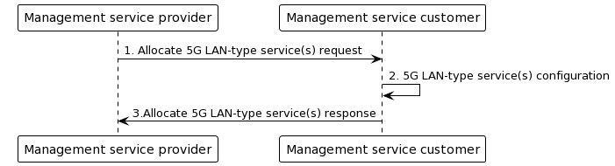

A.2 Procedure for Topic 2: PDU Session management

@startuml

!theme plain

"Management service provider" -> "Management service customer": 1. Allocate 5G LAN-type service(s) request

"Management service customer" -> "Management service customer":2. 5G LAN-type service(s) configuration

"Management service customer" -> "Management service provider":3.Allocate 5G LAN-type service(s) response

@enduml

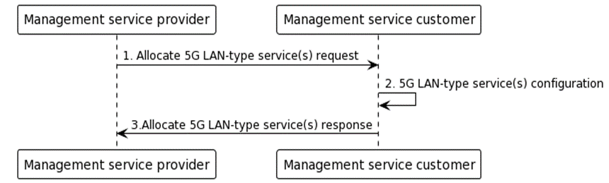

|  |
| --- |
| **End of Change** |