3GPP TSG SA WG5 Meeting 145-e S5-225500

electronic meeting, online, 15-24th August 2022
CR-Form-v12.0
CHANGE REQUEST
 | 28.405 | CR | 0014 | rev | - | Current version: | 17.2.0
For HELP on using this form: comprehensive instructions can be found at
http://www.3gpp.org/Change-Requests.

Proposed change affects: | UICC apps |  | ME |  | Radio Access Network | X | Core Network | X

Title: | Adding Signalling Based Activation for NR
Source to WG: | Ericsson, Nokia
Source to TSG: | S5
Work item code: | eQoE |  |  |  |  |  | Date: |  |  | 2022-08-03
Category: | B |  |  |  |  |  | Release: |  |  | Rel-18
 | Use one of the following categories:  F (correction)  A (mirror corresponding to a change in an earlier release)  B (addition of feature),  C (functional modification of feature)  D (editorial modification)  Detailed explanations of the above categories can  be found in 3GPP TR 21.900. |  |  |  |  |  |  |  | Use one of the following releases:  Rel-8 (Release 8)  Rel-9 (Release 9)  Rel-10 (Release 10)  Rel-11 (Release 11)  …  Rel-15 (Release 15)  Rel-16 (Release 16)  Rel-17 (Release 17)  Rel-18 (Release 18)
Reason for change: |  | The feature was missing in the specification
Summary of change: |  | Add Signalling Based Activation for NR
Consequences if not approved: |  | Not aligned with RAN and CT groups resulting in interoperability problems
Clauses affected: |  | 4.z (new), 4.z.1 (new), 4.z.1.2 (new), 4.z.1.3 (new)
 |  | Y | N
Other specs |  |  | x | Other core specifications |  |  |  | TS/TR ... CR ...
affected: |  |  | x | Test specifications |  |  |  | TS/TR ... CR ...
(show related CRs) |  |  | X | O&M Specifications |  |  |  | TS 28.622 CR 0174
Other comments:
This CR's revision history:

First change

4.z Signalling based activation in NR

4.z.1.0 Activation of measurement collection for a UE in NR
Activation of measurement collection for a UE can be done after UE is registered or before UE Registration procedure.

4.z.1.1 Activation of QoE measurement task after completion of UE registration procedure
Figure 4.z.1.1-1 and the text below describes the activation of QoE measurement collection after completion of UE registration procedure.
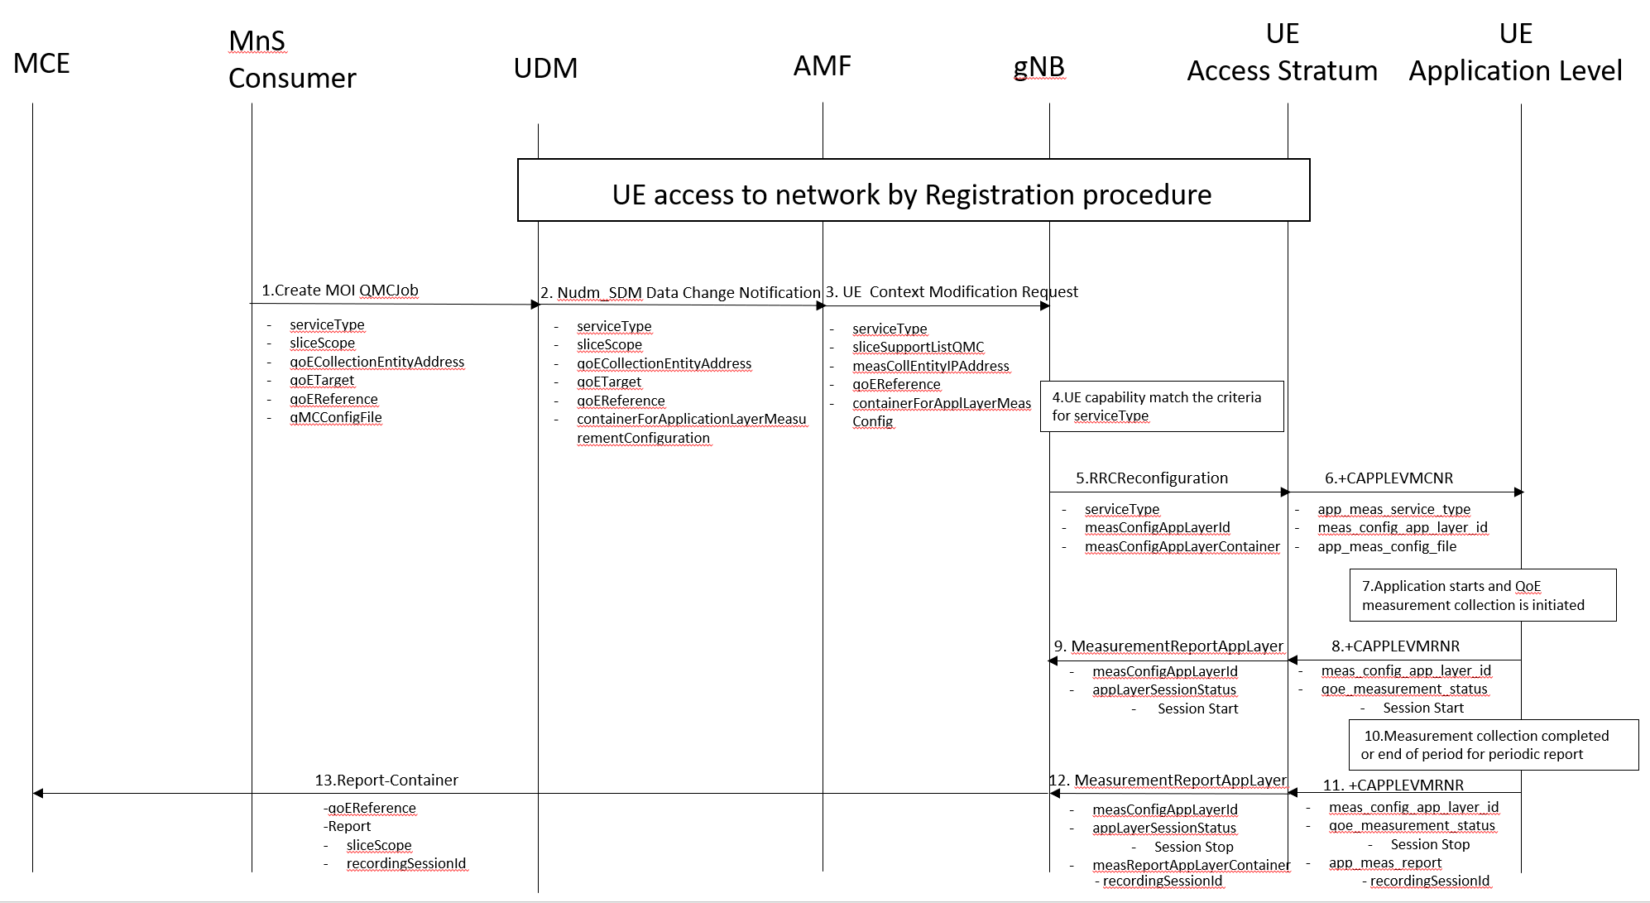
Figure 4.z.1.1-1: QMC activation and reporting in NR after UE is registered

1. The MnS Consumer sends createMOI request for QMCJob to UDM that controls the impacted gNB(s), and includes the parameters: serviceType, sliceScope, qoECollectionEntityAddress, qoETarget, qoEReference and qMCConfigFile.
2. The UDM inserts subscriber related data and forwards it to the AMF.
3. The AMF forwards the configuration parameters serviceType, sliceSupportListQMC, measCollEntityIPAddress, qoEReference and containerForAppLayerMeasConfig in message UE Context Modification Request to the impacted gNB.
4. The gNB checks if the UE capability matches the criteria for serviceType in the QoE measurement configuration information.
5. If the UE has the wanted UE capability, the gNB starts a UE request session and stores the associated qoECollectionEntityAddress, sends the message RRCReconfiguration to the UE including serviceType, measConfigAppLayerId and measConfigAppLayerContainer.
NOTE: The IE measConfigAppLayerId indicates the identity of the application layer measurement configuration, see [14].
6. The access stratum in the UE sends an unsolicited response to the application level including app-meas_service_type, meas_config_app_layer_id and app-meas_config_file. The unsolicited response is for the AT command +CAPPLEVMCNR which is sent from UE Application Level to UE Access Stratum during Registration procedure.
7. When the application for the specified serviceType starts, the QMC is initiated. To specify the session which is started, the application generates a recordingSessionId.
8. The application layer sends the AT command +CAPPLEVMRNR [7] including meas_config_app_layer_id and qoe_measurement_status that indicates that a session is started to the access stratum.
9. The UE sends the message MeasurementReportAppLayer including measConfigAppLayerId and appLayerSessionStatus to the gNB.
10. When the QMC is completed or at the end of period for periodic report, the recorded information is collected in a QMC report, see [6], [7] or [13].
11. The application layer sends the AT command +CAPPLEVMRNR [7] including meas_config_app_layer_id, qoe_measurement_status indicating that session has ended and app-meas_report including recordingSessionId to the access stratum.
12. The UE sends the message MeasurementReportAppLayer including measConfigAppLayerId, appLayerSessionStatus and measReportAppLayerContainer including recordingSessionId to the gNB.
13. The gNB sends the QMC report to the MCE associated to the qoEReference. The report contains the qoEReference and the RAN transparent container including the recordingSessionId and sliceScope, which contains only the S-NSSAI used. Note that the qoEReference is mappaed to the measConfigAppLayerId at gNB on the previous step and is included in QMC report.

4.z.1.2 Activation of QoE measurement task before UE Registration procedure to the network
Figure 4.z.1.2-1 and the text below describes the activation of QoE measurement collection before UE registration procedure to the network.
The AMF receives and stores QoE measurement collection job as part of API: Numd_SDM . Then the same procedure for activation of measurement collection job is applied as after completion of UE registration procedure, except that instead of UE Context Modification Request the message Initial Context Setup Request is sent, see 4.z.1.1.
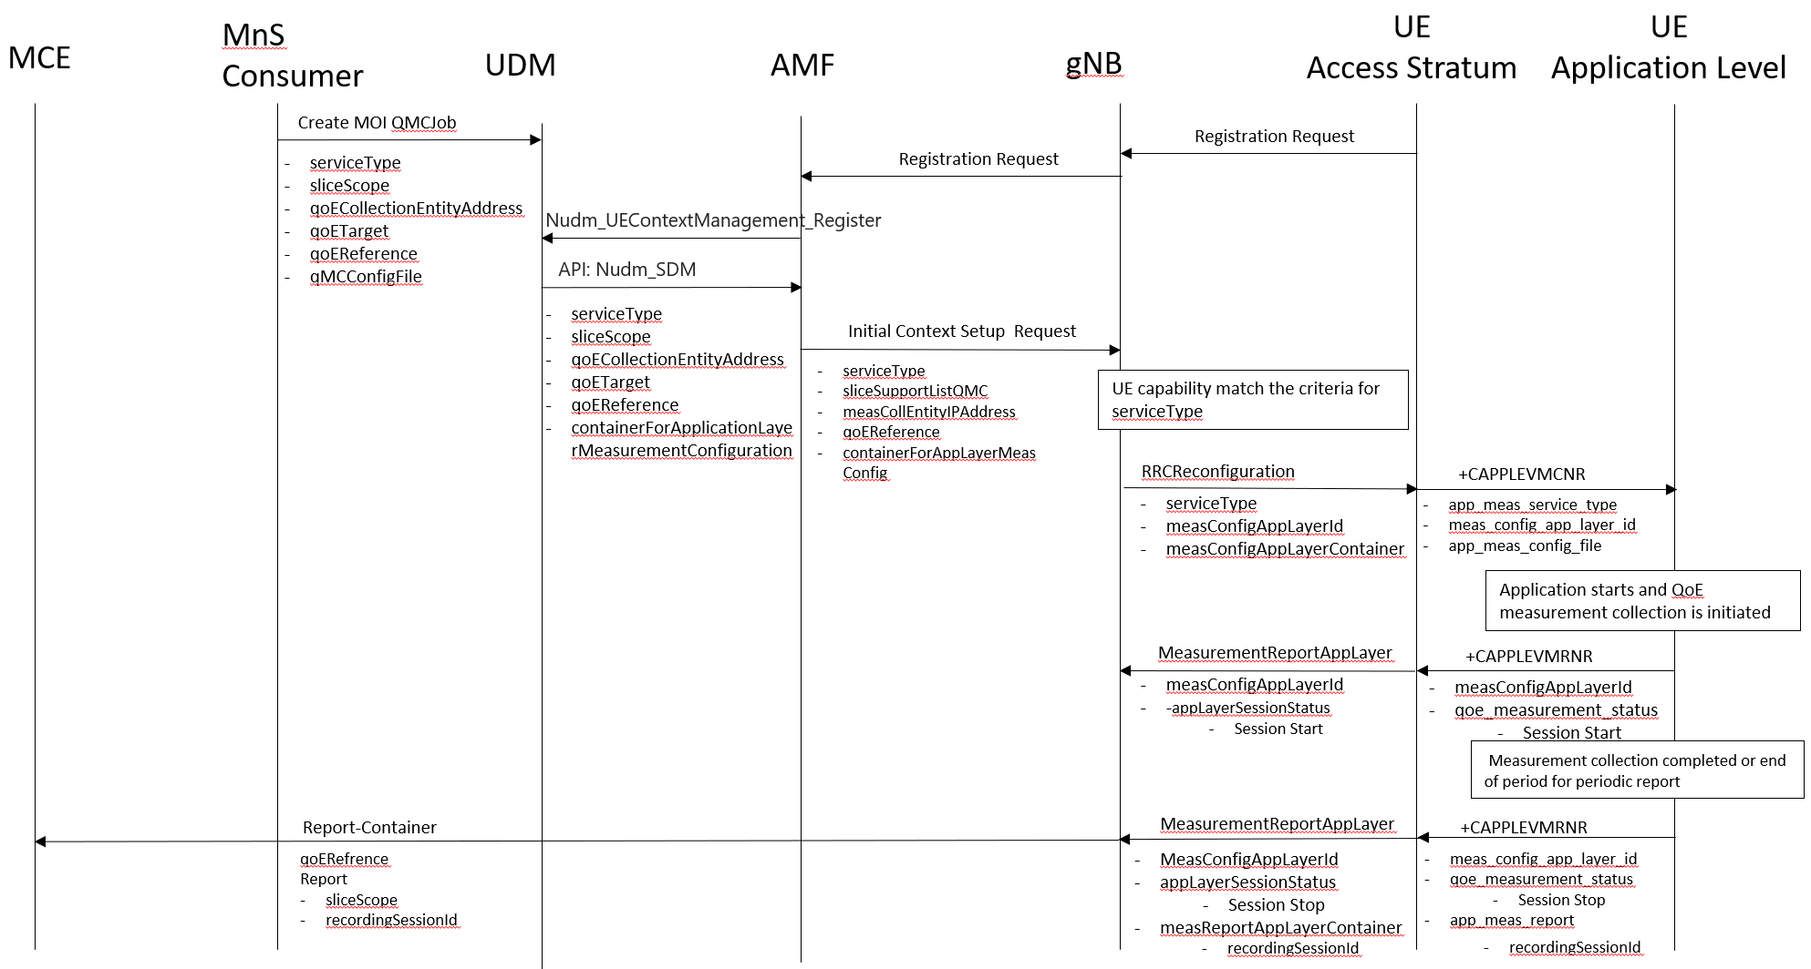
Figure 4.z.1.2-1: QMC activation and reporting in NR before UE Registration procedure to the network

End change

