3GPP TSG SA WG5 Meeting 145-e S5-225350

electronic meeting, online, 15-24th August 2022
CR-Form-v12.0
CHANGE REQUEST
 | 32.422 | CR | 0402 | rev |  | Current version: | 17.7.1
For HELP on using this form: comprehensive instructions can be found at
http://www.3gpp.org/Change-Requests.

Proposed change affects: | UICC apps |  | ME |  | Radio Access Network | X | Core Network | X

Title: | Correction on NG-RAN activation mechanism
Source to WG: | Ericsson
Source to TSG: | S5
Work item code: | TM_SBMA |  |  |  |  |  | Date: |  |  | 2021-08-03
Category: | A |  |  |  |  |  | Release: |  |  | Rel-17
 | Use one of the following categories:  F (correction)  A (mirror corresponding to a change in an earlier release)  B (addition of feature),  C (functional modification of feature)  D (editorial modification)  Detailed explanations of the above categories can  be found in 3GPP TR 21.900. |  |  |  |  |  |  |  | Use one of the following releases:  Rel-8 (Release 8)  Rel-9 (Release 9)  Rel-10 (Release 10)  Rel-11 (Release 11)  …  Rel-15 (Release 15)  Rel-16 (Release 16)  Rel-17 (Release 17)  Rel-18 (Release 18)
Reason for change: |  | Trace reporting format parameter is unused and alignment with 38.413/423.
Summary of change: |  | Trace reporting format describes if the output is to file or stream. But if URI is provided it is stream, else it is file. Trace reporting format is needed to be removed for better alignment with 38.413/423.
Consequences if not approved: |  | The TS contains unused information
Clauses affected: |  | 4.1.1.8, 4.1.1.9.1, 4.1.2.15.1, 4.1.2.15.2, 4.1.2.15.3, 4.1.2.16, 4.2.3.11, 4.2.3.12, 5.11
 |  | Y | N
Other specs |  |  | x | Other core specifications |  |  |  | TS/TR ... CR ...
affected: |  |  | x | Test specifications |  |  |  | TS/TR ... CR ...
(show related CRs) |  | X |  | O&M Specifications |  |  |  | TS 28.622 and TS 28.623
Other comments:
This CR's revision history:

First change

4.1.1.8 5GC Domain activation mechanisms
When an AF, AMF, AUSF, NEF, NRF, NSSF, PCF, SMF, SMSF, UPF or UDM receives Trace Session activation from the management function, it shall start a Trace Session. The following trace control and configuration parameters of the Trace Session are received in the Trace Session activation from the management function:
- Trace Target: SUPI or IMEISV.
- Trace Reference.
- Triggering Events for this network element.
- Trace Depth.
- List of Interfaces for this network element.
- Trace Collection Entity IP Address for the file-based trace reporting or Trace Reporting Consumer URI for the streaming trace reporting.

The AF, AMF, AUSF, NEF, NRF, NSSF, PCF, SMF, SMSF, UPF or UDM shall not forward these trace control and configuration parameters to other nodes. The received trace control and configuration parameters shall be saved and used to determine when and how to start a Trace Recording Session. (Starting a Trace Recording Session is described in subclause 4.2.2.9).
Next change

4.1.1.9 NG-RAN activation mechanisms

4.1.1.9.1 General
In NG-RAN the Management Based Trace Activation can be fulfilled with the NG-RAN Cell Traffic trace functionality. In this case the Trace Session Activation is done to one or a list NG-RAN cells within one NG-RAN node, where Trace Session is activated.
The following trace control and configuration parameters of the Trace Session are received by NG-RAN node in the Trace Session activation message from the management system:
- Trace Reference.
- Trace Depth.
- Trace Target: NG-RAN cells list.
- List of Interfaces for NG-RAN node.
- Trace Collection Entity IP Address for the file-based trace reporting or Trace Reporting Consumer URI for the streaming trace reporting.

When NG-RAN node receives the Trace Session Activation message from the management system for a given or a list of NG-RAN cell(s) the NG-RAN node shall start a Trace Session for the given or list of NG-RAN cell(s).
Next change

4.1.2.15 5GC activation mechanism

4.1.2.15.1 UE attached to 5GC via NG-RAN
Figure 4.1.2.15.1.1 illustrates the signaling Trace Session activation procedure in 5GC as part of the Registration procedure:
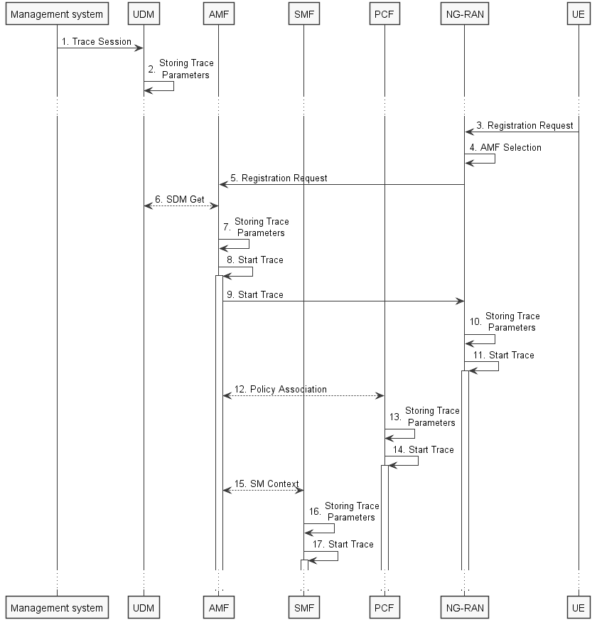
Figure 4.1.2.15.1.1: Trace activation in 5GC following the Registration procedure
The steps 3-6, 12 and 15 below are parts of the General Registration procedure - see 3GPP TS 23.502 [41] clause 4.2.2.2 for specific details. Present document does not attempt to re-define how General Registration procedure works, but rather illustrates the signaling Trace Activation aspects.
1. Management system activates Trace Session to the UDM. The following trace control and configuration parameters shall be included in the Trace Activation message:
- Trace Target: SUPI or IMEISV.
- Trace Reference.
- Triggering Events for AMF, SMF, UPF and PCF.
- Trace Depth.
- List of NE Types to trace.
- List of Interfaces for AMF, SMF, UPF, PCF and NG-RAN.
- Trace Collection Entity IP Address for the file-based trace reporting or Trace Reporting Consumer URI for the streaming trace reporting.

2. UDM stores the trace control and configuration parameters received from the management system.
3. UE sends Registration request to NG-RAN node.
4. NG-RAN node selects appropriate AMF.
5. NG-RAN node forwards the UE Registration request to the selected AMF.
6. AMF receives the trace control and configuration parameters information from UDM via Nudm_SDM_Get operation (see step 14 in clause 4.2.2.2.2 and clause 5.2.3.3 of 3GPP TS 23.502 [41]).
7. AMF stores the trace control and configuration parameters received from the UDM.
8. AMF starts the Trace Session according to the received configuration.
9. AMF sends the Start Trace message over NG interface (N2 interface from the 5GC perspective)
10. NG-RAN node stores the trace control and configuration parameters received from the AMF. This step is part of NG-RAN signaling trace activation - see clause 4.1.2.16 for more details.
11. NG-RAN node starts the Trace Session according to the received configuration. This step is part of NG-RAN signaling trace activation - see clause 4.1.2.16 for more details.
12. AMF establishes Policy Association with PCF (see step 16 in clause 4.2.2.2.2 of 3GPP TS 23.502 [41]) and provides the trace control and configuration parameters information to the PCF.
13. PCF stores the trace control and configuration parameters received from the AMF as part of Policy Association.
14. PCF starts the Trace Session according to the received configuration.
15. AMF provides the trace control and configuration parameters information to the SMF as part of the SM Context (see step 18 in clause 4.2.2.2.2 of 3GPP TS 23.502 [41]).
16. SMF stores the trace control and configuration parameters received from the AMF.
17. SMF starts the Trace Session according to the received configuration.

Figure 4.1.2.15.1.2 illustrates the signaling Trace Session activation procedure in 5GC as part of the PDU Session Establishment procedure for the UE that has already been registered:
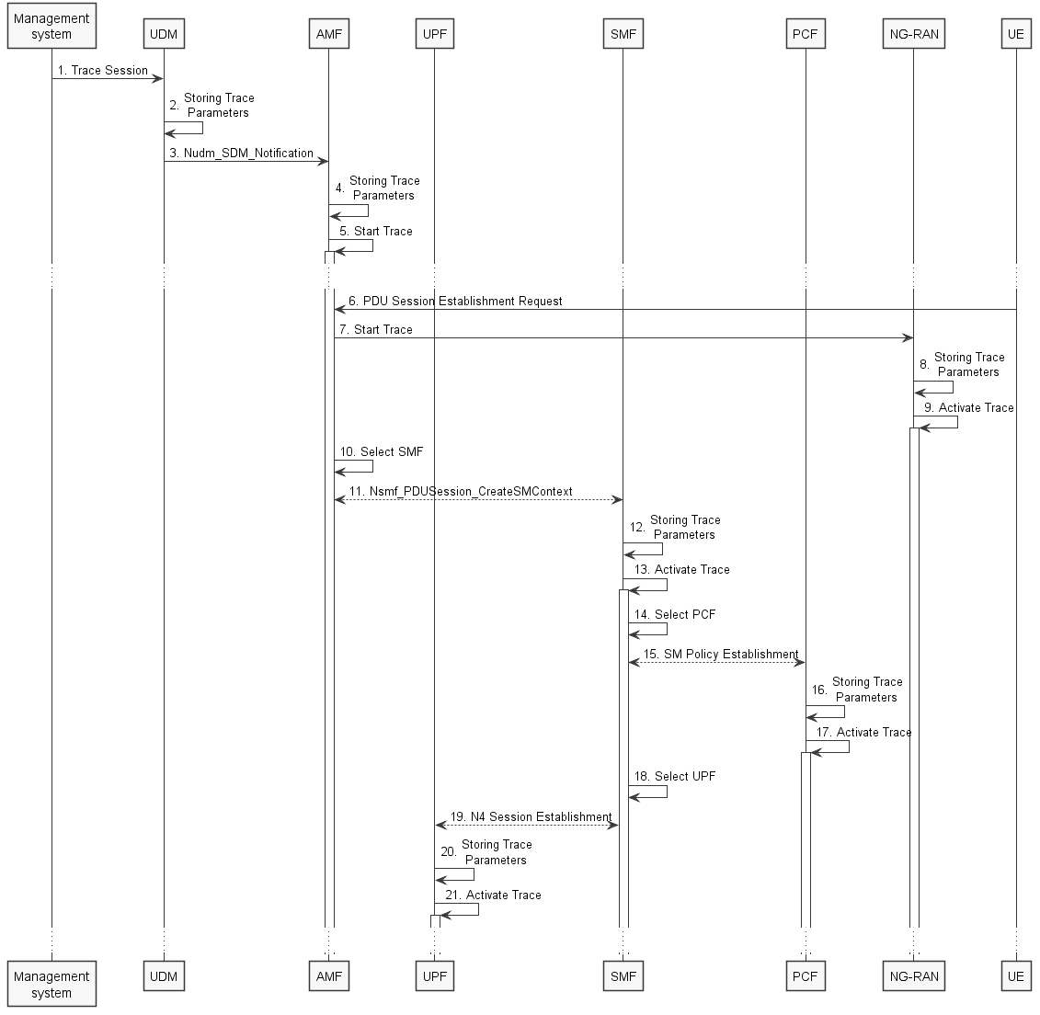
Figure 4.1.2.15.1.2: Trace activation in 5GC following the PDU Session Establishment procedure
The steps 6, 10, 11, 14 and 15 below are parts of the UE Requested PDU Session Establishment procedure - see 3GPP TS 23.502 [41] clause 4.3.2.2 for specific details. Present document does not attempt to re-define how UE Requested PDU Session Establishment procedure works, but rather illustrates the signaling Trace Activation aspects.
1. Management system activates Trace Session to the UDM. The following trace control and configuration parameters shall be included in the Trace Activation message:
- Trace Target: SUPI or IMEISV.
- Trace Reference.
- Triggering Events for AMF, SMF, UPF and PCF.
- Trace Depth.
- List of NE Types to trace.
- List of Interfaces for AMF, SMF, PCF, UPF and NG-RAN.
- Trace Collection Entity IP Address for the file-based trace reporting or Trace Reporting Consumer URI for the streaming trace reporting.
- .
2. UDM stores the trace control and configuration parameters received from the management system.
3. UDM sends Nudm_SDM_Notification to AMF with the trace control and configuration parameters information (see clauses 4.5.1 and 5.2.3.3 of 3GPP TS 23.502 [41]).
4. AMF stores the trace control and configuration parameters received from the UDM.
5. AMF starts the Trace Session according to the received configuration.
6. UE sends PDU Session Establishment request to AMF
7. AMF sends the Start Trace message over NG interface (N2 interface from the 5GC perspective)
8. NG-RAN node stores the trace control and configuration parameters received from the AMF. This step is part of NG-RAN signaling trace activation - see clause 4.1.2.16 for more details.
9. NG-RAN node starts the Trace Session according to the received configuration. This step is part of NG-RAN signaling trace activation - see clause 4.1.2.16 for more details.
10. AMF selects an appropriate SMF
11. AMF sends the Nsmf_PDUSession_CreateSMContext request to the selected SMF with the trace control and configuration parameters.
12. SMF stores the trace control and configuration parameters received from the AMF.
13. SMF starts the Trace Session according to the received configuration.
14. SMF selects an approprite PCF
15. SMF establishes Session Management Policy Association with PCF (see step 7 in clause 4.3.2.2.1 of 3GPP TS 23.502 [x5]) and provides the trace control and configuration parameters information to the PCF.
16. PCF stores the trace control and configuration parameters received from the SMF as part of Policy Association.
17. PCF starts the Trace Session according to the received configuration.
18. SMF selects an approprite UPF
19. SMF performs N4 Session Establishment with UPF (see step 10 in clause 4.3.2.2.1 of 3GPP TS 23.502 [41]) and provides the trace control and configuration parameters information to the UPF.
20. UPF stores the trace control and configuration parameters received from the SMF as part of N4 Session Establishment.
21. UPF starts the Trace Session according to the received configuration.

Figure 4.1.2.15.1.3 illustrates the signaling Trace Session activation procedure in 5GC as part of the PDU Session Establishment procedure for the UE that has already been registered where SMF obtains trace control and configuration parameters from UDM via Nudm_UECM_Registration procedure:
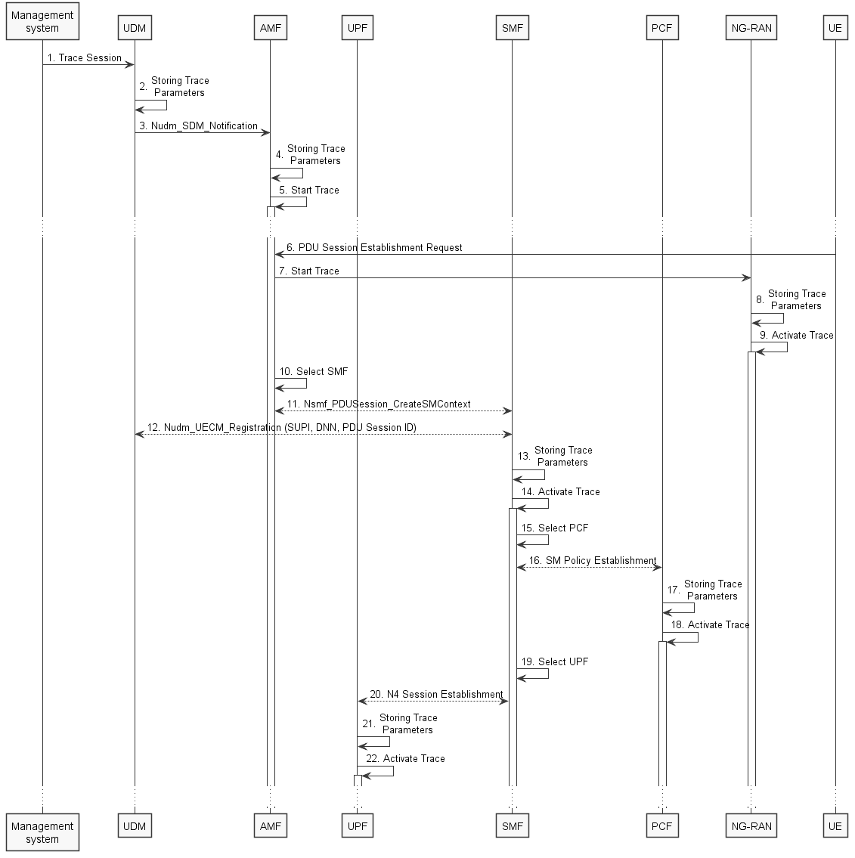
Figure 4.1.2.15.1.3: Trace activation in 5GC following the PDU Session Establishment procedure
The steps 6, 10, 11, 14 and 15 below are parts of the UE Requested PDU Session Establishment procedure - see 3GPP TS 23.502 [41] clause 4.3.2.2 for specific details. Present document does not attempt to re-define how UE Requested PDU Session Establishment procedure works, but rather illustrates the signaling Trace Activation aspects.
1. Management system activates Trace Session to the UDM. The following trace control and configuration parameters shall be included in the Trace Activation message:
- Trace Target: SUPI or IMEISV
- Trace Reference
- Triggering Events for AMF, SMF, UPF and PCF
- Trace Depth
- List of NE Types to trace
- List of Interfaces for AMF, SMF, UPF, PCF and NG-RAN
- Trace Collection Entity IP Address for the file-based trace reporting or Trace Reporting Consumer URI the streaming trace reporting
- .
2. UDM stores the trace control and configuration parameters received from the management system.
3. UDM sends Nudm_SDM_Notification to AMF with the trace control and configuration parameters information (see clauses 4.5.1 and 5.2.3.3 of 3GPP TS 23.502 [41]).
4. AMF stores the trace control and configuration parameters received from the UDM.
5. AMF starts the Trace Session according to the received configuration.
6. UE sends PDU Session Establishment request to AMF
7. AMF sends the Start Trace message over NG interface (N2 interface from the 5GC perspective)
8. NG-RAN node stores the trace control and configuration parameters received from the AMF. This step is part of NG-RAN signaling trace activation - see clause 4.1.2.16 for more details.
9. NG-RAN node starts the Trace Session according to the received configuration. This step is part of NG-RAN signaling trace activation - see clause 4.1.2.16 for more details.
10. AMF selects an appropriate SMF
11. AMF sends the Nsmf_PDUSession_CreateSMContext request to the selected SMF
12. SMF performs NuDM_UECM_Registration procedure with UDM and receives the trace control and configuration parameters from UDM
13. SMF stores the trace control and configuration parameters received from the UDM.
14. SMF starts the Trace Session according to the received configuration.
15. SMF selects an approprite PCF
16. SMF establishes Session Management Policy Association with PCF (see step 7 in clause 4.3.2.2.1 of 3GPP TS 23.502 [41]) and provides the trace control and configuration parameters information to the PCF.
17. PCF stores the trace control and configuration parameters received from the SMF as part of Policy Association.
18. PCF starts the Trace Session according to the received configuration.
19. SMF selects an approprite UPF
20. SMF performs N4 Session Establishment with UPF (see step 10 in clause 4.3.2.2.1 of 3GPP TS 23.502 [41]) and provides the trace control and configuration parameters information to the UPF.
21. UPF stores the trace control and configuration parameters received from the SMF as part of N4 Session Establishment.
22. UPF starts the Trace Session according to the received configuration.
Note: The specific scenarios where SMF receives trace control and configuration parameters either from UDM or from AMF are specified in 3GPP TS 23.502 [41].

Figure 4.1.2.15.1.4 illustrates the signaling Trace Session activation procedure in 5GC as part of the PDU Session Modification procedure for the UE that has already been registered and has an on-going PDU Session:
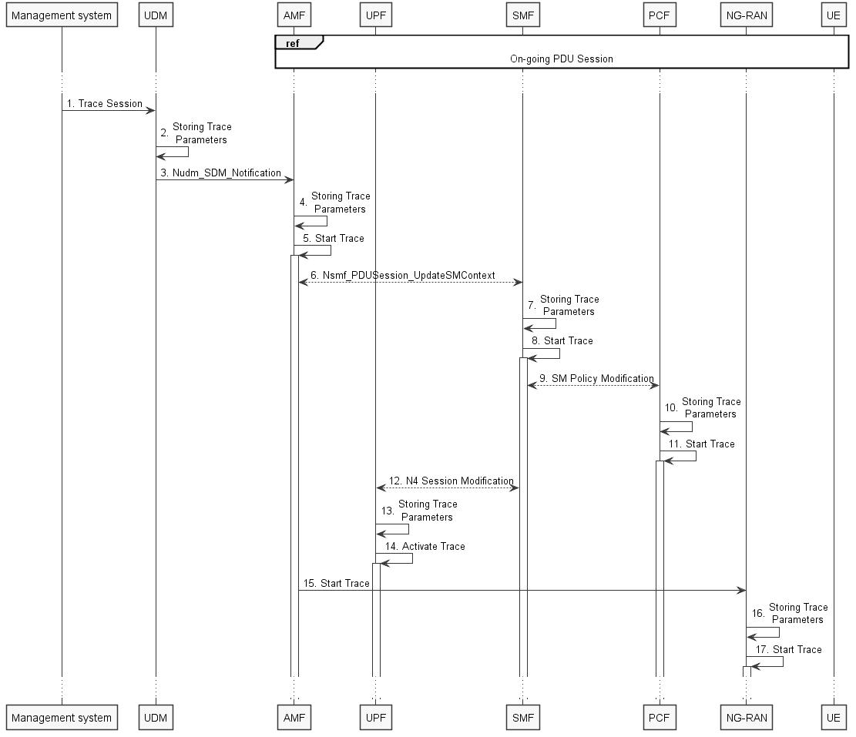
Figure 4.1.2.15.1.4: Trace activation in 5GC following the PDU Session Modification procedure
The steps 6 and 9 below are parts of the PDU Session Modification procedure - see 3GPP TS 23.502 [41] clause 4.3.3.2 for specific details. Present document does not attempt to re-define how PDU Session Modification procedure works, but rather illustrates the signaling Trace Activation aspects.
1. Management system activates Trace Session to the UDM. The following trace control and configuration parameters shall be included in the Trace Activation message:
- Trace Target:SUPI or IMEISV.
- Trace Reference.
- Triggering Events for AMF, SMF, UPF and PCF.
- Trace Depth.
- List of NE Types to trace.
- List of Interfaces for AMF, SMF, UPF, PCF and NG-RAN.
- Trace Collection Entity IP Address for the file-based trace reporting or Trace Reporting Consumer URI for the streaming trace reporting.
- .
2. UDM stores the trace control and configuration parameters received from the management system.
3. UDM sends Nudm_SDM_Notification to AMF with the trace control and configuration parameters information (see clauses 4.5.1 and 5.2.3.3 of 3GPP TS 23.502 [41]).
4. AMF stores the trace control and configuration parameters received in step 9.
5. AMF starts the Trace Session according to the received configuration.
6. AMF sends Nsmf_PDUSession_UpdateSMContext request with the trace control and configuration parameters information to the SMF
7. SMF stores the trace control and configuration parameters received from the UDM.
8. SMF starts the Trace Session according to the received configuration.
9. SMF performs Session Management Policy Modification with PCF (see step 7 in clause 4.3.3.2 of 3GPP TS 23.502 [41]) and provides the trace control and configuration parameters information to the PCF.
10. PCF stores the trace control and configuration parameters received from the SMF as part of Policy Association.
11. PCF starts the Trace Session according to the received configuration.
12. SMF performs N4 Session Modification with UPF (see step 10 in clause 4.3.2.2.1 of 3GPP TS 23.502 [41]) and provides the trace control and configuration parameters information to the UPF.
13. UPF stores the trace control and configuration parameters received from the SMF as part of N4 Session Modification.
14. UPF starts the Trace Session according to the received configuration.
15. AMF sends the Start Trace message over NG interface (N2 interface from the 5GC perspective)
16. NG-RAN node stores the trace control and configuration parameters received from the AMF. This step is part of NG-RAN signaling trace activation - see clause 4.1.2.16 for more details.
17. NG-RAN node starts the Trace Session according to the received configuration. This step is part of NG-RAN signaling trace activation - see clause 4.1.2.16 for more details.

Figure 4.1.2.15.1.5 illustrates the signaling Trace Session activation procedure in 5GC as part of the PDU Session Modification procedure for the UE that has already been registered and has an on-going PDU Session where UDM notifies SMF about trace activation directly:
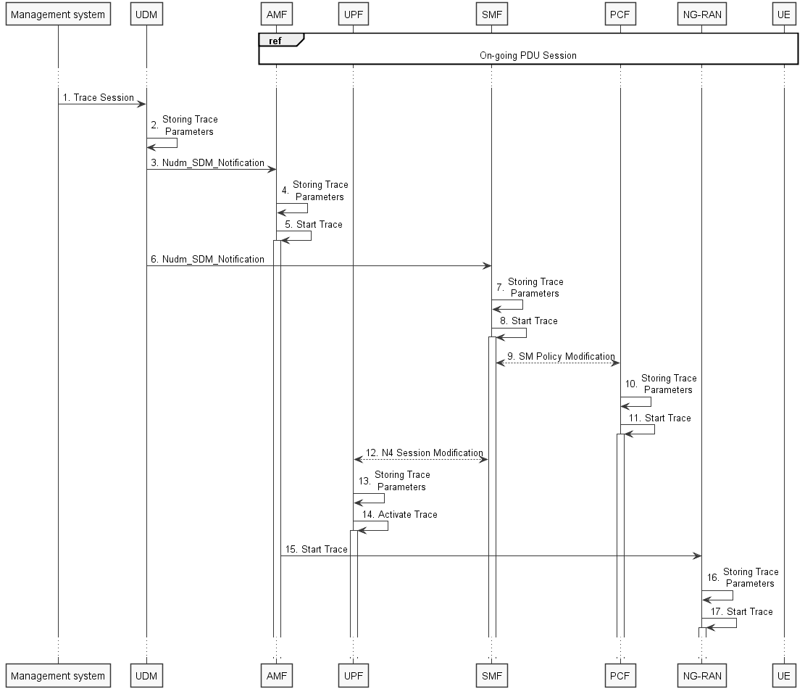
Figure 4.1.2.15.1.5: Trace activation in 5GC following the PDU Session Modification procedure (with UDM to SMF notification)
The steps 6 and 9 below are parts of the PDU Session Modification procedure - see 3GPP TS 23.502 [41] clause 4.3.3.2 for specific details. Present document does not attempt to re-define how PDU Session Modification procedure works, but rather illustrates the signaling Trace Activation aspects.
1. Management system activates Trace Session to the UDM. The following trace control and configuration parameters shall be included in the Trace Activation message:
- Trace Target: SUPI or IMEISV.
- Trace Reference.
- Triggering Events for AMF, SMF, UPF and PCF.
- Trace Depth.
- List of NE Types to trace.
- List of Interfaces for AMF, SMF, UPF, PCF and NG-RAN.
- Trace Collection Entity IP Address for the file-based trace reporting or Trace Reporting Consumer URI for the streaming trace reporting.
- .
2. UDM stores the trace control and configuration parameters received from the management system.
3. UDM sends Nudm_SDM_Notification to AMF with the trace control and configuration parameters information (see clauses 4.5.1 and 5.2.3.3 of 3GPP TS 23.502 [41]).
4. AMF stores the trace control and configuration parameters received in step 9.
5. AMF starts the Trace Session according to the received configuration.
6. UDM sends Nudm_SDM_Notification to SMF with the trace control and configuration parameters information (see clauses 4.5.2 and 5.2.3.3 of 3GPP TS 23.502 [41]).
7. SMF stores the trace control and configuration parameters received from the UDM.
8. SMF starts the Trace Session according to the received configuration.
9. SMF performs Session Management Policy Modification with PCF (see step 7 in clause 4.3.3.2 of 3GPP TS 23.502 [41]) and provides the trace control and configuration parameters information to the PCF.
10. PCF stores the trace control and configuration parameters received from the SMF as part of Policy Association.
11. PCF starts the Trace Session according to the received configuration.
12. SMF performs N4 Session Modification with UPF (see step 10 in clause 4.3.2.2.1 of 3GPP TS 23.502 [41]) and provides the trace control and configuration parameters information to the UPF.
13. UPF stores the trace control and configuration parameters received from the SMF as part of N4 Session Modification.
14. UPF starts the Trace Session according to the received configuration.
15. AMF sends the Start Trace message over NG interface (N2 interface from the 5GC perspective)
16. NG-RAN node stores the trace control and configuration parameters received from the AMF. This step is part of NG-RAN signaling trace activation - see clause 4.1.2.16 for more details.
17. NG-RAN node starts the Trace Session according to the received configuration. This step is part of NG-RAN signaling trace activation - see clause 4.1.2.16 for more details.
Note: The specific scenarios where SMF receives trace control and configuration parameters either from UDM or from AMF are specified in 3GPP TS 23.502 [41].

Next change

4.1.2.15.2 Inter-RAT handover between E-UTRAN and NG-RAN
The figure 4.1.2.15.2.1 below illustrates an example scenario when UE served by 5GC with ongoing PDU session and active Trace Session makes an inter-RAT handover from NG-RAN to the E-UTRAN and makes another handover back from E-UTRAN to NG-RAN illustrated in figure 4.1.2.15.2.2.
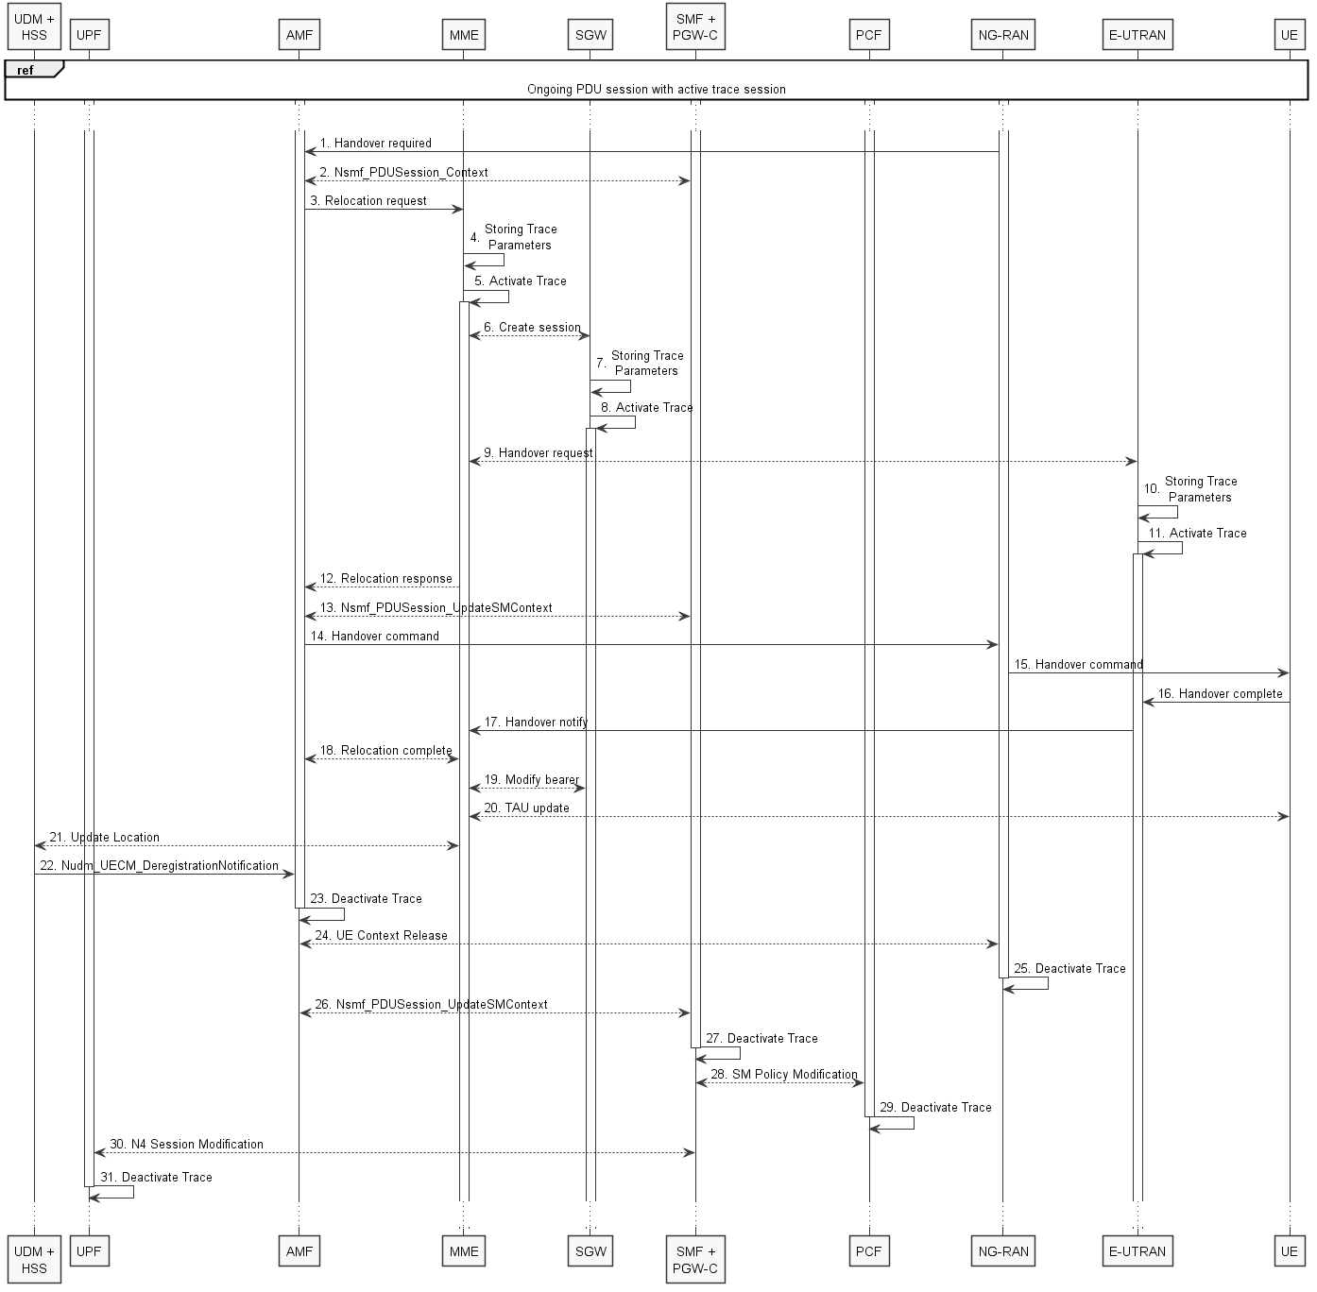
Figure 4.1.2.15.2.1: Signaling Trace Activation during Inter-RAT handover from NG-RAN to E-UTRAN
The steps 1 - 3, 6, 9, 12 - 22, 24, 26 and 28 on figure 4.1.2.15.2.1 are parts of the 5GS to EPS handover using N26 interface procedure - see 3GPP TS 23.502 [41] clause 4.11.1.2.1 for specific details. Present document does not attempt to re-define how 5GS to EPS handover using N26 interface procedure works, but rather illustrates the signaling Trace Activation aspects.
When AMF sends the Relocation Request to MME, AMF shall include the following trace control and configuration parameters for the Trace Activation:
- Trace Target:SUPI or IMEISV.
- Trace Reference.
- Triggering Events for MME, Serving GW, PDN GW, SGSN, GGSN.
- Trace Depth.
- List of NE Types to trace.
- List of Interfaces for MME, Serving GW, PDN GW, eNB, SGSN, GGSN, RNC.
- Trace Collection Entity IP Address for the file-based trace reporting or Trace Reporting Consumer URI for the streaming trace reporting.
- .
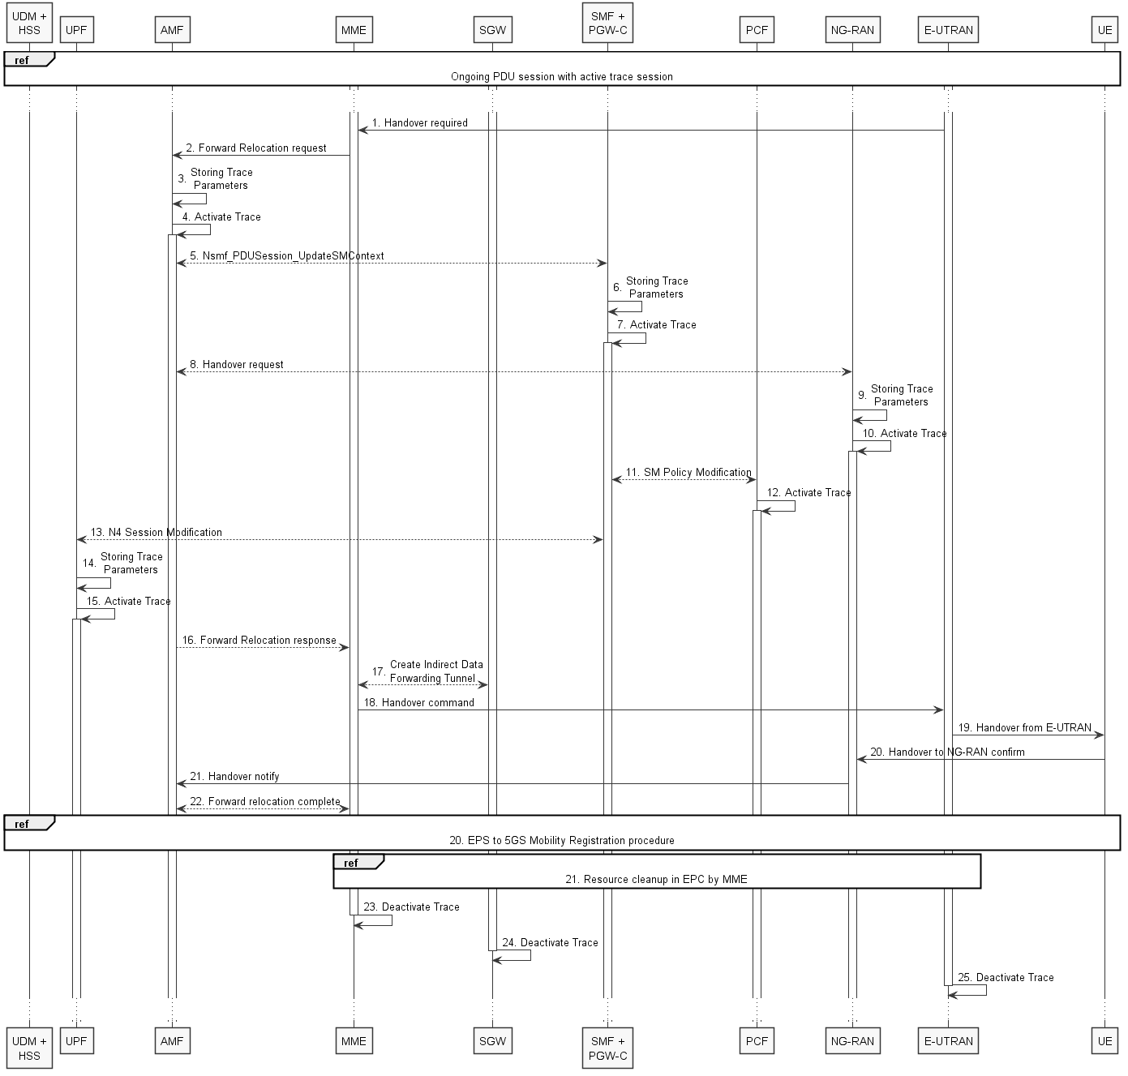
Figure 4.1.2.15.2.2: Signaling Trace Activation during Inter-RAT handover from E-UTRAN to NG-RAN
The steps 1, 2, 5, 8, 11 and 13 - 21 on figure 4.1.2.15.2.2 are parts of the EPS to 5GS handover using N26 interface procedure - see 3GPP TS 23.502 [41] clause 4.11.1.2.2 for specific details. Present document does not attempt to re-define how EPS to 5GS handover using N26 interface procedure works, but rather illustrates the signaling Trace Activation aspects.
When MME sends the Forward Relocation Request to AMF, MME shall include the following trace control and configuration parameters for the Trace Activation:
- Trace Target: SUPI or IMEISV.
- Trace Reference.
- Triggering Events for AMF, SMF, UPF and PCF.
- Trace Depth.
- List of NE Types to trace.
- List of Interfaces for AMF, SMF, UPF, PCF and NG-RAN.
- Trace Collection Entity IP Address.
Next change

4.1.2.15.3 Non-3GPP access scenarios
Figure 4.1.2.15.3.1 illustrates the signaling Trace Session activation procedure in 5GC as part of the Registration via Untrusted non-3GPP Access procedure:
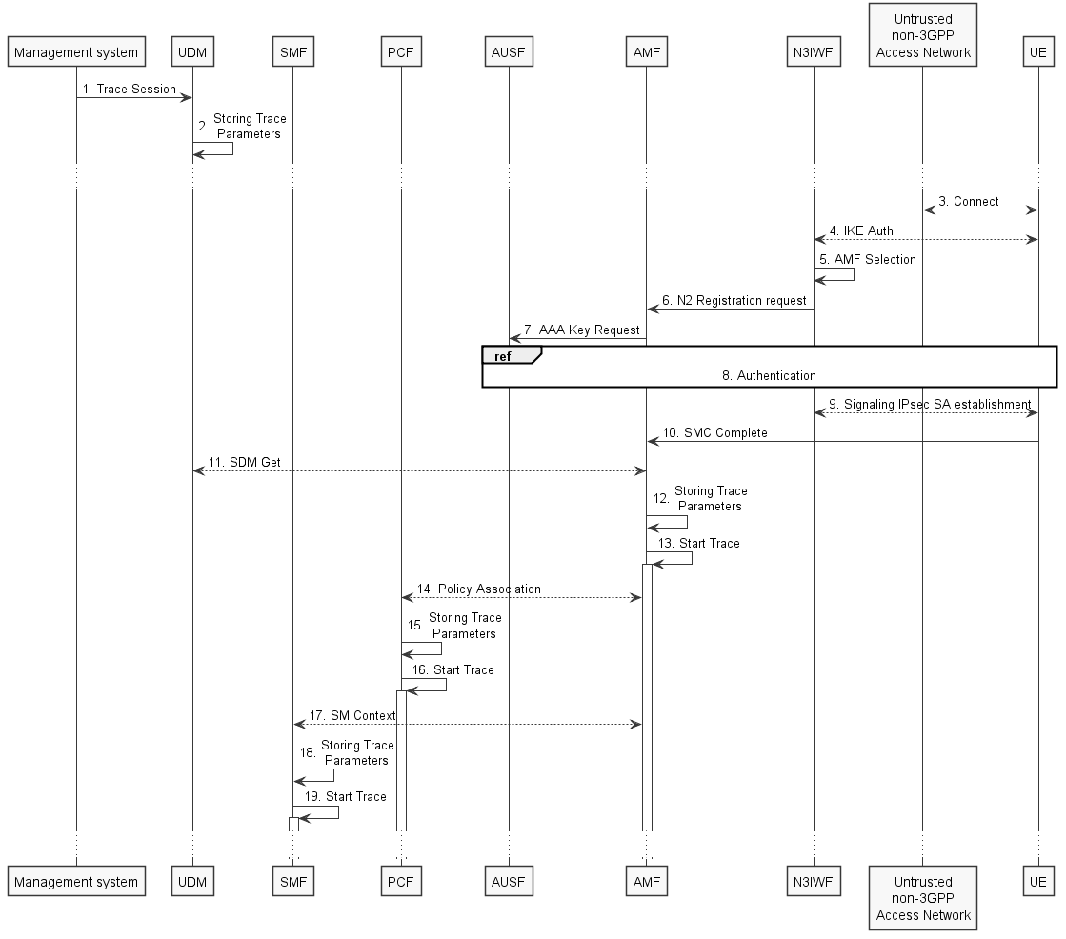
Figure 4.1.2.15.3.1: Trace activation in 5GC following the Registration via Untrusted non-3GPP Access procedure
The steps 3-11, 14 and 17 below are parts of the Registration via Untrusted non-3GPP Access procedure - see 3GPP TS 23.502 [41] clauses 4.12.2 and 4.2.2 for specific details. Present document does not attempt to re-define how Registration via Untrusted non-3GPP Access procedure works, but rather illustrates the signaling Trace Activation aspects.
1. Management system activates Trace Session to the UDM. The following trace control and configuration parameters shall be included in the Trace Activation message:
- Trace Target: SUPI or IMEISV.
- Trace Reference.
- Triggering Events for AMF, SMF, UPF and PCF.
- Trace Depth.
- List of NE Types to trace.
- List of Interfaces for AMF, SMF, UPF, PCF and NG-RAN.
- Trace Collection Entity IP Address for the file-based trace reporting or Trace Reporting Consumer URI for the streaming trace reporting.
- .
2. UDM stores the trace control and configuration parameters received from the management system.
3. UE connects to the Untrusted non-3GPP Access Network and obtains an IP address
4. UE performs IKE authentication with N3IWF
5. N3IWF selects appropriate AMF
6. N3IWF sends N2 Registration request to AMF
7. AMF requests AAA Key from AUSF
8. UE authenticates with AUSF via N3IWF and AMF
9. UE establishes Signaling IPsec SA with N3IWF
10. UE sends SMC Complete to AMF
11. AMF receives the trace control and configuration parameters information from UDM via Nudm_SDM_Get operation (see step 14 in clause 4.2.2.2.2 and clause 5.2.3.3 of 3GPP TS 23.502 [41]).
12. AMF stores the trace control and configuration parameters received from the UDM.
13. AMF starts the Trace Session according to the received configuration.
14. AMF establishes Policy Association with PCF (see step 16 in clause 4.2.2.2.2 of 3GPP TS 23.502 [41]) and provides the trace control and configuration parameters information to the PCF.
15. PCF stores the trace control and configuration parameters received from the AMF as part of Policy Association.
16. PCF starts the Trace Session according to the received configuration.
17. AMF provides the trace control and configuration parameters information to the SMF as part of the SM Context (see step 18 in clause 4.2.2.2.2 of 3GPP TS 23.502 [41]).
18. SMF stores the trace control and configuration parameters received from the AMF.
19. SMF starts the Trace Session according to the received configuration.

Figure 4.1.2.15.3.2 illustrates the signaling Trace Session activation procedure in 5GC as part of the PDU Session Establishment via Untrusted non-3GPP Access procedure for the UE that has already been registered:
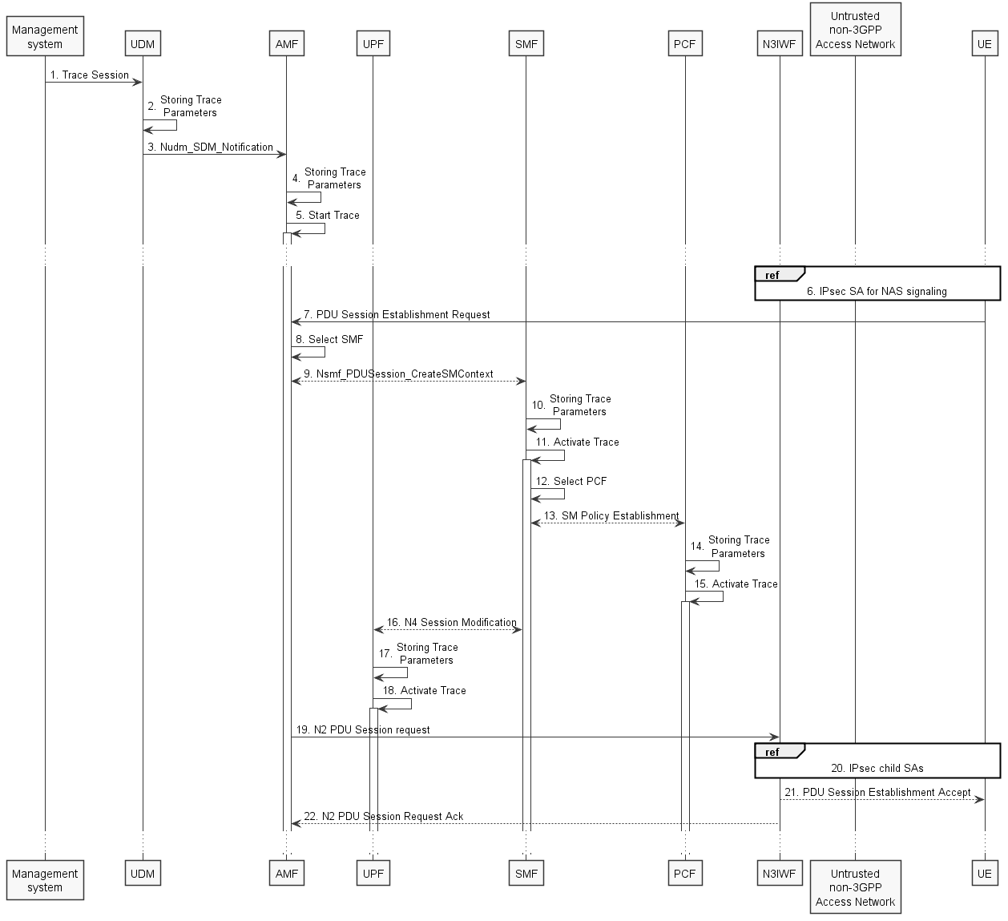
Figure 4.1.2.15.3.2: Trace activation in 5GC following the PDU Session Establishment via Untrusted non-3GPP Access procedure
The steps 6 - 9, 13 and 16 - 19 below are parts of the UE Requested PDU Session Establishment via Untrusted non-3GPP Access procedure - see 3GPP TS 23.502 [41] clause 4.12.5 for specific details. Present document does not attempt to re-define how UE Requested PDU Session Establishment via Untrusted non-3GPP Access procedure works, but rather illustrates the signaling Trace Activation aspects.
1. Management system activates Trace Session to the UDM. The following trace control and configuration parameters shall be included in the Trace Activation message:
- Trace Target: SUPI or IMEISV
- Trace Reference
- Triggering Events for AMF, SMF, UPF and PCF
- Trace Depth
- List of NE Types to trace
- List of Interfaces for AMF, SMF, UPF, PCF and NG-RAN
- Trace Collection Entity IP Address for the file-based trace reporting or Trace Reporting Consumer URI for the streaming trace reporting
- .
2. UDM stores the trace control and configuration parameters received from the management system.
3. UDM sends Nudm_SDM_Notification to AMF with the trace control and configuration parameters information (see clauses 4.5.1 and 5.2.3.3 of 3GPP TS 23.502 [41]).
4. AMF stores the trace control and configuration parameters received from the UDM.
5. AMF starts the Trace Session according to the received configuration.
6. The messages exchanged between UE and AMF shall be sent to N3IWF via the IPsec SA for NAS signalling established as specified in clause 4.12.2 of 3GPP TS 23.502 [41].
7. UE sends PDU Session Establishment request to AMF
8. AMF selects an appropriate SMF
9. AMF sends the Nsmf_PDUSession_CreateSMContext request to the selected SMF
10. SMF stores the trace control and configuration parameters received from the AMF.
11. SMF starts the Trace Session according to the received configuration.
12. SMF selects an approprite PCF
13. SMF establishes Session Management Policy Association with PCF (see step 7 in clause 4.3.2.2.1 of 3GPP TS 23.502 [41]) and provides the trace control and configuration parameters information to the PCF.
14. PCF stores the trace control and configuration parameters received from the SMF as part of Policy Association.
15. PCF starts the Trace Session according to the received configuration.
16. SMF performs N4 Session Establishment with UPF (see step 10 in clause 4.3.2.2.1 of 3GPP TS 23.502 [41]) and provides the trace control and configuration parameters information to the UPF.
17. UPF stores the trace control and configuration parameters received from the SMF as part of N4 Session Establishment.
18. UPF starts the Trace Session according to the received configuration.
19. AMF sends N2 PDU Session Request to N3IWF
20. N3IWF determines the necessary number of IPsec child SAs and establishes them with UE
21. N3IWF sends PDU Session Establishment accept to UE
22. N3IWF sends N2 PDU Session Request Ack to AMF

Figure 4.1.2.15.3.3 illustrates the signaling Trace Session activation procedure in 5GC as part of the PDU Session Establishment via Untrusted non-3GPP Access procedure for the UE that has already been registered where SMF obtains trace control and configuration parameters from UDM via Nudm_UECM_Registration procedure:
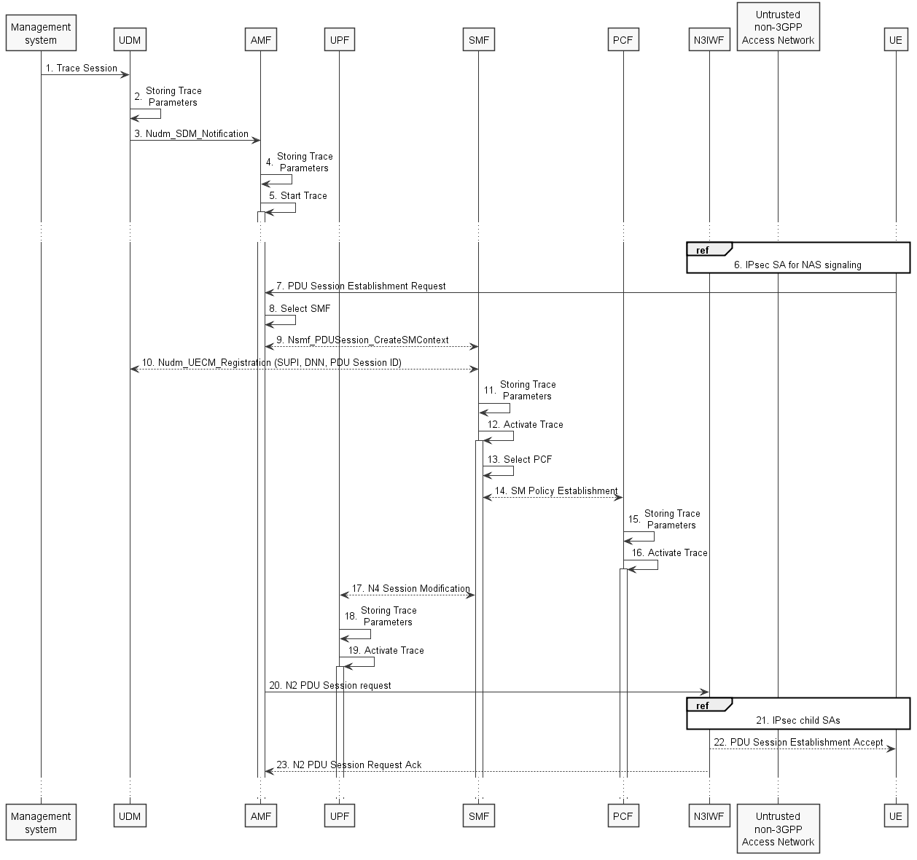
Figure 4.1.2.15.3.3: Trace activation in 5GC following the PDU Session Establishment via Untrusted non-3GPP Access procedure
The steps 6 - 9, 13 and 16 - 19 below are parts of the UE Requested PDU Session Establishment via Untrusted non-3GPP Access procedure - see 3GPP TS 23.502 [41] clause 4.12.5 for specific details. Present document does not attempt to re-define how UE Requested PDU Session Establishment via Untrusted non-3GPP Access procedure works, but rather illustrates the signaling Trace Activation aspects.
1. Management system activates Trace Session to the UDM. The following trace control and configuration parameters shall be included in the Trace Activation message:
- Trace Target: SUPI or IMEISV
- Trace Reference
- Triggering Events for AMF, SMF, UPF and PCF
- Trace Depth
- List of NE Types to trace
- List of Interfaces for AMF, SMF, UPF, PCF and NG-RAN
- Trace Collection Entity IP Address for the file-based trace reporting or Trace Reporting Consumer URI for the streaming trace reporting
- .
2. UDM stores the trace control and configuration parameters received from the management system.
3. UDM sends Nudm_SDM_Notification to AMF with the trace control and configuration parameters information (see clauses 4.5.1 and 5.2.3.3 of 3GPP TS 23.502 [41]).
4. AMF stores the trace control and configuration parameters received from the UDM.
5. AMF starts the Trace Session according to the received configuration.
6. The messages exchanged between UE and AMF shall be sent to N3IWF via the IPsec SA for NAS signalling established as specified in clause 4.12.2 of 3GPP TS 23.502 [41].
7. UE sends PDU Session Establishment request to AMF
8. AMF selects an appropriate SMF
9. AMF sends the Nsmf_PDUSession_CreateSMContext request to the selected SMF
10. SMF performs NuDM_UECM_Registration procedure with UDM and receives the trace control and configuration parameters from UDM
11. SMF stores the trace control and configuration parameters received from the UDM.
12. SMF starts the Trace Session according to the received configuration.
13. SMF selects an approprite PCF
14. SMF establishes Session Management Policy Association with PCF (see step 7 in clause 4.3.2.2.1 of 3GPP TS 23.502 [41]) and provides the trace control and configuration parameters information to the PCF.
15. PCF stores the trace control and configuration parameters received from the SMF as part of Policy Association.
16. PCF starts the Trace Session according to the received configuration.
17. SMF performs N4 Session Establishment with UPF (see step 10 in clause 4.3.2.2.1 of 3GPP TS 23.502 [41]) and provides the trace control and configuration parameters information to the UPF.
18. UPF stores the trace control and configuration parameters received from the SMF as part of N4 Session Establishment.
19. UPF starts the Trace Session according to the received configuration.
20. AMF sends N2 PDU Session Request to N3IWF
21. N3IWF determines the necessary number of IPsec child SAs and establishes them with UE
22. N3IWF sends PDU Session Establishment accept to UE
23. N3IWF sends N2 PDU Session Request Ack to AMF
NOTE: The specific scenarios where SMF receives trace control and configuration parameters either from UDM or from AMF are specified in 3GPP TS 23.502 [41].
Next change

4.1.2.16 NG-RAN activation mechanisms
The Trace Session should be activated in in an NG-RAN node when the NG-RAN node receives the TRACE START, INITIAL CONTEXT SETUP REQUEST or HANDOVER REQUEST message with the IE Trace Activation from the AMF and if some activities have been started on the interfaces that have been requested to be traced.
If the subscriber or equipment which is traced makes a handover to a target NG-RAN node using the Xn interface, the source NG-RAN node should propagate the trace control and configuration parameters further to the target NG-RAN node by using the HANDOVER REQUEST message. When the target NG-RAN node receives the HANDOVER REQUEST message it should immediately start a Trace Session according to the trace control and configuration parameters received in the HANDOVER REQUEST message.
If the subscriber or equipment being traced at the old NG-RAN node has been sent to RRC_INCTIVE and then establishes RRC Connection to a new NG-RAN node, the new NG-RAN node initiates the Retrieve UE Context procedure using Xn interface. The old NG-RAN node should propagate the trace control and configuration parameters further to the new NG-RAN node by using the RETRIEVE UE CONTEXT RESPONSE message. When the new NG-RAN node receives the RETRIEVE UE CONTEXT RESPONSE message it should immediately start a Trace Session according to the trace control and configuration parameters received in the RETRIEVE UE CONTEXT RESPONSE message.
If the subscriber or equipment which is traced makes a handover to a target NG-RAN node using the NG interface, it is the AMF's responsibility to propagate the trace control and configuration parameters to the target NG-RAN node.
If the tracing shall continue also after the relocation has been performed, the 5GC Trace Start procedure shall be re-initiated from the 5GC towards the future NG-RAN node after the Relocation Resource Allocation procedure has been executed successfully.
The TRACE START, INITIAL CONTEXT SETUP REQUEST or HANDOVER REQUEST message that is received from the AMF contains the following information:
- Trace Reference and Trace Recording Session Reference.
- List of Interfaces for NG-RAN node.
- Trace Depth.
- Trace Collection Entity IP Address for the file-based trace reporting or Trace Reporting Consumer URI for the streaming trace reporting.
- .
If the Trace Reference is the same as an existing Trace Session for the same subscriber or equipment, the NG-RAN node shall not activate a new Trace Session and the existing Trace Session will not be impacted. See clause 4.2.3.12 for the conditions on whether or not the Trace Recording Session should be started.
If the Trace Reference is the same as an existing Trace Session for different subscriber(s) or equipment(s), the NG-RAN node shall not activate a new Trace Session, and the NG-RAN node shall not start a new Trace Recording Session.
If the NG-RAN node is not able to activate the trace session due to ongoing handover of the UE to another NG-RAN node, the NG-RAN node shall inform the AMF with the TRACE FAILURE INDICATION message using NG interface.
Next change

4.2.3.11 5GC starting mechanisms
In AMF, PCF, SMF or UPF a Trace Recording Session should start after the reception of a Trace Session Activation message and if any of the defined start triggering events occur. During the Trace Recording Session, the AMF, PCF, SMF or UPF shall record the signalling messages in the interfaces that are defined in the list of interfaces parameter. The Trace Depth parameter defines whether entire signalling messages or just some IEs need to be recorded.
The AMF, PCF, SMF or UPF may not start a Trace Recording Session if there are insufficient resources available for the recording.
In case of an established session, the AMF, PCF, SMF or UPF may start the Trace Recording Session immediately after the reception of the trace control and configuration parameters. However, if any of the start triggering events occurs in AMF, PCF, SMF or UPF after receiving the trace control and configuration parameters, it shall start the Trace Recording Session.
In the case of the triggering events come into collision on the same traced UE as defined in 3GPP TS 24.501[45], the AMF shall not start a new Trace Recording Session for the later event(s), and shall use the existing Trace Recording Session and Trace Recording Session Reference to continuing the trace recording for these events until one stop triggerring event occurs.
AMF shall start a Trace Recording Session for a certain Trace Session only if there is no ongoing Trace Recording Session for this Trace Session. i.e. at any given time, there can be a maximum of one Trace Recording Session for a certain Trace Session.
When a Trace Recording Session is started in AMF, it shall assign a Trace Recording Session Reference for the Trace Recording Session. When the AMF propagates the Trace control and configuration parameters to NG-RAN (i.e. activates a Trace Session in NG-RAN node), it shall include the assigned Trace Recording Session Reference in the Trace Session Activation message.
Also, when an AMF starts a Trace Recording Session and the list of NE types parameter requires NF-RAN node tracing, it shall propagate the trace control and configuration parameters including the Trace Recording Session Reference via the NG interface to the NG-RAN node per one of the following messages:
1) if an NG connection exists, via the NG-Trace Start message
2) if the NG connection does not exist, via the NG-Trace Start message prior to NG connection setup, or via the NG-Initial Context Setup Request message during NG connection setup
3) during intra/inter-AMF handover over NG, via the NG-Handover Request message
In above cases the Trace Session and the Trace Recording Session in the receiving NE should start at the same time
If all events are set in the triggering event parameter at the AMF, AMF shall send Trace Session Activation message to NG-RAN node not only when the AMF starts the Trace Recording Session, but also when an Intra-AMF handover happens. In this case the AMF shall send Trace Session activation to the target NG-RAN node via the NG-Handover Request message.
Next change

4.2.3.12 NG-RAN starting mechanism
In a NG-RAN node the Trace Recording Session will always be the same as the Trace Session as no triggering events are defined in NG-RAN node.
Tracing starts immediately at NG-RAN node upon reception of the trace control and configuration parameters Trace Activation IE). The NG-RAN node may not start a Trace Recording Session if there are insufficient resources available for the recording, however, the NG-RAN node shall store the trace control and configuration parameters, and forward these parameters when the UE handovers to other NG-RAN nodes over Xn or when other NG-RAN node retrieves the UE Context over Xn.
The Trace Recording Session shall be started at the NG-RAN node when it receives trace control and configuration parameters via one of the following messages:
1) via an INITIAL CONTEXT SETUP REQUEST message over NG from the AMF
2) via a TRACE START message over NG from the AMF. If no UE-associated logical NG-connection exists, the UE-associated logical NG-connection will be established as part of the Trace Start procedure.
3) via an NG HANDOVER REQUEST message from the target AMF as part of intra/inter-AMF handover procedures via NG.
4) via an Xn HANDOVER REQUEST message from a source NG-RAN node as part of inter-NG-RAN node handover procedures via Xn
5) via an Xn RETRIEVE UE CONTEXT RESPONSE message from old NG-RAN node after been sent to RRC_INCTIVE and then establishing RRC Connection to a new NG-RAN node
There can only be one Trace Recording Session Reference per Trace Reference at one given time for a UE trace session. So there shall be only one TR/TRSR to be propagated during NG and Xn handover.
If the Trace Reference is the same as an existing Trace Session for the same subscriber or equipment, and the Trace Recording Session Reference is the same as the existing Trace Recording Session in the existing Trace Session having the same Trace Reference, the NG-RAN node shall not start a new Trace Recording Session and shall continue with the existing trace session and ignore the second request.
If the Trace Reference is the same as an existing Trace Session for the same subscriber or equipment, and the Trace Recording Session Reference is not the same as the existing Trace Recording Session in the existing Trace Session having the same Trace Reference, the NG-RAN node shall continue with the existing trace session and ignore the second request.
Next change

5.11 Void

End change

