3GPP TSG SA WG5 Meeting 144-e S5-224312rev1

electronic meeting, online, 27th June – 1st July 2022
CR-Form-v12.0
CHANGE REQUEST
 | 28.541 | CR | draftCR | rev |  | Current version: | 18.0.0
For HELP on using this form: comprehensive instructions can be found at
http://www.3gpp.org/Change-Requests.

Proposed change affects: | UICC apps |  | ME |  | Radio Access Network | X | Core Network

Title: | Add Enhanced QoS support in NRM (stage 2)
Source to WG: | Ericsson
Source to TSG: | S5
Work item code: | adNRM_ph2 |  |  |  |  |  | Date: |  |  | 2022-06-16
Category: | C |  |  |  |  |  | Release: |  |  | Rel-18
 | Use one of the following categories:  F (correction)  A (mirror corresponding to a change in an earlier release)  B (addition of feature),  C (functional modification of feature)  D (editorial modification)  Detailed explanations of the above categories can  be found in 3GPP TR 21.900. |  |  |  |  |  |  |  | Use one of the following releases:  Rel-8 (Release 8)  Rel-9 (Release 9)  Rel-10 (Release 10)  Rel-11 (Release 11)  …  Rel-15 (Release 15)  Rel-16 (Release 16)  Rel-17 (Release 17)  Rel-18 (Release 18)
Reason for change: |  | Add additional option to contain Configurable5QISet.
Summary of change: |  | Add option to contain Configurable5QISet under ManagedFunction.
Consequences if not approved: |  | One of the agreed containments would be missing from the NRM.
Clauses affected: |  | 4.2.1.1, 4.3.1
 |  | Y | N
Other specs |  |  | x | Other core specifications |  |  |  | TS/TR ... CR ...
affected: |  |  | x | Test specifications |  |  |  | TS/TR ... CR ...
(show related CRs) |  |  | x | O&M Specifications |  |  |  | TS/TR … CR…
Other comments: |  | As agreed in S5-222627 during SA5#142e.  Input to draftCR 28.541 for AdNRM_Ph2.
This CR's revision history:

1st Change

4.2.1 Class diagram for gNB and en-gNB

4.2.1.1 Relationships
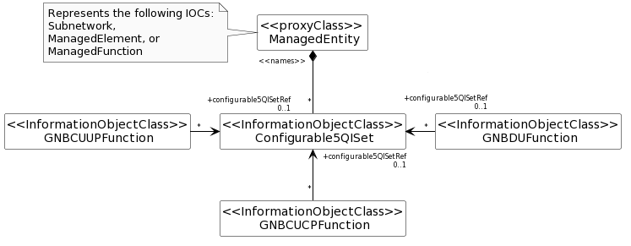

Figure 4.2.1.1-8: NRM fragment for pre-configured 5QIs in NG-RAN

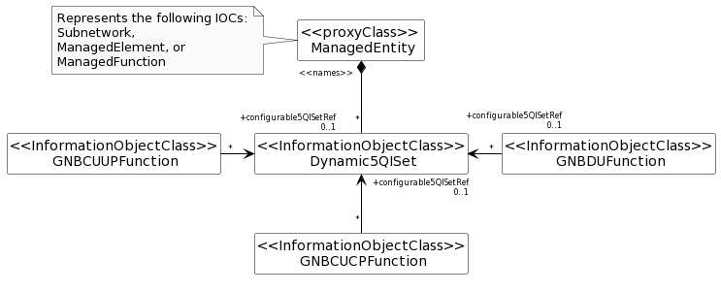
Figure 4.2.1.1-16: NRM fragment for dynamically assigned 5QIs in NG-RAN

2nd Change

4.3.1 GNBDUFunction

4.3.1.1 Definition
For non-split NG-RAN deployment scenario, this IOC together with GNBCUCPFunction IOC and GNBCUUPFunction IOC provide the management of gNB defined in clause 6.1.1 in 3GPP TS 38.401 [4].
For 2-split and 3-split NG-RAN architecture, this IOC provides the management representation of gNB-DU defined in clause 6.1.1 in 3GPP TS 38.401 [4].
The following table identifies the necessary end points required for the representation of gNB and en-gNB, of all deployment scenarios.

Req  Role | End point requirement for 3-split deployment scenario | End point requirement for 2-split deployment scenario | End point requirement for Non-split deployment scenario
gNB | <<IOC>>EP_F1C, <<IOC>>EP_F1U | <<IOC>>EP_F1C, <<IOC>>EP_F1U | None.
en-gNB | <<IOC>>EP_F1C, <<IOC>>EP_F1U | <<IOC>>EP_F1C, <<IOC>>EP_F1U | None.

4.3.1.2 Attributes
The GNBDUFunction IOC includes attributes inherited from ManagedFunction IOC (defined in TS 28.622[30]) and the following attributes:

Attribute name | S | isReadable | isWritable | isInvariant | isNotifyable
gNBDUId | M | T | T | F | T
gNBDUName | O | T | T | F | T
gNBId | CM | T | T | F | T
gNBIdLength | CM | T | T | F | T
rimRSReportConf | O | T | F | T | T
Attribute related to role
configurable5QISetRef | O | T | T | F | T
dynamic5QISetRef | O | T | F | F | T

4.3.1.3 Attribute constraints
None.

4.3.1.4 Notifications
The common notifications defined in subclause 4.5 are valid for this IOC, without exceptions or additions.

