3GPP TSG-SA5 Meeting #144-e S5-224259

e-meeting, June 27th – July 1st, 2022

Source: Nokia, Nokia Shanghai Bell, KDDI

Title: Federated network modelling for EP_Transport

Document for: Discussion and Endorsement
Agenda Item: 6.1

1 Decision/action requested
Please discuss the presented rationale and endorse the proposals

2 References
[1] 3GPP TS 28.541: "Management and orchestration; 5G Network Resource Model (NRM); Stage 2 and stage 3"
[2] IETF RFC 8299: " YANG Data Model for L3VPN Service Delivery"
[3] IETF RFC 8466: " A YANG Data Model for Layer 2 Virtual Private Network (L2VPN) Service Delivery "
[4] IETF Guidelines for Translation of UML information Model to YANG Data Model, draft-mansfield-netmod-uml-to-yang
[5] https://www.3gpp.org/ftp/TSG_SA/WG5_TM/TSGS5_131e/Inbox/Drafts/S5-203253rev2%20TD%20proposal%20to%20add%20transport%20endpoint%20in%20NRM.doc

3 Rationale

3.1 Introduction
TS 28.541 [1] provides the transport network touchpoint via EP_Transport IOC. The definition of "logical transport interface" in "EP_Transport" is a bit vague and different person has different understanding/definition, hence leads to confusion.
Observation 1
Considerations regarding using EP_Transport:
- CN/AN domain shall inform the reachability of EPs(i.e. EP_N3 or EP_NgU or EP_F1U) to TN domain so as to route/forward the packet from an EP to the opposite EP when a NetworkSlice Instance is being created, where the attachment circuit (AC) between CN/AN domain and TN domain is already established. (See DP S5-203253rev2 [5])
- Additionally, CN/AN and TN domains may want to newly establish the AC between CN/AN domain and TN domain, e.g. CE-PE link, when a NetworkSlice Instance is being created.
- The AN/CN end of the AC may be the same interface of the logical transport interface or not. Network technology between AN and CN logical transport interfaces through TN domain depends on the implementation, e.g. L2(VPN), L3(VPN), (SR-)MPLS or SRv6.
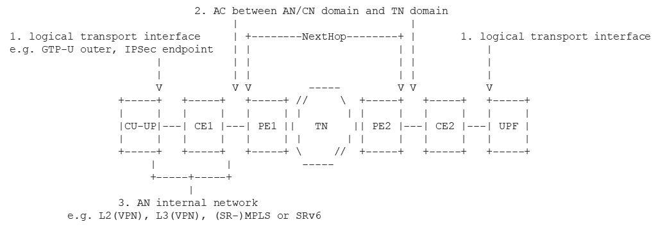

Observation 2
As for attribute logicInterfaceType, in clause 6.3.18.1 there is "This IOC represents the logical transport interface or endpoint which is part of a RAN or CN SubNetwork,…". It means “logical transport interface” doesn’t exist where "endpoint", e.g. EP_N3, is IP routable. "logical transport interface" shall include IPv4 or IPv6, e.g. "logical transport interface" is IPSec endpoint.
As for attribute logicInterfaceId, operators don’t usually statically configure MPLS tag and segment, but dynamically exchange them by a routing protocol based on "ipAddress", where "logical transport interface type" is MPLS or Segment. However, this doesn’t exclude the current definitions, e.g., MPLS tag and segment.
Recommendation
As above, we shall instead specify which routing protocol between AN/CN domain and TN domain is used to exchange them, and this should be as the AC information, i.e. "NextHopInfo". And AC is implementation dependent and shall be defined by TN domain related external SDOs. Therefore, NextHopInfo is defined as ProxyClass and the representing object classes defined in the external SDOs.

4 Detailed Proposal
This section details the proposed changes in TS 28.541 [1] for the problem discussed above.
First changes

6.2.1 Relationships
Figure 6.2.1-1: Network slice NRM fragment relationship
NOTE 1: The <<OpenModelClass>> NetworkService and <<OpenModelClass>> VNF are defined in [40].
NOTE 2: The target Network Service (NS) instance represents a group of VNFs and PNFs that are supporting the source network slice subnet instance.
NOTE 3: The instance tree of this NRM fragment would not contain the instances of NetworkService and VNF. However, the NetworkSliceSubNet instances would have an attribute holding the identifiers of NetworkService instances and the ManagedFunction instance would have an attribute holding identifiers of VNF instances.

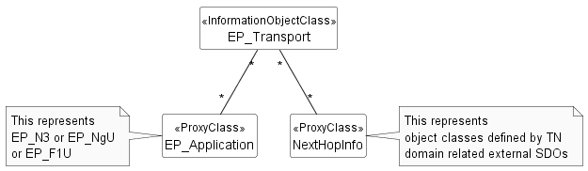
Figure 6.2.1-2: Transport EP NRM fragment relationship
Figure 6.2.1-3: containment relationship for network slice fragment

Second change

6.3.x NextHopInfo <<ProxyClass>>

6.3.x.1 Definition
This represents object classes defined by TN domain related external SDOs.
Note: The representing object class can be used to identify ingress node (s) which are part of a transport network and the attachment circuit between a RAN or CN SubNetwork and the transport network. Each node can be identified by any of a combination of
- IP address of next-hop router (the ingress node) in the transport network, it may be default GW,
- IP address and subnet mask of the attachment circuit at a RAN or CN Subnetwork end,
- system name,
- port name,
- VLAN ID,
- IP management address of transport nodes,
- Routing protocol to exchange logical transport interface information between RAN or CN Subnetwork and transport network.
The external object class(es) can use list, container or grouping statement(s) defined in L3SM (See RFC8299 [2]) or L2SM (See RFC8466 [3]), according to [4], in the case that the next-hop router is an L3VPN or L2VPN PE, e.g. l3vpn-svc:site/site-network-accesses/site-network-access , . l2vpn-svc:site/site-network-accesses/site-network-access .

6.3.x.2 Attributes
See that defined in.

6.3.x.3 Attribute constraints
See respective IOCs.

6.3.x.4 Notifications
See respective IOCs.
Third change

6.3.18.2 Attributes
The EP_Transport IOC includes attributes inherited from Top IOC (defined in TS 28.622[30]) and the following attributes:
Attribute name | S | isReadable | isWritable | isInvariant | isNotifyable
ipAddress | M | T | F | F | T
logicInterfaceInfo | M | T | T | F | T
qosProfile | O | T | T | F | T
Attribute related to role
epApplicationRef | M | T | T | F | T
nextHopinfoRef | M | T | T | F | T

Forth change

6.4.1 Attribute properties
…
logicInterfaceType | This parameter specifies the type of a logical transport interface. It could be VLAN, MPLS or Segment.  Allowed Value: VLAN,MPLS,Segment,IPV4, IPV6 | type:Enum  multiplicity: 1  isOrdered: N/A  isUnique: N/A  defaultValue: None  isNullable: False
logicInterfaceId | This parameter specifies the identify of a logical transport interface which is part of a RAN or CN SubNetwork. It could be VLAN ID (See IEEE 802.1Q [39]), MPLS Tag or Segment ID.  In case logical transport interface is VLAN, it is VLAN Id (See IEEE 802.1Q [39]).  In case logical transport interface is MPLS, it is MPLS Tag.  In case logical transport interface is Segment, it is Segment ID. | type: String  multiplicity: 1  isOrdered: N/A  isUnique: N/A  defaultValue: None  isNullable: False
qosProfile | This parameter specifies the QoS Profile for a logical transport interface. A QoS profile includes a set of parameters which are locally provisioned on both sides of a logical transport interface.  An example of the parameter value could be “DSCP” (See RFC 8436 [74]) | type: String  multiplicity: 1  isOrdered: N/A  isUnique: True  defaultValue: None  isNullable: True
…

Note: to simply the discussion, only part of the table in 6.4.1 is copied here, in Real CR the whole table will be used.

End of changes

