3GPP TSG-SA5 Meeting #144e S5-224041rev1

E-meeting, 27 June-01 July 2022

Source: AsiaInfo, CMCC

Title: Add key issue for autonomous network level for network slice subnet configuration

Document for: Approval

Agenda Item: 6.7.1.3

1 Decision/action requested
The group is asked to discuss and approval.

2 References
[1] 3GPP draft TR 28.910: “Management and orchestration; Study on enhancement of autonomous network levels v0.2.0”.

3 Rationale
This contribution proposes to add generic autonomous network level for network slice subnet configuration including generic workflow, generic autonomous network level, generic requirements

4 Detailed proposal
It proposes to make the following changes to TR 28.910 [1].

1st Change

6.X Key Issue# 6-x: Autonomous network level for network slice subnet configuration

6.X.1 Description

6.x.1.1 Use case
There has been this explosion in the requirements of network slice for vertical customers, the massive network slice and network slice subnet configuration need to be determined for the NOP based on different requirements from the different verticals before the network slice provisioning. How to realize the automation of network slice subnet configuration become a challenge for operators on the premise of meeting customers service level requirements.
Full autonomy of network slice subnet configuration can help the network operator to reduce OPEX by reducing manual involvement in such tasks. However, full autonomy of network slice provisioning is a long term goal, it will be beneficial for operator to achieve this goal step by step and have clear view on which typical issues can be addressed by utilizing network autonomy mechanisms in corresponding steps. The requirements for each autonomous level for network slice subnet SLA configuration are different.

6.X.1.2 Workflow
Following are the entire workflow for network slice subnet configuration:
Intent handling:
- Task A: Network slice subnet configuration control information generation based on received network slice subnet configuration intent (e.g. network slice requirements of the vertical). The tasks of generating and determining the network slice configuration related control information (e.g. control information for network slice subnet configuration data generation).
- Task B: Network slice subnet configuration intent fulfilment evaluation, the tasks of evaluating network slice planning intent fulfilment information (e.g. network slice requirements are satisfied or not.)
Awareness:
- Task C: Network slice subnet related information collection, this task includes collecting the network slice related information, including network configure information (e.g. 5GC NF, RAN NE and transport network configure information), network performance data (e.g. PM, FM, virtualised resource information, MDT data), environment data (e.g. electronic map, site location) and network slice related requirements（network slice requirements of vertical）
Analysis:

- Task D: Network slice configuration data analysis, the tasks of analysing and generating the recommended network slice SLA parameters (e.g. attributes of the ServiceProfile (e.g. (coverageArea, dLThptPerSlice)) based on the network slice related information collection.
- Task E: Network slice related requirements translation analysis, the task of analysing and translating network slice configuration data to the network slice subnet related requirements (e.g. RAN network slice subnet requirements, CN network slice subnet requirements and TN network slice subnet requirements)
- Task F: Network slice subnet configuration solution analysis, the tasks of analysing and generating the recommended network slice subnet configuration data based on the network slice related information collection and network slice subnet requirements, including network slice subnet SLA parameters (e.g. attributes of the SliceProfile (e.g. latency, dLThptPerSliceSubnet) and network configuration data (e.g. VNF package, RRM policy information for individual Radio cells)

Decision:
- Task G: Network slice subnet configuration solutions evaluation and determination, the tasks of evaluating and determining the network slice subnet SLA configuration solutions , and deciding the network slice subnet SLA solution to be executed
Execution:
- Task H: Network slice subnet configuration solution execution, the tasks of configuring the network configuration data and network slice subnet SLA parameters.

6.X.1.3 Classification of autonomous network level
Level 0:
- All the tasks in the network slice subnet SLA configuration workflow (Task A, Task B, Task C, Task D, Task E, Task F, Task G, Task H) are accomplished by human.
Level 1:
- Telecom system executes tasks of network slice subnet configuration solution execution (Task H) and tasks of collecting part of network slice information (including network configure information) based on specified rules (Task C).
- All the other tasks in the network slice subnet configuration workflow (Task A, Task B, Task D, Task E, Task F, Task G) are accomplished by human.
Level 2:
- Compared to Level 1, telecom system additionally executes the tasks of collecting network slice information (including network configure information) (Task C). Telecom system also can execute the tasks of analysing the network slice configuration data for the network slice subnet configuration (Task D). The tasks of network slice subnet configuration solution execution (Task H) are fully accomplished by telecom system.
- All the other tasks in the network slice subnet configuration workflow (Task A, Task B, Task E, Task F, Task G) are accomplished by human.
Level 3:
- Compared to Level 2, the telecom system additionally executes tasks of analysing and determining the configuration data for the network slice subnet configurationn based on the network configuration data generation policies specified by human (Task D). Telecom system also can execute tasks of network slice related requirements translation analysis and network slice subnet configuration solution analysis (Task E and Task F). The tasks of network slice related information collection (Task C) are fully accomplished by telecom system.
- All the other tasks in the network slice subnet configuration workflow (Task A, Task B) are accomplished by human.

Level 4:
- Compared to Level 3, the telecom system can additionally execute the tasks of network slice subnet configuration control information generation (Task A) and network slice subnet configuration intent evaluation (Task B) based on intent handling control information specified by human. The tasks of network slice configuration data analysis (Task D), network slice related requirements translation analysis (Task E), network slice subnet configuration solution analysis (Task F), Network slice subnet configuration solutions evaluation and determination (Task G) are fully accomplished by telecom system.
- The intent handling control information maybe pre-defined and specified by human.
Level 5:
- Telecom system can autonomously execute the entire workflow of network slice provisioning for all scenarios.

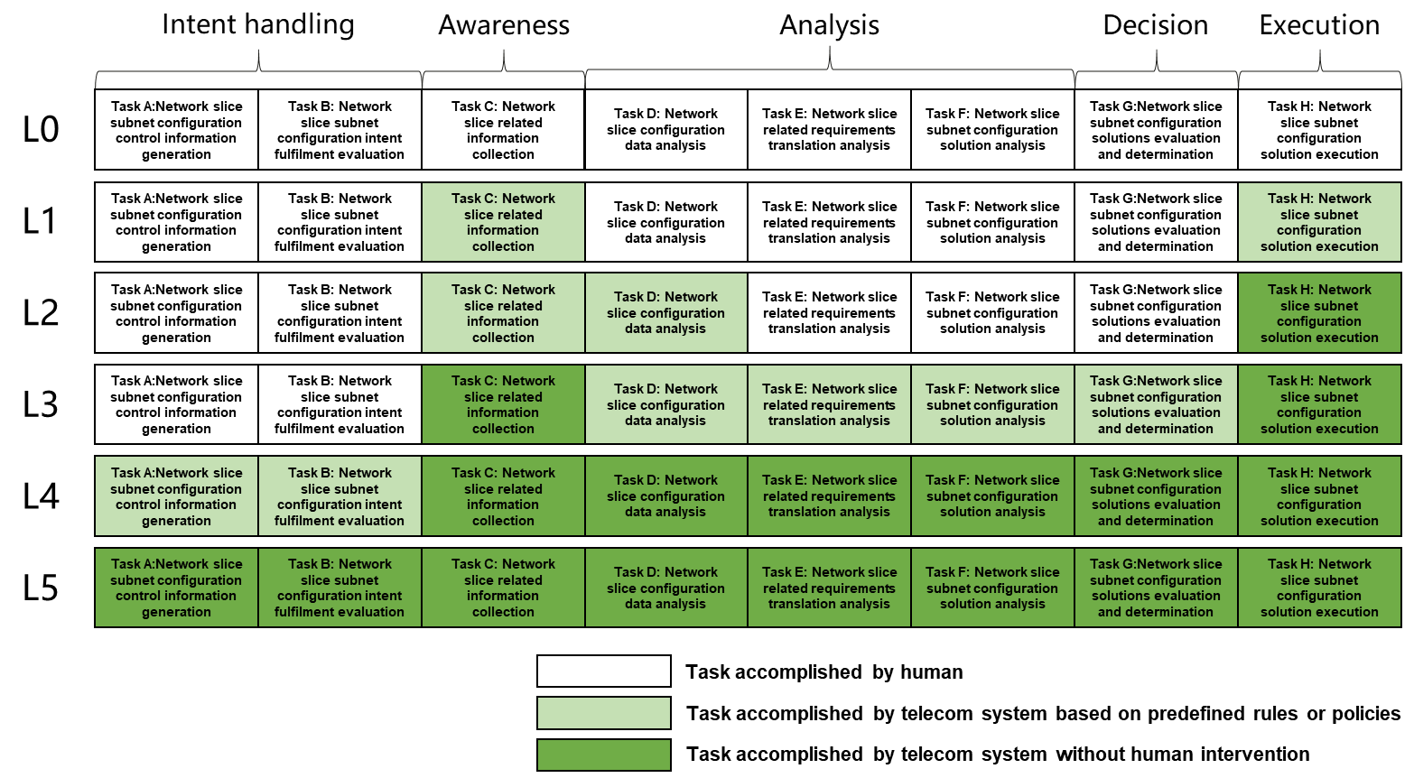
Figure 6.X.1.3-1 Classification of autonomous network level for network slice subnet configuration

6.x.2 Potential solutions
TBD

End of changes

