3GPP TSG SA WG5 Meeting 141-e S5-221557

electronic meeting, online, 7– 17th Jan 2022
CR-Form-v12.0
CHANGE REQUEST
 | 28.405 | CR | 0006 | rev | - | Current version: | 17.0.0
For HELP on using this form: comprehensive instructions can be found at
http://www.3gpp.org/Change-Requests.

Proposed change affects: | UICC apps |  | ME |  | Radio Access Network | X | Core Network | X

Title: | Adding Signalling Based Activation for NR
Source to WG: | Ericsson
Source to TSG: | S5
Work item code: | eQoE |  |  |  |  |  | Date: |  |  | 2021-12-18
Category: | B |  |  |  |  |  | Release: |  |  | Rel-17
 | Use one of the following categories:  F (correction)  A (mirror corresponding to a change in an earlier release)  B (addition of feature),  C (functional modification of feature)  D (editorial modification)  Detailed explanations of the above categories can  be found in 3GPP TR 21.900. |  |  |  |  |  |  |  | Use one of the following releases:  Rel-8 (Release 8)  Rel-9 (Release 9)  Rel-10 (Release 10)  Rel-11 (Release 11)  …  Rel-15 (Release 15)  Rel-16 (Release 16)  Rel-17 (Release 17)  Rel-18 (Release 18)
Reason for change: |  | The feature was missing in the specification
Summary of change: |  | Add Signalling Based Activation for NR
Consequences if not approved: |  | Not aligned with RAN groups
Clauses affected: |  | 4.z (new)
 |  | Y | N
Other specs |  |  | x | Other core specifications |  |  |  | TS/TR ... CR ...
affected: |  |  | x | Test specifications |  |  |  | TS/TR ... CR ...
(show related CRs) |  |  | x | O&M Specifications |  |  |  | TS/TR ... CR ...
Other comments:
This CR's revision history:

First change

4.z Signalling based activation in NR

4.z.1 Activation of measurement collection for a UE in NR
Actvation of measurement collection for a UE can be done after UE is attached or before UE attachment.

4.z.1.2 Activation of QoE measurement task after UE attachement to the network
When HSS activates the QoE measurement collection for a job, to the AMF/MME the following configuration parameters shall be included in the message: serviceType, areaScope, SliceScope, qoECollectionEntityAddress, pLMNTarget, qoETarget, qoEReference and QMC configuration file. The AMF/MME forwards activateAreaQMCJob to the impacted gNB. QoE measurement collection activation request is propagated to UE as below:
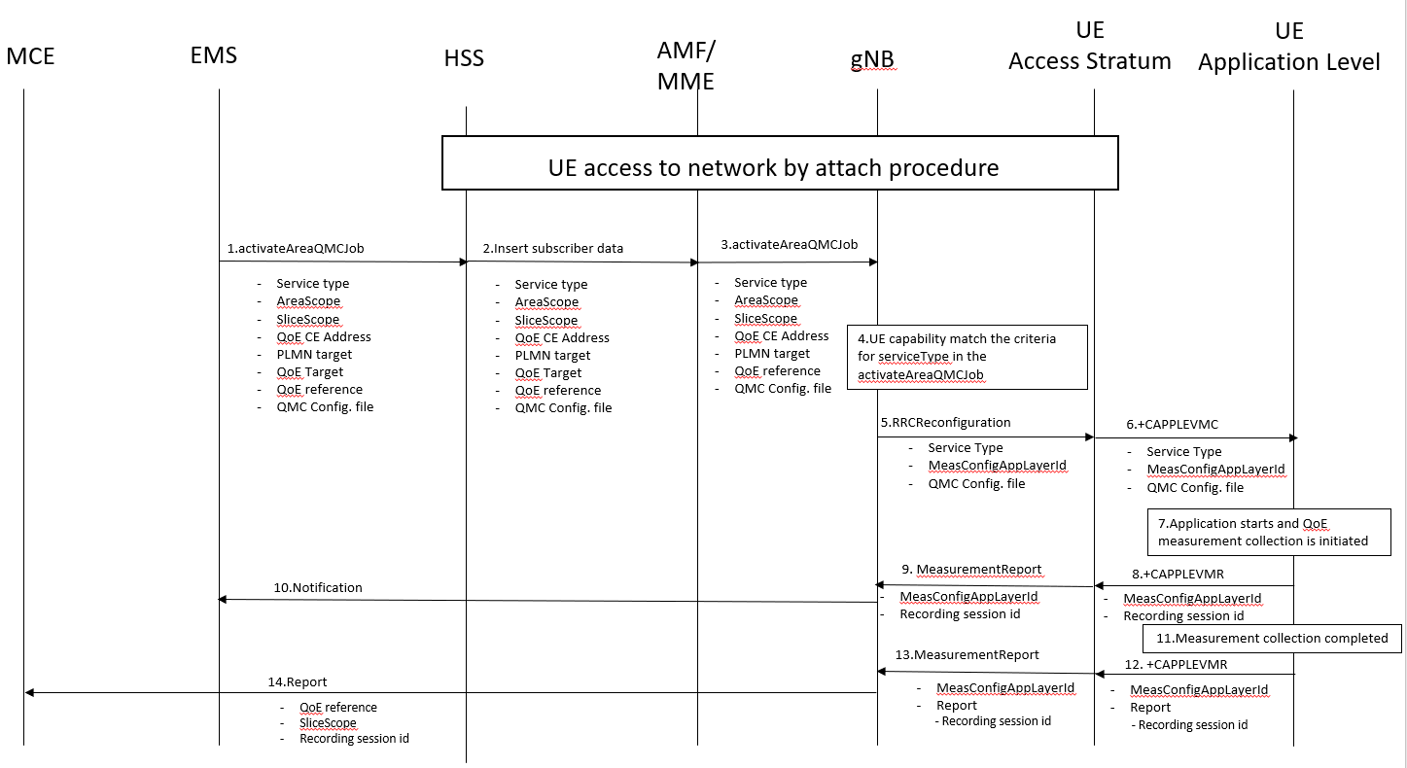
Figure 4.z.1-1: QMC activation and reporting in NR after UE is attached

- The EMS sends activateAreaQMCJob to HSS that controls the impacted gNB(s), and includes the parameters: serviceType, areaScope, SliceScope, qoECollectionEntityAddress, pLMNTarget, qoETarget, qoEReference and QMC configuration file.
- The HSS inserts subscriber related data and forwards it to the AMF/MME.
- The AMF/MME forwards activateAreaQMCJob to impacted gNB(s), and includes the parameters: serviceType, areaScope, SliceScope, qoECollectionEntityAddress, pLMNTarget, qoEReference and QMC configuration file.
- The gNB checks if the UE capability matches the criteria for serviceType in the activateAreaQMCJob.
- If the UE has the wanted UE capability, the gNB starts a UE request session and stores the associated QoECollectionEntityAddress, sends the message RRCReconfiguration to the UE, and includes the following: serviceType, MeasConfigAppLayerId and QMC configuration file.
- The access stratum in the UE sends the AT command +CAPPLEVMC to application level and includes the following: serviceType, MeasConfigAppLayerId and QMC configuration file.
- When the application in the serviceType starts, the QMC is initiated.
- The application layer sends the AT command +CAPPLEVMR and recording session indication that indicates that a session is started to the access stratum.
- The UE sends the message MeasConfigAppLayerId and the recording session indication to the gNB.
- The gNB sends a notification including the recording session indication to the NM.
- When the QMC is completed, the recorded information is collected in a QMC report [6], [7], including recordingSessionId. The qoEReference, Client Id [6] and [7] in the reporting container (that represent the UE request session), and recordingSessionId are needed in the QMC collection entity for post processing purposes.
- The application layer sends the AT command +CAPPLEVMR including MeasConfigAppLayerId and the QMC report to the access stratum.
- The UE sends the message including MeasConfigAppLayerId and the QMC report to the gNB.
- The gNB sends the QMC report to the MCE associated to the qoEReference, recordingSessionId and SliceScope.

4.z.1.3 Activation of QoE measurement task before UE attaches to the network
When HSS activates the QoE measurement collection for a job, to the AMF/MME the following configuration parameters shall be included in the message: serviceType, areaScope, SliceScope, qoECollectionEntityAddress, pLMNTarget, qoETarget, qoEReference and QMC configuration file.
At UE attachment the configuration parameters for the QoE measurement collection for a job is propagated to the UE.
The AMF/MME receives and stores QoE measurement collection job as part of Update Location Answer (or Insert Subscriber Information). Then the same procedure for activation of measurement collection job is applied as after UE is attached, described in see 4.z.1.2.
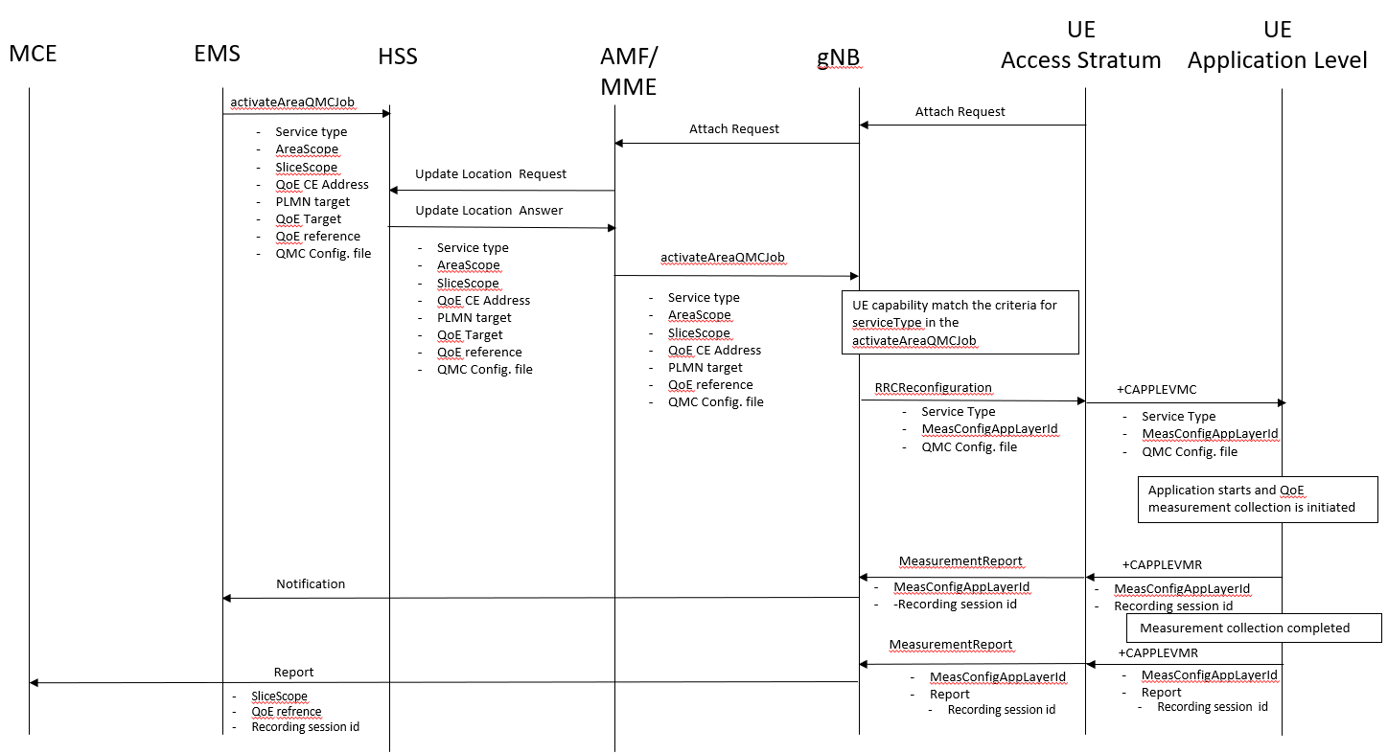
Figure 4.z.1-2: QMC activation and reporting in NR before UE is attached

End change

