3GPP TSG-SA5 Meeting #141-e S5-221421

e-meeting, 17 - 26 January 2022

Source: Ericsson

Title: Update intent information model

Document for: Approval
Agenda Item: 6.4.9

1 Decision/action requested
The group is asked to discuss and approval.

2 References
[1] 3GPP draft TS 28.312: “Management and orchestration; Intent driven management services for mobile networks v0.7.0”
[2] S5-221420 “TD Paper on TTM reduction for new Service offerings”

3 Rationale
As per discussion paper on “TTM reduction for new Service offerings” [2] this document proposes changes in TS 28.312 [1] to address following “detailed proposal” stated in the TD:
- Modelling of Intent object in 3GPP System should be based on Intent Common Model which is being specified by TM Forum in IG1253A [4]. Update TS 28.312 [1] accordingly.
- Domain-specific extensions to Intent Common Model needs to be defined in format compatible with RDF vocabulary as classes, individuals and properties. Intent modelling definitions made in RDF compliant format needs to be de-coupled from the rest of the NRM which is provided in UML format*. Update TS 28.312 [1] accordingly.
- Align 3GPP and TM Forum terminology around Intent modelling.
This document also addresses Editor’s note stated in TS 28.312 [1] cl.3.1 “Terms” as it is TM Forum Intent Common Model defined by IG1253A [3]:
Editor's note: Alignment with other organization is to be considered.

4 Detailed proposal
It proposes to make the following changes to TS 28.312[1].
1st Change

2 References
The following documents contain provisions which, through reference in this text, constitute provisions of the present document.
- References are either specific (identified by date of publication, edition number, version number, etc.) or non-specific.
- For a specific reference, subsequent revisions do not apply.
- For a non-specific reference, the latest version applies. In the case of a reference to a 3GPP document (including a GSM document), a non-specific reference implicitly refers to the latest version of that document in the same Release as the present document.
[1] 3GPP TR 21.905: "Vocabulary for 3GPP Specifications".
[2] 3GPP TS 28.531: "Management and orchestration; Provisioning".
[3] 3GPP TS 28.532: " Management and orchestration; Generic management services"
[4] TM Forum IG1253A “Intent Common Model”, v.1.1.0
[5] W3C "The RDF Schema vocabulary (RDFS)” https://www.w3.org/2000/01/rdf-schema
[6] W3C “The RDF Concepts Vocabulary (RDF)” https://www.w3.org/1999/02/22-rdf-syntax-ns

Next Change

6.2 Information model definition for Intent (MnS component typeB)

6.2.1 Information model definition for Intent
Editor’s Note: The following information model needs to be revisited based on the further discussion, and the alignment/coordination work with other SDO needs to be considered, which may impact the following information model.

6.2.1.1 Class diagram

6.2.1.1.1 Relationship

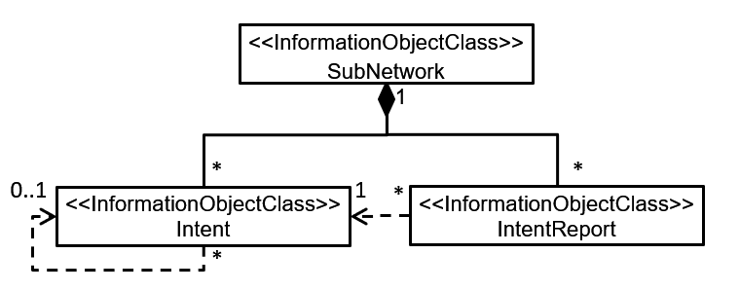
Figure 6.2.1.1.1-1 Relationship UML diagram for intent

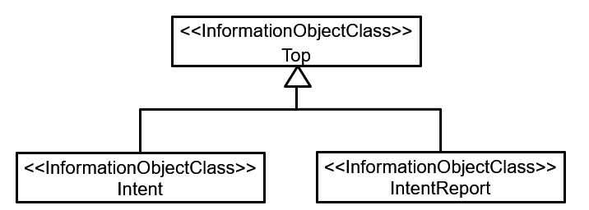
Figure 6.2.1.1.2-1 Inheritance UML diagram for intent

6.2.1.2 Class definition

6.2.1.2.1 Intent <<IOC>>

6.2.1.2.1.1 Definition
The Intent IOC contains information about intent object retrieved by 3GPP system from MnS Consumer.
The Intent IOC includes the attribute objectClass and objectInstance from the TOP IOC. The value of attribute objectClass is “Intent” and the value of attribute objectInstance is the DN of the instance of Intent IOC.

6.2.1.2.1.2 Attributes
The Intent includes attributes inherited from TOP IOC (defined in TS 28.622) and the following attributes:
Attribute Name | Support Qualifier | isReadable | isWritable | isInvariant | isNotifyable
userLabel | M | T | T | F | T
intentFulfilStatus | M | T | F | F | T
intentObject | M | T | T | T | T
intentOperation | M | T | T | T | T
intentReference | O | T | T | T | T

Editor’s Note: whether other the attributes are needed for the Intent IOC needs further discussion.

6.2.1.2.1.3 Attribute constraints
None

6.2.1.2.3 IntentReport

6.2.1.2.3.1 Definition
IntentReport class represent intent fulfilment feedback information that MnS consumer can obtained from a 3gpp system.
Editor’s Note: more description for IntentReport will be added later based on the further discussion.

6.2.1.2.3.2 Attributes

The IntentReport includes attributes inherited from TOP IOC (defined in TS 28.622) and the following attributes:
Attribute Name | Support Qualifier | isReadable | isWritable | isInvariant | isNotifyable
intentReportObject | M | T | F | T | T
intentReference | M | T | F | T | T

6.2.1.2.3.3 Attribute constraints
TBD

6.2.1.4 Attribute definition
Attribute Name | Documentation and Allowed Values | Properties
userLabel | A user-friendly (and user assignable) name of the intent.  allowedValues: Not Applicable | type: String  multiplicity: 1  isOrdered: F  isUnique: F  defaultValue: None  isNullable: False
intentObject | Contains an intent object (meta-data) obtained by the system.  The format of the intent object is defined in cl.6.X  allowedValues: Not Applicable | type: String  multiplicity: 1  isOrdered: F  isUnique: F  defaultValue: None  isNullable: False
intentReportObject | An intent report object (meta-data) reported back to the system sourcing an intent  The format of the intent object is defined in cl.6.X  allowedValues: Not Applicable | type: String  multiplicity: 1  isOrdered: F  isUnique: F  defaultValue: None  isNullable: False
intentReference | DN of a referred Intent IOC | type: DN  multiplicity: 0..1  isOrdered: F  isUnique: F  defaultValue: None  isNullable: False
intentOperation | Describes the purpose of the intent.  allowedValues: SET, PROBE, BEST | type: ENUM  multiplicity: 1  isOrdered: F  isUnique: F  defaultValue: None  isNullable: False
intentFulfilStatus | It describes the current status of the intent fulfilment result, which is configured by MnS producer and can be read by MnS consumer.  allowedValues: "FULFILLED", “NOT_FULFILLED  Editor’s Note: whether other allowed values should be supported is FFS, and the name for the attribute intentFulfilStatus is FFS. | type: ENUM  multiplicity: 1  isOrdered: N/A  isUnique: N/A  defaultValue: None  isNullable: False

Next Change

6.X Intent Object Format Specification

6.X.1 Intent Object Modelling
Intent Object format is based on Intent Common Model and 3GPP Specific Intent Model.

Intent Common Model is defined by TM Forum IG1253A “Intent Common Model” [4].

6.X.2 3GPP Specific Intent Model

6.X.2.1 Motivation and Background
3GPP Specific Intent Model extends Intent Common Model and therefore it is based on the Resource Description Framework (RDF) and the Resource Description Framework Schema (RDFS).

Similarly, to Intent Common Model Vocabulary ([4], cl.X.X) it defines 3GPP Specific classes which are derived from the definition of “Class” in RDFS [5] and properties which are respectively derived from the definition of “Properties” in RDF [6].

6.X.2.1 3GPP Specific Intent Model Vocabulary
This intent extension model proposes the following 3gpp extension to Intent Common Model:
Property: | icm:targetType
Definition: | The icm:targetType property is used in the parameters of a delivery expectation. It defines what the target is or shall be. The object is the class the target shall be an instance of. Note that the intent common model does not specify a taxonomy of deliverable entities and that the range of this property would be provided by other models.
Instance of: | rdf:Property  icm:DeliveryExpectationParam
Range: | rdf:Class  3gpp:CommunicationServiceSupport

This intent extension model proposes the following properties:
Property: | 3gpp:hasServiceParam
Definition: | Indicates which instances of PropertyParam are applicable to a specific class in 3gpp extension model
Instance of: | rdf:Property
Domain: | 3gpp:CommunicationServiceSupport
Range: | 3gpp:plmnIdList  icm:PropertyParam  icm:ContextParam  icm:ReportingParam  Editor’s Note: full list of PropertyParam for CommunicationServiceSupport are ffs
Task: | Intent Modeling

This intent extension model proposes the following classes:
Class: | 3gpp:CommunicationServiceSupport
Definition: | Indicates 3GPP system is expected to support Communication Service as further defined by Property Expectation
Instance of: | rdfs:Class
Task: | Intent Modeling

Class: | 3gpp:plmnIdList
Definition: | Indicates a list of PLMN ids to be supported for a certain Communication Service
Instance of: | rdfs:Class
Task: | Intent Modeling

Class: | 3gpp:maxNumberofUEs
Definition: | Indicates a maximum number of UEs which needs to be supported for a certain Communication Service
Instance of: | rdfs:Class  icm:ContextParam
Task: | Intent Modeling

Class: | 3gpp:latency
Definition: | Indicates a latency to be supported for a certain Communication Service
Instance of: | rdfs:Class  icm:PropertyParam
Task: | Intent Modeling

Class: | 3gpp:dlThptPerUE
Definition: | Indicates DL bandwidth per UE which needs to be supported for a certain Communication Service
Instance of: | rdfs:Class  icm:PropertyParam
Task: | Intent Modeling

Class: | 3gpp:ulThptPerUE
Definition: | Indicates UL bandwidth per UE which needs to be supported for a certain Communication Service
Instance of: | rdfs:Class  icm:PropertyParam
Task: | Intent Modeling

Class: | 3gpp:coverageAreaTAList
Definition: | Specifies a list of Tracking Areas for the communication service to be supported
Instance of: | rdfs:Class  icm:ContextParam
Task: | Intent Modeling

Class: | 3gpp:uEMobilityLevel
Definition: | Specifies the mobility level of UE accessing the network slice. See 6.2.1 of TS 22.261 [28].
Instance of: | rdfs:Class  icm:ContextParam
Task: | Intent Modeling

Class: | 3gpp:resourceSharingLevel
Definition: | Indicates if network resources allocated for a Communication Service to be supported, can be shared with other Communication Service
Instance of: | rdfs:Class  icm:ContextParam
Task: | Intent Modeling

Class: | 3gpp:activityFactor
Definition: | Specifies the percentage value of the amount of simultaneous active UEs to the total number of UEs where active means the UEs are exchanging data with the network.
Instance of: | rdfs:Class  icm:ContextParam
Task: | Intent Modeling

Class: | 3gpp:uESpeed
Definition: | Specifies the maximum speed (in km/hour) supported by the network slice or network slice subnet at which a defined QoS can be achieved. See Table 7.1-1 of TS 22.261 [28]).
Instance of: | rdfs:Class  icm:ContextParam
Task: | Intent Modeling

Class: | 3gpp:nROperatingBands
Definition: | This attribute represents which 5G NR frequency bands can be used to access the network slice. 5G NR operating bands are defined in 3GPP TS 38.101-1 [42].
Instance of: | rdfs:Class  icm:ContextParam
Task: | Intent Modeling

End of changes

