3GPP TSG SA WG5 Meeting 141e S5-221420

electronic meeting, online, 17 - 26 January 2022

Source: Ericsson

Title: Technical Discussion on TTM reduction for new Service offerings

Document for: Discussion, Endorsement
Agenda Item: 6.4.9

1 Decision/action requested
The group is asked to discuss and Endorse the proposals.

2 References
[1] 3GPP TS 28.312 Management and orchestration;
Intent driven management services for mobile networks [Rel-17]
[2] IG1230 TM Forum Introductory Guide “Autonomous Networks Technical Architecture”
[3] IG1253 TM Forum Introductory Guide “Intent in Autonomous Networks”
[4] IG1253A TM Forum Introductory Guide “Intent Modelling”
[5] RDF 1.1 Primer (w3.org)

3 Rationale
This document provides clarifications on importance to address handling of external to 3GPP system information while working on 3GPP Intent-driven management service specification [1]. This document also provides further clarifications on importance of alignment with TM Forum [2, 3, 4] to achieve usable 3GPP Intent management solution.

3.1 Background: New Service offering
While 5G system provides a support to a wide range of communication services there are other systems involved into design, ordering, activation and optimization of those services (Figure 1)

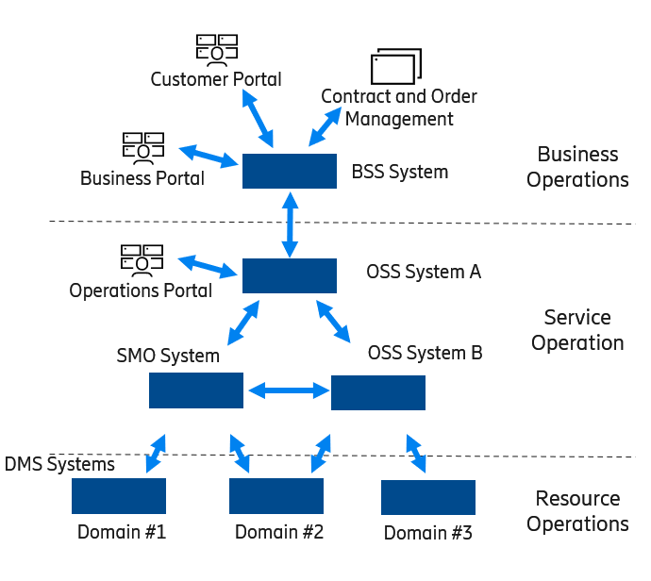
Figure 1: Different Operation Systems involved in handling of Communication Services

When there is a market demand or opportunity to offer a new service there are several issues which needs to be solved by a service provider (Figure 2):
- Mapping of relevant management data and information flows in those systems involved in support of that new service, needs to be added / changed which most of the times is carried as integration efforts by the service provider or by its vendors
- Workflow logic in some systems needs to be updated especially if handling of the new service requires extension of system functionality. In many cases it should be carried as design activities which later will require system update
- If extension of the system functionality affects its external interface but wanted changes are not captured by a relevant standard, the changes to the interface will be handled as extensions. As mentioned above this will involve extra design efforts. Please, also note that making certain extensions to the interface specified by standard can be tricky sometimes (e.g., extension to enumeration data-type)

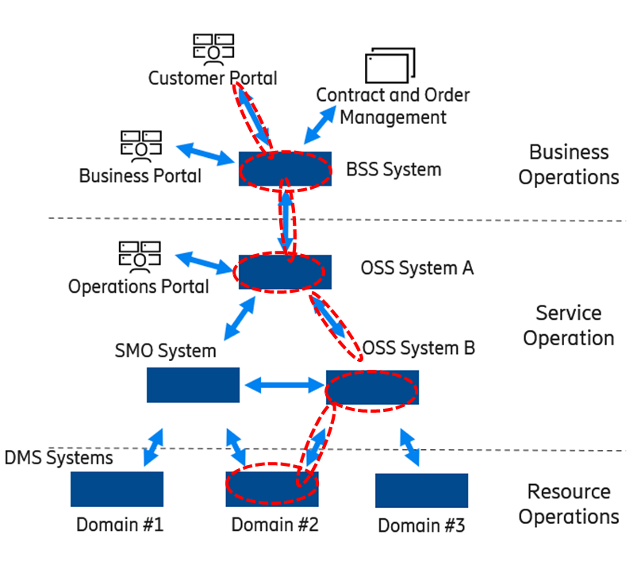

Figure 2: Different Operation Systems impacted by New service offering
All the activities captured above increase TTC/TTM significantly.

3.2 Minimizing TTM/TTC for new service offering
Following can be done to minimize cost of introduction of new communication services to the market:
- Eliminate / reduce mapping of data between information models of different systems by alignment of those using of common definitions, structures, data types, naming, etc.
- Provide a method which will allow extension of system interface beyond what is already defined by the standard including extension of system functionality.

At present, being a critical part in providing support for many different communication services, 3GPP system does not offer any method which would allow network operators to extend system external interface and connect it with wanted system behaviour which [while captured externally] can still be executed by the system in question [e.g., 3GPP system]. If offered, it will allow the operators to significantly reduce TTM/TTC for many [new] service offerings.

One of the possible solutions will be to rely on W3C (www.w3.org) RDF semantic triple to specify structure of Intent object received by 3GPP management system from external source. While this requires changing way of working in stage-2 by 3GPP SA5 working group this will also allow to reuse Intent Common Model defined by TM Forum in IG1253A [4].

3.2.1 RDF Semantic Triple
RDF allows us to make statements about resources. The format of these statements (Figure 3) is simple. A statement always has the following structure:

<subject> <predicate> <object>

An RDF statement expresses a relationship between two resources. The subject and the object represent the two resources being related; the predicate represents the nature of their relationship. The relationship is phrased in a directional way (from subject to object) and is called in RDF a property. Because RDF statements consist of three elements and they are called triples. Each RDF element can be referred by URI.

The RDF Semantic Triple is main building block of so-called knowledge graph.

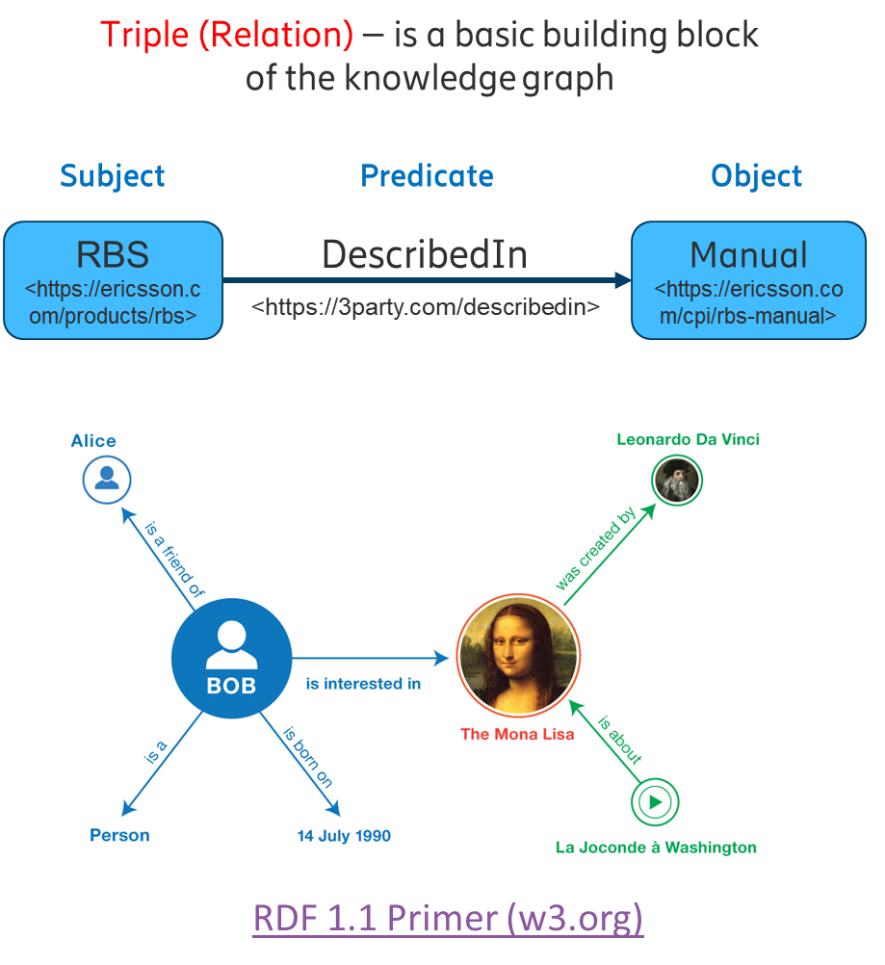

Figure 3: RDF triple
While there is more explanation on RDF triple provided by RDF Primer [5] it is important to mention that URI (universal resource identity) of the <object> in the triple can refer to a resource external to the system and e.g., it can refer to an artifact which describes the wanted system behaviour.

3.2.2 New Service Offering with RDF involvement
A Figure (Figure 4) below depicts an example about how new service offering can be defined by a certain service provider without any costly design and/or integration activities needed (provided network resources and infrastructure are able to support this new service) which significantly can reduce TTM/TTC for this new service
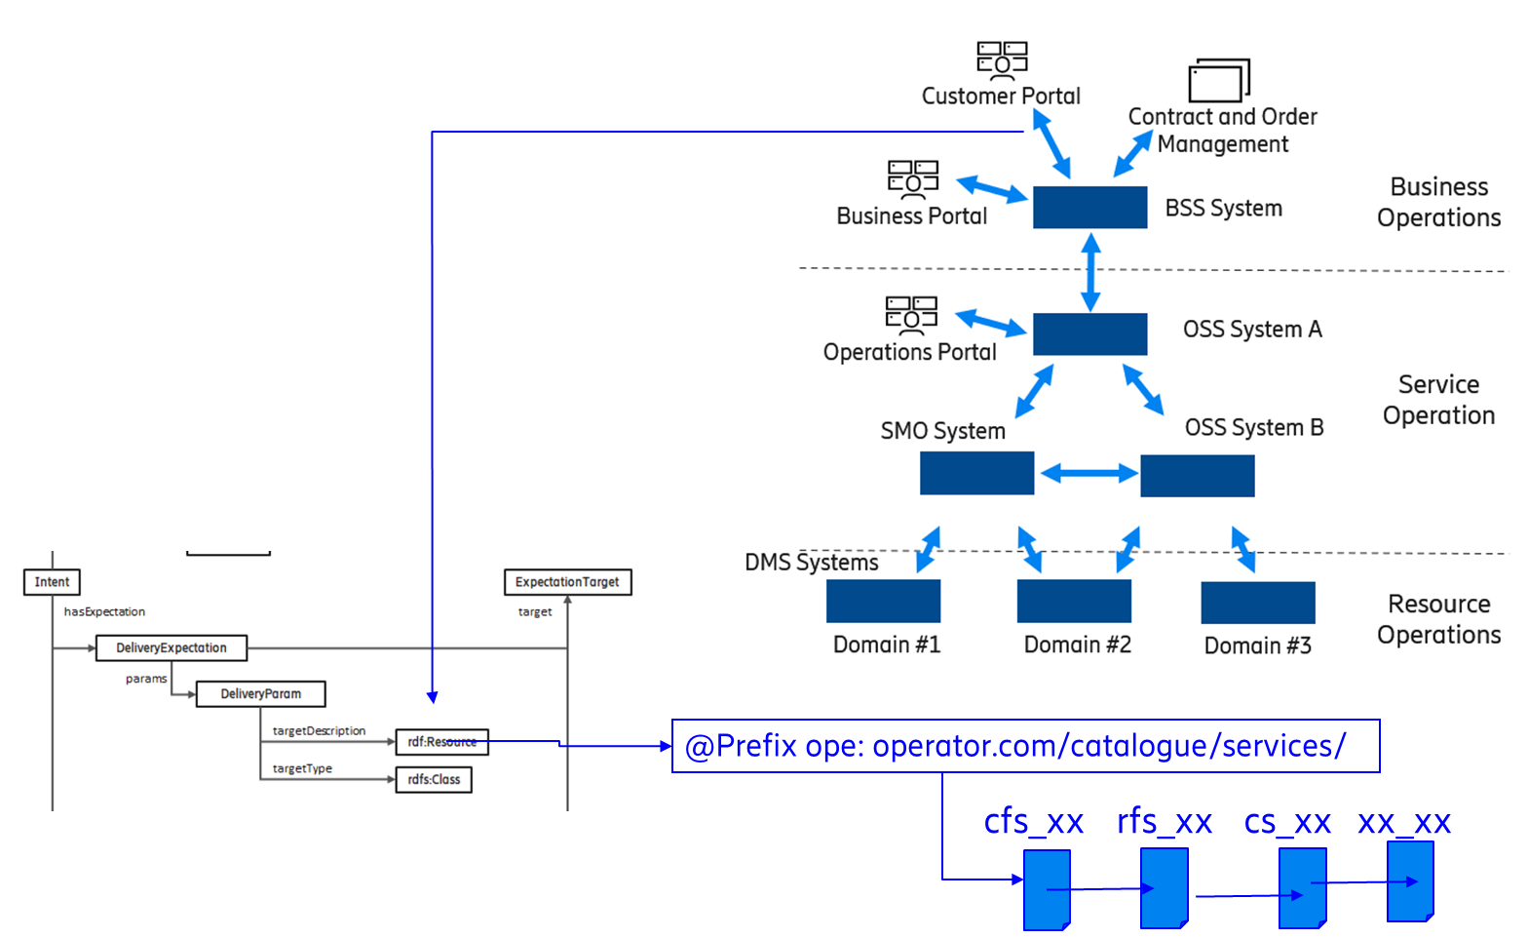

Figure 4: New service offering with short TTM/TTC, example
If interface of BSS system towards customer portal provides a reference to a new service as rdf:Resource which could be a URI link to an artifact describing that new service by referring to the components of that communication service. Then BSS system will contact other Systems referring components with other URI links constructed based on information retrieved from artifact above and so on.
The only task of the service provider will be creation of the artifacts (e.g., cfs_xx, rfs_xx, xx_xx … as depicted in Figure 4 above) and making those accessible over URIs (e.g. operator.com/catalogue/services/ as shown above). If network resources are provided by 3GPP System, the 3GPP management system needs to facilitate handling of such URIs to allow reduction of TTM/TTC for new service offerings as described above. The reduction of TTM/TTC can be maximized if all systems rely on the same structure, e.g., on Intent Common Model defined by [4] while exchanging Intent objects capturing requirements / expectations towards each other.

3.2.3 RDF vs UML
At the moment UML is being used 3GPP to carry work at “stage 2”. However, there are some limitations in UML which do not exist in RDF. Let’s look at the Figure below which represents an example of simplified definition of UML class:

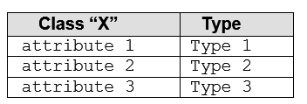
Figure 5: UML defines static classes
As per figure above the UML states that there is a Class “X” which has attributes 1 (of type 1), 2 (of type 2) and 3 (of type 3). If one wants to introduce a new attribute of the class he needs to update the definition of the whole class. If one wants to update type of attribute (e.g., datatype) it affects the whole data type definition. This modelling approach is a good match to capture data when it is very static, e.g., management data of telecom system: as soon as the changes to the class are identified, class is being redefined, the system implementation is updated and new/modified attribute appears on its interface after the system is updated.

But there is a limitation of such solid (read: UML) class definition: before system implementation is changed (e.g by system upgrade) the changes on the interface will not be handled by the system: they either be ignored (e.g. if the new attribute is added) or even can cause a fault / wrong behaviour within the system (e.g. type of the attribute changed).

There is no such a solid class definition in RDF where .everything is based on triplets (see cl.3.2.1 above). The Class “X” which has attributes 1, 2 and 3 with RDF will be looking like this

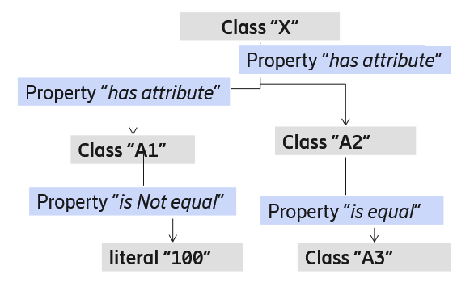
Figure 6: RDF classes and properties
As you see RDF is different. There is no single monolith box (usually it is a table in TS) representing a class but rather a graph of elements (individuals) where each having its own definitions (a table in TS).
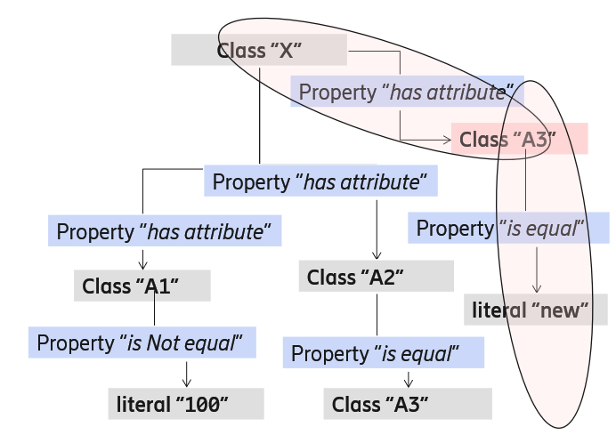

Figure 6: RDF triplets extending model
RDF modelling approach allows to capture data external to the system which is more dynamic and less predictable. E.g., if one needs to make a new statement only missing pieces are being defined (e.g. Class “A3”). Other already defined parts (classes and properties) of the model are not affected.

This is a big advantage of the RDF over UML especially for those who are building network management solutions exchanging intents which are expressing “requirements” which are very dynamic and external to the system rather than ordinary management data which are very static. E.g. relying on RDF definitions of class “rdfs:Resource” one can add an extension to the existing system interface which will not require the system to be updated as system already understands how to handle the given class. The only what needs to be done by an organization extending an interface (e.g. by NOP or CSP) is to ensure that system behavior is captured by the IRI (similar to URI) specified by the extension.

3.3 Conclusions
Since the definition of the Intent for 3GPP [management] system is the same to that of TM Forum it is proposed to rely on TM Forum defined Intent Common Model, ICM, which will fully exclude (or significantly reduce) efforts to integrate 3GPP-compliant systems (e.g., OSS) with TMF-compliant systems (e.g., BSS) around handling of intents bringing requirement about wanted support of communication services in 3GPP system from higher management layers and other systems.
3GPP should focus on 3GPP specific extensions to ICM, which will rather capture information specific to 3GPP domain which is not captured by Intent Common Model. 3GPP specific extensions needs to be aligned with definitions made in ICM (by TM Forum)
RDF / RDFS has defined methods to allow extensions to standardized interfaces including new parameters, parameter values and parameter containers. These methods also allow to describe both, input (as an extension to the standard) and required system behaviour, outside of the system. This is seen as crucial for intents handling and is recommended to be used for modelling of Intent in stage-2 work. Further evaluation is required if UML provides any extra value along with RDF / RDFS
Specification of Intent-driven management service to support other types of requirements should be aligned with above

4 Detailed proposal
- Modelling of Intent object in 3GPP System should be based on Intent Common Model which is being specified by TM Forum in IG1253A [4]. Update TS 28.312 [1] accordingly.
- Domain-specific extensions to Intent Common Model needs to be defined in format compatible with RDF vocabulary as classes, individuals and properties. Intent modelling definitions made in RDF compliant format needs to be de-coupled from the rest of the NRM which is provided in UML format*. Update TS 28.312 [1] accordingly.
- Align 3GPP and TM Forum terminology around Intent modelling. Two alternatives, Fast and Slow, can be considered.
  - Fast (recommended): 3GPP aligns with those terms defined by TM Forum in IG1253A (e.g., as Intent Common Model).
  - Slow: Number of meetings or liaisons are written to TM Forum proposing to change various constructions and concepts in Intent Common Model as per draft of 3GPP TS 28.312 [1].
*/ Usage of UML diagrams for representing 3GPP domain extensions to Intent Common Model made with RDF graphs, is for further discussion

