3GPP TSG-SA5 Meeting #141-e S5-221347
e-meeting, 17 -26 January 2022

Source: China Unicom

Title: New SID on Network Data Quality Management

Document for: Approval
Agenda Item: 6.2
3GPP™ Work Item Description
Information on Work Items can be found at http://www.3gpp.org/Work-Items
See also the 3GPP Working Procedures, article 39 and the TSG Working Methods in 3GPP TR 21.900

Title: Study on Network Data Quality Management

Acronym: FS_NDQM

Unique identifier:
Potential target Release: Rel-18

1 Impacts
Affects: | UICC apps | ME | AN | CN | Others (specify)
Yes |  |  | X | X
No | X | X
Don't know

2 Classification of the Work Item and linked work items

2.1 Primary classification
This work item is a
 | Feature
 | Building Block
 | Work Task
X | Study Item

2.2 Parent Work Item

Parent Work / Study Items
Acronym | Working Group | Unique ID | Title (as in 3GPP Work Plan)

2.3 Other related Work Items and dependencies

Other related Work Items (if any)
Unique ID | Title | Nature of relationship
910027 | Rel-17 Work Item on enhancements of Management Data Analytics Service | This SID will study the management of the input data quality of MDAS

3 Justification

With the data driven autonomous network development, data quality will have a significant impact on the machine learning model practical application.
Considering the WI/SI of NWDAF, MDAF, ML for NG-RAN, existing studies have normalized some specifications of network data collection, analysis, and ML application. However, this intelligent analysis actual practice may be hindered by low data quality.
Due to the network element fault, resource constrained of the data collection entities, manual configuration error, cross domain data-binding and so on, it is inevitable that network element creates ‘dirty data’.
For some instance:
- the coverage analysis extensively need MDT (3gpp management data ), Geographical and terrain data of the RAN (OSS data : gNBs location, antennas parameter, sector azimuth, etc.). When it applied to the large-scale commercial network, the accuracy of the geographical data of Node/sector is greatly affects the application performance of the analysis model.
- For the sake of congestion control, trace collection will discard portion of signalling when gNBs resource utilization rate is high. It is a common implementation used by a lot of manufacturers. If MDAF can't aware the data completeness in advance, it is prone to make some mistake analysis conclusion.
- Currently cross-domain data integration cost high. Cross domain data from several network element with different vendors, because of using different UE-id, timestamp etc, the multi-sources data correlation mismatch frequently. If relying on the implementation of MDAF or OSS to do the whole data check, it will expand too many computing and storage resources with data search and correlation. But if the original data can be pre-cautioned, pre-processed and well co-ordinated ahead of inputting into the analysis entity, cross domain data analysis will gain a lot of momentum.
Operators have strong need to improve the network data quality for better support the large-scale application of automation technology of 5G.
Therefore, we proposed to kick off a study item, in which to set up a management data quality control framework.
Facing to network data analysis, management data quality could be defined as the extent of the dataset meet the demand of analysis model. The analysis model may have explicit demand (datatype, missing value, etc.) and implicit demand (accuracy of GPS location, signalling completeness, etc.).
From our view, Data quality management of SA5 should be a framework of evaluate and promote the common goal of data quality that provision to the data consumers (MDAF, SON, etc.)
The objective of this SID is to
- identify the concept, requirements of management data quality and which kind of network data need standardized quality control. For instance, 3gpp management data (like MDT/Trace) and external data (like geographical data, base station antenna parameters and so on) should be included.
- Then a data quality evaluation indicator and mechanism would be intensively studied. And potential solutions of 5G data quality improvement could be discussed as well.
- For ensure the data quality that input to MDAF, an interface of data quality management may be brought in. On the one hand, it gathers the data quality requirement from MDAS. On the other hand, it checks the input data quality and give an evaluation response to the NF of the data source.

Clarification 1: the reason why we need an additional mechanism to evaluate data quality
In the WID MDAS, degree of confidence of analysis result have been proposed. Whereas it is an indicator of result. But without the assurance of input data quality (these data will be used as both training data and testing data usually, in ML process), due to the testing data quality is doubtful, the confidence score will be intangible.
Furthermore, when MDAF do the input data check with non-standard implementation, it can evaluation the input data conclusively, then giving a decision that the existing data would be worthwhile or plausible. However, it has limit ability to improve data quality. On account of data input of MDAF may come from network element, OMC and OSS which are supplied by several vendors. To help data quality improvement from the origins, it lacks an explicit and systematic metrics to inform the data producer which data characters affect the analysis running.

Clarification 2: The reference of data quality management framework
3Gpp data quality management could partially refer to ITU “Technical Specification D4.4 Framework to support data quality management in IoT” :
The data quality management framework should have the following characteristics.
– The quality data should be managed in a way that it should be accurate, available, consistent, confident, integrated, relevant, reusable, current, and complete;
– The quality of data should be measured with relevant data quality metrics;
– The management system contains methodologies to maintain the metadata;
– The system provides support to improve the data quality if the received data has poor quality;
– Multi-source data integration testing mechanism is provided in the data quality management framework;
– The ranking of the data with respect to its data quality indicators is supported
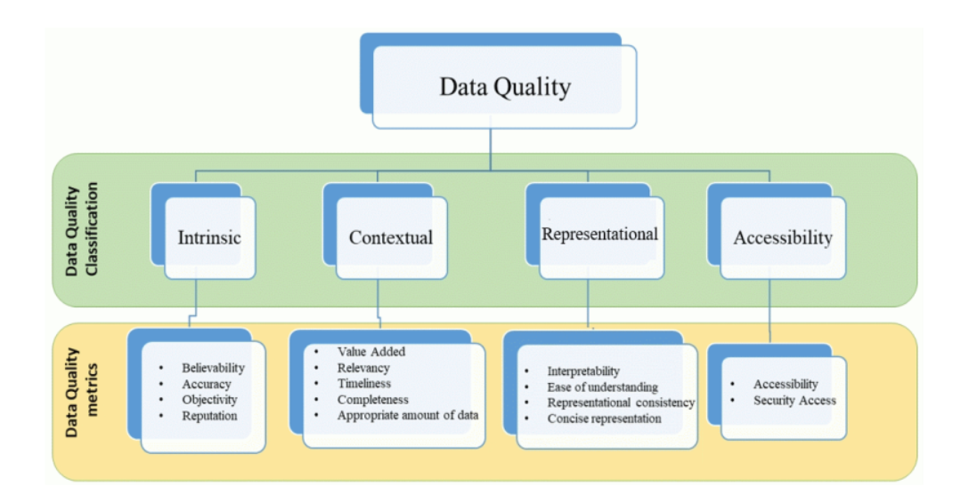
ITU -T 《Technical Specification D4.4 Framework to support data quality management in IoT》”

4 Objective
The objectives of this study item are:

- Specify concept, potential requirements of management data quality .
- Study which kinds of network data should take data quality control.
- Study the framework of 5G network data quality management. It may include the data quality evaluation indicator system, data quality test method etc.
- Study an interface of data quality management to interact with MDAF and NFs of data sources.
- Recommendations and potential solutions for 5G network data quality improvement and assurance.

5 Expected Output and Time scale
New specifications {One line per specification. Create/delete lines as needed}
Type | TS/TR number | Title | For info  at TSG# | For approval at TSG# | Rapporteur
TR | 28.xyz | Study on Network Data Quality Management | SA#96 (June 2022) | SA#97 (Sep 2022) | Feibi Lyu, ChinaUnicom, lvfb@chinaunicom.cn

Impacted existing TS/TR {One line per specification. Create/delete lines as needed}
TS/TR No. | Description of change | Target completion plenary# | Remarks

6 Work item Rapporteur(s)
Feibi Lyu, China Unicom, lvfb@chinaunicom.cn

7 Work item leadership
SA5

8 Aspects that involve other WGs

9 Supporting Individual Members
Supporting IM name
China Unicom
ZTE
CATT

