3GPP TSG-SA5 Meeting #141-e S5-221269

Online, , 17th Jan 2022 - 26th Jan 2022
CR-Form-v12.2
CHANGE REQUEST
 | 28.531 | CR | 0103 | rev | - | Current version: | 17.2.0
For HELP on using this form: comprehensive instructions can be found at
http://www.3gpp.org/Change-Requests.

Proposed change affects: | UICC apps |  | ME |  | Radio Access Network |  | Core Network

Title: | Rel-17 CR 28.531 Network slice subnet capabilities
Source to WG: | Samsung Electronics Benelux BV
Source to TSG: | S5
Work item code: | NETSLICE-PRO_NS |  |  |  |  |  | Date: |  |  | 2022-01-07
Category: | F |  |  |  |  |  | Release: |  |  | Rel-17
 | Use one of the following categories:  F (correction)  A (mirror corresponding to a change in an earlier release)  B (addition of feature),  C (functional modification of feature)  D (editorial modification)  Detailed explanations of the above categories can  be found in 3GPP TR 21.900. |  |  |  |  |  |  |  | Use one of the following releases:  Rel-8 (Release 8)  Rel-9 (Release 9)  Rel-10 (Release 10)  Rel-11 (Release 11)  …  Rel-16 (Release 16)  Rel-17 (Release 17)  Rel-18 (Release 18)  Rel-19 (Release 19)
Reason for change: |  | The capabilities query procedures are not clearly defined. The relation between allocation and capabilities query are also not defined.
Summary of change: |  | This proposal clarify the capabilities query procedure and its relation with allocation procedure.
Consequences if not approved: |  | In correct secification.
Clauses affected:
 |  | Y | N
Other specs |  |  | X | Other core specifications |  |  |  | TS/TR ... CR ...
affected: |  |  | X | Test specifications |  |  |  | TS/TR ... CR ...
(show related CRs) |  |  | X | O&M Specifications |  |  |  | TS/TR ... CR ...
Other comments: |  | 7.3, 7.8.2
This CR's revision history:

1st Modified Section

7.2 Procedure of Network Slice Instance Allocation
The Figure 7.2-1 illustrates the procedure of creating a new NSI or using an existing NSI to satisfy the required network slice related requirements.
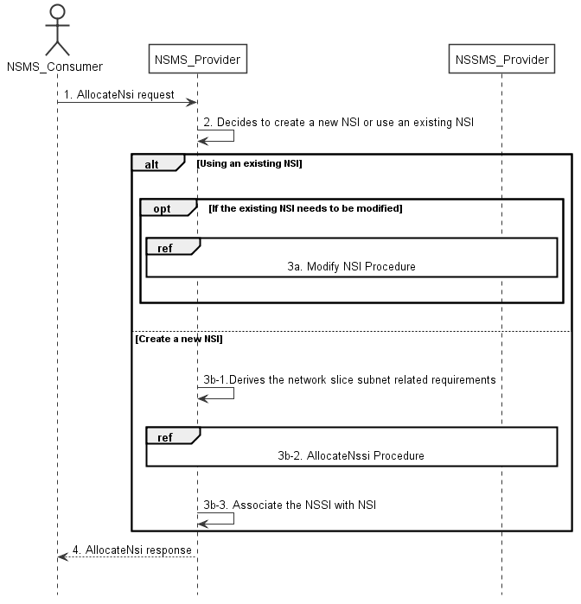
Figure 7.2-1: Network Slice Instance Allocation Request procedure
1) Network Slice Management Service Provider (NSMS_Provider) receives an AllocateNsi request (see AllocateNsi operation defined in clause 6.5.1) from Network Slice Management Service Consumer (NSMS_Consumer) with network slice related requirements (the network slice related requirements are defined as the attributes in the ServiceProfile see clause 6.3.3 in TS 28.541 [6]).
2) Based on the network slice related requiremen and the knowledge of the capabilities of existing deployed network slices and the slice subnet (slice subnet capabilities can be queried as defined in clause 7.8), the NSMS_Provider compare/match the provided requirements against all the candidate NetworkSlice instances, and then decides whether to use an existing NSI or create a new NSI. If the network slice related requirements allow the requested NSI to be shared and if an existing suitable NSI can be reused, the NSMS_Provider may decide to use the existing NSI.
3a) If using an existing NSI and the existing NSI needs to be modified to satisfy the network slice related requirements, the NSMS_Provider invokes the procedure to modify the existing NSI as described in clause 7.6.
3b-1) If creating a new NSI, the NSMS_Provider derives the network slice subnet related requirements from the received network slice related requirements. Before NSMS_Provider derives the network slice subnet related requirements, NSMS_Provider may invoke corresponding network slice subnet capability information querying procedure as described in clause 7.8.
3b-2) The NSMS_Provider invokes the NSSI allocation procedure as described in clause 7.3.
3b-3) The NSMS_Provider creates the MOI for NetworkSlice and configures the MOI with the DN of MOI for the NetworkSliceSubnet, other configuration information may be configured for the created MOI.
Note: The detailed configuration information is described in network slice NRM (see NetworkSlice IOC defined in clause 6.3.1 in TS 28.541 [6]).
4) The NSMS_Provider sends NSI allocation result (see AllocateNsi operation defined in clause 6.5.1) to the NSMS_Consumer. If an existing NSI is modified or a new NSI is created successfully to satisfy the network slice related requirements, the result includes the relevant network slice instance information (see NetworkSlice IOC defined in clause 6.3.1 in TS 28.541 [6]):
- DN of the NetworkSlice.
Otherwise the result may include the reason of failure, for example, the required latency or user number cannot be satisfied, or the physical resource is not enough.

Next Modified Section

7.8 Procedure of Obtaining Network Slice Subnet Capability

7.8.1 Introduction
The clause illustrates possible procedures of obtaining network slice subnet capability information (e.g. supported maximum latency, supported capacity (e.g. maximum user number)) of network slice subnet instance(s) which can be provided by network slice subnet management service provider.

7.8.2 Querying Network Slice Subnet Capability Information
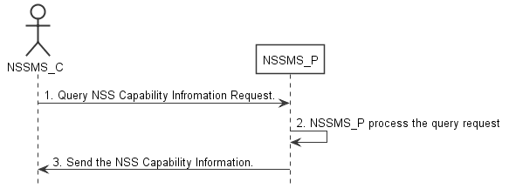
Figure 7.8-2: Procedure of querying network slice subnet capability information
1) Network Slice Subnet Management Service Consumer (NSSMS_C) wants to query the NSS capability information of the NSSI(s) which can be provided by corresponding Network Slice Subnet Management Service Producer (NSSMS_P). NSSMS_C sends getMOIAttributes operation (defined in TS 28.532 [8]), for NetworkSliceSubnet IOC, to NSSMS_P to obtain the NSS capability information of the NSSI(s) which can be provided by corresponding NSSMS_P.
2) NSSMS_P processes the NSS capability information querying request.
3) NSSMS_P sends the NSS capability information (e.g. supported maximum latency, supported capacity (e.g. user number)) of NSSI(s) that can be provided by itself, as a response to getMOIAttributes operation (as defined in TS 28.532 [8]), to NSSMS_C.

7.8.3 Void

