**3GPP TSG-SA5 Meeting #140-e *S5-216308rev2***

**e-meeting, 15 - 24 November 2021**

**Source: AsiaInfo**

**Title: pCR TR 28.824 add procedures related to product onboarding**

**Document for: Approval**

**Agenda Item: 6.5.4**

# 1 Decision/action requested

***The group is asked to discuss and approve the proposal.***

# 2 References

[1] 3GPP TR 28.824: " Study on network slice management capability exposure " V0.3.0

# 3 Rationale

Product onboarding is the procedure of managing the product catalog which can be exposed before a product order has been created.

# 4 Detailed proposal

|  |
| --- |
| **1st change** |

4.1.4.X Procedure for product onboarding

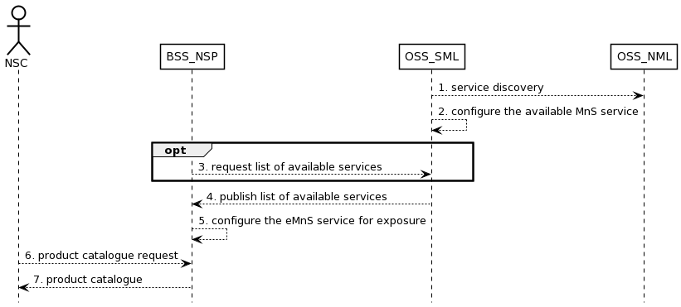

Figure 4.1.4.x.1 Procedure related to product onboarding

1. OSS_SML obtains 3GPP management services in the network through service discovery;
2. OSS_SML governs the rules and policies of MnS service and configures the available MnS service(e.g. eMnS service) to BSS_NSP. For example, if the RAN NE is dedicated to external customers, the performance monitoring service of RAN NE should be exposed. Otherwise, it should not be exposed;
3. Optional, tmay requestthe listof available services
4. OSS_SML publishes the list of available services to BSS_NSP;
5. BSS_NSP configures the eMnS service to be exposed to NSC;
6. NSC should request the product catalog from BSS_NSP.
7. BSS_NSP provides product catalog to NSC.

Editor’s Note: “Whether EGMF can have the functionality of eMnS data registration to an external discovery system is FFS.”

|  |
| --- |
| **2nd change** |

Annex A (informative):  
Appendix with UML code of the sequence diagrams

A.X UML code

@startuml

@startuml

skinparam sequence {

ArrowColor Black

ActorBorderColor Black

ActorBackgroundColor White

ParticipantBorderColor Black

ParticipantBackgroundColor White

LifeLineBorderColor Black

BackGroundColor <<BSS_Prov>> Black

}

skinparam NoteBackgroundColor White

skinparam NoteBorderColor Black

skinparam shadowing false

hide footbox

actor NSC

participant BSS_NSP

participant OSS_SML

participant OSS_NML

OSS_SML--> OSS_NML: 1. service discovery

OSS_SML---> OSS_SML: 2. configure the available MnS service

opt

BSS_NSP -->OSS_SML: 3. request list of available services

end

OSS_SML---> BSS_NSP: 4. publish list of available services

BSS_NSP --> BSS_NSP: 5. configure the eMnS service for exposure

NSC --> BSS_NSP: 6. product catalogue request

BSS_NSP --> NSC: 7. product catalogue

@enduml