3GPP TSG-SA5 Meeting #140-e S5-216193rev3

e-meeting, 15 - 24 November 2021

Source: Huawei

Title: PCR TS 28.104 add MDA analysis request and reporting workflow

Document for: Approval
Agenda Item: 6.4.18

1 Decision/action requested
In this box give a very clear / short /concise statement of what is wanted.

2 References
[1] 3GPP TS 28.104-020 “Management and orchestration; Management Data Analytics”

3 Rationale
This contribution propose to add generic MDA analysis request and reporting workflow in [1].

4 Detailed proposal
It is proposed to apply following changes in [1].
1st modified section

X Workflow for MDA management

X.1 MDA analysis request and reporting workflow
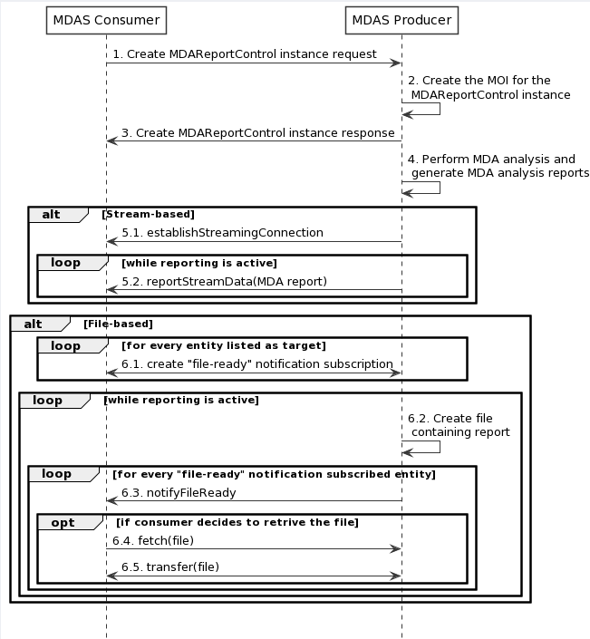
Figure X.1-1: Generic MDA analysis request/reporting workflow
1 MDAS Producer receives a Create MDAReportControl MOI request (see createMOI operation defined in TS 28.532 [11]) from MDAS Consumer with MDA request control related information.
Editor’s Note1: the reference of information model definition will be added, when they are available.
Editor’s Note2: the MDA request control related information is FFS.
2 The MDAS Producer creates the MOI for the MDAReportControl to be created.

3 The MDAS Producer sends the Create MDAReportControl MOI response (see createMOI operation defined in TS 28.532 [11]) to MDAS Consumer with identifier of MOI.
4 The MDAS Procedure perform MDA anlaysis and generate MDA report.
Alt1: For stream-based MDA reporting
5.1 Establish the streaming connection containing the stream information, by invoking the establishStreamingConnection operation;
5.2 The MDAS producer sends the MDA report to the MDAS consumer via data streams, by invoking the reportStreamData operation.
Alt2: For file-based MDA reporting
6.1~6.2 The MDAS consumer create a file-ready notification subscription operation by invoking the subscribe operation.
6.3~6.5 The MnS producer sends notifyFileReady notification to subscribed MnS consumers when a MDA report file becomes ready (available) on the MnS producer for upload by MnS consumers.

End of modified section

