3GPP TSG-SA5 Meeting #140-e S5-216193rev2

e-meeting, 15 - 24 November 2021

Source: Huawei

Title: PCR TS 28.104 add MDA analysis request and reporting workflow

Document for: Approval
Agenda Item: 6.4.18

1 Decision/action requested
In this box give a very clear / short /concise statement of what is wanted.

2 References
[1] 3GPP TS 28.104-020 “Management and orchestration; Management Data Analytics”

3 Rationale
This contribution propose to add generic MDA analysis request and reporting workflow in [1].

4 Detailed proposal
It is proposed to apply following changes in [1].
1st modified section

X Workflow for MDA management

X.1 MDA analysis request and reporting workflow
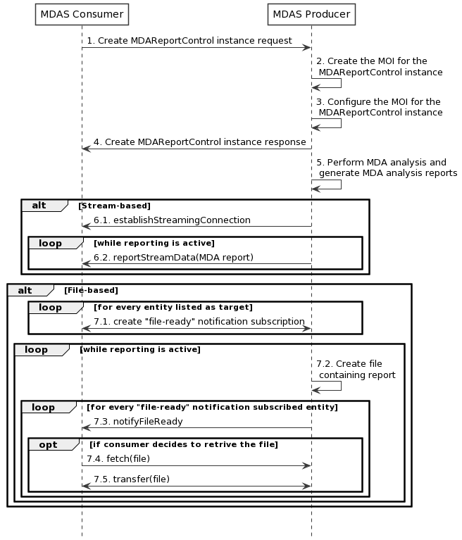
Figure X.1-1: Generic MDA analysis request/reporting workflow
1) MDAS Producer receives a Create MDAReportControl MOI request (see createMOI operation defined in TS 28.532 [11]) from MDAS Consumer with MDA request control related information.
Editor’s Note1: the reference of information model definition will be added, when they are available.
Editor’s Note2: the MDA request control related information is FFS.
2) The MDAS Producer creates the MOI for the MDAReportControl to be created.
3) The MDAS Producer configures the new created MOI with corresponding MDA request control related information.
NOTE: There is no limitation on whether step 2 and step 3 are combined into one step or two steps.
4) The MDAS Producer sends the Create MDAReportControl MOI response (see createMOI operation defined in TS 28.532 [11]) to MDAS Consumer with identifier of MOI.
5) The MDAS Procedure perform MDA anlaysis and generate MDA report.
Alt1: For stream-based MDA reporting
6.1) Establish the streaming connection containing the stream information, by invoking the establishStreamingConnection operation;
6.2) The MDAS producer sends the MDA report to the MDAS consumer via data streams, by invoking the reportStreamData operation.
Alt2: For file-based MDA reporting
7.1~7.2 The MDAS consumer create a file-ready notification subscription operation by invoking the subscribe operation.
7.3~7.5 The MnS producer sends notifyFileReady notification to subscribed MnS consumers when a MDA report file becomes ready (available) on the MnS producer for upload by MnS consumers.

End of modified section

