3GPP TSG SA WG5 Meeting 139e S5-215400

electronic meeting, online, 11 - 20 October 2021

Source: Ericsson

Title: Add definition around Intent Life Cycle Management

Document for: Approval
Agenda Item: 6.4.10

1 Decision/action requested
The group is asked to discuss and Endorse the proposals.

2 References
[1] 3GPP TS 28.312 Management and orchestration;
Intent driven management services for mobile networks [Rel-17]

3 Rationale
While Intent management was thoroughly studied in TR 28.812, the TR does not provide fully information about Intent Life Cycle Management. Also, the report carries a note that “The need for all actions above and details would be further discussed in the normative phase”.

In the normative phase the discussion already started around procedures and operations (reusing CRUD) to handle an Intent while the discussion on Intent Life Cycle Management was never concluded while it is one of the major input to conclude if CRUD is a good fit for Intent Management operations.

This document proposes to add more details on Life Cycle of Intent to TS 28.312 [1].

But first, let’s look at the definition of the Intent made in TS 28.312 [1]:
“Intent: the expectations including requirements, goals and constraints given to a 3GPP system, without specifying how to achieve them”

And let’s assume a 3GPP system exposes an interface and the external actor (e.g. a human) with a bunch of the requirements (relevant for the given 3GPP system) can create an object as a container for these requirements. Let’s call such a container “front-end intent”. When such a “front-end intent” object is created in the system by an actor it will become a representation of the external actor’s (e.g. human) list of requirements. What else such an object should express? Let’s assume the amount of information in the Front-End Intent object defined by an actor was enough for a system to deliver what was required (expected) by the end user. How does the actor know? E.g., when to initiate charging for delivering what was requested. Seemingly the object capturing requirements should indicate status on fulfilment of the requirements. As soon as requirements captured in the intent are fulfilled the status of the object will change to indicate that requirements are fulfilled. Hence, in case of “front-end intent” we have a very simple flow for an actor: step 1: create Intent object; step 2: wait and see if the intent is fulfilled. And it seems this is the expectation we have in the group how 3GPP intent should look like.

Issue #1 “Not enough input”
The flow above was a successful flow. But what if there was not enough information in the intent object for the system to follow-up on the specified intent (“front-end intent”)? E.g. the actor didn’t specify one of the important dimensions for the wanted service. In this case, the system will not be able to go ahead and book the resources as it makes no sense, apparently from the business point of view. The object representing “front-end intent” turns red and the actor needs to take actions in order to investigate and specify the dimension of the wanted service. And after it is specified there might be another dimension for the wanted service to be specified as well. Which also needs to be understood, derived and then specified, which will take more time.

Issue #2 “Not enough specified”
While there might be enough input specified by an end-user for the system to start looking after the intent, there might be a requirement which can not be captured by the interface exposed by the system. Simple case, the value of the expected characteristic is out of the range defined in the interface. More complex case, there is not even such a characteristic in the list, while system can handle it (it is simply not defined in the interface). How it can be fixed? Changes in the system implementation. Coding, verifying. Which can take some time. It reminds some solutions based on templates and/or rule today. Somebody needs to preconfigure those

Issue #3 “Not enough competence”
It may happen that after actor creates a “front-end intent” and the action is triggered towards a system with a specific input required towards that system. The input might be outside of the actors list of requirements and outside of the actors area of competence. How could it be resolved? Hard-coding, pre-programming, templates is a only way forward. It takes some design time and we already have solution in 3GPP called Slice management.

Issue #4 “Not enough resources”
While it might take some time for an actor to investigate what should be captured in the “front-end intent” object the system after all might have enough input to proceed. But when executing on the intent there might be not enough resources in the system to fully comply with what is captured by the “front-end intent”. The actor needs to collect more input about state of the system overall, to analyze and see if it is possible to tweak or change what was specified in the intent initially and it takes time.

Issue #5 “Out of the context”
It may happen that an actor creates certain “front-end intent” as a part of the bigger task where the expectations from the system can be tweaked depends on the environmental conditions. To tweak those expectations the actor will need to monitor the environment and tweak “front-end intent” parameters accordingly. This is will be a time consuming procedure in case the environment monitoring is done by a human and if external actor is another system, that system needs to learn how to act in many different scenarios.

Summary
A 3GPP Management system can produce an MnS which can offer an external actor (MnS consumer) a simple way to specify what’s expected from the system, for example, as Intent IOC which can be handled with CRUD operations (blue arrow on the figure below) as trivial extension of provisioning MnS. While specification of such a CRUD-based MnS looks trivial and not complex, managing of an Intent with such an Interface is not trivial. It could happen that after all the research done on what’s needed to be defined in the Intent IOC and all the performed evalutions of the system state (red arrow on the figure below) to ensure that Intent is aligned with the system state, the system will reject an intent because it is outdated. And even if the actor moves quickly it may be rejected too because it is incomplete.
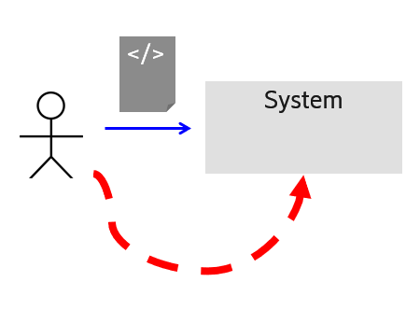

Figure 1. Before Intent can be created and sent towards 3GPP System an actor needs to evaluate a system state

It also can happen that even after the Intent is accepted by the system, the system state changes so the Intent will not be best aligned with a system state and after all it is either system resources are overbooked and an intent is failing to meet expectations of the external author or the resources of the system become underbooked which makes such a solution very expensive and therefore useless.

This brings to a conclusion that deriving an intent which is aligned with the system state and keeping the intent aligned with a system state while still meeting actor’s expectations, should be also automated as well. A full solution could look as follows:

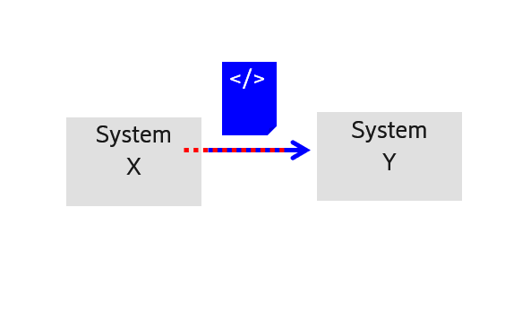
Figure 2. Creation and maintaining an Intent best aligned with a state of receiving system state should be automated which means a life of the intent begins before it is inserted into system Y

The automation of the process of the creation and maintenance of the intent requires to reconsider the life-cycle management of the Intent. An intent life starts before it gets instantiated in System Y (e..g. with trivial Create IOC operation in case of 3GPP System). The Intent is being derived in System X and then when it is fully aligned with state of the System Y it can be moved over into “System Y” where it is executed.

In order to construct and maintain an Intent in System X best aligned with a state of the System Y there are some extra operations required between System X and System Y additionally to well-known CRUD operations. These operations will allow System X to delegate evaluation of the Intent against System Y state, to System Y itself and will be invoked in time well before Intent is being created in System Y.

The Intent life cycle including its creation and mainaining alignment between it and system state needs to be fully explained in the TS 28.312 [1] before starting description of these operations

4 Detailed proposal
This document proposes to make the following changes to TS 28.312[1].

1st Change

Annex <X> (informative): Intent Life Cycle Management
Editor's note: Some content of this Annex can become a normative content after it is aligned with 3GPP terminology

X.1 Intent Life Cycle Management
As the system state (e.g. number and/or availability of the system resources) can change even after the Intent is accepted by the system, the Intent might not be best aligned with the system state. For example, system resources are overbooked, and an intent is failing to meet expectations of the external author or the resources of the system become underbooked which makes such a solution very expensive and therefore useless. Hence the creation of an Intent and keeping it aligned with the state of the receiving system, should be automated.

This means that the life cycle of the Intent can begin before an Intent is retrieved by the receiving system, e.g., an Intent is being defined in a sourcing system based on requirements towards a target system (e.g., to deliver a service with certain characteristics), then be optimized based on the system state (e.g. availability of system resources in certain area, time, etc.), then be refined if the initially captured requirement needs further detalization, etc.
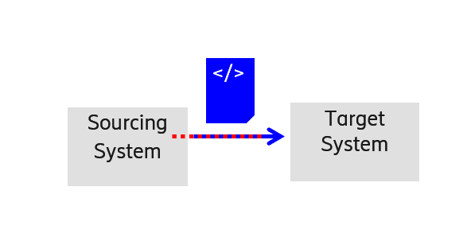
Figure 4.1.X-1: Intent Life-Cycle involving Automated Intent Creation

The intent lifecycle consists of the following phases:
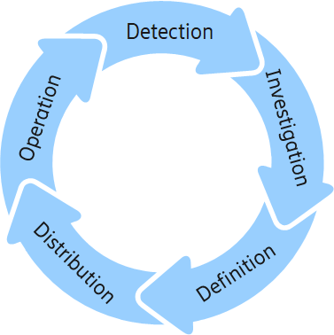
Figure 4.1.X-2: Intent Lifecycle Phases

Detection:
In the detection phase, the Intent sourcing system as the system creating an intent, identifies if there is a need to define new or change/remove existing intent to set requirements, goals, constraints. An intent management functionality of this system has its own terminal goals to fulfill. It would break its terminal goals down into a suitable set of detailed instrumental goals. Typically, these instrumental goals need to be fulfilled by other functions and domains and therefore they need to be not only defined but distributed to suitable handlers throughout the system. This is what the system is doing using intent. In the detection phase the asourcing system can react to changes in its own terminal goals or to changes in the fulfillment in its instrumental goals. In this respect the system deriving an intent will need to collect information about the goals' fulfillment. Intent reports coming from an Intent target system, as a system to receive an intent are one source for this information. Through intent reports the sourcing system is able to react on intent handling outcomes in the Target System. In any case it is task of the Intent sourcing system to assure the fulfillment of its terminal goals and the first step is to detect if any changes are needed in its instrumental goals and therefore in the intent objects it owns.
Investigation:
In the investigation phase, the system creatin the Intent finds out what intents are feasible. This has two aspects: first, it needs to find right target system that have the right domain responsibilities and support the intent information the sourcing system wants to define. Intent handler capability management and detection would be used for this process.
The other aspect of investigation would be finding out if the wanted intent is realistic. This means, if the intent handler would be able to successfully reach the wanted goals and meet the requirements. This depends on the current resource situation and state of the system and can vary over time. Typically, the feasibility of intent is done through a guided negotiation process between the intent handler and intent owner. The owner can explore what the handling result of a wanted intent would be, what would be the best result the handler can achieve, or what would be the most challenging requirements, the aspiring intent handler can offer to fulfill.
Definition:
At the end of the investigation phase the system sourcing the Intent knows what is possible and what the target systems to be involved. By combining this information with the needs that were identified in detection, the sourcing system can now decide and plan all needed intents. In the definition phase the intent management functionality in sourcing system formulates the intent it needs to use, and it creates the respective intent objects.
Distribution:
In the distribution phase the sourcing system contacts a target system in order to send a new intent or modify or change an existing one. This way the sourcing system acts on the plan it has made in definition phase. In this phase an intent management functionality in target system start handling the intent by receiving it. The target system decides if it can accept the intent. If not, it would send a report with the rejection reason back to the sourcing system. While this finishes the lifecycle of this particular intent object, the sourcing system can start over with detection to create a new plan. If the target system accepts the intent, it starts operating based on it.
Operation:
Each intent constitutes yet another set of goals and requirements to be considered for decisions and actions by the target systems. The systems operate their domains of responsibility according to the given intents. They also report back to the sourcing system about status and success while continuously reacting to intent fulfillment threats. Intent reports would be evaluated by the sourcing system as part of its detection process, which leads to the next iteration of the intent life cycle.
End of changes

