3GPP TSG-SA5 Meeting #139e S5-215349d1

e-meeting, 11 - 20 October 2021 Revision of S5-21xxxx

Source: Orange, AT&T, Telefonica, Huawei, Ericsson, Nokia, Deutsche Telekom

Title: Add use case for the exposure of network slice as a product

Document for: Approval
Agenda Item: 6.5.4

1 Decision/action requested
The group is asked to discuss and agree on the proposal.

2 References
[1] TR 28.824 0.2.0: Study on network slice management capability exposure

3 Rationale
This contribution proposes to add a use case for the exposure of network slice as a product.

4 Detailed proposal
This document proposes the following changes in TR 28.824 [1].

1st Change

5 Use cases for network management capability exposure

5.x Exposure of network slice as a product

5.x.1 Description
This use case involves the following roles:
- NSP: Network Slice Provider
- NSC: Network Slice Customer
- NOP: Network Operator
- CSC: Communication Service Customer
- CSP: Communication Service Provider
, and the following systems:
- BSS: Business Support System
- OSS: Operations Support System, made up of the two following sub-systems:
- SML: Service Management Layer
- NML: Network Management Layer (for sake of simplicity, network management and network element / function management are both in the NML).

5.x.1.1 Sub-use case 1: NSP and NOP played by the same organization
In this scenario, the following organizations play aforementioned roles as follows:
- Vertical-V plays the role of NSC
- Company-A plays the role of NSP and NOP
- As NSP, it has:
- a BSS, e.g. to manage its customers, products, contracts, and
- a SML, to manage the services that support its products
- As NOP, it has:
- its own 5G network (RAN + core). In this sub-use case, Company-A owns the whole set of network resources used by the service required to support the product ordered by Vertical V
- a NML, to manage the network resources used by services
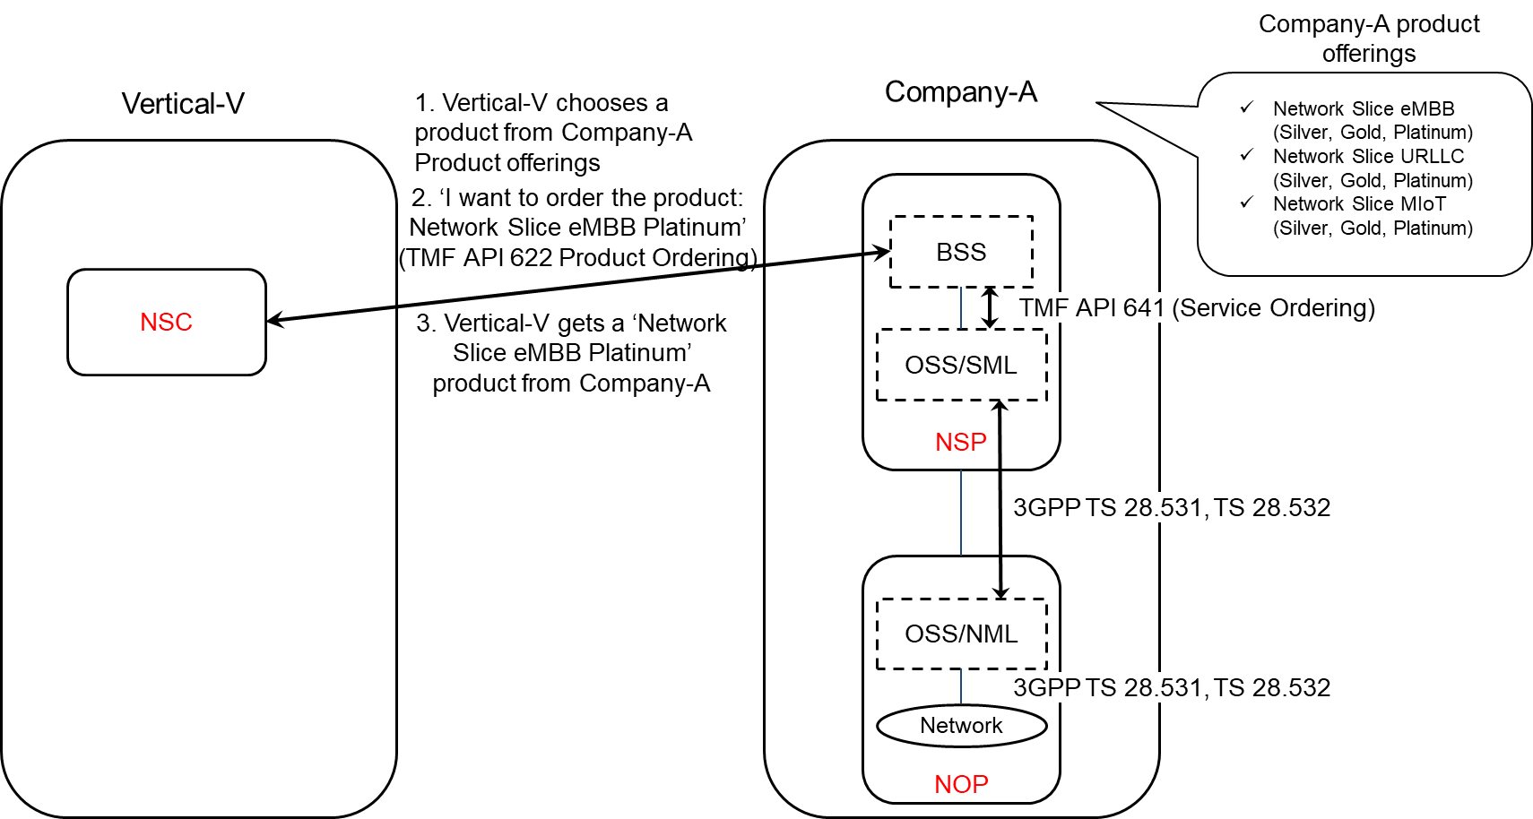
Figure 5.x.1.1-1: Sub-use case 1 - NSP and NOP played by the same organization

Company-A product catalogue proposes the following product offerings:
- Network Slice eMBB with different flavours: Silver, Gold, Platinum
- Network Slice URLLC with different flavours: Silver, Gold, Platinum
Network Slice MIoT with different flavours: Silver, Gold, Platinum.
In this sub-use case 1:
1. Vertical-V (as the NSC) chooses a product from Company-A product offerings
2. Vertical-V sends a request to Company-A (as the NSP) to order the product ‘Network Slice eMBB Platinum’. To achieve this, a candidate API is TMF API 622 (Product Ordering)
2.1 Company-A BSS determines which service supports the product being ordered by Vertical-V and issues a request to its OSS/SML to order this service. This service can be e.g. a network slice. To achieve this, a candidate API is TMF API 641 (Service Ordering)
2.2 OSS / SML determines which network resources support the service being ordered and issues a request to the OSS / NML to allocate required network resources, e.g. network slice subnet(s), network functions, etc. To achieve this, candidate APIs are from 3GPP TS 28.531 and TS 28.532
2.3 OSS / NML allocates network resources required to support the service and informs OSS / SML back about the characteristics of the network resources being allocated
2.4 OSS / SML associates the allocated network resources to the service and informs its BSS back about the characteristics of the service supporting the product
3. Company-A (as the NSP) sends a reply to Vertical-V to inform that the product ordered is now available to Vertical-V.
NOTE: in this use case, aspects related to Transport Network(s) are not addressed as they are out of 3GPP scope.

5.x.1.2 Sub-use case 2: NOP role played simultaneously by different organizations
In this scenario, the following organizations play aforementioned roles as follows:
- Vertical-V plays the role of NSC
- Company-A plays the role of NSP and NOP
- As NSP, it has:
- a BSS, e.g. to manage its customers, products, contracts, and
- a SML, to manage the services that support its products
- As NOP, it has:
- its own 5G core network. In this sub-use case, Company-A owns the whole set of 5G core network resources used by the service required to support the product ordered by Vertical-V
- a NML, to manage the 5G core network resources used by services
As Company-A has no RAN in all requested areas, it relies on external organizations, namely Company-X and Company-Y, to provide RAN coverage in the US and in Spain respectively. Therefore:
- Company-A plays the role of Communication Service Customer (CSC) wrt. Company-X and Company-Y who both play the role of Communication Service Provider (CSP)
- Both Company-X and Company-Y have their own catalogue of products to offer RAN coverage in their respective countries
- Both Company-X and Company-Y play the role of CSP (for their respective product offerings) and NOP (for their respective RAN).

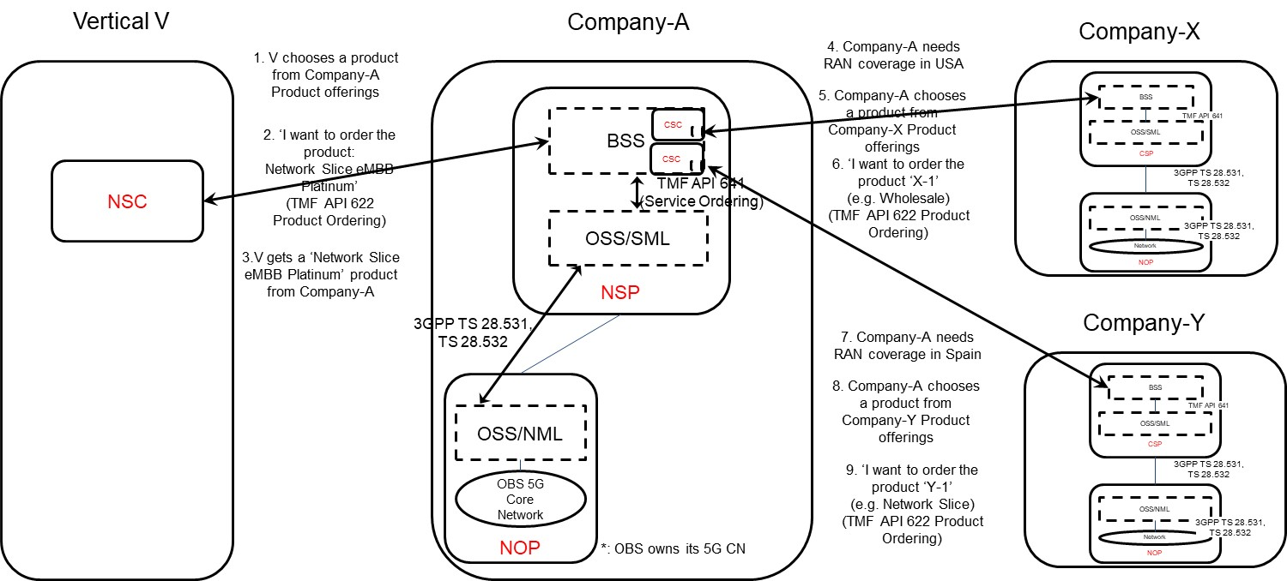
Figure 5.x.1.2-1: Sub-use case 2 - NOP role played simultaneously by different organizations

Company-A product catalogue proposes the following product offerings:
- Network Slice eMBB with different flavours: Silver, Gold, Platinum
- Network Slice URLLC with different flavours: Silver, Gold, Platinum
Network Slice MIoT with different flavours: Silver, Gold, Platinum.
In this sub-use case 2:
1. Vertical-V (as the NSC) chooses a product from Company-A product offerings
2. Vertical-V sends a request to Company-A (as the NSP) to order the product ‘Network Slice eMBB Platinum’. To achieve this, a candidate API is TMF API 622 (Product Ordering)
2.1 Company-A BSS determines which service supports the product being ordered by Vertical-V and issues a request to its OSS/SML to order this service. This service can be e.g. a network slice. To achieve this, a candidate API is TMF API 641 (Service Ordering)
2.2 Company-A OSS / SML determines which network resources support the service being ordered and:
2.2.1 based on its knowledge that required 5G core network resources are available internally, it issues a request to its own OSS / NML to allocate required 5G core network resources, e.g. network slice subnet(s) for its 5G core network, etc. To achieve this, candidate APIs are from 3GPP TS 28.531 and TS 28.532
2.2.2 Company-A OSS / NML allocates 5G core network resources required to support the service and informs OSS / SML about the characteristics of the network resources being allocated
2.2.3 based on its knowledge that required RAN resources are not available internally, it informs Company-A BSS about missing RAN resources
2.3 Company-A BSS:
2.3.1 acting as a CSC, issues a request to Company-X to order product X-1 (e.g. from the Wholesale offerings) to get RAN coverage in the US. To achieve this, a candidate API is TMF AP 622 (Product ordering). Company-X, as the CSP, receives the product order. Company-X BSS determines which service supports the product being ordered by Company-A and issues a request to its OSS/SML to order this service. This service can be e.g. a network slice. To achieve this, a candidate API is TMF API 641 (Service Ordering). Company-X OSS / SML determines which network resources support the service being ordered, etc. Once completed, Company-X BSS informs Company-A BSS that the product which has been ordered is now available to Company-A
2.3.2 acting as a CSC, issues a request to Company-Y to order product Y-1 (e.g. from the inter-operator network slice offerings) to get RAN coverage in Spain. To achieve this, a candidate API is TMF AP 622 (Product ordering). Company-Y, as the CSP, receives the product order. Company-Y BSS determines which service supports the product being ordered by Company-A and issues a request to its OSS/SML to order this service. This service can be e.g. a network slice. To achieve this, a candidate API is TMF API 641 (Service Ordering). Company-Y OSS / SML determines which network resources support the service being ordered, etc. Once completed, Company-Y BSS informs Company-A BSS that the product which has been ordered is now available to Company-A
2.3.3 informs its own OSS/SML that required RAN resources are available
2.4 Company-A OSS / SML associates the network resources allocated either internally or externally (by Company-X or Company-Y) to the service and informs its BSS about the characteristics of the service supporting the product
3. Company-A (as the NSP) sends a reply to Vertical-V to inform that the product ordered is now available to Vertical-V.
NOTE: in this use case, aspects related to Transport Network(s) are not addressed as they are out of 3GPP scope.

5.x.1.3 Exposure of the network slice as a product
In both sub-use case 1 and sub-use case 2, the characteristics of the network slice ordered by the NSC to the NSP are exposed by the NSP to the NSC at product-level, i.e. as specified by the product specification in the NSP catalogue. The product specification provides the characteristics of the product being offered by the NSP at business level and is not subject to standardization. These characteristics are generally more abstract than attributes defined in the 3GPP 5G NRM (cf. TS 28.541) and performance measurements defined in TS 28.552.
In these two sub-use cases, there is no exposure of service or network resources directly to the NSC.

End of changes

