3GPP TSG-SA5 Meeting #139-e S5-215320

e-meeting, 11 - 20 October 2021 revision of S5-21xabc

Source: Huawei Technologies

Title: pCR TR 28.827 Addition of the LBO,HR and BCE in Concept and Overview

Document for: Approval
Agenda Item: 7.5.7

1 Discussion
This is a pCR to TR 28.827 introducing the LBO, HR and BCE in Concept and Overview.

2 References
[1] 3GPP TR 28.827 "Telecommunication management; Charging management; Study on 5G charging for additional roaming scenarios and actors".

3 Rationale
This pCR proposes to add the LBO, HR and BCE in Concept and Overview in TR 28.827.

4 Detailed proposal
Propose to incorporate the following change into the TR 28.827[1].
First change

2 References
The following documents contain provisions which, through reference in this text, constitute provisions of the present document.
- References are either specific (identified by date of publication, edition number, version number, etc.) or non-specific.
- For a specific reference, subsequent revisions do not apply.
- For a non-specific reference, the latest version applies. In the case of a reference to a 3GPP document (including a GSM document), a non-specific reference implicitly refers to the latest version of that document in the same Release as the present document.
[1] 3GPP TR 21.905: "Vocabulary for 3GPP Specifications".
[2] 3GPP TS 23.501:"System Architecture for the 5G System".
[3] GSMA TD.201: "Common Billing and Charging Processes ".
…
[x] <doctype> <#>[ ([up to and including]{yyyy[-mm]|V<a[.b[.c]]>}[onwards])]: "<Title>".
Next change

3.3 Abbreviations
For the purposes of the present document, the abbreviations given in 3GPP TR 21.905 [1] and the following apply. An abbreviation defined in the present document takes precedence over the definition of the same abbreviation, if any, in 3GPP TR 21.905 [1].

BCE Billing and Charging Evolution
CHF Charging Function
HR Home Routed
LBO Local Breakout
5 Concepts and overview

5.1 General
The 5G charging for additional roaming scenarios and actors includes the following aspects:
- HR Roaming (Home Routed), refer to TS 23.501 [2];
- LBO Roaming (Local Breakout), refer to TS 23.501 [2];
- BCE (Billing and Charging Evolution), refer to GSMA TD 201 [3].

5.2 Home Routed
The 5G System roaming architecture in the case of home routed scenario with service-based interfaces within the Control Plane, as defined by TS 23.501[2] Figure 4.2.4-3.
The 5G System roaming architecture in the case of home routed scenario using the reference point representation, as defined by TS 23.501[2] Figure 4.2.4-6.

5.3 Local Breakout
The 5G System roaming architecture with local breakout with service-based interfaces within the Control Plane as defined by TS 23.501[2] Figure 4.2.4-1.
The 5G System roaming architecture in the case of local break out scenario using the reference point representation, as specified in TS 23.501 [2] Figure 4.2.4-4.

5.4 Billing and Charging Evolution (BCE)
The BCE process is a simplified and flexible optional settlement method, tailor made for future wholesale roaming settlement needs of operators. The process is driven by new formats like Usage Data Report, Billing Statement Report and Detailed Data Record which together build a robust framework for seamless revenue assurance.
The 5.4-1 depicts the BCE Process as specified in GSMA TD.201 [3] clause 2.2.
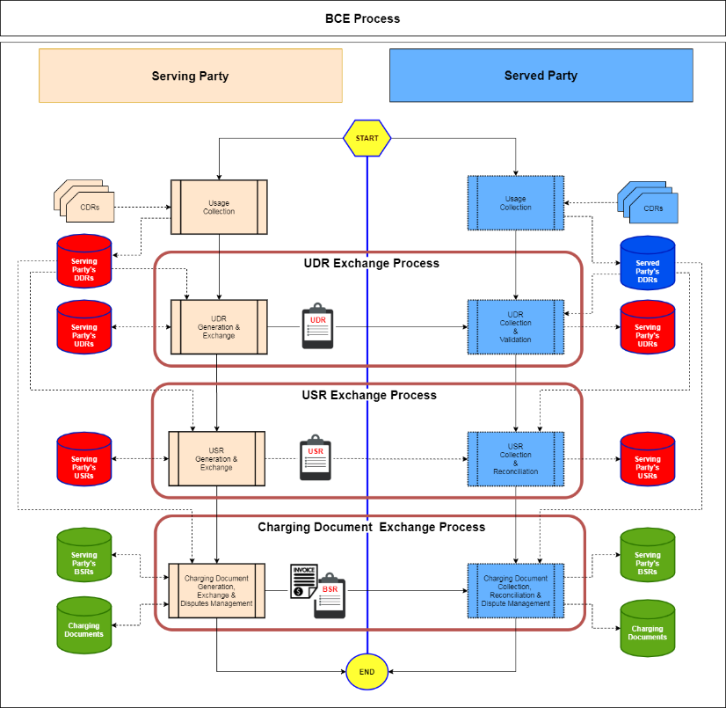
Figure 5.4-1: BCE Process
End of change

