3GPP TSG-SA5 Meeting #139-e S5-215106

e-meeting, October 11 – 19 2021 (revision of S5-214204)

Source: Huawei, China Unicom, CATT, China Mobile, Orange, China Telecom, Ericsson, Teleconfica

Title: Add scenario, requirements and potential solution for 5G MOCN network sharing scenarios

Document for: Approval
Agenda Item: 6.5.9

1 Decision/action requested
The group is asked to discuss and approval.

2 References
[1] 3GPP TS 32.130 Telecommunication management; Network sharing; Concepts and requirements.
[2] S5-205304 Discuss on NR NRM update to support MOCN network sharing scenario.
[3] S5-211444 Discussion paper for NR NRM support 5G MOCN network sharing scenario.

3 Rationale
There are some agreements for the scenarios and requirements for NG-RAN MOCN network sharing discussed in the previous meetings. So it proposes to add these agreements in the TR 28.825 as the starting point for the study, and also proposes to potential solution for satisfy the agreed requirements.

Observation1: It is endorsed in the DP S5-211444 that the NR NRM for MOCN Network sharing should support following two scenarios:
- NG-RAN MOCN Network Sharing with same Cell Identity broadcast.
- NG-RAN MOCN Network Sharing with multiple Cell Identity broadcast.
Observation2: Some description and management requirements for NG-RAN MOCN Network Sharing with same Cell Identity broadcast is captured in TS 32.130
/******************Extracted from TS 32.130 Beginning*********************/
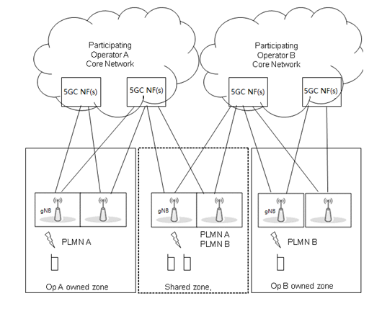
5.1.4 Requirements for management support for 5G MOCN network sharing scenario with same Cell Identity broadcast
Req-MOCN_SameCellId_Cfg-CON-1. The 3GPP management system shall have the capability to configure NgC and NgU individually for each supported network operator.
Req- MOCN_SameCellId_Cfg-CON-2. The 3GPP management system shall have the capability to configure PLMNId individually for each supported network operator.
Req- MOCN_SameCellId_Per-CON-3. The 3GPP management system shall have the capability to collect and report some measurements (e.g. active UEs measurements, packet delay measurements) in PLMN granularity for different network operator.

/*****************Extracted from TS 32.130 Ending*********************/
Observation3: Some description and management requirements for NG-RAN MOCN Network Sharing with multiple Cell Identity broadcast is captured in TS 32.130
3.1.2.2 NG-RAN MOCN Network Sharing with Multi Cell Identity broadcast
/******************************Extracted from TS 32.130 beginning*****************************/
5.1.5 Requirements for management support for 5G MOCN network sharing scenario with multiple Cell Identity broadcast
Req-MOCN-MultiCellId-Cfg-CON-1 The 3GPP management system shall have the capability to configure NgC and NgU individually for each supported network operator.
Req-MOCN-MultiCellId-Cfg-CON-2 The 3GPP management system shall have the capability to configure PLMN-IdentityInfo (including PLMNId, CellId, TAC) individually for each supported network operator.
Req-MOCN-MultiCellId-Perf-CON-3 The 3GPP management system shall have the capability to collect and report some measurements (e.g. active UEs measurements, packet delay measurements) in PLMN granularity for different network operator.
/******************************Extracted from TS 32.130 Ending*****************************/

4 Detailed proposal
It proposes to capture above information in the TR 28.825[1].
1st Change

5.X Scenario #1 NG-RAN MOCN Network Sharing with same Cell Identity broadcast

5.X.1 Scenario description
For NG-RAN MOCN Network Sharing with same cell identity broadcast scenario, different POPs use the same NR Cell Identity but different PLMN Id, which is captured by following figure in TS 32.130 [1].
Figure 5.X.1-1 NG-RAN MOCN Network Sharing with same cell identity broadcast scenario

5.X.2 Management requirements
Req-MOCN_SameCellId_Cfg-CON-1. The 3GPP management system of the MOP shall have the capability to configure NgC and NgU individually for each POP.
Req-MOCN_SameCellId_Cfg-CON-2. The 3GPP management system of the MOP shall have the capability to configure PLMNId individually for each POP.
Req-MOCN_SameCellId_Per-CON-3. The 3GPP management system of the MOP shall have the capability to collect and report some measurements (e.g. active UEs measurements, packet delay measurements) in PLMN granularity for each POP.

5.X.3 Potential solution
1. For the Req-MOCN_SameCellId_Cfg-CON-1, individual EP_NgC instance and EP_NgU instance can be created and configured for each POP.
2. For the Req-MOCN_SameCellId_Cfg-CON-2, the attribute “PLMNInfoList” in NRCellDU IOC in existing NR NRM can be used to represent the POPs supported by the cell.
3. For the Req-MOCN_SameCellId_Per-CON-3, existing PLMN granularity subcounter can be used to present operator granularity measurements.
2nd Change

5.Y Scenario #2 NG-RAN MOCN Network Sharing with multi Cell Identity broadcast

5.Y.1 Scenario description
For NG-RAN MOCN Network Sharing with multiple cell identity broadcast scenario, different POPs use different PLMN Id, NR Cell Identity and TAC, which is captured by following figure.
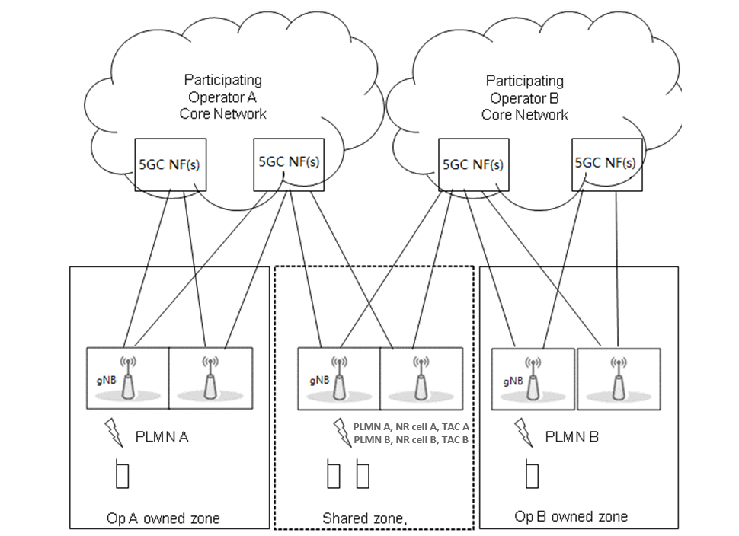
Figure 5.Y.2-1 NG-RAN MOCN Network Sharing with multiple cell identity broadcast scenario

5.Y.2 Management requirements
Req-MOCN-MultiCellId-Cfg-CON-1 The 3GPP management system of the MOP shall have the capability to configure NgC and NgU individually for each POP.
Req-MOCN-MultiCellId-Cfg-CON-2 The 3GPP management system of the MOP shall have the capability to configure PLMN-IdentityInfo (including PLMNId, NR Cell Identity, TAC) individually for each POP.
Req-MOCN-MultiCellId-Perf-CON-3 The 3GPP management system of the MOP shall have the capability to collect and report some measurements (e.g. active UEs measurements, packet delay measurements) in PLMN granularity for each POP.

5.Y.3 Potential solution
1. For the Req-MOCN_MultiCellId_Cfg-CON-1, individual EP_NgC instance and EP_NgU instance can be created and configured for each POP.
2. For the Req-MOCN-MultiCellId-Cfg-CON-2, following enhanced NR NRM solution is proposed:
Introduce new OperatorDU <<IOC>> name-contained by GNBDUFunction<<IOC >> to represent operator specific gNB level information (including operator specific gNB Id, gNBIdlength), and new NROperatorCellDU<<IOC>> name-contained by OperatorDU<<IOC>> to represent operator specific cell level information (including operator specific nRTAC, CelllocalId, PLMNInfoList). Which means individual OperatorDU instance and NROperatorCellDU needs to be created and configured for each POP.
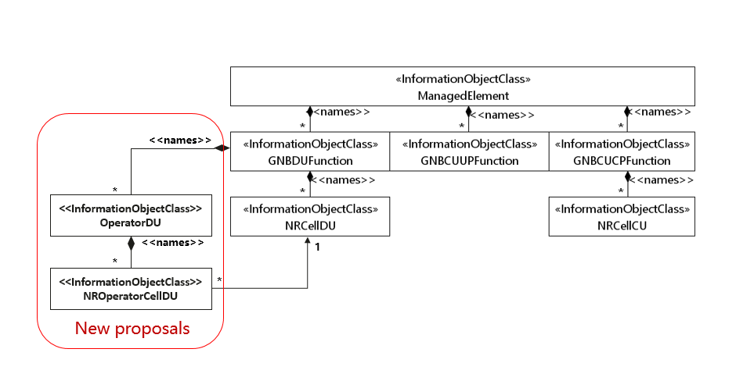
Figure 5.Y.3-1 NR NRM enhancement to suport NG-RAN sharing MOCN network sharing with multiple cell identity broadcast feature
- OperatorDU<<IOC>>
The OperatorDU <<IOC>> contains attributes to support operator specific gNB level information (including gNB Id, gNBIdLength) to support 5G Multi-Operator Core Network (5G MOCN) network sharing with multiple cell identity broadcast feature. Individual instance of OperatorDU <<IOC>> should be created and configured for each POP. When configured the attributes override those in parent GNBDUFunction instance.
The OperatorDU<<IOC>> is only used to support MOCN with multiple cell identity broadcast feature. If the MOCN with multiple Cell Identity broadcast feature is not supported, this IOC is not used.
Attribute name | Support Qualifier | isReadable | isWritable | isInvariant | isNotifyable
gNBId | M | T | T | F | T
gNBIdLength | M | T | T | F | T

- NROperatorCellDU<<IOC>>
The NROperatorCellDU <<IOC>> contains attributes to support operator specific cell level information (including cellLocalId, pLMNInfoList, nRTAC) to support 5G Multi-Operator Core Network (5G MOCN) network sharing with multiple Cell Identity broadcast feature. Individual instance of NROperatorCellDU <<IOC>> should be created and configured for each POP. When configured the attributes override those in associated NRCellDU instance.
The NROperatorCellDU <<IOC>> is only used to support MOCN with multiple cell identity broadcast feature. If the MOCN with multiple cell identity broadcast feature is not supported, this IOC is not used.
Attribute name | Support Qualifier | isReadable | isWritable | isInvariant | isNotifyable
cellLocalId | M | T | T | F | T
pLMNInfoList | M | T | T | F | T
nRTAC | CM | T | T | F | T
Attribute related to role
nRCellDURef | M | T | T | F | T

Following two updates are needed for GNBDUFunction IOC and NRCellDU IOC in the existing NR NRM:
- The Support Qualifier for attribute "gNBId " and " gNBIdLength " in existing GNBDUFunction IOC needs to be changed to "CM", the condition is " If MOCN Network Sharing is configured the value is not used "
- The Support Qualifier for attribute "cellLocalId " , "pLMNInfoList" and "nRTAC" in existing NRCelDU IOC needs to be changed to "CM", the condition is " If MOCN Network Sharing is configured the value is not used "

3. For the Req-MOCN-MultiCellId-Cfg-CON-3, Operator specific measurements can be collected and reported within OperatorDU<<IOC>> and NROperatorCellDU<<IOC>>, Operator agnostic measurements can be collected and reported within GNBDUFunction<<IOC>> and NRCellDU<<IOC>>.
Editor’s Note: above potential solution need to be revisited according to further discussion based on other existing requirements or new requirements
End of Changes

