3GPP TSG-SA5 Meeting #139-e S5-215094r1

e-meeting, October 11 – 19 2021 (revision of S5-214212)

Source: Huawei, Nokia, Ericcson, China Telecom, China Mobile, AsiaInfo

Title: Update intent information model

Document for: Approval
Agenda Item: 6.4.10

1 Decision/action requested
The group is asked to discuss and approval.

2 References
[1] 3GPP draft TS 28.312: “Management and orchestration; Intent driven management services for mobile networks v0.5.0”.

3 Rationale
This contribution proposes to update stage2 intent information model definition to include the intent model framework for further discussion.

4 Detailed proposal
It proposes to make the following changes to TS 28.312[1].
1st Change

6.2.1.1 Class diagram

6.2.1.1.1 Relationship

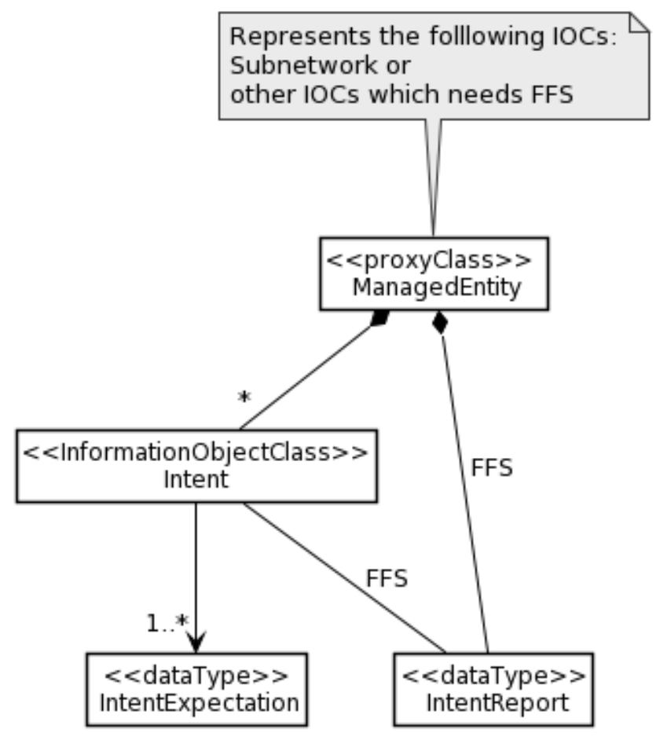

Figure 6.2.1.1.1-1 Relationship UML diagram for intent
Editor’s Note: The detailed model for Intent, IntentReport and IntentExpectation objects (e.g. is it <<IOC>>, <<DataType>>, or string) is FFS as their relationship needs to be decided later based on the content of these three objects

6.2.1.1.2 Inheritance
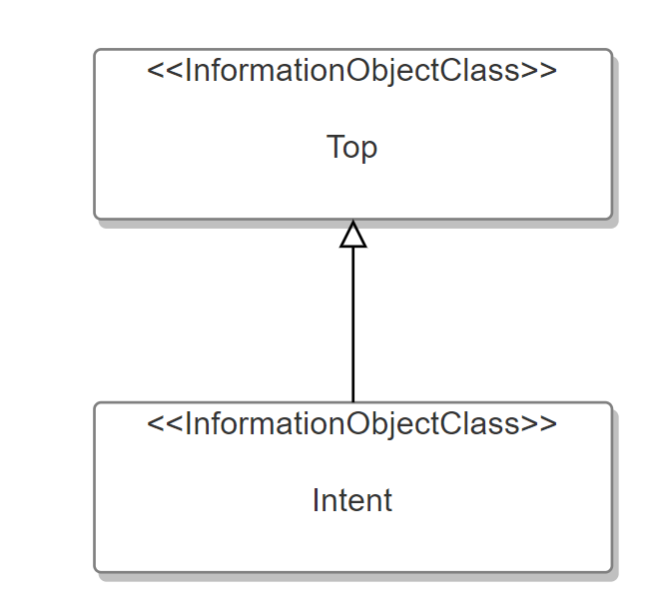
Figure 6.2.1.1.2-1 Inheritance UML diagram for intent

6.2.1.2 Class definition

6.2.1.2.1 Intent <<IOC>>

6.2.1.2.1.1 Definition
This IOC represents the properties of an Intent. The Intent IOC contains one or multiple intentExpectation(s) which includes MnS consumer’s requirements, goals and constraints given to a 3GPP system.
The Intent IOC includes the attribute objectClass and objectInstance from the TOP IOC. The value of attribute objectClass is “Intent” and the value of attribute objectInstance is the DN of the instance of Intent IOC.

6.2.1.2.1.2 Attributes
The Intent includes attributes inherited from TOP IOC (defined in TS 28.622) and the following attributes:
Attribute Name | Support Qualifier | isReadable | isWritable | isInvariant | isNotifyable
intentExpectation | M | T | T | F | T
userLabel | M | T | T | F | T
intentFulfilStatus | M | T | F | F | T

Editor’s Note: whether other the attributes are needed for the Intent IOC needs further discussion.

6.2.1.2.1.3 Attribute constraints
None

6.2.1.2.2 IntentExpectation

6.2.1.2.2.1 Definition
IntentExpectation class represent MnS consumer’s requirements, goals and constraints given to a 3GPP system.
Editor’s Note: more description for IntentExpectation will be added later based on the further discussion.

6.2.1.2.2.2 Attributes
TBD

6.2.1.2.2.3 Attribute constraints
TBD

6.2.1.2.3 IntentReport

6.2.1.2.3.1 Definition
IntentReport class represent intent fulfilment feedback information that MnS consumer can obtained from a 3gpp system.
Editor’s Note: more description for IntentReport will be added later based on the further discussion.

6.2.1.2.3.2 Attributes
TBD

6.2.1.2.3.3 Attribute constraints
TBD

6.2.1.4 Attribute definition
Attribute Name | Documentation and Allowed Values | Properties
userLabel | A user-friendly (and user assignable) name of the intent.  allowedValues: Not Applicable | type: String  multiplicity: 1  isOrdered: F  isUnique: F  defaultValue: None  isNullable: False
intentExpectation | It indicates the expectations including requirements, goals and constraints given to a 3GPP system.  The intentExpectation includes the intentAreas which describes a list of coverage areas for the intent to be applied.  Editor’s Note: the detailed intentExpectation is for further discussion | type: FFS  multiplicity: *  isOrdered: F  isUnique: F  defaultValue: None  isNullable: False
intentFulfilStatus | It describes the current status of the intent fulfilment result, which is configured by MnS producer and can be read by MnS consumer.  allowedValues: "FULFILLED", “NOT_FULFILLED  Editor’s Note: whether other allowed values should be supported is FFS, and the name for the attribute intentFulfilStatus is FFS. | type: ENUM  multiplicity: 1  isOrdered: N/A  isUnique: N/A  defaultValue: None  isNullable: False

2nd Change

Annex A (informative): PlantUML source code

A.X Information model definition for Intent

A.X.1 Relationship UML diagram for intent (Figure 6.2.1.1.2-1)
@startuml
hide circle
hide methods
hide members

skinparam class {
AttributeIconSize 0
BackgroundColor white
BorderColor black
ArrowColor black
}
skinparam Shadowing false
skinparam Monochrome true
skinparam ClassBackgroundColor White

class “<<proxyClass>> \n ManagedEntity ” as ManagedEntity{}
class “<<InformationObjectClass>>\n Intent ” as Intent {}
class “<<dataType>>\n IntentExpectation” as IntentExpectation{}
class “<<dataType>>\n IntentReport” as IntentReport{}
ManagedEntity *-- "*" Intent
ManagedEntity *-- IntentReport: FFS
Intent --> "1..*" IntentExpectation
Intent -- IntentReport: FFS
note top of ManagedEntity
Represents the folllowing IOCs:
Subnetwork or
other IOCs which needs FFS
end note

@enduml

End of changes

