**3GPP TSG- Meeting # *d1***

**, , -**

|  |  |  |  |  |  |  |  |  |
| --- | --- | --- | --- | --- | --- | --- | --- | --- |
| *CR-Form-v12.1* | | | | | | | | |
| **CHANGE REQUEST** | | | | | | | | |
|  | | | | | | | | |
|  |  | **CR** |  | **rev** |  | **Current version:** |  |  |
|  | | | | | | | | |
| *For* [***HE******LP***](http://www.3gpp.org/3G_Specs/CRs.htm#_blank)*on using this form: comprehensive instructions can be found at* [*http://www.3gpp.org/Change-Requests*](http://www.3gpp.org/Change-Requests)*.* | | | | | | | | |
|  | | | | | | | | |

|  |  |  |  |  |  |  |  |  |
| --- | --- | --- | --- | --- | --- | --- | --- | --- |
| ***Proposed change affects:*** | UICC apps |  | ME |  | Radio Access Network | **X** | Core Network | **X** |

|  |  |  |  |  |  |  |  |  |  |  |
| --- | --- | --- | --- | --- | --- | --- | --- | --- | --- | --- |
|  | | | | | | | | | | |
| ***Title:*** | Rel-17 DraftCR 28.622 for FIMA | | | | | | | | | |
|  |  | | | | | | | | | |
| ***Source to WG:*** | Nokia, Nokia Shanghai Bell | | | | | | | | | |
| ***Source to TSG:*** | SA5 | | | | | | | | | |
|  |  | | | | | | | | | |
| ***Work item code:*** | FIMA | | | | |  | ***Date:*** | | |  |
|  |  | | | |  | |  | | |  |
| ***Category:*** |  |  | | | | | ***Release:*** | | |  |
|  | *Use one of the following categories:* ***F*** *(correction)* ***A*** *(mirror corresponding to a change in an earlier release)* ***B*** *(addition of feature),* ***C*** *(functional modification of feature)* ***D*** *(editorial modification)*  Detailed explanations of the above categories can be found in 3GPP [TR 21.900](http://www.3gpp.org/ftp/Specs/html-info/21900.htm). | | | | | | | | *Use one of the following releases: Rel-8 (Release 8) Rel-9 (Release 9) Rel-10 (Release 10) Rel-11 (Release 11) … Rel-15 (Release 15) Rel-16 (Release 16) Rel-17 (Release 17) Rel-18 (Release 18)* | |
|  |  | | | | | | | | | |
| ***Reason for change:*** | | The file control NRM fragment needs to be added based on the requirements for file management in TS 28.537. | | | | | | | | |
|  | |  | | | | | | | | |
| ***Summary of change:*** | | The file control NRM fragment is added. | | | | | | | | |
|  | |  | | | | | | | | |
| ***Consequences if not approved:*** | | The WI FIMA cannot progress. | | | | | | | | |
|  | |  | | | | | | | | |
| ***Clauses affected:*** | | A | | | | | | | | |
|  | |  | | | | | | | | |
|  | | **Y** | **N** |  | | | |  | | |
| ***Other specs*** | |  | **X** | Other core specifications | | | | TS/TR ... CR ... | | |
| ***affected:*** | |  | **X** | Test specifications | | | | TS/TR ... CR ... | | |
| ***(show related CRs)*** | |  | **X** | O&M Specifications | | | | TS/TR ... CR ... | | |
|  | |  | | | | | | | | |
| ***Other comments:*** | | Baseline DraftCR: None  The following inputs to the DraftCR are considered:   * S5-2142623 | | | | | | | | |
|  | |  | | | | | | | | |
| ***This CR's revision history:*** | |  | | | | | | | | |

|  |
| --- |
| **First modification** |

## 4.2 Class diagrams

### 4.2.1 Relationships

This clause depicts the set of classes (e.g. IOCs) that encapsulates the information relevant for this IRP. This clause provides the overview of the relationships of relevant classes in UML. Subsequent clauses provide more detailed specification of various aspects of these classes.

The following figure shows the containment/naming hierarchy and the associations of the classes defined in the present document. See Annex A of a class diagram that combines this figure with Figure 1 of [2], the class diagram of UIM.

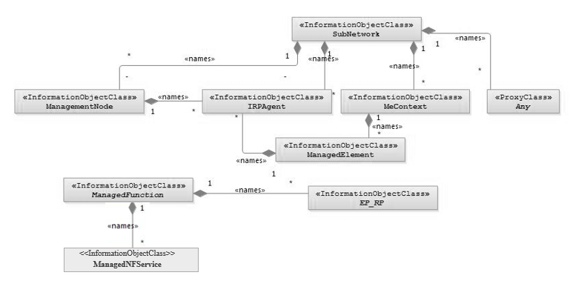

NOTE 1: ManagedElement may be contained either

- in a SubNetwork (since *SubNetwork* inherits from *Domain*_ and *ManagedElement* inherits from *ManagedElement*_ and *Domain*_ name-contained *ManagedElement_* as observed in the figure of Annex A) or

- in a MeContext instance as observed by the above figure or in the figure of Annex A.

This either-or relation cannot be shown by using an {xor} constraint in the above figure.

ManagedElement may also have no parent instance at all.

NOTE 2: Void

NOTE 3: If the configuration contains several instances of SubNetwork, exactly one SubNetwork instance shall directly or indirectly contain all the other SubNetwork instances.

NOTE 4: The SubNetwork instance not contained in any other instance of SubNetwork is referred to as "the root SubNetwork instance".

NOTE 5: ManagementNode shall be contained in the root SubNetwork instance.

NOTE 6: If contained in a SubNetwork instance, IRPAgent shall be contained in the root SubNetwork instance.

NOTE 7: For a clarification on the choice of containment of the IRPAgent (since it has three possible parents), see the def. of IRPAgent.

NOTE 8: Cardinality * is identical to multiplicity 0..*.

Figure 4.2.1-1: Containment/Naming and Association NRM fragment

Each Managed Object is identified with a Distinguished Name (DN) according to 3GPP TS 32.300 [13] that expresses its containment hierarchy. As an example, the DN of a ManagedElement instance could have a format like:

SubNetwork=Sweden,MeContext=MEC-Gbg-1,ManagedElement=RNC-Gbg-1.

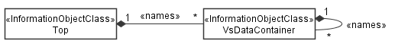

NOTE 8: Void

NOTE 9: Void

Figure 4.2.1-2: Vendor specific data container NRM fragment

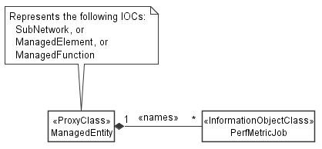

Figure 4.2.1-3: PM control NRM fragment

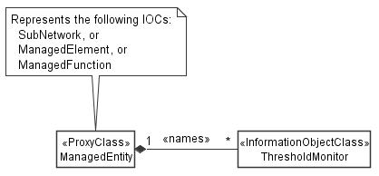

Figure 4.2.1-4: Threshold monitoring control NRM fragment

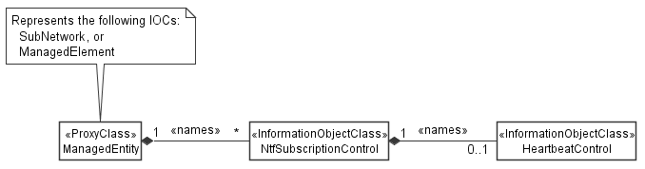

Figure 4.2.1-5: Notification subscription and heartbeat notification control NRM fragment

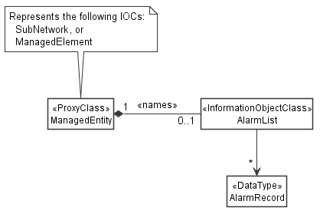

Figure 4.2.1-6: FM control NRM fragment

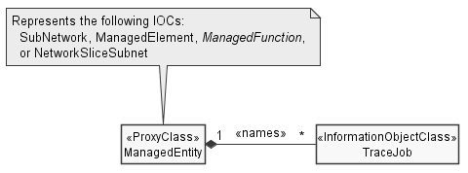

Figure 4.2.1-7: Trace control NRM fragment

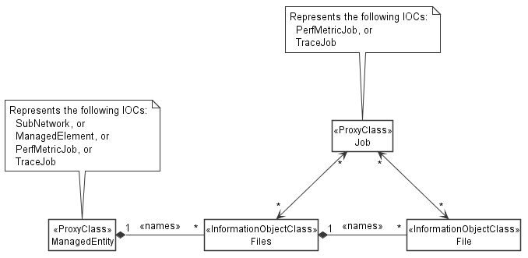

Figure 4.2.1-8: File control NRM fragment

### 4.2.2 Inheritance

This clause depicts the inheritance relationships.

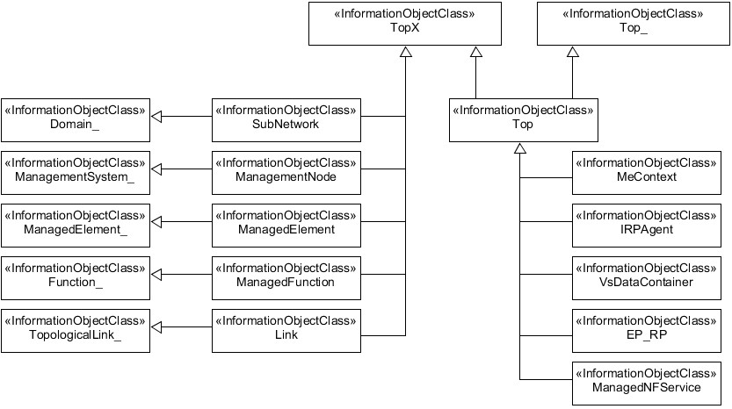

Figure 4.2.2-1: Inheritance Hierarchy NRM fragment

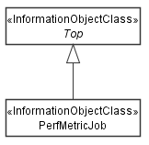

Figure 4.2.2-2: PM control NRM fragment

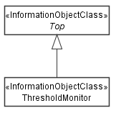

Figure 4.2.2-3: Threshold monitoring control NRM fragment

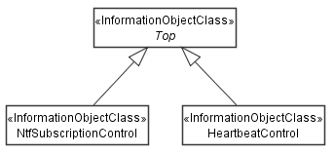

Figure 4.2.2-4: Notification subscription and heartbeat notification control NRM fragment

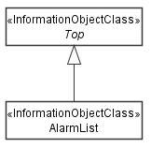

Figure 4.2.2-5: FM control NRM fragment

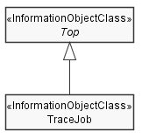

Figure 4.2.2-6: Trace control NRM fragment

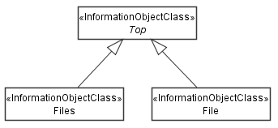

Figure 4.2.2-7: File control NRM fragment

|  |
| --- |
| **Next modification** |

### 4.3.X Files

#### 4.3.X.1 Definition

This IOC represents a collection of files. It can be name-contained by "SubNetwork", "ManagedElement", "PerfMetricJob" or "TraceJob". The "Files" object name-contains "File" objects, that represent the files of the collection. File collections allow to structure related files under a common root.

Instances of "Files" are created by the MnS producer when files become available, or soon available, for retrieval by MnS consumers.

The attributes of "Files" represent properties of the file collection and not properties of individual files.

The attributes "jobObjectInstances" and "jobIds" shall be supported when the MnS producer supports "PerfMetricJob" or "TraceJob". They shall be present and have a valid value when the files in the collection are produced based on a "PerfMetricJob" or "TraceJob", otherwise they shall be absent. They identify all jobs that the files in the collection are related to.

#### 4.3.X.2 Attributes

|  |  |  |  |  |  |
| --- | --- | --- | --- | --- | --- |
| Attribute name | S | isReadable | isWritable | isInvariant | isNotifyable |
| numberOfFiles | M | T | F | F | F |
| **Attributes related to roles** |  |  |  |  |  |
| jobObjectInstances | CM | T | F | T | F |
| jobIds | CM | T | F | T | F |

#### 4.3.X.2a Attribute definitions

| Attribute Name | Documentation and Allowed Values | Properties |
| --- | --- | --- |
| numberOfFiles | Number of files in a file collection  allowedValues: NA | Type: Integer  multiplicity: 1  isOrdered: N/A  isUnique: N/A  defaultValue: None  isNullable: False |
| jobObjectInstances | Object instances of the "PerfMetricJob" or "TraceJob" that produced the complete or some file content  allowedValues: NA | Type: Dn  multiplicity: 1  isOrdered: N/A  isUnique: N/A  defaultValue: None  isNullable: False |
| jobIds | Job identifiers of the "PerfMetricJob" or "TraceJob" that produced the complete or some file content  allowedValues: NA | Type: string  multiplicity: 0..*  isOrdered: N/A  isUnique: N/A  defaultValue: None  isNullable: False |

#### 4.3.X.3 Attribute constraints

|  |  |
| --- | --- |
| Name | Definition |
| jobObjectInstances  Support Qualifier | Condition: This attribute shall be supported when "PerfMetricJob" or "TraceJob" are supported. |
| jobIds  Support Qualifier | Condition: This attribute shall be supported when "PerfMetricJob" or "TraceJob" are supported. |

#### 4.3.X.4 Notifications

The common notifications defined in clause 4.5 are valid for this IOC, without exceptions or additions

### 4.3.Y File

#### 4.3.Y.1 Definition

This IOC represents a file. It is name-contained by "Files".

When a file becomes available on a MnS producer for upload by a MnS consumer, the MnS producer shall create a "File" instance representing that file. The time of creation shall be captured in the "fileReadyTime" attribute. The MnS producer shall keep the file at least until the time specified by "fileExpirationTime". After that time the MnS producer may delete the "File" instance.

The "fileSize", "fileCompression", "fileFormat" and "fileDataType" describe the file properties.

The "fileLocation" attribute indicates the address where the file can be retrieved. It can be identical to the address of the "File" instance or different. For retrieving the actual file content the attribute "fileContent" is provided.

The attributes "jobObjectInstances" and "jobIds" shall be supported when the MnS producer supports "PerfMetricJob" or "TraceJob". They shall be present and have a valid value when the file is produced based on a "PerfMetricJob" or "TraceJob", otherwise they shall be absent. They identify the job that the file is related to. This allows to set notification filters in the subscription in such a way that only "notifyFileReady" or "notifyMOICreation" notifications are sent to a MnS consumer if the file contains data related to jobs this MnS consumer created or is interested in.

Upon creation of a "File" instance, a notification of type "notifyMOICreation" shall be emitted to subscribed MnS consumers as usual. For the case that the file contains performance metric data the MnS producer shall emit either a notification of type "notifyMOICreation" or of type "notifyFileReady". The MnS consumer selects the notification type he wishes to receive with the subscription created on the MnS producer.

The "objectClass" and "objectInstance" parameters in the notification header of "notifyFileReady" shall identify the new "File" instance, instead of the related "PerfMetricJob", "ManagedElement" or "ManagementNode"as described in 3GPP TS 28.532 [27], clause 11.6.1.1.1 for the case when "notifyFileReady" is used as part of the file data reporting MnS.

For the case of performance metric data files, the notification "notifyFilePreparationError" shall be supported as well. The "objectClass" and "objectInstance" parameters of the notification header are populated as described in 3GPP TS 28.532 [27], clause 11.6.1.1.1.

#### 4.3.Y.2 Attributes

|  |  |  |  |  |  |
| --- | --- | --- | --- | --- | --- |
| Attribute name | S | isReadable | isWritable | isInvariant | isNotifyable |
| fileLocation | M | T | F | T | F |
| fileSize | O | T | F | T | F |
| fileReadyTime | O | T | F | T | F |
| fileExpirationTime | O | T | F | T | F |
| fileCompression | M | T | F | T | F |
| fileFormat | M | T | F | T | F |
| fileDataType | M | T | F | T | F |
| fileContent | M | T | F | T | F |
| **Attributes related to roles** |  |  |  |  |  |
| jobObjectInstances | CM | T | F | T | F |
| jobIds | CM | T | F | T | F |

#### 4.3.Y.2a Attribute definitions

| Attribute Name | Documentation and Allowed Values | Properties |
| --- | --- | --- |
| fileLocation | Location of the file.  allowedValues: NA | Type: String  multiplicity: 1  isOrdered: N/A  isUnique: N/A  defaultValue: None  isNullable: False |
| fileSize | Size of the file.  Unit is byte.  allowedValues: non-negative integers | Type: Integer  multiplicity: 1  isOrdered: N/A  isUnique: N/A  defaultValue: None  isNullable: False |
| fileReadyTime | Date and time when the file was closed (the last time) and made available on the MnS producer. The file content will not be changed anymore.  allowedValues: N/A | Type: DateTime  multiplicity: 1  isOrdered: N/A  isUnique: N/A  defaultValue: None  isNullable: False |
| fileExpirationTime | Date and time after which the file may be deleted.  allowedValues: N/A | Type: DateTime  multiplicity: 1  isOrdered: N/A  isUnique: N/A  defaultValue: None  isNullable: False |
| fileCompression | Name of the algorithm used for compressing the file. An empty or absent "fileCompression" parameter indicates the file is not compressed. The MnS producer selects the compression algorithm. It is encouraged to use popular algorithms such as GZIP.  allowedValues: N/A | Type: String  multiplicity: 1  isOrdered: N/A  isUnique: N/A  defaultValue: None  isNullable: False |
| fileFormat | Identifier of the XML or ASN.1 schema (incl. its version) used to produce the file content.  allowedValues: N/A | Type: String  multiplicity: 1  isOrdered: N/A  isUnique: N/A  defaultValue: None  isNullable: False |
| fileDataType | Type of the management data stored in the file.  AllowedValues:  - "PERFORMANCE"  - "TRACE"  - "ANALYTICS"  - "PROPRIETARY"  The value "PERFORMANCE" refers to measurements and KPIs. | Type: ENUM  multiplicity: 1  isOrdered: N/A  isUnique: N/A  defaultValue: None  isNullable: False |
| fileContent | File content  allowedValues: N/A | Type: String  multiplicity: 1  isOrdered: N/A  isUnique: N/A  defaultValue: None  isNullable: False |

#### 4.3.Y.3 Attribute constraints

|  |  |
| --- | --- |
| Name | Definition |
| jobObjectInstances  Support Qualifier | Condition: This attribute shall be supported when "PerfMetricJob" or "TraceJob" are supported. |
| jobIds  Support Qualifier | Condition: This attribute shall be supported when "PerfMetricJob" or "TraceJob" are supported. |

#### 4.3.Y.4 Notifications

The common notifications defined in clause 4.5 are valid for this IOC. In addition, the following set of notifications is also valid.

| Name | S | Notes |
| --- | --- | --- |
| notifyFileReady | M |  |
| notifyFilePreparationError | M |  |

|  |
| --- |
| **End of modifications** |