3GPP TSG-SA5 Meeting #138-e S5-214492

e-meeting, 23 - 31 August 2021

Source: Ericsson, Deutsche Telekom

Title: Service management provided by multiple companies at product change

Document for: Approval
Agenda Item: 6.5.6

1 Decision/action requested
The group is asked to approved the detailed proposal in section 4.

2 References
[1] TM Forum GB921 Business Process Framework (eTOM) Suite v20.5
[2] TM Forum GB922 Information Framework Suite v20.5
[3] TM Forum TMF641 Service Ordering API
[4] TM Forum TMF622 Product Order API REST Specification
[4] ITU-T M.3010: "Principles for a telecommunications management network"
[5] 3GPP TS 28.531: "Management and orchestration; Concepts, use cases and requirements"

3 Rationale
Operator’s that provide services to their customers have a BSS (Business Support system) to manage information on customers, product offerings, tariffs, subscriptions, contracts etc…
This contribution describes the different scenario’s when one company changes a purchased product bought from another company.
The use of BSS is independent of the role an operator plays, if an operator plays the role of CSP, or a more specialized role like an NSP in all cases the operator’s organization has a BSS when dealing with their customer base and products sold to their customers.
The use of OSS is independent of the role an operator plays if an operator plays the role of CSP or NSP in all cases the operator’s organization has an OSS when dealing with the services and the resources in the network.
The customer of a company in the role CSP is a CSC, the CSC has bought the communication services provided by the CSP. In the descriptions in this contribution the CSC is always an Enterprise.
The customer of a company in the role NSP is a CSP, the CSP uses the NSaaS provided by the NSP to provide its own communication services. The NOP is in this context the operations part connected to the NSP.
The following scenarios are examples of interactions between companies playing a particular role or combination of roles. The product offers from the companies in different roles are examples to show that a product offer from a company can be associated or connected to product offers from other companies. The scenarios are as follows:
- An enterprise (CSC) orders a change to a purchased network slice enabled product from another enterprise (CSP) involving single provider (NSP)
- An enterprise (CSC) orders a change to a purchased network slice enabled product from another enterprise (CSP) involving multiple providers (NSP)

4 Detailed proposal

1st change

2 References
The following documents contain provisions which, through reference in this text, constitute provisions of the present document.
- References are either specific (identified by date of publication, edition number, version number, etc.) or non-specific.
- For a specific reference, subsequent revisions do not apply.
- For a non-specific reference, the latest version applies. In the case of a reference to a 3GPP document (including a GSM document), a non-specific reference implicitly refers to the latest version of that document in the same Release as the present document.
[1] 3GPP TR 21.905: "Vocabulary for 3GPP Specifications".
[x] ITU-T M.3010: "Principles for a telecommunications management network"
[y] 3GPP TS 28.531: "Management and orchestration; Concepts, use cases and requirements"
[z] TM Forum TMF622 Product Order API REST Specification

2nd change

5.x An enterprise orders product change for a network slice enabled product from another enterprise involving single NSP

5.x.1 Description
In this scenario an enterprise in the role of CSC orders a change to a network slice enabled product purchased from another enterprise in the role of CSP. The CSP interacts with an NSP to enhance its own services with the services that the NSP provides. The product order modification from the CSC may result in product modification order from the CSP to the NSP.
Note that the scenario description assumes that the CSP and NSP have sufficient capabilities to complete their order. In case the CSP internal process cannot be completed before the NSP internal process is completed the CSC is notified after the NSP has notified CSP of order completion.
The procedure for product order change is shown in Figure 5.x.1-1.
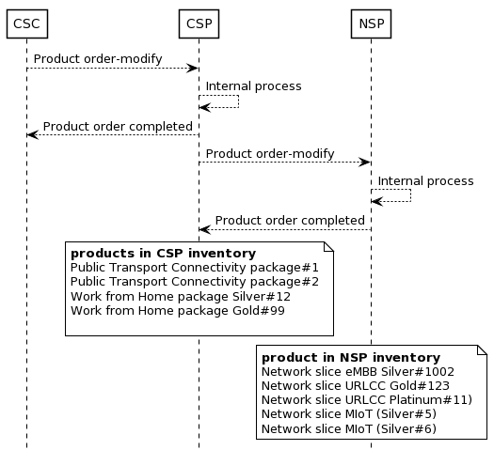
Figure 5.x.1-1 Example procedure for product order change involving single NSP
The CSC interacts with the CSP internal process through the business management layer as shown in Figure 5.x.1-2. The CSP interacts with the NSP through the business management layer also as shown in Figure 5.x.1-2.

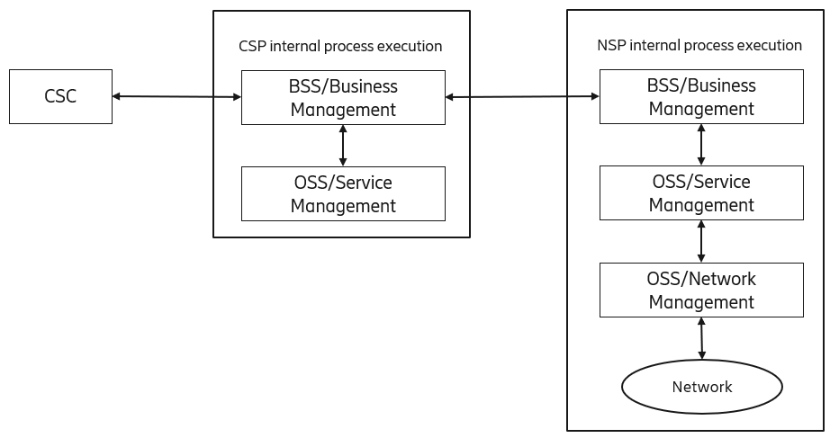
Figure 5.x.1-2: View of systems involved in execution of the CSP and NSP internal processes.

5.x.2 Issues and gaps

In the scenario for “product change of network slice enabled product” between companies (in roles as described in scenario) the interface used between CSC and CSP and the interface used between CSP and NSP is typically based on TM Forum [z] supporting business management layer interactions.
Business management layer interactions are outside of current SA5 scope.

5.y An enterprise orders product change for a network slice enabled product from another enterprise involving multiple NSPs

5.y.1 Description
In this scenario an enterprise in the role of CSC orders a change to a network slice enabled product purchased from another enterprise in the the role of CSP. The CSP interacts with an NSP to enhance its own services with the services that the NSP provides. The NSP interacts with other NSPs to enhance its own services before they are offered to the CSP. The product order modification from the CSC may result in product modification order from the CSP to the NSP, and from NSP to NSP1 and NSP2.
Note that the scenario description assumes that the CSP, NSP, NSP1 and NSP2 have sufficient capabilities to complete their order. In case the CSP internal process cannot be completed before the NSP internal process is completed the CSC is notified after the NSP has notified CSP of order completion.

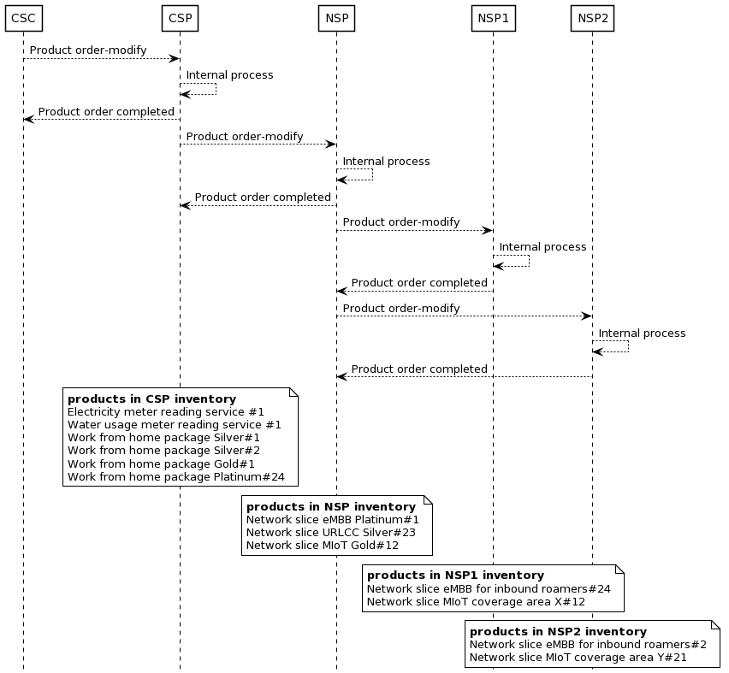
Figure 5.y.1-1 Example procedure for product order change involving multiple NSPs
The CSC interacts with the CSP internal process through the business management layer as shown in Figure 5.y.2-2. The CSP interacts with the NSP1 through the business management layer, and NSP1 and NSP2/NSP3 interact with each other through the business management layer.
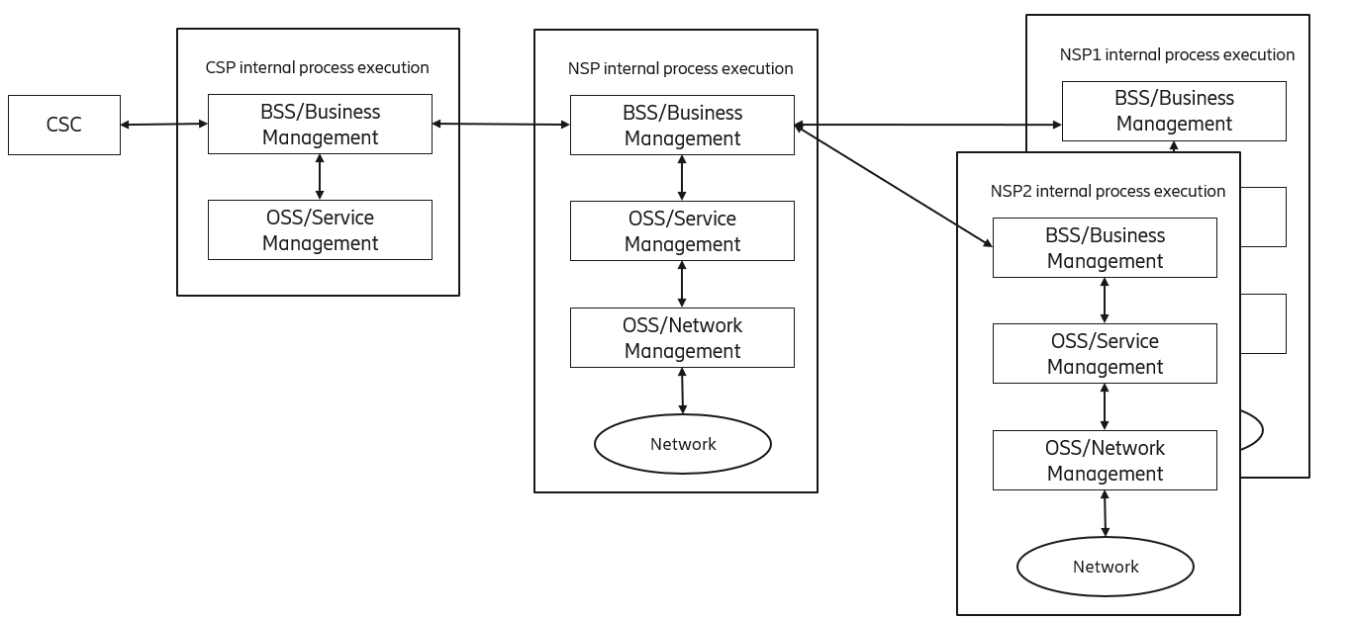
Figure 5.y.1-2: View of systems involved in execution of the NSP internal process.

5.y.2 Issues and gaps

In the scenario for “product change of network slice enabled product” between companies (in roles as described in scenario) the interface used between CSC and CSP, the interface used between CSP and NSP and the interface used between NSPs is typically based on TM Forum [z] supporting business management layer interactions.
Business management layer interactions are outside of current SA5 scope.

3rd change

Annex X (informative):
Change history

Annex X.1
The following PlantUML source code is used to describe the procedure in Figure 5.x.1-1
@startuml
skinparam backgroundColor white
skinparam sequence {
ArrowColor black
ActorBorderColor black
LifeLineBorderColor black
LifeLineBackgroundColor white
ParticipantBorderColor black
ParticipantBackgroundColor white
}
skinparam{
noteBorderColor black
noteBackgroundColor white
}
skinparam shadowing false
hide footbox

CSC --> CSP: Product order-modify
CSP --> CSP: Internal process
CSC <-- CSP: Product order completed
CSP --> NSP: Product order-modify
NSP --> NSP: Internal process
CSP <-- NSP: Product order completed

note over CSP
**products in CSP inventory**
Public Transport Connectivity package#1
Public Transport Connectivity package#2
Work from Home package Silver#12
Work from Home package Gold#99

end note

note over NSP
**product in NSP inventory**
Network slice eMBB Silver#1002
Network slice URLCC Gold#123
Network slice URLCC Platinum#11)
Network slice MIoT (Silver#5)
Network slice MIoT (Silver#6)
end note
@enduml

Annex X.2
The following PlantUML source code is used to describe the procedure in Figure 5.y.1-1
@startuml
skinparam backgroundColor white
skinparam sequence {
ArrowColor black
ActorBorderColor black
LifeLineBorderColor black
LifeLineBackgroundColor white
ParticipantBorderColor black
ParticipantBackgroundColor white
}
skinparam{
noteBorderColor black
noteBackgroundColor white
}
skinparam shadowing false
hide footbox

CSC --> CSP: Product order-modify
CSP --> CSP: Internal process
CSC <-- CSP: Product order completed
CSP --> NSP: Product order-modify
NSP --> NSP: Internal process
CSP <-- NSP: Product order completed
NSP --> NSP1: Product order-modify
NSP1 --> NSP1: Internal process
NSP <-- NSP1: Product order completed
NSP --> NSP2: Product order-modify
NSP2 --> NSP2: Internal process
NSP <-- NSP2: Product order completed

note over CSP
**products in CSP inventory**
Electricity meter reading service #1
Water usage meter reading service #1
Work from home package Silver#1
Work from home package Silver#2
Work from home package Gold#1
Work from home package Platinum#24
end note

note over NSP
**products in NSP inventory**
Network slice eMBB Platinum#1
Network slice URLCC Silver#23
Network slice MIoT Gold#12
end note

note over NSP1
**products in NSP1 inventory**
Network slice eMBB for inbound roamers#24
Network slice MIoT coverage area X#12
end note

note over NSP2
**products in NSP2 inventory**
Network slice eMBB for inbound roamers#2
Network slice MIoT coverage area Y#21
end note
@enduml
End of changes

