**3GPP TSG-SA5 Meeting #138-eS5-214490**

**e-meeting, 23 - 31 August 2021**

|  |  |  |  |  |  |  |  |  |
| --- | --- | --- | --- | --- | --- | --- | --- | --- |
| *CR-Form-v12.1* | | | | | | | | |
| **CHANGE REQUEST** | | | | | | | | |
|  | | | | | | | | |
|  |  | **CR** |  | **rev** |  | **Current version:** |  |  |
|  | | | | | | | | |
| *For* [***HE******LP***](http://www.3gpp.org/3G_Specs/CRs.htm#_blank)*on using this form: comprehensive instructions can be found at* [*http://www.3gpp.org/Change-Requests*](http://www.3gpp.org/Change-Requests)*.* | | | | | | | | |
|  | | | | | | | | |

|  |  |  |  |  |  |  |  |  |
| --- | --- | --- | --- | --- | --- | --- | --- | --- |
| ***Proposed change affects:*** | UICC apps |  | ME |  | Radio Access Network | **X** | Core Network | **X** |

|  |  |  |  |  |  |  |  |  |  |  |
| --- | --- | --- | --- | --- | --- | --- | --- | --- | --- | --- |
|  | | | | | | | | | | |
| ***Title:*** | Introduce support for reallocation to modify service characteristics | | | | | | | | | |
|  |  | | | | | | | | | |
| ***Source to WG:*** | Ericsson, Deutsche Telekom | | | | | | | | | |
| ***Source to TSG:*** | S5 | | | | | | | | | |
|  |  | | | | | | | | | |
| ***Work item code:*** | EMA5SLA | | | | |  | ***Date:*** | | |  |
|  |  | | | |  | |  | | |  |
| ***Category:*** | **C** |  | | | | | ***Release:*** | | | Rel-17 |
|  | *Use one of the following categories:* ***F*** *(correction)* ***A*** *(mirror corresponding to a change in an earlier release)* ***B*** *(addition of feature),* ***C*** *(functional modification of feature)* ***D*** *(editorial modification)*  Detailed explanations of the above categories can be found in 3GPP [TR 21.900](http://www.3gpp.org/ftp/Specs/html-info/21900.htm). | | | | | | | | *Use one of the following releases: Rel-8 (Release 8) Rel-9 (Release 9) Rel-10 (Release 10) Rel-11 (Release 11) … Rel-15 (Release 15) Rel-16 (Release 16) Rel-17 (Release 17) Rel-18 (Release 18)* | |
|  |  | | | | | | | | | |
| ***Reason for change:*** | | The current specification does not support the use case to satisfy request for reallocation of a serviceProfile in deployed network slice instance | | | | | | | | |
|  | |  | | | | | | | | |
| ***Summary of change:*** | | Add use case description for reallocate  Add requirement for reallocate  Update table with management service information  Add stage 2 operation for reallocate  Add procedure for reallocate  Add stage 3 operation for reallocate | | | | | | | | |
|  | |  | | | | | | | | |
| ***Consequences if not approved:*** | | Not having the reallocate operation may lead to incompatible network slice solutions, service interruptions when changing service characteristics, more complex procedure for consumers, increase of signalling traffic between UE’s and CN. | | | | | | | | |
|  | |  | | | | | | | | |
| ***Clauses affected:*** | | 5.1, 5.1.x (new), 5.2, 6.1,  6.5.x (new), 6.5.x.1 (new), 6.5.x.2 (new), 6.5.x.3 (new)  7.x (new), 8.1.1, 8.1.x (new) | | | | | | | | |
|  | |  | | | | | | | | |
|  | | **Y** | **N** |  | | | |  | | |
| ***Other specs*** | |  | **X** | Other core specifications | | | | TS/TR ... CR ... | | |
| ***affected:*** | |  | **X** | Test specifications | | | | TS/TR ... CR ... | | |
| ***(show related CRs)*** | |  | **X** | O&M Specifications | | | | TS/TR ... CR ... | | |
|  | |  | | | | | | | | |
| ***Other comments:*** | | no impact on 3GPP forge | | | | | | | | |
|  | |  | | | | | | | | |
| ***This CR's revision history:*** | |  | | | | | | | | |

|  |
| --- |
| ***First change*** |

### 5.1.24 Management interaction with NFV MANO for network service priority

| Use case stage | Evolution/Specification | <<Uses>> Related use |
| --- | --- | --- |
| **Goal** | To enable the authorized consumer to request creation of a 3GPP sub-network, management interactions with NFV MANO is needed. This management interaction will assign priority on NFV NS(s). |  |
| **Actors and Roles** | An authorized consumer of 3GPP sub-network creation. |  |
| **Telecom resources** | VNF package(s) of the virtualized part of 3GPP NF(s);  NSD(s) of the NS(s);  ETSI NFV MANO system; |  |
| **Assumptions** | N/A |  |
| **Pre-conditions** | The ETSI NFV VNF package(s) of the virtualized part of 3GPP NF(s) have been on-boarded to ETSI NFV MANO system;  The ETSI NFV NSD(s) used to instantiate NS(s) for realizing the 3GPP sub-network have been on-boarded to ETSI NFV MANO system. |  |
| **Begins when** | The authorized consumer needs to create a 3GPP sub-network. This creation operation also needs to assign priority on 3GPP sub-network and on related ETSI NFV NS(s). |  |
| **Step 1 (M)** | The authorized consumer requests the 3GPP sub-network creation service producer to create a 3GPP sub-network. |  |
| **Step 2 (M)** | The sub-network creation service producer interacts, or requests another sub-network creation service producer to interact, with ETSI NFV MANO system to instantiate the NS(s) realizing the 3GPP sub-network. |  |
| **Step 3 (M)** | ETSI NFV MANO is informed about NS priority. |  |
| **Ends when** | All the steps identified above are successfully completed. |  |
| **Exceptions** | One of the steps identified above fails. |  |
| **Post-conditions** | The 3GPP sub-network has been created. Network service priority is identified by NFVO to support the 3GPP sub-network. |  |
| **Traceability** | REQ-PRO_NW-FUN-1, REQ-PRO_NW-FUN-2 |  |

### 5.1.x Network slice instance reallocation

| Use case stage | Evolution/Specification | <<Uses>> Related use |
| --- | --- | --- |
| **Goal** | To satisfy request for reallocation of a serviceProfile in deployed network slice instance, by modifying the deployed network slice instance or by creating a new network slice instance or by using a different deployed network slice instance; the request includes the network slice instance id and network slice related requirements. |  |
| **Actors and Roles** | A network slice provisioniong management service consumer. NOP (Network Operator) |  |
| **Telecom resources** | Network slice instance Network slice subnet instance Transport network A network slice provisioning management service provider. A network slice subnet provisioning management service provider. |  |
| **Assumptions** | N/A |  |
| **Pre-conditions** | N/A |  |
| **Begins when** | The network slice provisioning management service provider receives the request for reallocation of the network slice instance; the request contains, the current network slice instance id, the current service profile id, network slice related requirements. |  |
| **Step 1 (M)** | If the network slice related requirements allow the current NSI to be used, the network slice provisioning management service provider decides to use the current NSI. In this case modification of the existing NSI may be needed to satisfy the network slice instance related requirements. Use case is completed go to “Step 8". Or else,  the network slice provisioning management service provider checks and decides to use different deployed NSI. In this case modification of this different NSI may be needed to satisfy the network slice instance related requirements. Use case is completed go to “Step 8". Before reallocation of the current service profile to a different NSI the service profile has to be deallocated from the current NSI.  Otherwise, the network slice provisioning management service provider triggers to create a new NSI, for which the following steps 2 – 8 are needed. Before creation of a new NSI, the current service profile has to be deallocated from the current NSI. | Network slice instance deallocation use case |
| **Step 2 (M)** | The network slice provisioning management service provider decides on the constituent NSSIs and the topology of the NSI to be created using the information from service profile [6]. For the constituent NSSIs, the network slice provisioning management service provider derives network slice subnet related requirements from the network slice related requirements. If reconfiguration of the transport network is needed, the network slice provisioning management service provider derives transport network related requirements (e.g., latency, bandwidth) from the network slice related requirements. |  |
| **Step 3 (M)** | For the required NSSI(s), the network slice provisioning management service provider sends network slice subnet related requirements to the network slice subnet provisioning management service provider to request allocation of the required NSSI(s). | Network slice subnet instance allocation use case |
| **Step 4 (M)** | The network slice provisioning management service provider receives the information of the allocated NSSI(s) (e.g., the management identifier of NSSI, service access point information of NSSI, external connection point information of NSSI) from NSSMF. |  |
| **Step 5 (M)** | The network slice provisioning management service provider, via the network slice subnet provisioning management service provider, sends the transport network related requirements (e.g., external connection point, latency and bandwidth) to the TN Manager. The TN manager reconfigures the TN accordingly and responds to the network slice provisioning management service provider via the network slice subnet provisioning management service provider. |  |
| **Step 6 (M)** | The network slice provisioning management service provider receives the response from TN Manager via the network slice subnet provisioning management service provider. |  |
| **Step 7 (M)** | The network slice provisioning management service provider associates the NSSI(s) with the corresponding NSI (e.g., allocation of the management identifier of NSI and mapping the management identifier of NSI with the received management Identifier of NSSI(s)) and triggers to establish the links between the service access points of the NSSI(s). |  |
| **Step 8 (M)** | The network slice provisioning management service provider notifies the network slice instance information of NSI (e.g., the management identifier of NSI) to the network slice management service consumer. |  |
| **Ends when** | All the steps identified above are successfully completed. |  |
| **Exceptions** | One of the steps identified above fails. |  |
| **Post-conditions** | An NSI is ready to satisfy the network slice related requirements. |  |
| **Traceability** | REQ-PRO_NSI-FUN-X |  |

|  |
| --- |
| ***Second change*** |

## 5.2 Requirements

### 5.2.1 Requirements for network slice provisioning service

**REQ-PRO_NSI-FUN-1** The network slice provisioning service provider shall have the capability allowing its authorized consumer to request a network slice instance.

**REQ-PRO_NSI-FUN-2** The network slice provisioning service provider shall have the capability allowing its authorized consumer to send the network slice related requirements.

NOTE 1: The network slice related requirements include requirements such as area traffic capacity, charging, coverage area, isolation, end-to-end latency, mobility, overall user density, priority, service availability, service reliability, UE speed; see TS 22.261 [5] where these parameters are defined for end user services.

NOTE 2: The network slice related requirements also include requirements derived from the Generic network Slice Template (GST) defined by GSMA in [9].

NOTE 3: The SLA requirements can be translated to network service profile which can be used to decides on the constituent NSSIs and the topology of the NSI.

NOTE 4: The ServiceProfile can be translated to corresponding requirements for dedicated domains/NSSI.

**REQ-PRO_NSI-FUN-3** The network slice provisioning service provider shall have the capability allowing its authorized consumer to request the deallocation of a network slice instance.

**REQ-PRO_NSI–FUN-4** The network slice provisioning service provider shall have the capability allowing its authorized consumer to request activation of a network slice instance.

**REQ-PRO_NSI–FUN-5** The network slice provisioning service provider shall have the capability allowing its authorized consumer to request deactivation of a network slice instance.

**REQ-PRO_NSI-FUN-6** The network slice provisioning service provider shall have the capability allowing its authorized consumer to request the modification of a network slice instance.

**REQ-PRO_NSI-FUN-7** The network slice provisioning service provider shall have the capability allowing its consumer to obtain the network slice management data.

**REQ-PRO_NSI-FUN-8** The network slice provisioning service provider shall have the capability allowing its authorized consumer to obtain the feasibility of provisioning the requested network slice instance at a particular point of time.

**REQ-PRO_NSI-FUN-9** The network slice management service provider shall have the capability allowing its authorized consumer to request the capacity planning of a network slice instance.

**REQ-PRO_NSI-FUN-X** The network slice provisioning service provider shall have the capability allowing its authorized consumer to request the reallocation of a network slice instance to avoid or minimize service interruption.

|  |
| --- |
| ***Third change*** |

# 6 Management services for provisioning of networks and network slicing

## 6.1 Management services for network slice provisioning

The management services for network slice provisioning are listed in table 6.1-1.

Table 6.1-1: Management services for network slice provisioning

|  |  |  |  |
| --- | --- | --- | --- |
| MnS Name | MnS Component Type A (operations and notifications) | MnS Component Type B (information model) | Note |
| Provisioning for NSI | Operations defined in clause 5 of TS 28.532 [8]:  - createMOI operation  - deleteMOI operation  - getMOIAttributes operation  - modifyMOIAttributes operation  Operations defined in clause 6.5:  - allocateNsi operation  - deallocateNsi operation  - reallocateNsi operation | NSI information model defined in clause 6.3 of TS 28.541 [6] | This management service enables its consumer to request allocating, deallocating, or modifying an NSI.  The typical scenario is "Network Slices as NOP internals" model where this MnS is consumed by operators. |
| Provisioning data report for NSI | Operations defined in clause 5 of TS 28.532 [8]:  - subscribe operation  - unSubscribe operation  Notifications defined in clause 5 of TS 28.532 [8]:  - notifyMOICreation notification  - notifyMOIDeletion notification  - notifyMOIAttributeValueChanges notification | NSI information model defined in clause 6.3 of TS 28.541 [6] | This management service enables its consumer to obtain notifications about NSI Information model data.  The typical scenario is "Network Slices as NOP internals" model where this MnS is consumed by operators |
| Provisioning exposure for NSI | Operations defined in clause 5 of TS 28.532 [8]:  - createMOI operation  - deleteMOI operation  - getMOIAttributes operation  - modifyMOIAttributes operation  Operations defined in clause 6.5:  - allocateNsi operation  - deallocateNsi operation  - reallocateNsi operation | NSI information model defined in clause 6.3 of TS 28.541 [6] | This management service enables its consumer to request allocating, deallocating or modifying an NSI.  The typical scenario is NSaaS model where this MnS is consumed by vertical industry. |
| Provisioning data report exposure for NSI | Operations defined in clause 5 of TS 28.532 [8]:  - subscribe operation  - unSubscribe operation  Notifications defined in clause 5 of TS 28.532 [8]:  - notifyMOICreation notification  - notifyMOIDeletion notification  -notifyMOIAttributeValueChanges notification | NSI information model defined in clause 6.3 of TS 28.541 [6] | This management service enables its consumer to obtain notifications about NSI Information model data.  The typical scenario is NSaaS model where this MnS is consumed by vertical industry. |

|  |
| --- |
| ***Fourth change*** |

### 6.5.5 AllocateNetwork operation

#### 6.5.5.1 Description

This operation is invoked by allocateNetwork operation service consumer to request the provider to satisfy the network related requirements.

#### 6.5.5.2 Input parameters

|  |  |  |  |
| --- | --- | --- | --- |
| Parameter Name | Support Qualifier | Information Type / Legal Values | Comment |
| attributeListIn | M | LIST OF SEQUENCE< attribute name, attribute value> | This parameter specifies the network related requirements defined in ServiceProfile in Clause 6.3.3 in TS 28.541 [6]. |

#### 6.5.5.3 Output parameters

|  |  |  |  |
| --- | --- | --- | --- |
| Parameter name | Support Qualifier | Matching Information / Legal Values | Comment |
| serviceProfileId | M | String | A unique identifier of the network related requirements which have been supported by the allocated network. |
| status | M | ENUM (OperationSucceeded, OperationFailed) | An operation may fail because of a specified or unspecified reason. |

### 6.5.x ReallocateNsi operation

#### 6.5.x.1 Description

This operation is invoked by reallocateNsi operation service consumer to request the provider to reallocate a serviceProfile in a network slice instance to satisfy the changed service requirements. The provider decides if the service characteristics may be changed while using the same NSI or if a different NSI must be allocated. The requirements in the request are compared/matched against the actual capabilitites of the current NSI and if needed against the other candidate NSIs by the provider, when no matching NSI can be found a new NSI will be created.

#### 6.5.x.2 Input parameters

|  |  |  |  |
| --- | --- | --- | --- |
| Parameter Name | Support Qualifier | Information Type / Legal Values | Comment |
| attributeListIn | M | LIST OF SEQUENCE< attribute name, attribute value> | This parameter specifies the network slice related characteristics requirements defined in ServiceProfile in Clause 6.3.3 in TS 28.541 [6]. It is mandatory to include the current ServiceProfileId. |
| DN | M | An attribute uniquely identifies the network slice instance. | It specifies the unifique identifier of the NSI which is currently used by the ServiceProfile |

#### 6.5.x.3 Output parameters

|  |  |  |  |
| --- | --- | --- | --- |
| Parameter name | Support Qualifier | Matching Information / Legal Values | Comment |
| attributeListOut | M | LIST OF SEQUENCE< attribute name, attribute value> | This list of name/value pairs contains the attributes of the NSI which network slice enabled service has been reallocated and the actual value assigned to each. |
| status | M | ENUM (OperationSucceeded, OperationFailed) | An operation may fail because of a specified or unspecified reason. |
| DN | M | An attribute uniquely identifies the network slice instance. | It specifies the unifique identifier of the NSI which network slice enabled service has been reallocated. |

|  |
| --- |
| ***Sixth change*** |

## 7.16 Procedure of allocating network with or without slicing for communication services

The Figure 7.16-1 illustrates the procedure of allocating network with or without slicing for communication services.

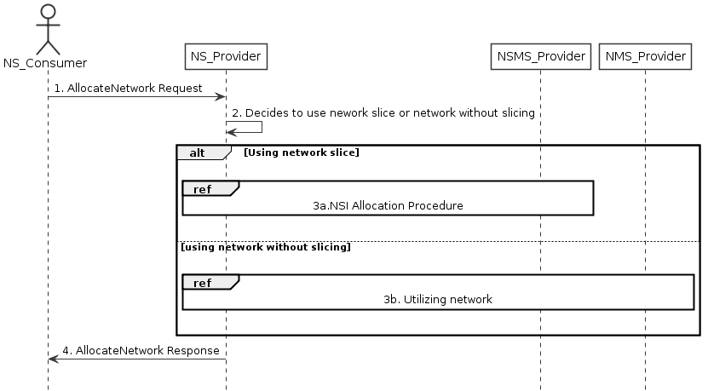

Figure 7.16-1 Allocating network with or without slicing for communication services

1) Network Service Provider (NS_Provider) receives AllocateNetwork request (see AllocateNetwork operation defined in clause 6.5.5) from Network Service Consumer (NS_Consumer). The received request includes network related service requirements (e.g. isolation, latency, coverage).

2) NS_Provider decides to use the network with or without slicing depending on these network related service requirements based on some internal admission control.

3) Based on the decision by NS_Provider:

3a) If NS_Provider decides to use a network with slicing, network slice instance allocation procedures in clause 7.2 follows. These procedures may result a new network slice to be created, or use an existing network slice with modification.

3b) If NS_Provider decides to use network without slicing, the network without slicing is utilized to satisfy the network related service requirements, there may be modification of the existing network or creation of a new network.

4) NS_Provider sends the AllocateNetwork response (see AllocateNetwork operation defined in clause 6.5.5) to NS_Consumer.

## 7.x Procedure of reallocating network slice to modify service characteristics

The Figure 7.X-1 illustrates the procedure of reallocating network slice enabled service.

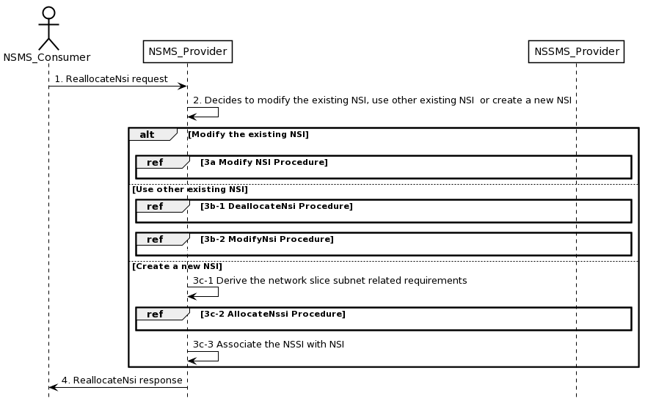

Figure 7.X-1 Reallocating network slice enabled service

1) Network Slice Management Service Provider (NSMS_Provider) receives an ReallocateNsi request (see ReallocateNsi operation defined in clause 6.5.x) from Network Slice Management Service Consumer (NSMS_Consumer) with the current NSI and network slice related requirements (the network slice related requirements are defined as the attributes in the ServiceProfile see clause 6.3.3 in TS 28.541 [6]).

2) Based on the network slice related requiremen and the knowledge of the capabilities of the current deployed NSI, the NSMS_Provider decides whether to use the current existing NSI, use other existing NSI or create a new NSI.

3a) If using the current existing NSI and this NSI needs to be modified to satisfy the network slice related requirements, the NSMS_Provider invokes the procedure to modify the existing NSI as described in clause 7.6.

3b-1) If using an existing other than the current NSI, the NSMS_Provider invokes the procedure to deallocate the service profile from the current NSI as described in clause 7.4.

3b-2) When using an existing other than the current NSI and this NSI needs to be modified to satisfy the network slice related requirements, the NSMS_Provider invokes the procedure to modify the existing NSI as described in clause 7.6.

3c-1) If creating a new NSI, the NSMS_Provider derives the network slice subnet related requirements from the received network slice related requirements. Before NSMS_Provider derives the network slice subnet related requirements, NSMS_Provider may invoke corresponding network slice subnet capability information querying procedure as described in clause 7.8.

3c-2) The NSMS_Provider invokes the NSSI allocation procedure as described in clause 7.3.

3c-3) The NSMS_Provider creates the MOI for NSI and configures the MOI with the DN of the MOI from the NSSI, other configuration information may be configured for the created MOI.

Note: The detailed configuration information is described in network slice NRM (see NetworkSlice IOC defined in clause 6.3.1 in TS 28.541 [6]).

4) The NSMS_Provider sends NSI reallocation result (see ReallocateNsi operation defined in clause 6.5.x) to the NSMS_Consumer. If the current existing NSI is modified, another existing NSI is used, or a new NSI is created successfully to satisfy the network slice related requirements, the result includes the relevant network slice instance information (see NetworkSlice IOC defined in clause 6.3.1 in TS 28.541 [6]):

- DN of the MOI for NSI.

Otherwise, the result may include the reason of failure, for example, the required latency or user number cannot be satisfied, or the physical resource is not enough.

|  |
| --- |
| ***Seventh change*** |

# 8 RESTful HTTP-based solution set of provisioning

## 8.1 Mapping of operations

### 8.1.1 Introduction

Table 8.1.1-1: Mapping of IS operations to SS equivalents

|  |  |  |  |
| --- | --- | --- | --- |
| **IS operation** | **HTTP Method** | **Resource URI** | **Qualifier** |
| allocateNsi | POST | ObjectManagement/NS/ServiceProfiles | M |
| allocateNssi | POST | ObjectManagement/NSS/SliceProfiles | M |
| deallocateNsi | DELETE | ObjectManagement/NS/ServiceProfiles/{ServiceProfileId} | M |
| deallocateNssi | DELETE | ObjectManagement/NSS/SliceProfiles/{SliceProfileId} | M |
| allocateNetwork | POST | ObjectManagement/ServiceProfiles | M |
| reallocateNsi | POST | ObjectManagement/NS/ServiceProfiles | M |

|  |
| --- |
| ***Eight change*** |

### 8.1.6 Operation AllocateNetwork

This operation is to allocate a network provided by the service provider.

Table 8.1.6-1: Mapping of IS operation input parameters to SS equivalents (HTTP POST)

|  |  |  |  |  |
| --- | --- | --- | --- | --- |
| **IS operation parameter name** | **SS parameter location** | **SS parameter name** | **SS parameter type** | **Qualifier** |
| attributeListIn | request body | attributeListIn | LIST OF SEQUENCE< attribute name, attribute value > | M |

Table 8.1.6-2: Mapping of IS operation output parameters to SS equivalents (HTTP POST)

|  |  |  |  |  |
| --- | --- | --- | --- | --- |
| **IS operation parameter name** | **SS parameter location** | **SS parameter name** | **SS parameter type** | **Qualifier** |
| serviceProfileId | response body | serviceProfileId | String | M |
| status | response status codes | n/a | n/a | M |

### 8.1.x Operation ReallocateNsi

This operation is to reallocate a serviceProfile in a network slice instance provided by the service provider, the service characteristics may be changed without having to create a new or modify an existing network slice.

Table 8.1.2-1: Mapping of IS operation input parameters to SS equivalents (HTTP POST)

|  |  |  |  |  |
| --- | --- | --- | --- | --- |
| **IS operation parameter name** | **SS parameter location** | **SS parameter name** | **SS parameter type** | **Qualifier** |
| attributeListIn | request body | attributeListIn | LIST OF SEQUENCE< attribute name, attribute value > | M |
| DN | request body | href | type:string, format: uri | M |

Table 8.1.2-2: Mapping of IS operation output parameters to SS equivalents (HTTP POST)

|  |  |  |  |  |
| --- | --- | --- | --- | --- |
| **IS operation parameter name** | **SS parameter location** | **SS parameter name** | **SS parameter type** | **Qualifier** |
| attributeListOut | response body | attributeListOut | LIST OF SEQUENCE< attribute name, attribute value > | M |
| status | response status codes | n/a | n/a | M |
| DN | response body | href | type:string, format: uri | M |

|  |
| --- |
| ***End of changes*** |