3GPP TSG SA WG5 Meeting 138-e S5-214469

electronic meeting, online, 23 - 31 August 2021 revision for S5-21xxxx

Source: Nokia, Nokia Shanghai Bell

Title: possible solution for network slice protection on N6 interface

Document for: Approval
Agenda Item: 6.5.3

1 Decision/action requested
The group is asked to discuss and approve the proposal..

2 References
[1] 3GPP TR 28.811: "Management and orchestration; Network Slice Management Enhancement"
[2] GSMA NG.116: "Generic Network Slice Template"

3 Rationale
This pCR is to add possible solution for network slice protection on N6 interface according to potential requirements defined in clause 6.5 of this study report.

4 Detailed proposal
Start of 1st Change

7.x Possible solutions for network slice protection on N6 interface
It is proposed to enhance the 5G NRM to support network slice protection on N6 interface :
- Add an optional new attribute for N6 interface protection requirement in ServiceProfile and CNSliceSubnetProfile for CN. The attribute includes required security functions and corresponding rules of each function. E.g. the dataType of the attribute could be defined as following:
N6Protection <<dataType>>:
Attribute Name | Support Qualifier | isWritable | multiplex | Description
servAttrCom | CM | T | 1 | Only valid when the attribute is in ServiceProfile
secFuncs | M | T | 1..* | List of security control functions/features required by the slice/slice subnet consumer. E.g. Fireware, NAT, antimalware, parental control, DDoS protection function, etc.

Each security function could be defined as:
SecFunc <<dataType>>:

Attribute Name | Support Qualifier | isWritable | multiplex | Description
secFunType | M | F | 1 | Type of the security function
secRules | O | T | 0..* | security rules could be configured on each function. If it's absent, the default rules could be applied

- Enhance PCC rules associated to PCFFunction or SMFFunction IOC to support routing traffic to security function on N6 interface. e.g. extend PredefinedPccRuleSet IOC (add an optional sNSSAIList attribute in the IOC definition) to support per slice (or list of slices) PCC rule list, or extend PccRule dataType (add an optional sNSSAIList attribute in the dataType definition) to support per slice (or list of slices) PCC rule which including traffic steering rules, or extend TrafficControlData dataType directly (add an optional sNSSAIList attribute in the dataType definition) to support per slice (or list of slices) traffic steering policies/rules.
Example workflow to deploy a network slice for a NSC with N6 protection requirement

skinparam shadowing false
skinparam monochrome true
hide footbox
autonumber "0."

NSC -> NSP: create a network slice\n(service profile)
NSP -> CNNSSP: create a core network slice subnet\n(core network slice profile)
CNNSSP -> CNNSSP: extract and interpret\nN6 protection attribute
CNNSSP -> MANO: trigger to deploy 5GC NFs\nand security functions required\nin the N6 protection attribute
MANO --> CNNSSP: complete deployment and\nsecurity function configuration
CNNSSP -> CNNFMF: configure 5GC NFs
CNNFMF -> NF: configure 5GC NFs including\nconfiguring per slice\ntraffic steering rules\n in PCF or SMF
@enduml
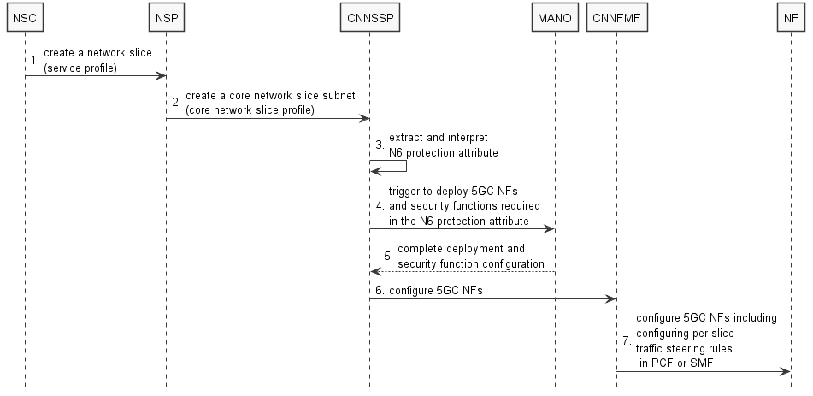
Note: how to deploy and configure security function is out of scope of 3GPP
End of Change

