3GPP TSG-SA5 Meeting #138-e S5-214379

Online, , 23rd Aug 2021 - 31st Aug 2021
CR-Form-v12.1
CHANGE REQUEST
 | 28.531 | CR | 0077 | rev | - | Current version: | 15.8.0
For HELP on using this form: comprehensive instructions can be found at
http://www.3gpp.org/Change-Requests.

Proposed change affects: | UICC apps |  | ME |  | Radio Access Network | X | Core Network | X

Title: | Rel-17 CR 28.531 Removing Notify Network Slice Subnet Capability Information
Source to WG: | Samsung Electronics Benelux BV
Source to TSG: | S5
Work item code: | NETSLICE-PRO_NS |  |  |  |  |  | Date: |  |  | 2021-08-13
Category: | F |  |  |  |  |  | Release: |  |  | Rel-15
 | Use one of the following categories:  F (correction)  A (mirror corresponding to a change in an earlier release)  B (addition of feature),  C (functional modification of feature)  D (editorial modification)  Detailed explanations of the above categories can  be found in 3GPP TR 21.900. |  |  |  |  |  |  |  | Use one of the following releases:  Rel-8 (Release 8)  Rel-9 (Release 9)  Rel-10 (Release 10)  Rel-11 (Release 11)  …  Rel-15 (Release 15)  Rel-16 (Release 16)  Rel-17 (Release 17)  Rel-18 (Release 18)
Reason for change: |  | The notify/subscription procedures for network slice subnet capability information" is not implementable because of the follwing reasons:  NSS Capability change subscription request is not defined.  notify the NSS capability information is not defined.  Unless we define both stage 2 and stage 3 solutions for these request/response, they cannot be implemented. And, will just confuse the readers.
Summary of change: |  | Delete procedure of Notify Network Slice Subnet Capability Information
Consequences if not approved: |  | Incorrect and unimplementable specification.
Clauses affected: |  | 7.8.3
 |  | Y | N
Other specs |  |  | X | Other core specifications |  |  |  | TS/TR ... CR ...
affected: |  |  | X | Test specifications |  |  |  | TS/TR ... CR ...
(show related CRs) |  |  | X | O&M Specifications |  |  |  | TS/TR ... CR ...
Other comments:
This CR's revision history:

1st Modified Section

7.8 Procedure of Obtaining Network Slice Subnet Capability

7.8.1 Introduction
The clause illustrates possible procedures of obtaining network slice subnet capability information (e.g. supported maximum latency, supported capacity (e.g. maximum user number)) of network slice subnet instance(s) which can be provided by network slice subnet management service provider.

7.8.2 Querying Network Slice Subnet Capability Information
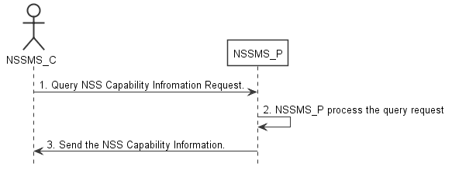
Figure 7.8-2: Procedure of querying network slice subnet capability information
1) Network Slice Subnet Management Service Consumer (NSSMS_C) wants to query the NSS capability information of the NSSI(s) which can be provided by corresponding Network Slice Subnet Management Service Consumer (NSSMS_P), NSSMS_C sends NSS capability querying request (see getMOIAttributes operation defined in TS 28.532 [8]) to NSSMS_P to obtain the NSS capability information of the NSSI(s) which can be provided by corresponding NSSMS_P.
2) NSSMS_P processes the NSS capability information querying request.
3) NSSMS_P sends the NSS capability information (e.g. supported maximum latency, supported capacity (e.g. user number)) of NSSI(s) that can be provided by itself (see getMOIAttributes operation defined in TS 28.532 [8]) to NSSMS_C.

7.8.3

Void

