3GPP TSG SA WG5 Meeting 138-e S5-214355

electronic meeting, online, 23 - 31 August 2021

Source: China Mobile

Title: Add relationInfo for intent management

Document for: Approvals
Agenda Item: 6.4.10

1 Decision/action requested
The group is asked to discuss and approval.

2 References
[1] 3GPP draft TS 28.312: “Management and orchestration; Intent driven management services for mobile networks v0.1.0”.
[2] 3GPP TR 28.812: “Study on scenarios for Intent driven management services for mobile networks v17.1.0”.

3 Rationale
The “judgeInfo” and “relationInfo” is missing in the attributes table for Intent IOC in clause 6.2.1. “judgeInfo” is important to assess the intent preliminarily. “relationInfo” is important to describe the relationship between a newly requested intent and other intents when there are multiple intents. Following are the description of intent assessment and intent storage.

3.1 Intent assessment
When the MnS Consumer sends a request to create an intent instance to the MnS Producer, it is necessary for the MnS Producer to assess the intent preliminarily. If the intent is judged to be malicious or infeasible, it will not be activated. Therefore, by introducing the preliminary assessment of intent in the intent creation process, the malicious intent or infeasible intent can be filtered out, to reduce the risk of malicious intent fulfilment, and reduce unnecessary policy generation computing.

3.2 Intent storage
When there are multiple intents, an intent may have some relationship with other intents, e.g. an intent may be equal to anther intent, an intent may be conflict with another intent. Considering that the multiple intents can be requested by different MnS Consumers and responded by different MnS Producers, the intent database is necessary to store the intent MOI and determine the intent relationship. In addition, intent storage helps to better manage multiple intents and maintains the intent information to support subsequent audit and policy generation.

According to above description, this contribution has following three proposals:
Proposal 1: propose to add judgeInfo as an attribute of Intent IOC to describe the result of preliminary assessment of the intent. It can have two values:
- “Malicious”: The intent instance can have a negative impact on the network, e.g. requiring a device to be shut down or requiring critical data to be deleted.
- “Non-malicious”: The intent instance is not malicious.

Proposal 2: propose to add relationInfo as attribute of Intent IOC to describe the relationship with other intents. The relationship includes:
- “equal”: The intent instance is equal to anther intent when the two intents have the same value for the attribute ‘intentExpectation’ .
- “conflict”: The intent instance is conflict with another intent when the two intents have the same intentAreas but cannot be fulfilled at the same time due to conflicting goals or some other reasons.

Proposal 3: propose creating procedures including preliminary assessment of the intent and querying intent database.

4 Detailed proposal
It proposes to make the following changes to TS 28.312[1].
1st Change

6 Stage 2 definition for Intent Driven Management

6.2 Information model definition for Intent (MnS component typeB)

6.2.1 Information model definition for Intent

6.2.1.2 Class definition

6.2.1.2.1.2 Attributes
The Intent includes attributes inherited from TOP IOC (defined in TS 28.622) and the following attributes:
Attribute Name | Support Qualifier | isReadable | isWritable | isInvariant | isNotifyable
intentExpectation | M | T | T | F | T
userLabel | M | T | T | F | T
intentFulfilStatus | M | T | F | F | T
JudgeInfo | M | T | T | F | T
relationInfo | M | T | T | F | T
Editor’s Note: whether other the attributes are needed for the Intent IOC needs further discussion.

6.2.1.2.1.3 Attribute constraints
None

6.2.1.3 DataType definition
None

6.2.1.4 Attribute definition
Attribute Name | Documentation and Allowed Values | Properties
userLabel | A user-friendly (and user assignable) name of the intent.  allowedValues: Not Applicable | type: String  multiplicity: 1  isOrdered: F  isUnique: F  defaultValue: None  isNullable: False
intentExpectation | It indicates the expectations including requirements, goals and constraints given to a 3GPP system.  The intentExpectation includes the intentAreas which describes a list of coverage areas for the intent to be applied.  Editor’s Note: the detailed intentExpectation is for further discussion | type: FFS  multiplicity: *  isOrdered: F  isUnique: F  defaultValue: None  isNullable: False
intentFulfilStatus | It describes the status of the intent fulfilment result, which is configured by MnS producer and can be read by MnS consumer.  allowedValues: "FULFILLED", “NOT_FULFILLED  Editor’s Note: whether other allowed values should be supported is FFS, and the name for the attribute intentFulfilStatus is FFS. | type: ENUM  multiplicity: 1  isOrdered: N/A  isUnique: N/A  defaultValue: None  isNullable: False
judgeInfo | It describes the initial assessment of intent, which is configured by MnS producer and can be read by MnS consumer.  allowedValues: “Malicious”, “Non-malicious” | type: ENUM  multiplicity: 1  isOrdered: N/A  isUnique: N/A  defaultValue: None  isNullable: False
relationInfo | It indicates the relationship to an intent in the intend database.  The relationship including conflict relationship, equal relationship. | type: FFS  multiplicity: 1  isOrdered: N/A  isUnique: N/A  defaultValue: None  isNullable: False

2nd Change

6.3.2 Create an intent
The Figure 6.3.2-1 illustrates the procedure for MnS consumer to create an intent.

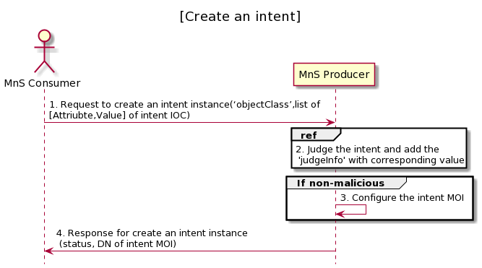
Figure 6.3.2-1 Procedure for MnS consumer to create an intent
1. MnS Consumer sends a request to create an intent instance to MnS Producer with ‘objectClass’ and list of [Attribute,Vlaue] for the new intent to be created. The detailed [Attribute,Value] see the concrete intent IOC defined in clause 6.2. ‘objectCalss’ is the name for the concrete intent IOC.
2. The MnS Producer determine the attribute ‘judgeInfo’ with the value " malicious”, or “non-malicious” by assessing the intent preliminarily.
3. If the attribute ‘judgeInfo’ with the value " non-malicious”, based on the request, the MnS Producer creates the concrete intent MOI (i.e. instance of intent IOC) with value for attribute ‘objectInstance’ allocated, and configure the new created intent MOI with the list of [Attribute, Value]. ‘objectInstance’ is the identifier (DN) for the concrete intent MOI.
4. MnS Producer sends a response to the MnS consumer with status (OperationSucceeded or OperationFailed) and ‘objectInstance’ of the created intent MOI.

6.3.2.x Create an intent when there are multiple intents
The Figure 6.3.2-x illustrates the procedure for MnS consumer to create an intent.
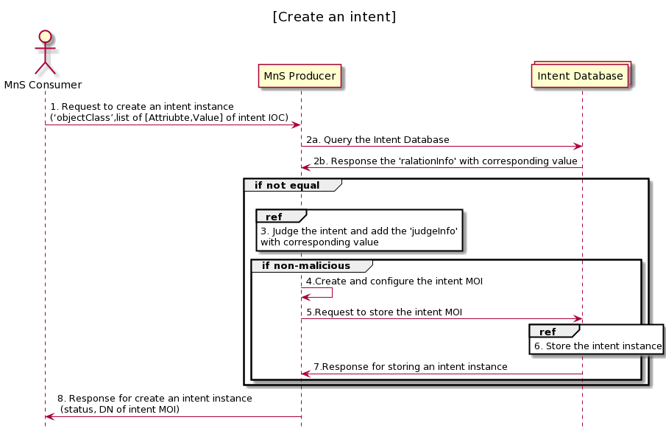
Figure 6.3.2-x Procedure for MnS consumer to create an intent
1. MnS Consumer sends a request to create an intent instance to MnS Producer with ‘objectClass’ and list of [Attribute,Vlaue] for the new intent to be created. The detailed [Attribute,Value] see the concrete intent IOC defined in clause 6.2. ‘objectCalss’ is the name for the concrete intent IOC.
2a. The MnS Producer sends a request to query the intent database.
2b. The intent database sends a response to the MnS Producer with the value for attribute ‘relationInfo’.
3. If the requested intent is not equal to any intents in the database, the MnS Producer determines the intent and add the 'judgeInfo' with corresponding value.
4. If the attribute ‘judgeInfo’ with the value " Non-malicious”, based on the request, the MnS Producer creates the concrete intent MOI (i.e. instance of intent IOC) with value for attribute ‘objectInstance’ allocated, and configure the new created intent MOI with the list of [Attribute, Value]. ‘objectInstance’ is the identifier (DN) for the concrete intent MOI.
5. The MnS Producer sends a request to store the intent instance to the intent database.
6. The intent database stores the intent instance.
7. The intent database sends a response for storing the intent instance.
8. MnS Producer sends a response to the MnS consumer with status (OperationSucceeded or OperationFailed) and ‘objectInstance’ of the created intent MOI.

3rd Change

A.1.x Create an intent when there are multiple intents
@startuml
title "[Create an intent]"
actor "MnS Consumer" as MnS_Consumer
participant "MnS Producer" as MnS_Producer
Collections "Intent Database" as Intent_Database
MnS_Consumer -> MnS_Producer: 1. Request to create an intent instance\n(‘objectClass’,list of [Attriubte,Value] of intent IOC)

MnS_Producer -> Intent_Database: 2a. Query the Intent Database
Intent_Database -> MnS_Producer: 2b. Response the 'ralationInfo' with corresponding value
group if not equal
|||
ref over MnS_Producer: 3. Judge the intent and add the 'judgeInfo' \nwith corresponding value
group if non-malicious
MnS_Producer -> MnS_Producer: 4.Create and configure the intent MOI
MnS_Producer -> Intent_Database: 5.Request to store the intent MOI
ref over Intent_Database: 6. Store the intent instance
Intent_Database -> MnS_Producer: 7.Response for storing an intent instance
end
end
MnS_Producer -> MnS_Consumer: 8. Response for create an intent instance \n (status, DN of intent MOI)

hide footbox
@enduml

End of changes

