3GPP TSG-SA5 Meeting #138-e S5-214299

e-meeting, 23 - 31 August 2021

Source: Huawei

Title: Add key issue on modelling of MnF

Document for: Approval
Agenda Item: 6.5.8

1 Decision/action requested
Discuss and approve on the proposal.

2 References
[1] 3GPP TS 28.622 Generic Network Resource Model (NRM). Integration Reference Point (IRP); Information Service (IS)
[2] 3GPP TS 28.533 Management and orchestration; Architecture framework
[3] 3GPP TR 28.925 enhancement of service based management architecture

3 Rationale
Observation#1: Management Function Definition and Concept in TS 28.533[2].
A Management Function (MnF) is a logical entity playing the roles of MnS consumer and/or MnS producer.
Management Function can be deployed as a separate entity or embedded in Network Function to provide MnS(s). Following figure 1 shows an example (on the left) which MnF deployed as a separate entity to provide MnS(s) and another example (on the right) which MnF is embedded in Network Function to provide MnS(s):
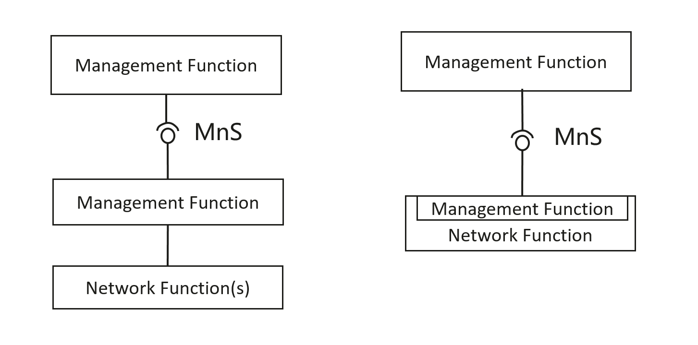
Figure 1：Examples of MnS deployment scenario
Observation#2: Network Element definition in TR 21.905.
Network Element: A discrete telecommunications entity which can be managed over a specific interface e.g. the RNC.
Observation#3: Network Function definition in TS 28.533.
Network Function (NF): defined in TS 23.501[31].
TS 23.501:
Network Function: A 3GPP adopted or 3GPP defined processing function in a network, which has defined functional behaviour and 3GPP defined interfaces.
NOTE 1: A network function can be implemented either as a network element on a dedicated hardware, as a software instance running on a dedicated hardware, or as a virtualised function instantiated on an appropriate platform, e.g. on a cloud infrastructure.

Observation#3: ManagedElement, ManagedFunction and ManagementNode IOC definition in TS 28.622.
MaangedElement: This IOC represents telecommunications equipment or TMN entities within the telecommunications network providing support and/or service to the subscriber. A ManagedElement IOC is used to represent a Network Element defined in TS 32.101[1] including virtualization or non-virtualization scenario.
ManagedFunction: This IOC is provided for sub-classing only. It provides attribute(s) that are common to functional IOCs. Note that a ManagedElement may contain several managed functions, a managed function may contain other managed functions as specified for the specific subclass.This IOC can represent a telecommunication function either realized by software running on dedicated hardware or realized by software running on NFVI.
ManagementNode: This IOC represents a telecommunications management system (EM) within the TMN that contains functionality for managing a number of ManagedElements (MEs). The management system communicates with the MEs directly or indirectly over one or more interfaces for the purpose of monitoring and/or controlling these MEs.

Based on obove observations, it proposes to discuss the following 3gpp system (including management system and corresponding network system) deployment scenarios and corresponding NRM to represent such 3gpp system deployment scenarios.
Following is the deployment scenarios:
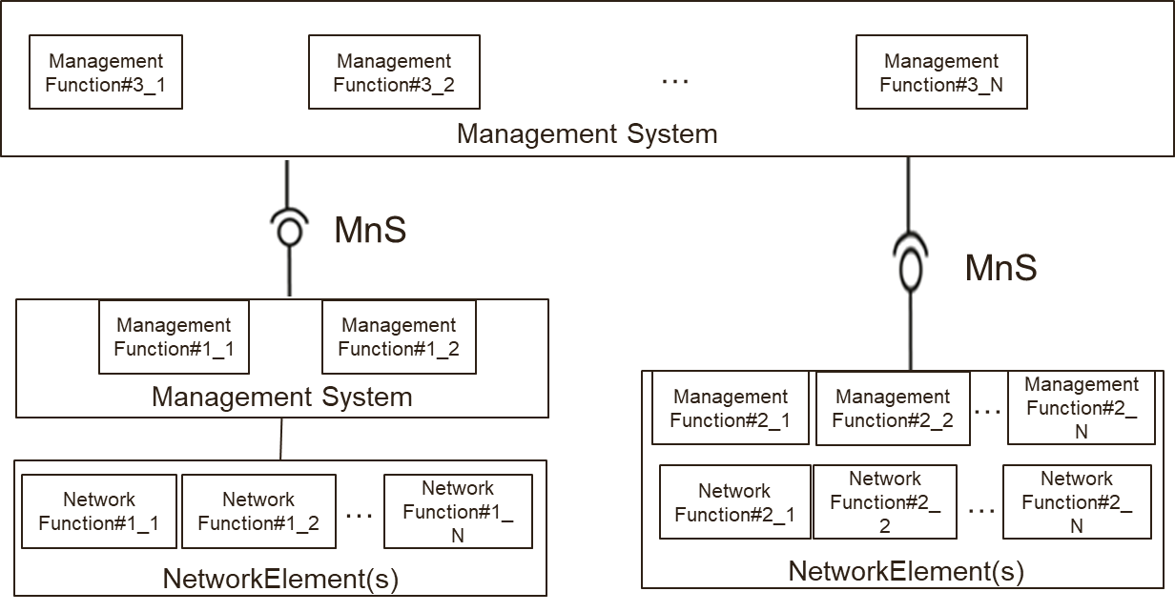
Following is the potential generic NRM fragment for above deployment scenarios
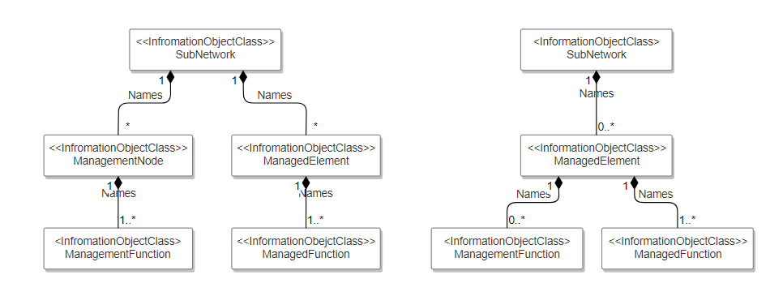
- The ManagedElement IOC is used to represent a Network Element. The ManagedElement IOC name-contain at least one instance of ManagedFunction IOC. The ManagedElement IOC may name-contain one or multiple instance(s) of ManagedFunction IOC.
- The ManagedFunction IOC is used to represents a Network Function. The ManagedFunction IOC is name contained by ManagedElement IOC.
- The ManagementNode IOC is used to represent a management system within the TMN that contains management functionality for managing a number of ManagedElements (MEs). The ManagementNode IOC name-contain at least one instance of ManagementFunction IOC.
- The ManagementFunction IOC is used to represent a management function. The ManagementFunction IOC can be name contained by ManagementNode IOC or ManagedElement IOC.
- Observation#4: SA5 has specified some management related features like MDA, COSLA etc. Such features also need to be managed in the same way as managing network node in 3GPP management system.

To summarize, the SBMA related concepts have corresponding IOCs except there is no corresponding IOC to represent Management Function. And based on the figure 1 above, Management Function takes an important role to build the links with Network Element, Network Function and other Management Function. Management Function is also needed to be managed from 3GPP management system using the same approach as managing network node. We propose to add corresponding ManagementFunction IOC to show the completeness of SBMA concept.

4 Detailed proposal
It is proposed to add a new Key issue on modelling for MnF. This document proposes the following changes in TR 28.925 [1].

1st Change

4.x Issue #x: Use of Models in SBMA

4.x.1 Description
The following concepts are related to SBMA:
- TS 28.533 Management Function: A Management Function (MnF) is a logical entity playing the roles of MnS consumer and/or MnS producer. Management Function can be deployed as a separate entity or embedded in Network Function to provide MnS(s).

Figure 4.x-1: Examples of MnS deployment scenario
- TR 21.905 Network Element: A discrete telecommunications entity which can be managed over a specific interface e.g. the RNC.
- TS 28.533 / TS 23.501 Network Function: A 3GPP adopted or 3GPP defined processing function in a network, which has defined functional behaviour and 3GPP defined interfaces.
- TS 28.622 ManagementNode IOC: This IOC represents a telecommunications management system (EM) within the TMN that contains functionality for managing a number of ManagedElements (MEs).
- TS 28.622 ManagedElement IOC: This IOC represents telecommunications equipment or TMN entities within the telecommunications network providing support and/or service to the subscriber. A ManagedElement IOC is used to represent a Network Element defined in TS 32.101[1] including virtualization or non-virtualization scenario.
- TS 28.622 ManagedFunction IOC: This IOC is provided for sub-classing only. It provides attribute(s) that are common to functional IOCs. Note that a ManagedElement may contain several managed functions, a managed function may contain other managed functions as specified for the specific subclass.This IOC can represent a telecommunication function either realized by software running on dedicated hardware or realized by software running on NFVI.
The relations of the above concepts used in different SBMA MnS deployment scenarios need further described.

4.x.2 Potential solutions
This clause provides the illustration of using related NRM to represent SBMA deployment scenarios.
- The ManagementFunction can be deployed in management system, including
  - The Management Function deployed in domain management system.
  - The Management Function deployed in cross domain management system.
- The Management Function deployed in Network Element.
A Management Function can manage one or multiple Network Functions
Following is an example of deployment scenario:

Figure 4.x-2: Management Function deployment scenarios
Following is one way of representation of using generic NRM fragment for above deployment scenarios:
Figure 4.x-3: generic NRM fragment for Management Function deployment scenarios
Editor’s Notes: whether ManagementFunction IOC be name-contained by ManagementNode IOCor SubNetwork IOC needs further discussion.
- The ManagedElement IOC is used to represent a Network Element. The ManagedElement IOC name-contain at least one instance of ManagedFunction IOC. The ManagedElement IOC may name-contain one or multiple instance(s) of ManagedFunction IOC.
- The ManagedFunction IOC is used to represents a Network Function. The ManagedFunction IOC is name contained by ManagedElement IOC.
- The ManagementNode IOC is used to represent a management system within the TMN that contains management functionality for managing a number of ManagedElements (MEs). The ManagementNode IOC name-contain at least one instance of ManagementFunction IOC.
- The ManagementFunction IOC is used to represent a management function. The ManagementFunction IOC can be name contained by ManagementNode IOC or ManagedElement IOC.

End of change

