3GPP TSG-SA5 Meeting #138-e S5-21xxxx

e-meeting, 23 - 31 August 2021

Source: Huawei

Title: Add concrete scenarios for management capability exposure to external vertical customer

Document for: Approval
Agenda Item: 6.5.6

1 Decision/action requested
It proposes to discuss and approve

2 References
[1] 3GPP TR 28.824 Study on on network slice management capability exposure

3 Rationale

3.1 Observations
Following are the observations related to the discussion on scenarios for management capability exposure to external customers.
Observation#1: In SA5#137e.3 Rapporteur call, the following concept for management capability exposure to vertical customer is discussed, which means the management capability can be exposed in different layers:
- Business management exposure
- Service management expsosure
- Network management exposure
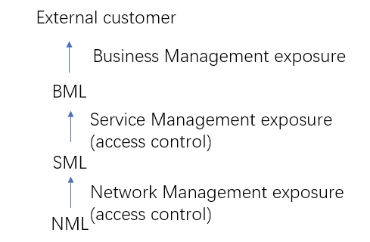
Figure 1 concept for management capability exposure
Observation#2: In TS 28.530, following two network slice business modes are described:
- Network Slice as a Service (NSaaS), in this mode, operator offer network slice as service to its vertical customer, vertical customer is aware of the network slice. This is related to network management exposure in the Figure 1.
- Network slices as NOP internals, in this mode, operator offer communication service to its vertical custumer, vertical customer have no knowledge of the network slice. This is related to service management exposure in Figure 1.

Observation#3: In TS 28.533, the Exposure governance management function (EGMF) is introduced as an Management Function entity with the role of management service exposure governance. And also Annex A3 illustrates a deployment scenario for EGMF produces exposure governance management capability that operators can apply on Management Function (MnF) 1 MnS for exposing different derivation of MnF 1 MnS to:
- MnF 2 (e.g. from another Operator) and
- 3rd party (e.g. from vertical industry).
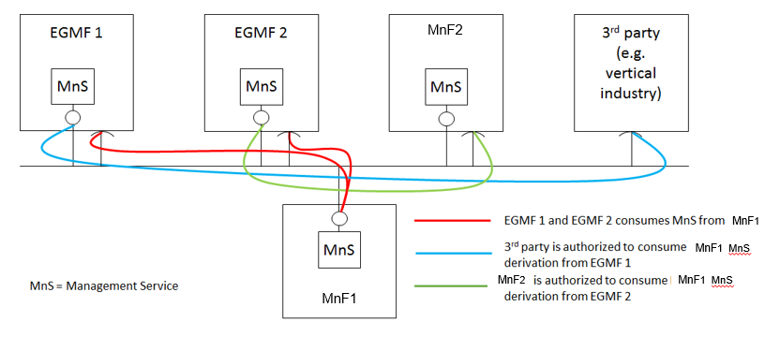
This contribution proposes to add EGMF based management exposure deployment scenario as one potential solution.

4 Detailed proposal
It poposes to add following exposure scenario in TR 28.824.

1st Change

7.X Potential deployment scenarios for management capability exposure for vertical customer

7.X.1 EGMF based management exposure:

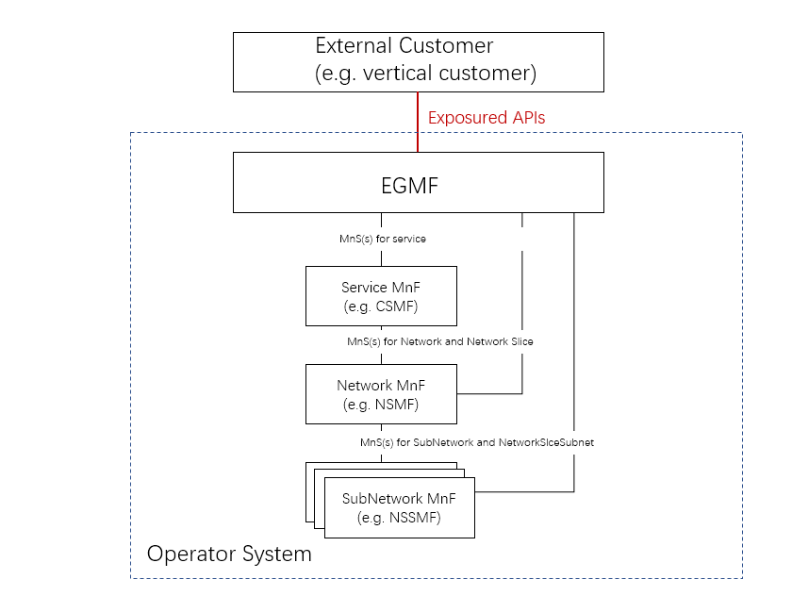
Figure 7.X.1 EGMF based management exposure scenario
Note: EGMF is a logical MnF, which may be deployed in BSS or OSS, the detailed deployment is FFS. The illustrated deployment of the operator internal system (including Service MnF, Network MnF and SubNetwork MnS) is one deployment scenario for the SBMA.
In this deployment scenario:
- EGMF is controlled and configured by Operator for which management capability (i.e. MnS instances) can be exposured to the specific external customer. This functionality can be implemented by access control feature based on the negotiation information or product information between Operator and its external customer.
- EGMF can provide exposure API(s) to its external customer, including:
  - Provide corresponding exposure API(s) for service (e.g. communication service level alarm/performance information supervision) to the specified customer.
  - Provide corresponding exposure API(s) for network and network slice (e.g. network and network slice level alarm/performance information supervision)
  - Provide corresponding exposure API(s) for SubNetwork and network slice subnet (e.g. Subnetwork and network slice subnet level alarm/performance information supervision)
Editor’s Note: Which concrete management APIs can be exposure to external customer is FFS.

End Change

