3GPP TSG-SA5 Meeting #138-e S5-214203

e-meeting, 23 - 31 August 2021

Source: Huawei

Title: Analyse on the solution set for management service

Document for: Approval
Agenda Item: 6.5.4

1 Decision/action requested
Discuss and approve on the proposal.

2 References
[1] 3GPP TR 28.818 Study on YANG PUSH

3 Rationale
Observation#1: in current SA5 specifications, there are already 2 alternative solution sets defined to support SA5 defined subscription/notification functionalities. Following using the configuration management for example.
Option#1: YAML (REST based) for configuration (including subscription), and YAML for notification. This is decided and introduced by the group since Rel-15.
Option#2: NetConf/YANG for configuration (including subscription), and YAML for notification. This is decided and introduced by the group since Rel-16 because of 3GPP-ONAP integration purpose.
Observation#2: Following two more options are discussed and proposed in SA5#137emeeting (S5-213675, S5-213676)
Option#3: NetConf/YANG for configuration (including subscription), and YANG-push for notification.
Option#4: NetConf/YANG for configuration, YANG-push for subscription, and YANG-push for notification.
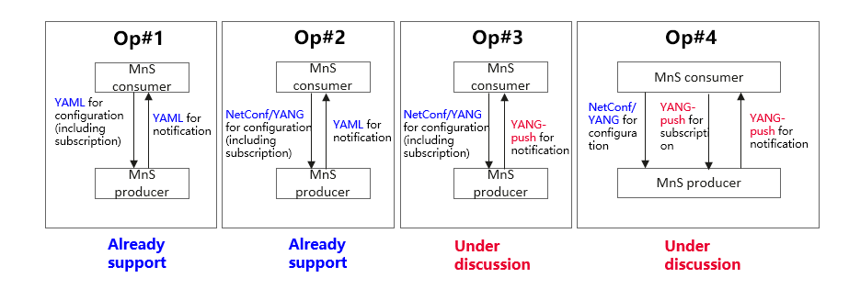
Following aspects need to be considered in the study according to the investigation on the YANG push materials (e.g. IETF RFC 8639, 8641):
- For the existing SA5 defined subscription/notification functionality (existing proctocal agnotic stage1 and stage2 aspects), there are already two solution sets (option#1 and option#2) to support, needs to analyse what’s the benefits to introduce more solution sets (option#3 and option#4) support the same functionality capabilities.
- For the new subscription/notification functionalities identified, following analyses are needed:
- Analyse whether these new fucntionalities are applicable and useful for the management of 3GPP network and service.
    - If yes, introduce these new fucntionalities in proctocal agnotic level (i.e. including stage1 and stage2).
- Analyse whether the solution set option#1 and option#2 can be enhanced to satify these new functionalities.
- If yes, enhance the solution set option#1 and option#2 to support these new fucntionalities.
- If no, then discuss to introduce new solution set (e.g. YANG-PUSH) to satisfy the new functionalities.

4 Detailed proposal
It proposes the following changes in TR 28.818 [1].
1st Change

Annex X Analysis on the solution sets for management service
Observation#1: in current SA5 specifications, there are already 2 alternative solution sets defined to support SA5 defined subscription/notification functionalities. Following using the configuration management for example.
Option#1: YAML (openAPI) for configuration (including NtfSubscriptionControl IOC), and YAML (openAPI) for notification. This is decided and introduced by the group since Rel-15.
Option#2: NetConf/YANG for configuration (including NtfSubscriptionControl IOC), and YAML (openAPI) for notification. This is decided and introduced by the group since Rel-16 because of 3GPP-ONAP integration purpose.
Observation#2: Following two more options are discussed and proposed in SA5#137emeeting (S5-213675, S5-213676)
Option#3: NetConf/YANG for configuration (including NtfSubscriptionControl IOC), and YANG-push for notification.
Option#4: NetConf/YANG for configuration, YANG-push for subscription, and YANG-push for notification.
Note1: Option#1 is only backgroud infromation and is not applicable for the YANG solution set or YANG-Push.
Note2: For the completion of Option#2 for implementation, some additional work maybe needed.
Following aspects need to be considered in the study according to the investigation on the YANG push materials (e.g. IETF RFC 8639, 8641):
- For the existing SA5 defined subscription/notification functionality (existing proctocal agnotic stage1 and stage2 aspects), there are already two solution sets (option#1 and option#2) to support, needs to analyse what’s the benefits to introduce more solution sets (option#3 and option#4) support the same functionality capabilities.
- For the new subscription/notification functionalities identified, following analyses are needed:
- Analyze whether these new fucntionalities are applicable and useful for the management of 3GPP network and service.
- Analyze whether
- these new functionalities can be introduced in proctocol agnostic level (i.e. including stage1 and stage2).
- Analyze whether the solution set option#1 and option#2 can be enhanced to satify these new functionalities
- Comparision with the all solution sets ( including option#1, option#2, option#3 and option4) if possible to support the identfiied new functionalities.

End of change

