**3GPP TSG-SA5 Meeting #138-e *S5-214197***

**e-meeting, 23 - 31 August 2021**

|  |  |  |  |  |  |  |  |  |
| --- | --- | --- | --- | --- | --- | --- | --- | --- |
| *CR-Form-v12.1* | | | | | | | | |
| **CHANGE REQUEST** | | | | | | | | |
|  | | | | | | | | |
|  | **28.622** | **CR** | **0113** | **rev** | **1** | **Current version:** | **16.8.1** |  |
|  | | | | | | | | |
| *For* [***HE******LP***](http://www.3gpp.org/3G_Specs/CRs.htm#_blank)*on using this form: comprehensive instructions can be found at* [*http://www.3gpp.org/Change-Requests*](http://www.3gpp.org/Change-Requests)*.* | | | | | | | | |
|  | | | | | | | | |

|  |  |  |  |  |  |  |  |  |
| --- | --- | --- | --- | --- | --- | --- | --- | --- |
| ***Proposed change affects:*** | UICC apps |  | ME |  | Radio Access Network | **X** | Core Network | **X** |

|  |  |  |  |  |  |  |  |  |  |  |
| --- | --- | --- | --- | --- | --- | --- | --- | --- | --- | --- |
|  | | | | | | | | | | |
| ***Title:*** | Rel-16 CR TS 28.541 Fix the issue caused by the updated NetworkSliceSubnet inheritence relationship | | | | | | | | | |
|  |  | | | | | | | | | |
| ***Source to WG:*** | Huawei | | | | | | | | | |
| ***Source to TSG:*** | S5 | | | | | | | | | |
|  |  | | | | | | | | | |
| ***Work item code:*** | eNRM | | | | |  | ***Date:*** | | | 2021-07-29 |
|  |  | | | |  | |  | | |  |
| ***Category:*** | F |  | | | | | ***Release:*** | | | Rel-16 |
|  | *Use one of the following categories:* ***F*** *(correction)* ***A*** *(mirror corresponding to a change in an earlier release)* ***B*** *(addition of feature),* ***C*** *(functional modification of feature)* ***D*** *(editorial modification)*  Detailed explanations of the above categories can be found in 3GPP [TR 21.900](http://www.3gpp.org/ftp/Specs/html-info/21900.htm). | | | | | | | | *Use one of the following releases: Rel-8 (Release 8) Rel-9 (Release 9) Rel-10 (Release 10) Rel-11 (Release 11) … Rel-15 (Release 15) Rel-16 (Release 16) Rel-17 (Release 17) Rel-18 (Release 18)* | |
|  |  | | | | | | | | | |
| ***Reason for change:*** | | Following issues caused by the updated NetworkSliceSubnet inheritance relationship.   1. Remove NetworkSliceSubnet as ManagedEntity for Trace job control NRM fragment | | | | | | | | |
|  | |  | | | | | | | | |
| ***Summary of change:*** | | 1. Remove NetworkSliceSubnet as ManagedEntity for Trace job control NRM fragment | | | | | | | | |
|  | |  | | | | | | | | |
| ***Consequences if not approved:*** | | TraceJobControl NRM fragement is not aligned with other control NRM fragment | | | | | | | | |
|  | |  | | | | | | | | |
| ***Clauses affected:*** | | 4.2.1,4.3.30.1 | | | | | | | | |
|  | |  | | | | | | | | |
|  | | **Y** | **N** |  | | | |  | | |
| ***Other specs*** | |  | **X** | Other core specifications | | | | TS/TR ... CR ... | | |
| ***affected:*** | |  | **X** | Test specifications | | | | TS/TR ... CR ... | | |
| ***(show related CRs)*** | |  | **X** | O&M Specifications | | | | TS/TR ... CR ... | | |
|  | |  | | | | | | | | |
| ***Other comments:*** | |  | | | | | | | | |
|  | |  | | | | | | | | |
| ***This CR's revision history:*** | |  | | | | | | | | |

|  |
| --- |
| **1st Change** |

### 4.2.1 Relationships

This clause depicts the set of classes (e.g. IOCs) that encapsulates the information relevant for this IRP. This clause provides the overview of the relationships of relevant classes in UML. Subsequent clauses provide more detailed specification of various aspects of these classes.

The following figure shows the containment/naming hierarchy and the associations of the classes defined in the present document. See Annex A of a class diagram that combines this figure with Figure 1 of [2], the class diagram of UIM.

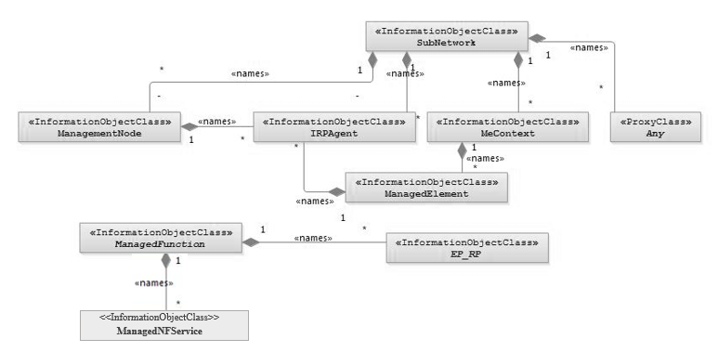

NOTE 1: ManagedElement may be contained either

- in a SubNetwork (since *SubNetwork* inherits from *Domain*_ and *ManagedElement* inherits from *ManagedElement*_ and *Domain*_ name-contained *ManagedElement_* as observed in the figure of Annex A) or

- in a MeContext instance as observed by the above figure or in the figure of Annex A.

This either-or relation cannot be shown by using an {xor} constraint in the above figure.

ManagedElement may also have no parent instance at all.

NOTE 2: Void

NOTE 3: If the configuration contains several instances of SubNetwork, exactly one SubNetwork instance shall directly or indirectly contain all the other SubNetwork instances.

NOTE 4: The SubNetwork instance not contained in any other instance of SubNetwork is referred to as "the root SubNetwork instance".

NOTE 5: ManagementNode shall be contained in the root SubNetwork instance.

NOTE 6: If contained in a SubNetwork instance, IRPAgent shall be contained in the root SubNetwork instance.

NOTE 7: For a clarification on the choice of containment of the IRPAgent (since it has three possible parents), see the def. of IRPAgent.

NOTE 8: Cardinality * is identical to multiplicity 0..*.

Figure 4.2.1-1: Containment/Naming and Association NRM fragment

Each Managed Object is identified with a Distinguished Name (DN) according to 3GPP TS 32.300 [13] that expresses its containment hierarchy. As an example, the DN of a ManagedElement instance could have a format like:

SubNetwork=Sweden,MeContext=MEC-Gbg-1,ManagedElement=RNC-Gbg-1.

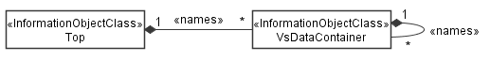

NOTE 8: Void

NOTE 9: Void

Figure 4.2.1-2: Vendor specific data container NRM fragment

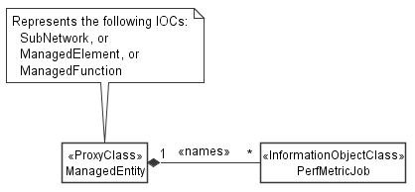

Figure 4.2.1-3: PM control NRM fragment

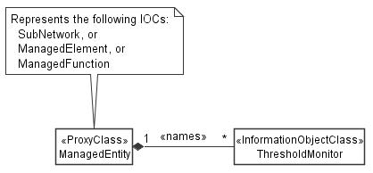

Figure 4.2.1-4: Threshold monitoring control NRM fragment

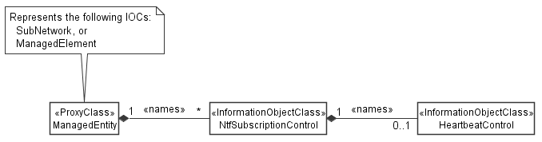

Figure 4.2.1-5: Notification subscription and heartbeat notification control NRM fragment

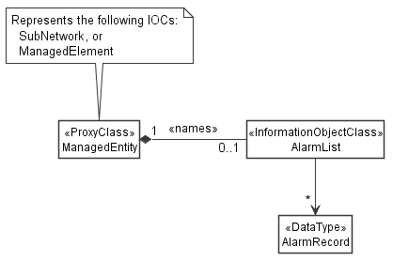

Figure 4.2.1-6: FM control NRM fragment

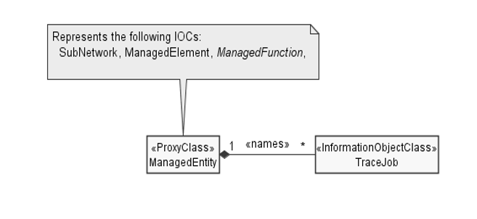

Figure 4.2.1-7: Trace control NRM fragment

|  |
| --- |
| **2nd of Change** |

#### 4.3.30.1 Definition

A TraceJob instance represents the Trace Control and Configuration parameters of a particular Trace Job (see TS 32.421 [29] and TS 32.422 [30] for details). It can be name-contained by SubNetwork, ManagedElement, ManagedFunction.

To activate Trace Jobs, a MnS consumer has to create TraceJob object instances on the MnS producer. A MnS consumer can activate a Trace Job for another MnS consumer since it is not required the value of tjTraceCollectionEntityAddress or tjStreamingTraceConsumerUri to be his own.

For the details of Trace Job activation see clauses 4.1.1.1.2 and 4.1.2.1.2 of TS 32.422 [30].

When a MnS consumer wishes to deactivate a Trace Job, the MnS consumer shall delete the corresponding TraceJob instance. For details of management Trace Job deactivation see clause 4.1.1.1.2 of TS 32.422 [30].

The attribute tjJobType specifies the kind of data to collect. Dependent on the selected type various parameters shall be available. The attributes tjJobType, tjTraceReference, tjTraceRecordSessionReference, tjTraceCollectionEntityAddress and tjTraceReportingFormat are mandatory for all job types. If streaming reporting is selected for tjTraceReportingFormat, tjStreamingTraceConsumerURI shall be present additionally. The attribute tjPLMNTarget shall be present if trace activation method is management based.

For the different job types the attributes are differentiated as follows:

- In case of TRACE_ONLY additionally the following attributes shall be available: tjListOfNeTypes, tjTraceDepth, tjTraceTarget and tjTriggeringEvent.

For this case the optional attribute tjListOfInterfaces allows to specify the interfaces to be recorded.

- In case of IMMEDIATE_MDT_ONLY additionally the following attributes shall be available:

- tjTraceTarget

- tjMDTAnonymizationOfData,

- tjMDTListOfMeasurements,

- tjMDTCollectionPeriodRrmUmts (conditional for M3, M4 and M5 in UMTS),

- tjMDTMeasurementPeriodUMTS (conditional for M6 and M7 in UMTS),

- tjMDTCollectionPeriodRrmLte (conditional for M2 and M3 in LTE),

- tjMDTMeasurementPeriodLTE (conditional for M4 and M5 in LTE),

- tjMDTCollectionPeriodM6Lte (conditional for M6 in LTE),

- tjMDTCollectionPeriodM7Lte (conditional for M7 in LTE),

- tjMDTCollectionPeriodRrmNR (conditional for M4 and M5 in NR),

- tjMDTCollectionPeriodM6NR (conditional for M6 in NR),

- tjMDTCollectionPeriodM7NR (conditional for M7 in NR),

- tjMDTReportInterval (conditional for M1 in LTE or NR and M1/M2 in UMTS),

- tjMDTReportAmount (conditional for M1 in LTE or NR and M1/M2 in UMTS),

- tjMDTReportingTrigger (conditional for M1 in LTE or NR and M1/M2 in UMTS),

- tjMDTEventThreshold (conditional for A2 event reporting or A2 event triggered periodic reporting),

- tjMDTMeasurementQuantity (conditional for 1F event reporting).

For this case the optional attribute tjMDTAreaScope allows to specify the area in terms of cells or Tracking Area/Routing Area/Location area where the MDT data collection shall take place and the optional attributes tjMDTPositioningMethod, tjMDTSensorInformation allow to specify the positioning methods to use or the sensor information to include.

- In case of IMMEDIATE_MDT_AND_TRACE both additional attributes of TRACE_ONLY and IMMEDIATE_MDT_ONLY shall apply.

- In case of LOGGED_MDT_ONLY additionally the following attributes shall be available: tjTraceTarget, tjMDTAnonymizationOfData, tjMDTTraceCollectionEntityID, tjMDTLoggingInterval, tjMDTLoggingDuration, tjMDTReportType, tjMDTEventListForTriggeredMeasurements.

For this case the optional attribute tjMDTAreaScope allows to specify the area in terms of cells or Tracking Area/Routing Area/Location area where the MDT data collection shall take place, the optional attribute tjMDTPLMNList allows to specify the PLMNs where measurement collection, status indication and log reporting is allowed, the optional attribute tjMDTAreaConfigurationForNeighCell allows to specify the area for which UE is requested to perform measurements logging for neighbour cells which have list of frequencies and the optional attribute tjMDTSensorInformation allows to specify the sensor information to include.

- In case of RLF_REPORT_ONLY and RCEF_REPORT_ONLY additionally the attribute tjTraceTarget shall be available, the optional attribute tjMDTAreaScope allows to specify the eNB or list of eNBs or gNB or list of gNBs where the reports should be collected.

- In case of LOGGED_MBSFN_MDT additionally the following attributes shall be available: tjMDTAnonymizationOfData, tjMDTLoggingInterval, tjMDTLoggingDuration, tjMDTMBSFNAreaList.

Creation and deletion of TraceJob instances by MnS consumers is optional; when not supported, the TraceJob instances may be created and deleted by the system or be pre-installed.

|  |
| --- |
| **End of Change** |