**3GPP TSG-SA5 Meeting #138-e *S5-214197***

**e-meeting, 23 - 31 August 2021**

|  |  |  |  |  |  |  |  |  |
| --- | --- | --- | --- | --- | --- | --- | --- | --- |
| *CR-Form-v12.1* | | | | | | | | |
| **CHANGE REQUEST** | | | | | | | | |
|  | | | | | | | | |
|  | **28.622** | **CR** | **0113** | **rev** | **1** | **Current version:** | **16.8.1** |  |
|  | | | | | | | | |
| *For* [***HE******LP***](http://www.3gpp.org/3G_Specs/CRs.htm#_blank)*on using this form: comprehensive instructions can be found at* [*http://www.3gpp.org/Change-Requests*](http://www.3gpp.org/Change-Requests)*.* | | | | | | | | |
|  | | | | | | | | |

|  |  |  |  |  |  |  |  |  |
| --- | --- | --- | --- | --- | --- | --- | --- | --- |
| ***Proposed change affects:*** | UICC apps |  | ME |  | Radio Access Network | **X** | Core Network | **X** |

|  |  |  |  |  |  |  |  |  |  |  |
| --- | --- | --- | --- | --- | --- | --- | --- | --- | --- | --- |
|  | | | | | | | | | | |
| ***Title:*** | Rel-16 CR TS 28.541 Fix the issue caused by the updated NetworkSliceSubnet inheritence relationship | | | | | | | | | |
|  |  | | | | | | | | | |
| ***Source to WG:*** | Huawei | | | | | | | | | |
| ***Source to TSG:*** | S5 | | | | | | | | | |
|  |  | | | | | | | | | |
| ***Work item code:*** | eNRM | | | | |  | ***Date:*** | | | 2021-07-29 |
|  |  | | | |  | |  | | |  |
| ***Category:*** | F |  | | | | | ***Release:*** | | | Rel-16 |
|  | *Use one of the following categories:* ***F*** *(correction)* ***A*** *(mirror corresponding to a change in an earlier release)* ***B*** *(addition of feature),* ***C*** *(functional modification of feature)* ***D*** *(editorial modification)*  Detailed explanations of the above categories can be found in 3GPP [TR 21.900](http://www.3gpp.org/ftp/Specs/html-info/21900.htm). | | | | | | | | *Use one of the following releases: Rel-8 (Release 8) Rel-9 (Release 9) Rel-10 (Release 10) Rel-11 (Release 11) … Rel-15 (Release 15) Rel-16 (Release 16) Rel-17 (Release 17) Rel-18 (Release 18)* | |
|  |  | | | | | | | | | |
| ***Reason for change:*** | | Following issues caused by the updated NetworkSliceSubnet inheritence relationship.   1. Several control capabilities (e.g. PM control, threshould monitoring control) for network slice subnet are missing | | | | | | | | |
|  | |  | | | | | | | | |
| ***Summary of change:*** | | 1. Update several control NRM fragment to support control capability for nrtwork slice subnet | | | | | | | | |
|  | |  | | | | | | | | |
| ***Consequences if not approved:*** | | Some network slice subnet capabilities are missing. | | | | | | | | |
|  | |  | | | | | | | | |
| ***Clauses affected:*** | | 4.2.1 | | | | | | | | |
|  | |  | | | | | | | | |
|  | | **Y** | **N** |  | | | |  | | |
| ***Other specs*** | |  | **X** | Other core specifications | | | | TS/TR ... CR ... | | |
| ***affected:*** | |  | **X** | Test specifications | | | | TS/TR ... CR ... | | |
| ***(show related CRs)*** | |  | **X** | O&M Specifications | | | | TS/TR ... CR ... | | |
|  | |  | | | | | | | | |
| ***Other comments:*** | | Forge link: to be added | | | | | | | | |
|  | |  | | | | | | | | |
| ***This CR's revision history:*** | |  | | | | | | | | |

|  |
| --- |
| **1st Change** |

### 4.2.1 Relationships

This clause depicts the set of classes (e.g. IOCs) that encapsulates the information relevant for this IRP. This clause provides the overview of the relationships of relevant classes in UML. Subsequent clauses provide more detailed specification of various aspects of these classes.

The following figure shows the containment/naming hierarchy and the associations of the classes defined in the present document. See Annex A of a class diagram that combines this figure with Figure 1 of [2], the class diagram of UIM.

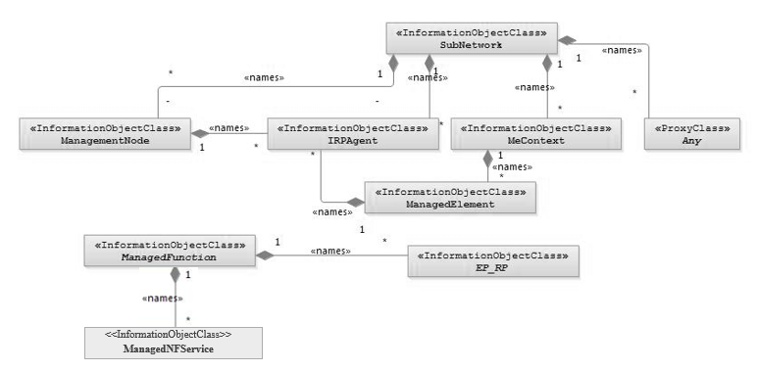

NOTE 1: ManagedElement may be contained either

- in a SubNetwork (since *SubNetwork* inherits from *Domain*_ and *ManagedElement* inherits from *ManagedElement*_ and *Domain*_ name-contained *ManagedElement_* as observed in the figure of Annex A) or

- in a MeContext instance as observed by the above figure or in the figure of Annex A.

This either-or relation cannot be shown by using an {xor} constraint in the above figure.

ManagedElement may also have no parent instance at all.

NOTE 2: Void

NOTE 3: If the configuration contains several instances of SubNetwork, exactly one SubNetwork instance shall directly or indirectly contain all the other SubNetwork instances.

NOTE 4: The SubNetwork instance not contained in any other instance of SubNetwork is referred to as "the root SubNetwork instance".

NOTE 5: ManagementNode shall be contained in the root SubNetwork instance.

NOTE 6: If contained in a SubNetwork instance, IRPAgent shall be contained in the root SubNetwork instance.

NOTE 7: For a clarification on the choice of containment of the IRPAgent (since it has three possible parents), see the def. of IRPAgent.

NOTE 8: Cardinality * is identical to multiplicity 0..*.

Figure 4.2.1-1: Containment/Naming and Association NRM fragment

Each Managed Object is identified with a Distinguished Name (DN) according to 3GPP TS 32.300 [13] that expresses its containment hierarchy. As an example, the DN of a ManagedElement instance could have a format like:

SubNetwork=Sweden,MeContext=MEC-Gbg-1,ManagedElement=RNC-Gbg-1.

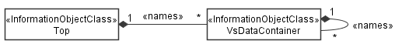

NOTE 8: Void

NOTE 9: Void

Figure 4.2.1-2: Vendor specific data container NRM fragment

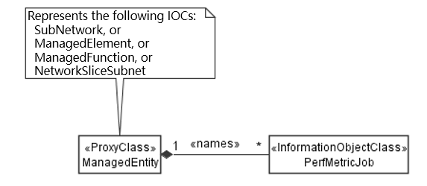

Figure 4.2.1-3: PM control NRM fragment

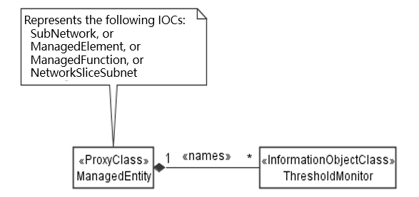

Figure 4.2.1-4: Threshold monitoring control NRM fragment

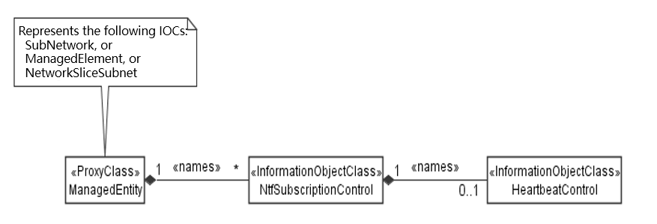

Figure 4.2.1-5: Notification subscription and heartbeat notification control NRM fragment

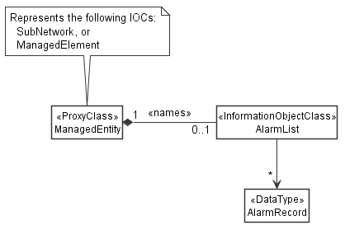

Figure 4.2.1-6: FM control NRM fragment

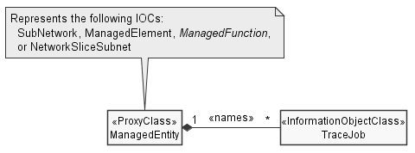

Figure 4.2.1-7: Trace control NRM fragment

|  |
| --- |
| **2nd of Change** |

### 4.3.16 ThresholdMonitor

#### 4.3.16.1 Definition

This IOC represents a threshold monitor for performance metrics. It can be name-contained by SubNetwork, ManagedElement, or ManagedFunction. This IOC can be name-contained by NetworkSliceSubnet also, which can be used to present s a threshold monitor for KPIs associated to NetworkSliceSubnet IOC. A threshold monitor checks for threshold crossings of performance metric values and generates a notification when that happens.

To activate threshold monitoring, a MnS consumer needs to create a ThresholdMonitor instance on the MnS producer. For ultimate deactivation of threshold monitoring, the MnS consumer should delete the monitor to free up resources on the MnS producer.

For temporary suspension of threshold monitoring, the MnS consumer can manipulate the value of the administrative state attribute. The MnS producer may disable threshold monitoring as well, for example in overload situations. This situation is indicated by the MnS producer with setting the operational state attribute to disabled. When monitoring is resumed the operational state is set again to enabled.

All object instances below and including the instance name-containing the ThresholdMonitor (base object instance) are scoped for performance metric production. Performance metrics are monitored only on those object instances whose object class matches the object class associated to the performance metrics to be monitored.

The optional attributes objectInstances and rootObjectInstances allow to restrict the scope. When the attribute objectInstances is present, only the object instances identified by this attribute are scoped. When the attribute rootObjectInstances is present, then the subtrees whose root objects are identified by this attribute are scoped. Both attributes may be present at the same time meaning the total scope is equal to the sum of both scopes. Object instances may be scoped by both the objectInstances and rootObjectInstances attributes. This shall not be considered as an error by the MnS producer.

Multiple thresholds can be defined for multiple performance metric sets in a single monitor using thresholdInfoList. The attribute monitorGranularityPeriod defines the granularity period to be applied.

A threshold is defined using the attributes thresholdValue , thresholdDirection and hysteresis.

When hysteresis is absent or carries no information, a threshold is triggered when the thresholdValue is reached or crossed. When hysteresis is present, two threshold values are specified for the threshold as follows: A high treshold value equal to the threshold value plus the hysteresis value, and a low threshold value equal to the threshold value minus the hysteresis value. When the monitored performance metric increases, the theshold is triggered when the high threshold value is reached or crossed. When the monitored performance metric decreases, the theshold is triggered when the low threshold value is reached or crossed. The hsyteresis ensures that the performance metric value can oscillate around a comparison value without triggering each time the threshold when the threshold value is crossed.

Using the thresholdDirection attribute a threshold can be configured in such a manner that it is triggered only when the monitored performance metric is going up or down upon reaching or crossing the threshold.

A ThresholdMonitor creation request shall be rejected, if the performance metrics requested to be monitored, the requested granularity period, or the requested combination thereof is not supported by the MnS producer. A creation request may fail, when the performance metrics requested to be monitored are not produced by a PerfMetricJob.

Creation and deletion of ThresholdMonitor instances by MnS consumers is optional; when not supported, ThresholdMonitor instances may be created and deleted by the system or be pre-installed.

#### 4.3.16.2 Attributes

The ThresholdMonitor IOC includes attributes inherited from Top IOC (defined in clause 4.3.29) and the following attributes:

|  |  |  |  |  |  |
| --- | --- | --- | --- | --- | --- |
| Attribute name | S | isReadable | isWritable | isInvariant | isNotifyable |
| administrativeState | M | T | T | F | T |
| operationalState | M | T | F | F | T |
| thresholdInfoList | M | T | T | F | T |
| monitorGranularityPeriod | M | T | T | F | T |
| objectInstances | O | T | T | F | F |
| rootObjectInstances | O | T | T | F | F |

|  |
| --- |
| **3rd of Change** |

### 4.3.22 NtfSubscriptionControl

#### 4.3.22.1 Definition

NtfSubscriptionControl represents a notification subscription of a notification recipient. It can be name-contained by SubNetwork or ManagedElement. This IOC can be name-contained by NetworkSliceSubnet also, which can be used to subscribe the notifications (e.g. notifyMOIAttributeValueChanges) for NetworkSliceSubnet IOC.

The scope attribute is used to select managed object instances included in the subscription. The base object instance of the scope (see clause 4.3.23) is the object instance name-containing the NtfSubscriptionControl instance. When the scope attribute is absent, all objects below and including the base object are scoped. The notifications related to the selected managed object instances are candidates to be sent to the address specified by the notificationRecipientAddress attribute.

The notificationType attribute and notificationFilter attribute allow MnS consumers to control which candidate notifications are sent to the notificationRecipientAddress.

If the notificationType attribute is present, its value identifies the notification types that are candidates to be sent to the notificationRecipientAddress. If the notificationType attribute is absent, notifications of all types are candidates to be sent to notificationRecipientAddress.

If supported, the notificationFilter attribute defines a filter that is applied to the set of candidate notifications. The filter is applicable to all parameters of a notification. Only candidate notifications that pass the filter criteria are sent to the notificationRecipientAddress. If the notificationFilter attribute is absent all candidate notificatios are sent to the notificationRecipientAddress.

To receive notifications, a MnS consumer has to create a NtfSubscriptionControl instance on the MnS producer. A MnS consumer can create a subscription for another MnS consumer since it is not required the notificationRecipientAddress be his own address.

When a MnS consumer does not wish to receive notifications any more the MnS consumer shall delete the corresponding NtfSubscriptionControl instance.

Creation and deletion of NtfSubscriptionControl instances by MnS consumers is optional; when not supported, the NtfSubscriptionControl instances may be created and deleted by the system or be pre-installed.

|  |
| --- |
| **4th of Change** |

### 4.3.31 PerfMetricJob

#### 4.3.31.1 Definition

This IOC represents a performance metric production job. It can be name-contained by SubNetwork, ManagedElement, or ManagedFunction. This IOC can be name-contained by NetworkSliceSubnet also, which can be used to present a performance metric production job for KPI associated to NetworkSliceSubnet IOC.

To activate the production of the specified performance metrics, a MnS consumer needs to create a PerfMetricJob instance on the MnS producer. For ultimate deactivation of metric production, the MnS consumer should delete the job to free up resources on the MnS producer.

For temporary suspension of metric production, the MnS consumer can manipulate the value of the administrative state attribute. The MnS producer may disable metric production as well, for example in overload situations. This situation is indicated by the MnS producer with setting the operational state attribute to disabled. When production is resumed the operational state is set back to enabled.

The jobId attribute can be used to associate metrics from multiple PerfMetricJob instances. The jobId can be included when reporting performance metrics to allow a MnS consumer to associate received metrics for the same purpose.  For example, it is possible to configure the same jobId value for multiple PerfMetricJob instances required to produce the measurements for a specific KPI.

The attribute performanceMetrics defines the performance metrics to be produced and the attribute granularityPeriod defines the granularity period to be applied.

All object instances below and including the instance name-containing the PerfMetricJob (base object instance) are scoped for performance metric production. Performance metrics are produced only on those object instances whose object class matches the object class associated to the performance metrics to be produced.

The optional attributes objectInstances and rootObjectInstances allow to restrict the scope. When the attribute objectInstances is present, only the object instances identified by this attribute are scoped. When the attribute rootObjectInstances is present, then the subtrees whose root objects are identified by this attribute are scoped. Both attributes may be present at the same time meaning the total scope is equal to the sum of both scopes. Object instances may be scoped by both the objectInstances and rootObjectInstances attributes. This shall not be considered as an error by the MnS producer.

When the performance metric requires performance metric production on multiple managed objects, which is for example the case for KPIs, the MnS consumer needs to ensure all required objects are scoped. Otherwise a PerfMetricJob creation request shall fail.

The attribute reportingCtrl specifies the method and associated control parameters for reporting the produced measurements to MnS consumers. Three methods are available: file-based reporting with selection of the file location by the MnS producer, file-based reporting with selection of the file location by the MnS consumer and stream-based reporting.

For file-based reporting, all performance metrics that are produced related to a "PerfMetricJob" instance for a reporting period shall be stored in a single reporting file.

When the administrative state is set to "UNLOCKED" after the creation of a "PerfMetricJob" the first granularity period shall start. When the administrative state is set to "LOCKED" or the operational state to "DISABLED", the ongoing reporting period shall be aborted, for streaming the ongoing granularity period. When the administrative state is set back to "UNLOCKED" or the operational state to "ENABLED" a new reporting period period shall start, in case of streaming a new granularity period.

Changes of all other configurable attributes shall take effect only at the beginning of the next reporting period, for streaming at the beginning of the next granularity period.

When the "PerfMetricJob" is deleted, the ongoing reporting period shall be aborted, for streaming the ongoing granularity period.

A PerfMetricJob creation request shall be rejected, if the requested performance metrics, the requested granularity period, the requested repoting method, or the requested combination thereof is not supported by the MnS producer.

Creation and deletion of PerfMetricJob instances by MnS consumers is optional; when not supported, PerfMetricJob instances may be created and deleted by the system or be pre-installed.

|  |
| --- |
| **End of Change** |