**3GPP TSG-SA5 Meeting #138-e *S5-214190***

**e-meeting, 23 - 31 August 2021**

**Source: ZTE**

**Title: Add potential solution of NRM enhancement to support NG-RAN sharing**

**Document for: Approval**

**Agenda Item: 6.5.9**

# 1 Decision/action requested

***The group is asked to discuss and approve the proposals.***

# 2 References

[1] 3GPP TS 28.541: “Management and orchestration of networks and network slicing; 5G Core Network (5GC) Network Resource Model (NRM); Stage 2 and stage 3”

[2] 3GPP TS 38.401: “NG-RAN; Architecture description”

[3] 3GPP TS 38.300: “NR; NR and NG-RAN Overall description; Stage-2”

# 3 Rationale

In MOCN NG-RAN sharing with multiple CellId scenario, the NG-RAN nodes (i.e. gNBs) which share the same physical radio resources can be used by different operators, and from each operator point of view, each operator has its own gNB. To keep the backward compatibility, it is better to use the combination of the current defined GNBDUFunction, GNBCUCPFunction and GNBCUUPFuntion to represent the gNBs. And in order to avoid information redundancy, it is better to put all the attributes which are not operator specific in the common IOCs.

This contribution proposes the potential solution of NRM enhancement to support MOCN NG-RAN sharing based on the related requirements.

# 4 Detailed proposal

# X. Potential solution

## X.a Potential solution of NRM enhancement to support MOCN NG-RAN sharing with multiple CellIds

In MOCN NG-RAN sharing with multiple CellId scenario, the NG-RAN nodes (i.e. gNBs) which share the same physical radio resources can be used by different operators, and from each operator point of view, each operator has its own gNB. To keep the backward compatibility, it is better to use the combination of the current defined GNBDUFunction, GNBCUCPFunction and GNBCUUPFuntion to represent the gNBs of the different operators. And in order to avoid information redundancy, it is better to put all the attributes which are not operator specific in the common IOCs.

In TS 32.130, the related requirements have been captured, these requirements are:

**Req-MOCN-MultiCellId-Cfg-CON-2** The 3GPP management system shall have the capability to configure PLMN-IdentityInfo (including PLMNId, CellId, TAC) individually for each supported network operator.

**REQ-NS_NG-CON-1** The 3GPP management system of the MOP shall support a capability to manage both the non-shared network elements and shared network elements in a NG-RAN network at the same time.

To fulfil the abovementioned requirements, one potential solution of the NRM enhancement includes the follows:

1. Use the combination of the current defined GNBDUFunction, GNBCUCPFunction and GNBCUUPFuntion to represent the gNBs of the different operators.
2. Define new IOCs DUCommonPart and NRPhysicalCellDU to collect the common attributes of gNB-DU and NRCellDU in the NG-RAN sharing scenarios.
3. The support qualifier of some attributes in NRCellDU are changed to CM to support both non-sharing scenario and NG-RAN sharing with multiple CellId scenario.

Editor’s note 1: the name of the new added IOCs may be updated based on the group’s discussion.

Editor’s note 2: The following potential solution needs to be revisited according to further discussion based on other existing requirements or new requirements.

The detailed NRM enhancement solution is captured below.

**/******** Beginning of the detailed NRM enhancement solution ********/**

|  |
| --- |
| **1st Modified Section** |

#### 4.2.1.1 Relationships

This clause depicts the set of classes (e.g. IOCs) that encapsulates the information relevant for this gNB and en-gNB. For the UML semantics, see 3GPP TS 32.156 [43]. Subsequent clauses provide more detailed specification of various aspects of these classes.

The model fragments are for management representation of gNB and en-gNB for all NG-RAN deployment scenario as listed below.

- Non-split NG-RAN deployment scenario, represents the gNB defined in TS 38.401[4]. In this scenario, a gNB is represented by a combination of a GNBCUCPFunction, one or more GNBCUUPFunctions and one or more GNBDUFunctions.

- 2-split NG-RAN deployment scenario, represents the gNB consist of gNB-CU and gNB-DU defined in TS 38.401[4] clause 6.1.1. In this scenario, a gNB-CU is represented by a combination of a GNBCUCPFunction and one or more GNBCUUPFunctions, whereas a gNB-DU is represented by a GNBDUFunction.

- 3-split NG-RAN deployment scenario, represents the gNB consist of gNB-CU-CP, gNB-CU-UP and gNB-DU defined in TS 38.401[4] clause 6.1.2. In this scenario, a gNB-CU-CP is represented by a GNBCUCPFunction, a gNB-CU-UP is represented by a GNBCUUPFunction, and a gNB-DU is represented by a GNBDUFunction.

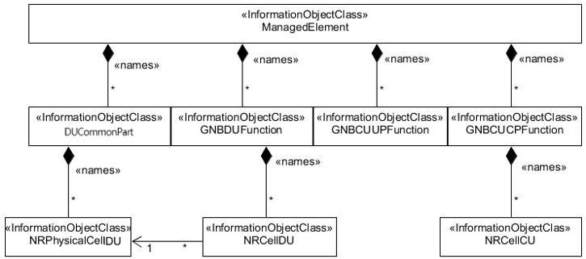

Figure 4.2.1.1-1: NRM for all deployment scenarios

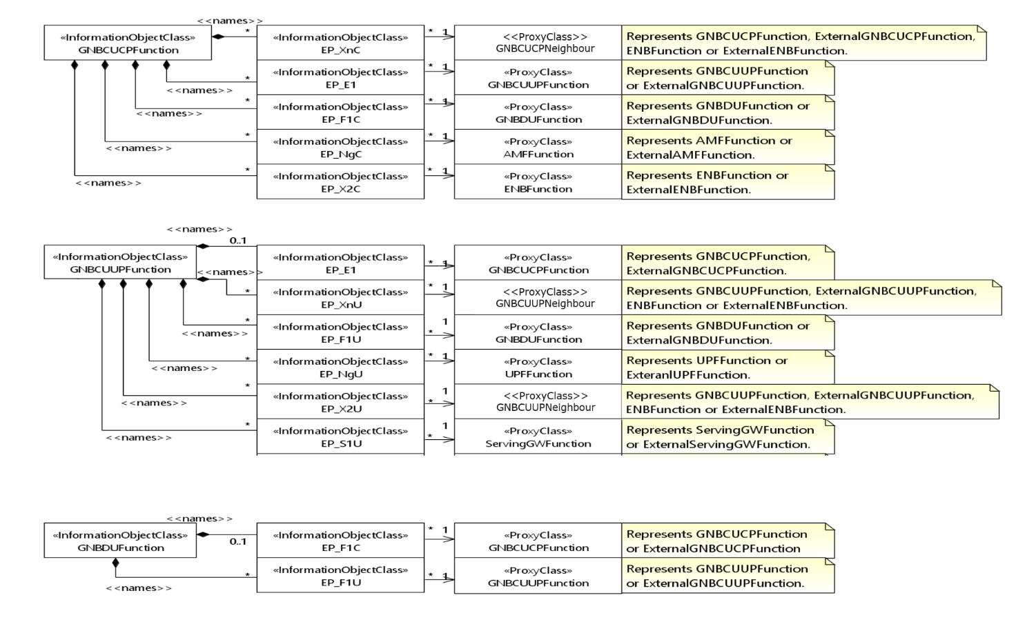

Figure 4.2.1.1-2: NRM for EPs for all deployment scenarios

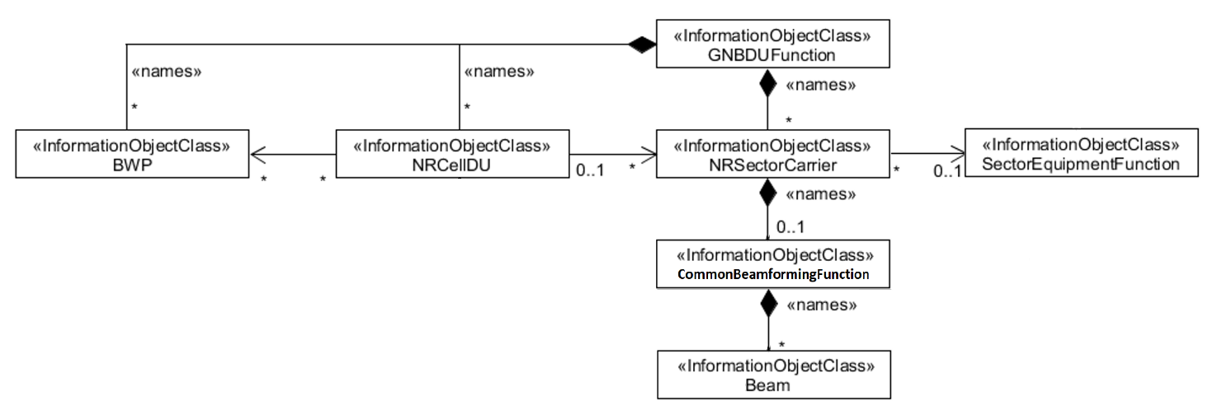

Figure 4.2.1.1-3: NRM for <<IOC>>NRSectorCarrier and <<IOC>>BWP for deployment scenarios without NG-RAN sharing

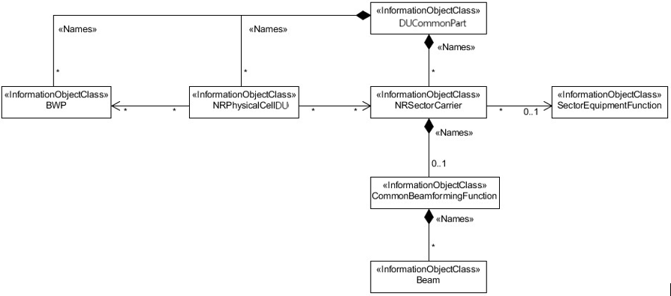

Figure 4.2.1.1-3a: NRM for <<IOC>>NRSectorCarrier and <<IOC>>BWP for NG-RAN sharing scenarios

……

|  |
| --- |
| **Next Modified Section** |

#### 4.2.1.2 Inheritance

……

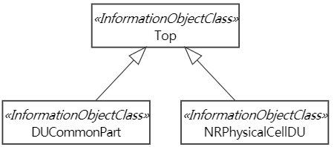

Figure 4.2.1.2-1: Inheritance Hierarchy

|  |
| --- |
| **Next Modified Section** |

#### 4.3.5.2 Attributes

The NRCellDU IOC includes attributes inherited from ManagedFunction IOC (defined in TS 28.622[30]) and the following attributes:

|  |  |  |  |  |  |
| --- | --- | --- | --- | --- | --- |
| Attribute name | Support Qualifier | isReadable | isWritable | isInvariant | isNotifyable |
| cellLocalId | M | T | T | F | T |
| operationalState | M | T | F | F | T |
| administrativeState | M | T | T | F | T |
| cellState | M | T | F | F | T |
| pLMNInfoList | M | T | T | F | T |
| nRPCI | CM | T | T | F | T |
| nRTAC | CM | T | T | F | T |
| arfcnDL | CM | T | T | F | T |
| arfcnUL | CM | T | T | F | T |
| arfcnSUL | CM | T | T | F | T |
| bSChannelBwDL | CM | T | T | F | T |
| ssbFrequency | CM | T | T | F | T |
| ssbPeriodicity | CM | T | T | F | T |
| ssbSubCarrierSpacing | CM | T | T | F | T |
| ssbOffset | CM | T | T | F | T |
| ssbDuration | CM | T | T | F | T |
| bSChannelBwUL | CM | T | T | F | T |
| bSChannelBwSUL | CM | T | T | F | T |
| **Attribute related to role** |  |  |  |  |  |
| nRSectorCarrierRef | CM | T | T | F | T |
| bWPRef | CM | T | T | F | T |
| nRFrequencyRef | CO | T | T | F | T |
| victimSetRef | CM | T | T | F | T |
| aggressorSetRef | CO | T | T | F | T |
| nRPhysicalCellDURef | CM | T | T | F | T |
| Note 1: No state propagation is implied.  Note 2: Void | | | | | |

#### 4.3.5.3 Attribute constraints

|  |  |
| --- | --- |
| Name | Definition |
| arfcnUL Support Qualifier | Condition: The cell has an uplink (FDD or TDD) and NG-RAN sharing with multiple Cell Identities is not supported |
| arfcnSUL Support Qualifier | Condition: The cell has a supplementary uplink and NG-RAN sharing with multiple Cell Identities is not supported |
| bSChannelBwUL Support Qualifier | Condition: The cell has an uplink (FDD or TDD) and NG-RAN sharing with multiple Cell Identities is not supported |
| bSChannelBwSUL Support Qualifier | Condition: The cell has a supplementary uplink and NG-RAN sharing with multiple Cell Identities is not supported |
| nRFrequencyRef Support Qualifier | Condition: Non-split deployment scenario is supported and NG-RAN sharing with multiple Cell Identities is not supported |
| ssbFrequency Support Qualifier | Condition: nRFrequencyRef is not used and NG-RAN sharing with multiple Cell Identities is not supported. |
| ssbSubCarrierSpacing Support Qualifier | Condition: nRFrequencyRef is not used and NG-RAN sharing with multiple Cell Identities is not supported. |
| victimSetRef Support Qualifier | Condition: RIM feature is supported and NG-RAN sharing with multiple Cell Identities is not supported |
| nRPCI Support Qualifier | Condition: NG-RAN sharing with multiple Cell Identities is not supported. |
| arfcnDL Support Qualifier | Condition: NG-RAN sharing with multiple Cell Identities is not supported. |
| bSChannelBwDL Support Qualifier | Condition: NG-RAN sharing with multiple Cell Identities is not supported. |
| ssbPeriodicity Support Qualifier | Condition: NG-RAN sharing with multiple Cell Identities is not supported. |
| ssbOffset Support Qualifier | Condition: NG-RAN sharing with multiple Cell Identities is not supported. |
| ssbDuration Support Qualifier | Condition: NG-RAN sharing with multiple Cell Identities is not supported. |
| nRSectorCarrierRef Support Qualifier | Condition: NG-RAN sharing with multiple Cell Identities is not supported. |
| bWPRef Support Qualifier | Condition: NG-RAN sharing with multiple Cell Identities is not supported. |
| aggressorSetRef Support Qualifier | Condition: NG-RAN sharing with multiple Cell Identities is not supported. |
| nRPhysicalCellDURef Support Qualifier | Condition: NG-RAN sharing with multiple Cell Identities is supported. |

|  |
| --- |
| **Next Modified Section** |

### 4.3.X DUCommonPart(O)

#### 4.3.X.1 Definition

This IOC represents the common part of a shared DU.

Note: If NG-RAN sharing with multiple Cell Identities is not supported, then this IOC is not used.

#### 4.3.X.2 Attributes

The DUCommonPart IOC includes attributes inherited from TOP IOC (defined in TS 28.622[30]) and the following attributes:

|  |  |  |  |  |  |
| --- | --- | --- | --- | --- | --- |
| Attribute name | Support Qualifier | isReadable | isWritable | isInvariant | isNotifyable |
| masterPLMNId | M | T | T | F | T |
| sharedDUId | M | T | T | F | T |

#### 4.3.X.3 Attribute constraints

None.

#### 4.3.X.4 Notifications

The common notifications defined in subclause 4.5 are valid for this IOC, without exceptions or additions.

|  |
| --- |
| **Next Modified Section** |

### 4.3.Y NRPhysicalCellDU (O)

#### 4.3.Y.1 Definition

This IOC represents a physical cell on a DU.

Note: If NG-RAN sharing with multiple Cell Identities is not supported, then this IOC is not used.

#### 4.3.Y.2 Attributes

The NRPhysicalCellDU IOC includes attributes inherited from TOP IOC (defined in TS 28.622[30]) and the following attributes:

|  |  |  |  |  |  |
| --- | --- | --- | --- | --- | --- |
| Attribute name | Support Qualifier | isReadable | isWritable | isInvariant | isNotifyable |
| physicalCellDUId | M | T | T | F | T |
| operationalState | M | T | F | F | T (see Note 2) |
| administrativeState | M | T | T | F | T (see Note 2) |
| cellState | M | T | F | F | T (see Note 2) |
| nRPCI | M | T | T | F | T |
| ssbFrequency | CM | T | T | F | T |
| ssbPeriodicity | M | T | T | F | T |
| ssbSubCarrierSpacing | CM | T | T | F | T |
| ssbOffset | M | T | T | F | T |
| ssbDuration | M | T | T | F | T |
| arfcnDL | M | T | T | F | T |
| arfcnUL | CM | T | T | F | T |
| arfcnSUL | CM | T | T | F | T |
| bSChannelBwDL | M | T | T | F | T |
| bSChannelBwUL | CM | T | T | F | T |
| bSChannelBwSUL | CM | T | T | F | T |
| **Attribute related to role** |  |  |  |  |  |
| nRSectorCarrierRef | M | T | T | F | T |
| bWPRef | M | T | T | F | T |
| nRFrequencyRef | CO | T | T | F | T |
| victimSetRef | CM | T | T | F | T |
| aggressorSetRef | O | T | T | F | T |
| Note 1: No state propagation is implied.  Note 2: The attribute value change is conveyed by the notifyStateChange notification. | | | | | |

#### 4.3.Y.3 Attribute constraints

|  |  |
| --- | --- |
| Name | Definition |
| arfcnUL Support Qualifier | Condition: The cell has an uplink (FDD or TDD) |
| arfcnSUL Support Qualifier | Condition: The cell has a supplementary uplink |
| bSChannelBwUL Support Qualifier | Condition: The cell has an uplink (FDD or TDD) |
| bSChannelBwSUL Support Qualifier | Condition: The cell has a supplementary uplink |
| nRFrequencyRef Support Qualifier | Condition: Non-split deployment scenario is supported |
| ssbFrequency Support Qualifier | Condition: nRFrequencyRef is not used. |
| ssbSubCarrierSpacing Support Qualifier | Condition: nRFrequencyRef is not used. |
| victimSetRef Support Qualifier | Condition: RIM feature is supported |

#### 4.3.Y.4 Notifications

The common notifications defined in subclause 4.5 are valid for this IOC, without exceptions or additions.

|  |
| --- |
| **Next Modified Section** |

### 4.4.1 Attribute properties

| Attribute Name | Documentation and Allowed Values | Properties |
| --- | --- | --- |
| …… | …… | …… |
| nRPhysicalCellDURef | This attribute contains the DN of the referenced NRPhysicalCellDU.  allowedValues:Not applicable | type: DN  multiplicity: 1  isOrdered: N/A  isUnique: True  defaultValue: None  isNullable: False |
| masterPLMNId | This attribute indicates the PLMNId of the Master Operator who manages the physical DU in the NG-RAN sharing scenario.  allowedValues: Not applicable. | Type: PLMNId  multiplicity: 1  isOrdered: N/A  isUnique: N/A  defaultValue: None  isNullable: False |
| sharedDUId | It uniquely identifies the physical DU within a PLMN.  allowedValues: 0..236-1 | type: Integer  multiplicity: 1  isOrdered: N/A  isUnique: N/A  defaultValue: None  isNullable: False |
| physicalCellDUId | It uniquely identifies the physicalCellDU within a physical DU.  allowedValues: 0..236-1 | type: Integer  multiplicity: 1  isOrdered: N/A  isUnique: N/A  defaultValue: None  isNullable: False |
| NOTE 1: Void  NOTE 2: The radio resource can be signaling resources (e.g. RRC connected users) or user plane resources (e.g. PRB, DRB). Different RRM Policy maybe applied for different types of radio resource. E.g. RRMPolicyRatio is used for PRB resource.  NOTE 3: Void  NOTE 4: A RRM Policy can make use of the defined policy (e.g. RRMPolicyRatio) or a vendor specific RRM Policy.  NOTE 5: For Global gNB Identifiers, the entries are formatted according to the pattern <mcc><mnc>-<gNBIdLength>-<gNBId>, where <mcc> is three digits, <mnc> two or three digits, <gNBIdLength> is a string containing a number n as digits, in the range 22 to 32, and <gNBId> is a string containing digits for the number 0 to 2n-1. For Global eNB Identifiers, the entries are formatted according to the pattern <mcc><mnc>-<eNBIdLength>-<eNBId>, where <mcc> is three digits, <mnc> two or three digits, <gNBIdLength> is a string containing a number m as digits, m being one of 18, 20, 21 or 22, and <eNBId> is a string containing digits for the number 0 to 2m-1.  NOTE 6: The maximum number of total RIM RS sequence within 10ms is 32 regardless single or two uplink-downlink period are configured in the 10ms..  NOTE 7:  1. The maximum number of consecutive uplink-downlink switching periods for repetition/near-far-functionality is 8 (the number can be either 2, 4, or 8) with near-far functionality and with repetition.  2. The maximum number of consecutive uplink-downlink switching periods for repetition is 4 (the number can be either 1, 2, or 4) without near-far functionality and with repetition only.  3. The maximum number of consecutive uplink-downlink switching periods is 2 with near-far functionality only and without repetition.  NOTE 8 (for information): “Not enough mitigation” means aggressor gNB needs to increase the interference mitigation level (i.e., further interference mitigation actions) (e.g., further reducing the DL transmission power on DL symbols at aggressor side), while “Enough mitigation” means aggressor gNB keeping the current interference mitigation level unchanged (i.e., no further interference mitigation actions) (e.g., remaining the DL transmission power on DL symbols unchanged at aggressor side).  NOTE 9: Value MS0P5 corresponds to 0.5 ms, MS0P625 corresponds to 0.625 ms, MS1 corresponds to 1 ms, MS1P25 corresponds to 1.25 ms, and so on. | | |

|  |
| --- |
| **End of Modified Sections** |

**/******** End of the detailed NRM enhancement solution ********/**