**3GPP TSG-SA5 Meeting #138-e *S5-214188***

**e-meeting, 23 - 31 August 2021**

**Source: ZTE**

**Title: Add deployment examples of NG-RAN sharing with&without multiple CellId**

**Document for: Approval**

**Agenda Item: 6.5.9**

# 1 Decision/action requested

***The group is asked to discuss and approve the proposals.***

# 2 References

[1] 3GPP TS 23.501: “System architecture for the 5G System (5GS)”

[2] 3GPP TS 32.130: “Telecommunication management; Network sharing; Concepts and requirements”

[3] 3GPP TS 38.401: “NG-RAN; Architecture description”

[4] 3GPP TS 38.300: “NR; NR and NG-RAN Overall description; Stage-2”

# 3 Rationale

The RAN groups have defined some features which can be used to support NG-RAN sharing, but there is no description to show how to use these features in the NG-RAN sharing deployment.

This contribution proposes to add the deployment approach examples of MOCN NG-RAN sharing without and with multiple CellId.

# 4 Detailed proposal

# X. NG-RAN sharing deployment approach examples

## X.a Deployment approach example of MOCN NG-RAN sharing without multiple CellId

When a gNB is not shared, its carrier resource is used by an operator alone, the gNB can be deployed as:

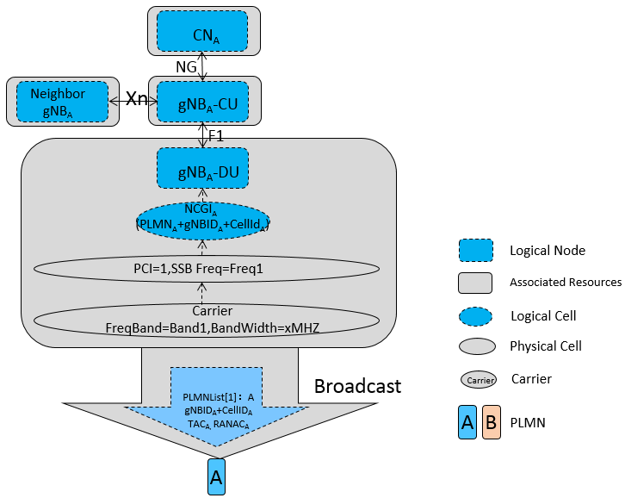

In this scenario, there is only one PLMNList in the broadcasted SIB1 IE, and the PLMNList only have one PLMN Id.

When two operators Operator A and Operator D want to share the resources of the abovementioned gNB, if they do not require the shared resources can be configured seperately, then the MOCN without Multiple CellIds feature can be used in the deployment, as follows:

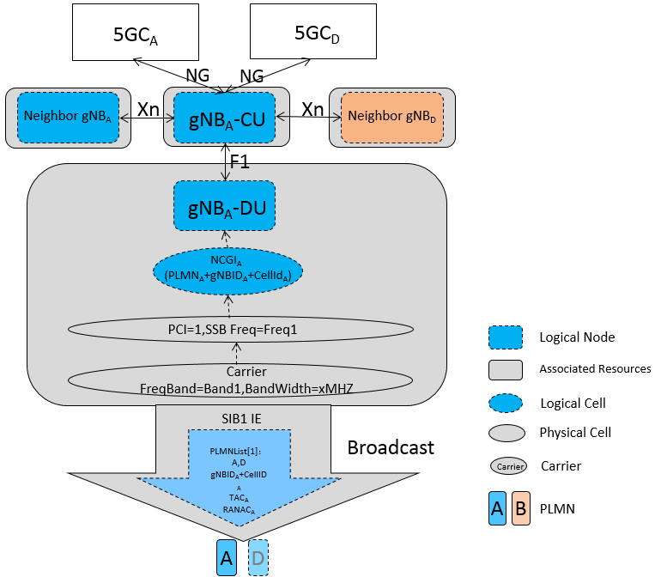

In this scenario, there is only one PLMNList in the broadcasted SIB1 IE, and the PLMNList have two PLMN Ids.

## X.b Deployment approach example of MOCN NG-RAN sharing with multiple CellId

If the two operators Operator A and Operator D want to share the resources of a gNB, and they require the shared resources can be configured seperately, then the MOCN with Multiple CellIds feature [see TS 38.401] can be used in the deployment, as follows:

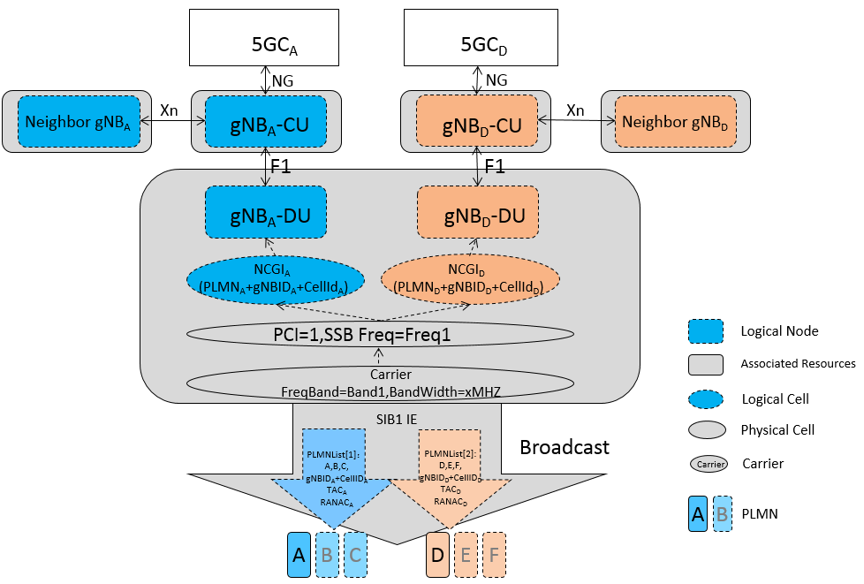

In this scenario, there are two PLMNLists in the broadcasted SIB1 IE, and every PLMNList has its own PLMN Ids. In this case, the shared resources are mapped to two separate gNBs, this provides the possibility for the POP to manage the shared resources individually based on its own policies.