**3GPP TSG- Meeting # *rev1***

**, , -**

|  |  |  |  |  |  |  |  |  |
| --- | --- | --- | --- | --- | --- | --- | --- | --- |
| *CR-Form-v12.1* | | | | | | | | |
| **CHANGE REQUEST** | | | | | | | | |
|  | | | | | | | | |
|  |  | **CR** |  | **rev** |  | **Current version:** |  |  |
|  | | | | | | | | |
| *For* [***HE******LP***](http://www.3gpp.org/3G_Specs/CRs.htm#_blank)*on using this form: comprehensive instructions can be found at* [*http://www.3gpp.org/Change-Requests*](http://www.3gpp.org/Change-Requests)*.* | | | | | | | | |
|  | | | | | | | | |

|  |  |  |  |  |  |  |  |  |
| --- | --- | --- | --- | --- | --- | --- | --- | --- |
| ***Proposed change affects:*** | UICC apps |  | ME |  | Radio Access Network | **X** | Core Network | **X** |

|  |  |  |  |  |  |  |  |  |  |  |
| --- | --- | --- | --- | --- | --- | --- | --- | --- | --- | --- |
|  | | | | | | | | | | |
| ***Title:*** |  | | | | | | | | | |
|  |  | | | | | | | | | |
| ***Source to WG:*** |  | | | | | | | | | |
| ***Source to TSG:*** | SA5 | | | | | | | | | |
|  |  | | | | | | | | | |
| ***Work item code:*** |  | | | | |  | ***Date:*** | | |  |
|  |  | | | |  | |  | | |  |
| ***Category:*** |  |  | | | | | ***Release:*** | | |  |
|  | *Use one of the following categories:* ***F*** *(correction)* ***A*** *(mirror corresponding to a change in an earlier release)* ***B*** *(addition of feature),* ***C*** *(functional modification of feature)* ***D*** *(editorial modification)*  Detailed explanations of the above categories can be found in 3GPP [TR 21.900](http://www.3gpp.org/ftp/Specs/html-info/21900.htm). | | | | | | | | *Use one of the following releases: Rel-8 (Release 8) Rel-9 (Release 9) Rel-10 (Release 10) Rel-11 (Release 11) … Rel-15 (Release 15) Rel-16 (Release 16) Rel-17 (Release 17) Rel-18 (Release 18)* | |
|  |  | | | | | | | | | |
| ***Reason for change:*** | | The "MnsAgent" was added but the class and inheritance diagrams were not updated. | | | | | | | | |
|  | |  | | | | | | | | |
| ***Summary of change:*** | | Update the class and inheritence diagrams with "MnsAgent". | | | | | | | | |
|  | |  | | | | | | | | |
| ***Consequences if not approved:*** | | Name-containment and inheritance of "MnsAgent" are not specified. | | | | | | | | |
|  | |  | | | | | | | | |
| ***Clauses affected:*** | |  | | | | | | | | |
|  | |  | | | | | | | | |
|  | | **Y** | **N** |  | | | |  | | |
| ***Other specs*** | |  | **X** | Other core specifications | | | | TS/TR ... CR ... | | |
| ***affected:*** | |  | **X** | Test specifications | | | | TS/TR ... CR ... | | |
| ***(show related CRs)*** | |  | **X** | O&M Specifications | | | | TS/TR ... CR ... | | |
|  | |  | | | | | | | | |
| ***Other comments:*** | |  | | | | | | | | |
|  | |  | | | | | | | | |
| ***This CR's revision history:*** | |  | | | | | | | | |

|  |
| --- |
| **First modification** |

## 4.2 Class diagrams

### 4.2.1 Relationships

This clause depicts the set of classes (e.g. IOCs) that encapsulates the information relevant for this IRP. This clause provides the overview of the relationships of relevant classes in UML. Subsequent clauses provide more detailed specification of various aspects of these classes.

The following figure shows the containment/naming hierarchy and the associations of the classes defined in the present document. See Annex A of a class diagram that combines this figure with Figure 1 of [2], the class diagram of UIM.

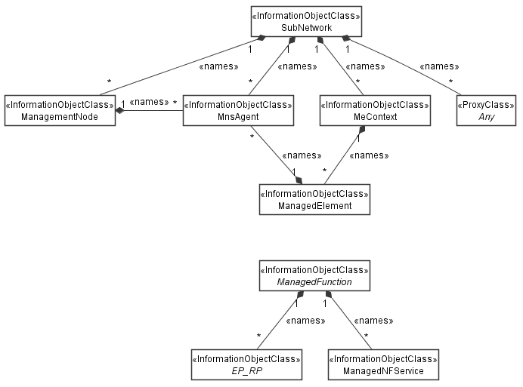

NOTE 1: ManagedElement may be contained either

- in a SubNetwork (since *SubNetwork* inherits from *Domain*_ and *ManagedElement* inherits from *ManagedElement*_ and *Domain*_ name-contained *ManagedElement_* as observed in the figure of Annex A) or

- in a MeContext instance as observed by the above figure or in the figure of Annex A.

This either-or relation cannot be shown by using an {xor} constraint in the above figure.

ManagedElement may also have no parent instance at all.

NOTE 2: Void

NOTE 3: If the configuration contains several instances of SubNetwork, exactly one SubNetwork instance shall directly or indirectly contain all the other SubNetwork instances.

NOTE 4: The SubNetwork instance not contained in any other instance of SubNetwork is referred to as "the root SubNetwork instance".

NOTE 5: ManagementNode shall be contained in the root SubNetwork instance.

NOTE 6: If contained in a SubNetwork instance, MnsAgent shall be contained in the root SubNetwork instance.

NOTE 7: For a clarification on the choice of containment of the MnsAgent (since it has three possible parents), see the definition of MnsAgent.

NOTE 8: The MnsAgent shall be replaced by the IRPAgent in deployments using the IRP framework as defined in TS 32.102 [2].

Figure 4.2.1-1: NRM fragment

Each Managed Object is identified with a Distinguished Name (DN) according to 3GPP TS 32.300 [13] that expresses its containment hierarchy. As an example, the DN of a ManagedElement instance could have a format like:

SubNetwork=Sweden,MeContext=MEC-Gbg-1,ManagedElement=RNC-Gbg-1.

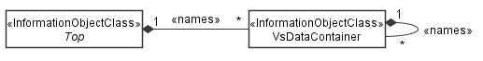

NOTE 8: Void

NOTE 9: Void

Figure 4.2.1-2: Vendor specific data container NRM fragment

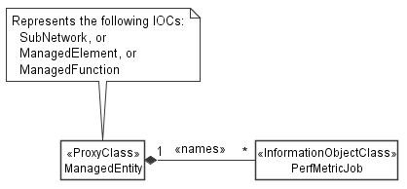

Figure 4.2.1-3: PM control NRM fragment

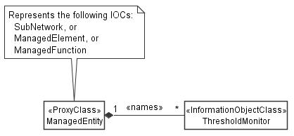

Figure 4.2.1-4: Threshold monitoring control NRM fragment

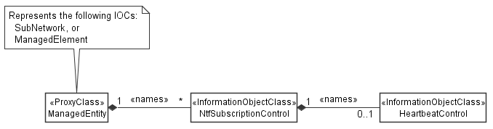

Figure 4.2.1-5: Notification subscription and heartbeat notification control NRM fragment

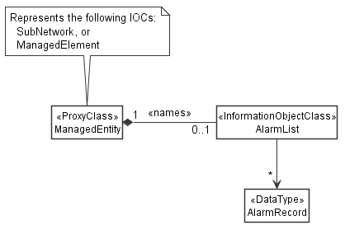

Figure 4.2.1-6: FM control NRM fragment

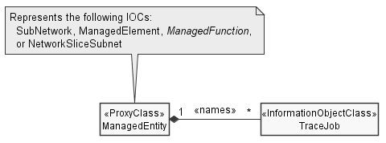

Figure 4.2.1-7: Trace control NRM fragment

### 4.2.2 Inheritance

This clause depicts the inheritance relationships.

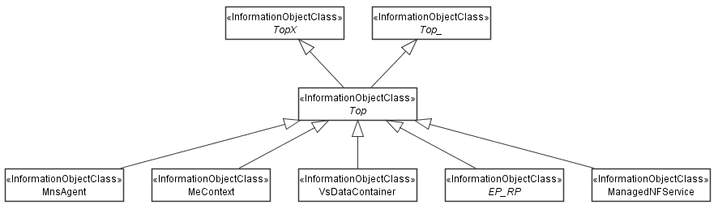

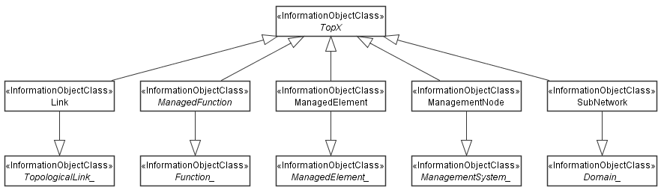

Figure 4.2.2-1: NRM fragment

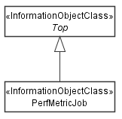

Figure 4.2.2-2: PM control NRM fragment

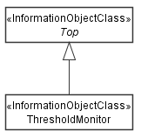

Figure 4.2.2-3: Threshold monitoring control NRM fragment

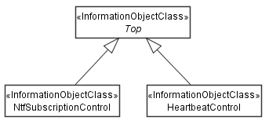

Figure 4.2.2-4: Notification subscription and heartbeat notification control NRM fragment

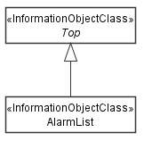

Figure 4.2.2-5: FM control NRM fragment

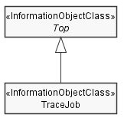

Figure 4.2.2-6: Trace control NRM fragment

|  |
| --- |
| **Next modification** |

Annex A (informative):  
Alternate class diagram

This class diagram combines the Figure 4.2.1-1 of this document with Figure 1 of [9], the class diagram of UIM.

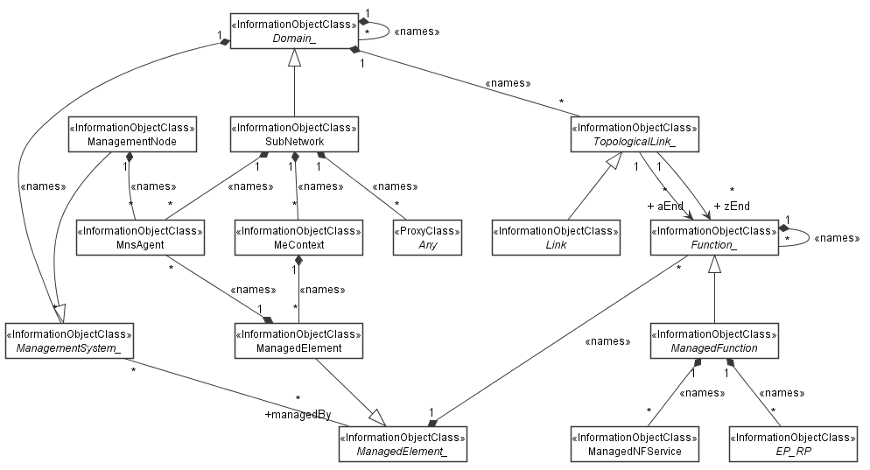

Figure A-1: Alternate class diagram

|  |
| --- |
| **End of modifications** |