3GPP TSG-SA5 Meeting #137e S5-213527

e-meeting 10th - 19th May 2021

Source: Huawei

Title: Discussion on assurance report for closed control loop

Document for: Approval
Agenda Item: 6.4.12

1 Decision/action requested
The group is asked to discuss and agree on the proposal.

2 References
[1] 3GPP TS 28.535: “Management and orchestration; Management services for communication service assurance; Requirements”, Rel-17 v17.0.0
[2] 3GPP TS 28.536: “Management and orchestration; Management services for communication service assurance; Stage 2 and stage 3”, Rel-17 v16.2.1
[3] 3GPP TS 28.311: “Management and orchestration; Network policy management for mobile networks based on Network Function Virtualization (NFV) scenarios”, Rel-16 v16.0.0
[4] 3GPP TS 28.532: “Management and orchestration; Generic management services”, Rel-16 v16.5.1
[5] S5-212120 DP on assurance report for closed control loop
[6] ETSI ZSM009-1; Closed-loop automation Enablers
[7] 3GPP TS 32.331 V16.0.0 Notification Log (NL) Integration Reference Point (IRP); Requirements
[8] S5-213329 DP on assurance report for closed control loop

3 Rationale
AssuranceGoal represents the subset of attributes (typically characteristics attributes) from an SLS, i.e. a ServiceProfile or a SliceProfile, that are subject to assurance requirements. It is used for the MnS consumer to input goals for the ACCL MnS producer. Assurance goal fulfilment status represents the status of the Assurance goal for the observationTime, i.e. AssuranceGoalStatusObserved and AssuranceGoalStatusPredicted in this release of specification. It is used for the ACCL MnS consumer to observe/monitor the status of the fulfilment of the AssuranceGoal and should be considered as report information of an ACCL. Existing ACCL model mixed up the input information and output information of an ACCL. It also lacks flexibility for future extention.
Proposal 1: It is proposed to introduce AssuranceReport IOC to accommodate the Assurance goal fulfilment status of a closed control loop. Existing attributes AssuranceGoalStatusObserved and AssuranceGoalStatusPredicted should be moved to the AssuranceReport IOC.
In addition to the assurance goal fulfilment result for the corresponding observationTime, the authorized consumer of a closed control loop should be allowed to monitor some ACCL governance behaviour in an assurance report based on service exposure agreements. Some examples could be ACCL coordination actions and results, ACCL modification actions and results, associated policies for the goverance operations, root cause or analytical information related to the ACCL governance etc. Therefore the MnS consumer may have more hints on how to adjust the assurance goal, assurance policies or configurations for the ACCL according to the assurance report.
For example, there may be different report scenarios for ACCL, e.g. to report actions and the associated policies for ACCL coordination. The report information may be "escalation", "delegation" actions of the ACCL coordination behaviour. The “Escalation” represents the action that a domain management MnS producer escalate the the situation to the correlated ACCL in the Cross Management Domain if it cannot achieve the goal assigned to it. The “Delegation” represent the Cross Management Domain setting the goals for the correlated ACCLs. The results of "escalation", "delegation" may be “success” or “unsucess” etc.
Report information may also contain the associated policy or analytical information for the ACCL coordination governance behaviour, e.g. the policy may be that “if goal cannot be achieved, escalate to MnS consumer” etc. The related analytical information may contain the root cause about why the ACCL cannot achieve the goal etc.
There are many other examples of AssuranceReport discussed in “S5-212120 DP on assurance report for closed control loop” [5] and “S5-213329 DP on assurance report for closed control loop”.
Proposal 2: In addition to Assurance goal fulfilment status, other information may also be introduced into the AssuranceReport IOC, e.g. ACCL governance operations and results, the associated policies and analytical information etc. The actual attributes and contents can be left for the next meeting.

The relationship between AssuranceReport (abbr. AR), AssuranceGoal (abbr. AG) and AssuranceClosedControlLoop (abbr. ACCL) will be revisited. The following options are possible.
- For ACCL to AR
Option 1: name containment 1..*
Option 2: name containment 1..1
Option 3: delete the relation between ACCL and AR, and may bring it back in the future.
- For AR to AG
Option 1: *..1, one AG status (including target fulfilment status list) may have multiple AR
Option 2: 1..*, one AR may contain multiple AG status
Option 3: (0..1)..*, zero or one AR may contain multiple AG status
Option 4: *..*
Option 5: remove the relationship AR-AG.
Proposal 3: It should be discussed which of the options for the relationship between ACCL, AR and AG can be adopted.
The following figure is an example of the model taking option 1 of ACCL to AR, and taking Option 3 for AR to AG.
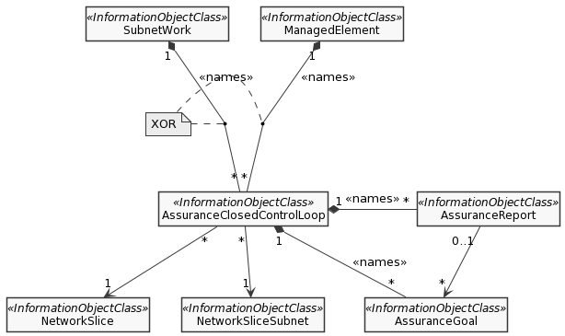
Assurance management NRM fragment

4 Detailed proposal
In this contribution, the following proposals are made:
Proposal 1: It is proposed to introduce AssuranceReport IOC to accommodate the Assurance goal fulfilment status of a closed control loop. Existing attributes AssuranceGoalStatusObserved and AssuranceGoalStatusPredicted should be moved to the AssuranceReport IOC.
Proposal 2: In addition to Assurance goal fulfilment status, other information may also be introduced into the AssuranceReport IOC, e.g. ACCL governance operations and results, the associated policies and analytical information etc. The actual attributes and contents can be left for the next meeting.
Proposal 3: It should be discussed which of the options for the relationship between ACCL, AR and AG can be adopted.

