3GPP TSG SA WG5 Meeting 137-e TDoc S5-213426

electronic meeting, online, 10 - 19 May 2021

Source: Ericsson

Title: Discussion paper on Cosla

Document for: Discussion
Agenda Item: 6.4.12

1 Decision/action requested
The group is asked to discuss and endorse section 4.

2 References
[1] 3GPP TS 28.536 Management and orchestration; Management services for communication service assurance; Stage 2 and stage 3

3 Rationale
The work item on Enhanced Closed Loop SLS Assurance is steadily progressing in terms of discussions and proposals being made, at the same time SA5 is working on several topics that potentially enables a more flexible solution allowing closed control loops to take advantage of the new specified capabilities.
The procedure shown in the Figure below can be found in TS 28.536 [1] will potentially be extended or replaced with a new management service defined by MADCOL work-item (see NOTE 1).
The ACCL consumer will be able to find the producers shown in the Figure through the discovery capability defined in 5GDMS work-item (see NOTE 2)
Figure 4.1.3.1.1 SLS assurance procedure
NOTE 1: The work item “Management data collection control and discovery” (MADCOL) specifies a solution that defines which MnSs should be involved in the discovery and collection of data needed to drive loop
NOTE 2: The work item “Discovery of management services in 5G” (5GDMS) specifies a solution that allows a producer to register its capabilities and by doing so the MnSs that the producer is capable of providing are discoverable by other producers, and how to discover MnSs used by an MnS consumer.
The advantage of the proposed approach is that the eCOSLA work-item can re-use the generic mechanisms currently being specified in work items for 5GDMS and MADCOL.
The figure below shows the different MnS’s and how they apply and support the MnS producer of Cosla.
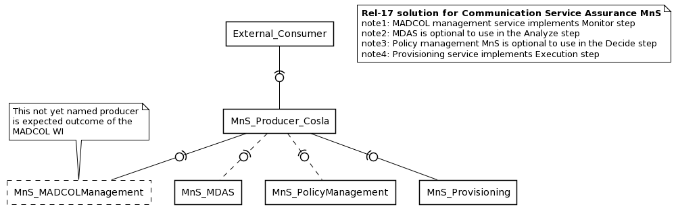

4 Detailed proposal
The group is asked to endorse the following:
- the notion of the dependencies between work-item eCOSLA, MADCOL and 5GDMS

