3GPP TSG SA WG5 Meeting 137e TDoc S5-213409

electronic meeting, online, 10 - 19 May 2021

Source: Ericsson, Huawei

Title: Discussion on Intent Management

Document for: Discussion, Endorsement
Agenda Item: 6.4.10

1 Decision/action requested
The group is asked to discuss and Endorse the proposals.

2 References
[1] 3GPP TS 28.312 Management and orchestration; Intent driven management services for mobile networks [Rel-17]
[2] TMF IG1230 Autonomous Networks Technical Architecture, TM Forum Introductory Guide
[3] SP-180899 WID Intent driven management services for mobile networks
[4] S5-213404 LS to TM Forum on Intent Management

3 Rationale
TS 28.312 [1], clause 3.1 carries an Editor’s note “Alignment with other organizations, is to be considered.” This note is very important and needs an immediate action. This TD paper clarifies why it is important and what actions should be taken

3.1 Intent Management in 3GPP SA5
There is already a definition of the Intent in clause 3.1 of the TS 28.312 [1] draft:

“Intent: the expectations including requirements, goals and constraints given to a 3GPP system, without specifying how to achieve them”

3.2 TMF Work on-going
There is already work on-going in several SDOs regarding Intent and Intent LCM.
The definition of intent in TMF is the following:
“Intent is the formal specification of all expectations including requirements, goals, and constraints given to a technical system”.
TMF Forum is working on many definitions around the Intent, refer to TMF IG1230 [2] for details.
A technology agnostic Intent meta-model and Intent API will be specified as part of this work. TMF also expects domain specific models to be further defined by other SDOs, extending the Intent meta-model.

3.3 Analysis
Since the Intent is an abstraction of system capabilities, it can be widely used in different systems e.g. in system supporting business operations, service and/or resource operations. Those different systems can exchange Intents, derive new Intents (as part of Closed or Open loop operations), modify and terminate them. The figure below shows the various operation layers where the Intents can be used.
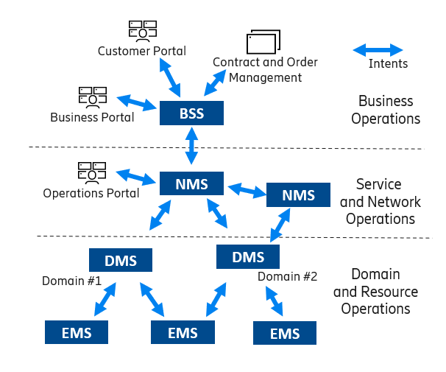
Figure 1: Intent in various operations layers
As per 3GPP definition of MnS and definition of Intent-driven MnS (IDMS) in TS 28.312 [1] the system sending an intent will contain MnF playing a role of IDMS consumer and the system receiving an intent will contain MnF playing a role of IDMS provider (see Figure 2)
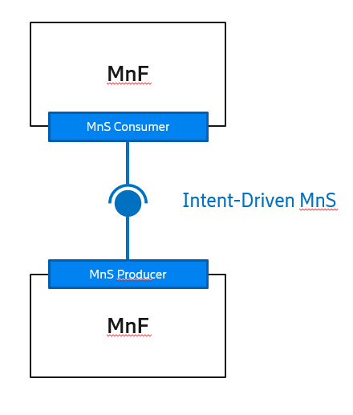
Figure 2. Intent Owner, Intent Handler and Intent API
Both MnFs will play certain parts in the management of an intent. For example, Intent-driven MnS consumer will probably govern an intent life cycle including creation, modification and termination of an intent. It might also select which IDMS provider to send the Intent to. Subsequently, on the reception of the Intent the IDMS provider will proceed towards Intent fulfilment: it will utilize certain system capabilities and resources to meet the expectations of the received Intent and will free-up all the utilized resources if the Intent is terminated by the IDMS Consumer.
Note 1: if both of MnFs are located in different systems, those systems should be aligned about how to execute Intent life-cycle management.
Note 2: a system can be receiving intents from one system and sending intents to another one (see Figure 1 above). It will be very beneficial for all the systems and especially for the system in the middle if they are aligned around intent life-cycle management, operations and modelling. This brings us to an editor note in TS 28.312 [1], clause 3.1.
“Editor's note: Alignment with other organizations, is to be considered.”
This is a very important note and needs an immediate action. If the definition around Intent Management are aligned between different SDOs, the Intents may be handled seamlessly between those systems which could be located in different domains and layers. Alignment to a common Intent meta-model, operations, etc. may save lots of efforts in the normative work and later when deploying solutions making use of Intent and involving different layers of operations.

4 Detailed proposal
It is proposed that following should be done in SA5 as per IDMS_MN, Work Item “Intent driven Management Service for Mobile Networks” [3]:
- Clarify the potential relationship between SA5 IDMS_MN work item with TMF work (carried by TMF Autonomous Networks project), send a Liaison
- to TM Forum for their working progress information related to the intent-driven management. Refer to a proposed liaison [4] requesting such an information from the TMF’s AN Project.
- Align the definition of the Intent provided by TMF in IG1230, focus on 3GPP specific aspects of Intent management.

