3GPP TSG SA WG5 Meeting 137-e S5-213368

electronic meeting, online, 10 - 19 May 2021 revision for S5-21xxxx

Source: Nokia, Nokia Shanghai Bell

Title: use case – support network slice protection on N6 interface

Document for: Approval
Agenda Item: 6.5.3

1 Decision/action requested
The group is asked to discuss and approve the proposal..

2 References
[1] 3GPP TR 28.811: "Management and orchestration; Network Slice Management Enhancement"
[2] 3GPP TS 22.101: " Service aspects; Service principles"
[3] 3GPP TS 22.261: " Service requirements for the 5G system; Stage 1"
[3] GSMA NG.116: "Generic Network Slice Template Version 4.0"

3 Rationale

With network slicing, various types of users/customers can enjoy connectivity and data processing of mobile networks tailored to their specific requirements (e.g. latency, throughput, reliability, security, etc.) that adhere to a Service Level Agreement (SLA). Providing secure inter- and intra- network slice communication and secure internet access (e.g. prevention of attacks at the edge of network slices) are major requirements from mobile network operators (MNOs) or industry verticals. User data access attribute defined in GSMA GST (NG.116 v4.0) describes how the network slice should handle the user data towards data network according to requirement for the network slice. There are several options, e.g. no access to internet, all data traffic is routed to the private network through secure tunnel, no access to either internet or private network.
This pCR is to study the potential requirements on 5G management system to support edge protection, especially on N6 interface, for network slice.

4 Detailed proposal

Start of 1st Change

5.x use case – support network slice protection on N6 interface

5.x.1 Description
With network slicing, various types of users/customers can enjoy connectivity and data processing of mobile networks tailored to their specific requirements (e.g. latency, throughput, reliability, security, etc.) that adhere to a Service Level Agreement (SLA). Providing secure inter- and intra- network slice communication and secure internet access (e.g. prevention of attacks at the edge of network slices) are major requirements from mobile network operators (MNOs) or industry verticals. User data access attribute defined in GSMA GST (NG.116 v4.0) describes how the network slice should handle the user data towards data network according to requirement for the network slice. There are several options, e.g. no access to internet, all data traffic is routed to the private network through secure tunnel, no access to either internet or private network. Deploying security function, e.g. firewalls, at the CN edge (e.g. N6 interface) could protect the network slice from the attack from internet. The network slice with edge protection could be looked like Figure 5.x.1-1.
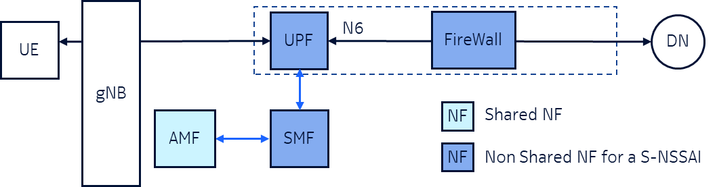
Figure 5.x.1-1 Example of edge protect for a network slice

5.x.2 Issue and gaps
3GPP TS 22.101 (see [x]) defines Flexible Mobile Service Steering (FMSS) requirements to steer the subscriber’s traffic to appropriate enablers (e.g. NAT, antimalware, parental control, Firewall, DDoS protection) in the N6-LAN. The implementation of the requirements in core network could improve the user’s QoE, apply the security control, etc., for the 5G network. Further, service function chaining (SFC) requirements were defined in clause 6.35 of 22.261 [see [y]], which enables operator to define and modify service function chaining policies for steering traffic, create/modify/delete a service function, create/configure/control a chain of service functions, etc. The requirements are for 5G network, which could be applicable to network slice as well to improve security of a network slice, especially at the edge towards internet.
However the existing management services (including MnS components A, B, C) specified in 3GPP can't support either edge protection requirement for a network slice, or FMSS and SFC requirements defined in SA1.
End of Change

Start of 2nd Change

6 Potential requirements for Network Slicing Management Enhancements

6.x Potential requirements for Network Slicing Management to support network slice protection on N6 interface
- REQ-NSSA-x The 3GPP management system may have the capability to support service level requirement to protect N6 interface of a network slice.
Note 1: The service level requirement to protect N6 interface of a network slice could be captured in service profile (or SLS) of a network slice.

- REQ-NSSA-y The 3GPP management system may have the capability to support deploying security functions to protect a network slice at N6 interface according to N6 interface protection requirement.
Note 1: For example, according to N6 interface protection requirement, a firewall could be deployed in core network slice subnet to protect N6 interface of the network slice.
Note 2: 3GPP management system may coordinate with other systems, e.g. management system defined in NFV or IETF, for security function deployment.
- REQ-NSSA-z The 3GPP management system may have the capability to breakdown service level requirement to protect N6 interface to requirements or policies on security functions.
- REQ-NSSA-xx The 3GPP management system may have the capability to support provisioning security policies on corresponding security functions to protect a network slice at N6 interface according to N6 interface protection requirement.
Note 3: For example, according to N6 interface protection requirement, traffic filter or DDoS protection rules could be derived by 3GPP management system, then provisioned on the firewall deployed at N6 interface.
Note 4: 3GPP management system may coordinate with other systems, e.g. management system defined in IETF, for security function provisioning.
- REQ-NSSA-x The 3GPP management system may have the capability to support scaling security functions according to performance or capacity change of the network slice.
- REQ-NSSA-x The 3GPP management system may have the capability to trigger reconfiguration of security function through management system defined in IETF.

End of Change

