3GPP TSG SA WG5 Meeting 137-e S5-213168

electronic meeting, online, 10 - 19 May 2021

Source: Huawei,China Mobile, AsiaInfo

Title: Update Clause 4.2 and 4.4

Document for: Approval
Agenda Item: 6.4.10

1 Decision/action requested
The group is asked to discuss and approval.

2 References
[1] 3GPP draft TS 28.312: “Management and orchestration; Intent driven management services for mobile networks v0.4.0”.

3 Rationale
This contribution proposes to update the following aspects of Clause 4.2 and Clause 4.4:
- The first paragraph of Clause 4.2.1 is ambiguous and cell rehome is not the use case described in TS 28.312, proposes to update the description to make it more clear
- Figure 4.4-1 described the relation of rule, policy and intent, however, the content and title of Clause 4.4 only described the policy and intent.

4 Detailed proposal
It proposes to make the following changes to TS 28.312[1].
1st Change

4.2 Intent driven management

4.2.1 Support for intent driven management
In Intent-driven management, the consumer provides its intent to the domain that is the producer of a set of management services that would otherwise be consumed. For example, the set provisioning MnSs to decommission a cell and instantiate the cell to a new Node B could be achieved by stating the intent to “rehome the cell”. The alternative management service produced by the domain is what may be referred to as the Intent-driven MnS.
The producer of an Intent-driven MnS shall allow the consumer to manage the service and /or network resources through the use of intents. The producer shall support the capabilities for intent fulfilment, which include the following:
- The consumer states the intent to be fulfilled (which can be implemented by createMOI operation on the Intent IOC) and the producer receives and acknowledges the receipt of the intent.
- The producer decomposing the intent to identify the required internal logic needed to fulfil the intent.
- The producer executing the compiled logic to fulfil the intent.
- The producer may report about the fulfilment of the intent.

4.2.2 Intent driven MnS
Introduction of service-based architecture for 5G, in combination with functional model of business roles, exceeds the level of complexity for managing network in different scenarios (including scenarios for design/planning, deployment, maintenance and optimization) both in a single and multivendor network. New/simpler ways of managing are needed.
Actions of an intent driven MnS related to the fulfilment of intents may be categorized as intent deployment and intent assurance. Intent fulfilment refers to the steps taken to satisfy a newly received intent or an update to an existing intent. The goal of intent fulfilment is to bring the network or service’s state to satisfy the new or updated intent. The fulfilment of some intents may end at the intent deployment, the case, if the intent’s goal simply describes the availability or presence of a service. In other cases, the intent’s goal describes the assurance requirements for a network or service (e.g., quality of service, end user experience, SLS, etc.) in addition to the need of existence of a service. Those intents have their fulfilment tied to the operation of the referred service or network function and may require frequent recurring actions to keep those assurance requirements achieved. This part of the intent fulfilment is referred to as intent assurance.
An Intent driven MnS allows its consumer to express intents for managing the network and services and obtain the feedback of intent evaluation result. The Intent-driven MnS producer have the following capabilities:
- Validate the intent
- Translate the received intent to executable actions as follows:
- Performing service or network management tasks
- Identifying, formulating and activating service or network management policies
- Evaluate the result/information about the intent fulfilment (e.g. the intent is initially satisfied or not) and intent assurance (e.g. the intent is continuously satisfied).
The following figure 4.2-1 shows the model of Intent-driven MnS.
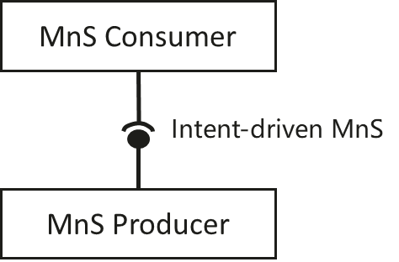
Figure 4.2-1: Intent-driven MnS
The intents may be fulfilled by utilizing multiple mechanisms including among others: Rule-based mechanisms, closed loop mechanisms and AI/ML mechanisms. These mechanisms can be combined in solutions of various complexity, ranging from a simple approach rule-based mechanisms, to more elaborate solutions combining AI/ML, closed loop automation to ensure the fulfillment of intents.
When the intent is created on the MnS producer, the MnS producer may consume other management services (including non-intent driven MnS and intent driven MnS) to fulfil or satisfy the intent. The internal implementation of the intent fulfilment will however not be standardized.
An Intent driven MnS includes the following management capabilities to support intent lifecycle management:
- Create an intent, a MnS Consumer request to create a new intent on the MnS producer.
- Activate an intent, MnS Consumer request to activate an intent on the MnS producer when the intent is suspend.
- De-activate an intent, MnS consumer request to de-activate an intent on the MnS producer for a temporary suspension.
- Delete an intent, MnS Consumer request to remove an intent on the MnS producer.
- Modify an intent, MnS Consumer request to modify the content of the intent (e.g. optimization goal) on the MnS producer.
- Query an intent, MnS Consumer request to return the content and state (e.g. active, inactive) of the intent on the MnS producer.
2nd Change

4.4 Relation between rule, policy and intent
An intent specifies the expectations including requirements, goals, and constraints for a specific service or network management workflow, while a policy specifies the action(s) to be taken when given condition occurs and rules specifies the explicit or formula logics to be executed. For certain scenarios, policies can be used in conjunction with intents to achieve the autonomous purposes. Figure 4.4-1 describes the relation between rule, policy and intent in the “what-how” view. As it now stands, the telecom systems are mainly focused on "how" and "less what". The current 5G networks brings more operational complexities, and the telecom system need to be able to adapt their operation to the business objectives of the operator as well as expectations of customer, which is driving customer to shift the focus from "how" to "what". The first step towards that shift, has been shift from "Rule based management" to "Policy driven management", with more focus on "how" and less on "what" covering domain specific issues/aspects (an example for policy is when the average throughput is lower than certain threshold, take specified actions). As technologies are evolving and the level of complexity exceeds, the need for an abstraction level description (i.e. Intent) becomes more apparent (an example for intent is the target average throughput for certain area should be assured). An intent driven system will be able to learn the behaviour of networks and services and allows a customer to provide the desired state, without detailed knowledge of how to get to the desired state.

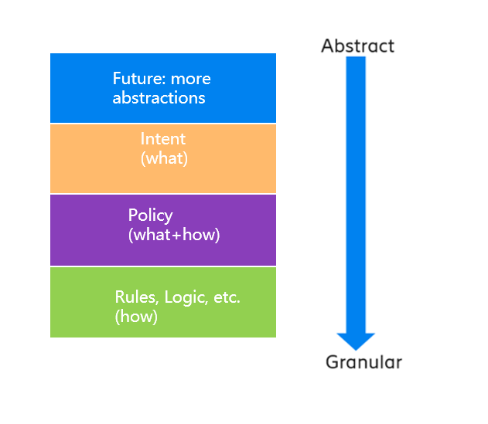
Figure 4.4-1: Relation between rule, policy and intent
End of changes

